Pratice 1

- Create the MDI child Orders form as below: (3 marks)
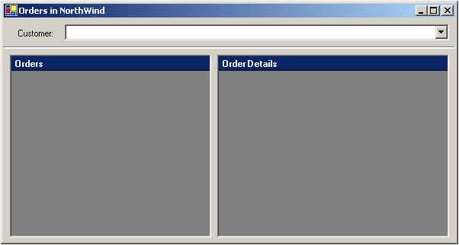
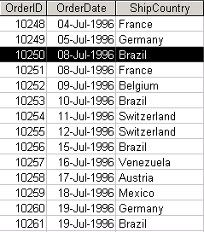
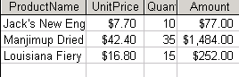
Using NorthWind database which is available in SQL server, write code to performs the tasks as following:
- When the form is loaded, populate Combobox with CompanyName from Customers table. (4 marks)
- When the user select a customer from Combobox, all Orders (from Orders table with OrderID, OrderDate and ShipCountry fields) of that customer must be shown in the DataGrid on the left of the form. (5 marks)
- When the user select an Order from the Orders list, all details (ProductName, UnitPrice, Quantity and Amount fields (Amount=UnitPrice*Quantity)) of that order must be shown in the DataGrid on the right of the form. (5 marks)
- Create About form as: (1 marks)

Insert the images into the form (any image) and the Close button
Write code to close the form when the user click on the Close button. (1 marks)

❐  

