Question (30 marks)

SupperShoppe, one of the leading department stores, is in need of a stock maintenance system. Given below is the table structure to be used:
  Table: | Category
  Column | Description
  CatCode | Item Category code
  CatDescription | Description of category
  Table: | User
  Column | Description
  UserName | User Name
  Password | Password
  Status | Status
  Table: | Items
  Column | Description
  ItemCode | Item Code
  ItemDesc | Description
  ItemCat | Category
  Price | Price
  Qoh | Quantity on hand
  Comp | Compliments if any
The database must be created in SQL server, and student must generate the script of creating tables and write down script to insert data into tables. All scripts must be submitted in the file
<Student Number>.SQL and save in the submitted folder.

Develop a MDI application for the client mentioned above, providing the following functionalities:
- Login (9 marks)
At start-up, the application should prompt for a valid user name and password as shown in Figure 1 below. In addition to the user name and password, the status of the user name is also to be considered for verification. A status value of 0 (zero) and 1(one) can be used to signify the status being active and inactive respectively. Only the active user names are valid. The application should terminate if the user clicked on cancel button.
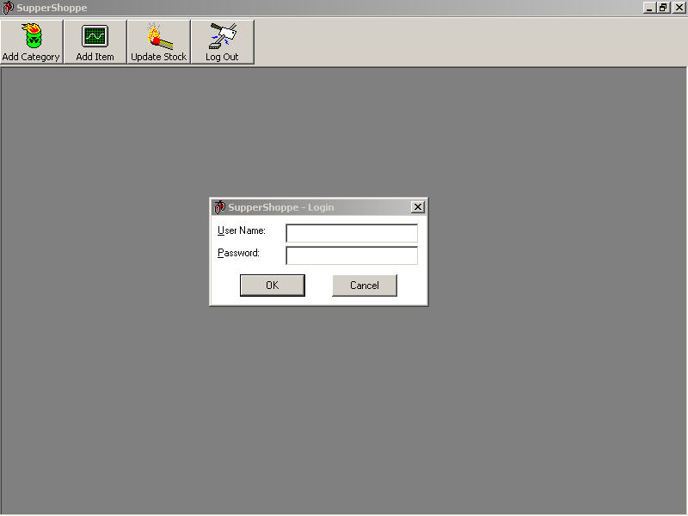
Figure 1

- Add Category (5 marks)
Adds new category to the category table as shown in Figure 2 below. The category code entered should not be an existing one.
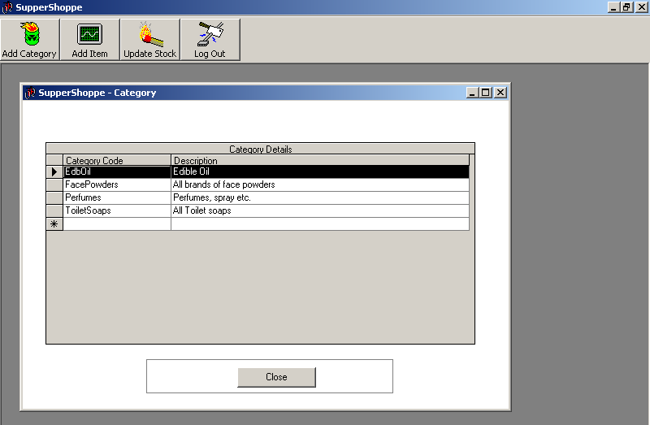
Figure 2
- Add Item: (9 marks)
Adds new items to the item table as shown in Figure 3. The item code has to be auto generated. The item code will be of 8 digits format including leading zeros. The textbox for compliments should contain the text “no compliments” by default.
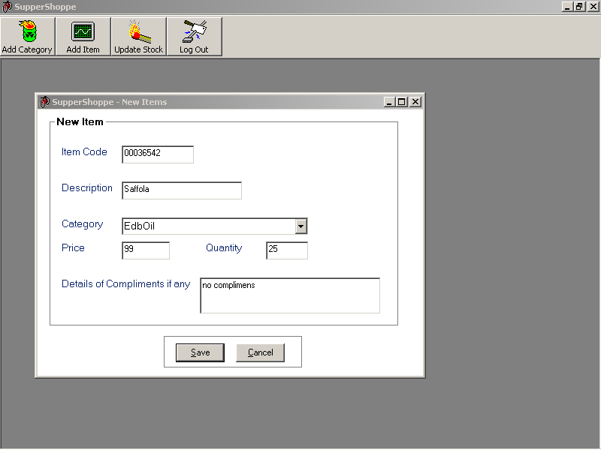
Figure 3
- Update Stock (8 marks)
This option permits to update the current stock of the available items by adding more quantities, as shown in Figure 4. The user should be able to enter or select a particular item code and on selection it should display the details of the item. Then the user can modify both quantity and compliment details.
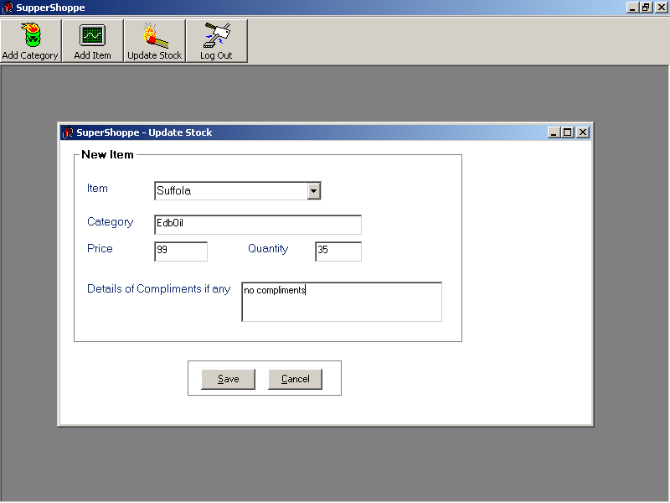
Figure 4
- Main form (9 marks)
Create a tool bar as shown in Figure 5 with four buttons representing the above functionalities.
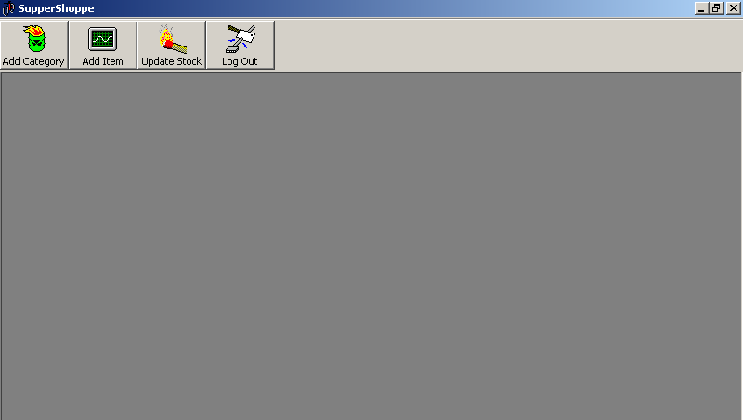
Figure 5

  

