Create a “Personal Assistant” application with the following specifications:
- Using SQL Server Database named: “PersonalAssistant” on LOCAL SQL-SERVER, with the data files to be named as Personal Assistant. MDF and Personal Assistant. LDF and SAVED on folder …\<Student Number>. Given below is the table structure to be used
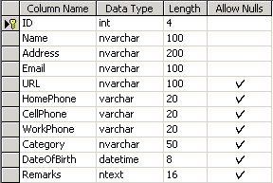
- The application interface as show in Figure 1 below. (8 marks)

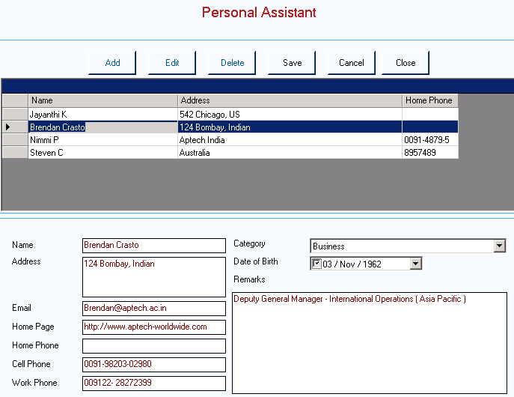
Datagrid
Input Area
Figure 1
DataGrid
Input Area

- The Category combo box included the following items: Business, Colleagues, Familly and Friends (1 mark)
- Date of Birth is the ‘Date Time Picker’ control and default value is set to current date (1 mark)
- At startup, all buttons are disabled, except ‘Add’ and ‘Close’ button. In addition, all controls in the Input area are disabled too. (1 mark)
- When user clicked on ‘Add’ button: the ‘Add’, ‘Edit’ and ‘Delete’ button will be disabled, the ‘Save’, ‘Cancel’ and ‘Close’ button will be enabled and all controls in the Input area will be enabed and set to blank. Allow user to enter data in to the controls. (4 marks)
- When user clicked on ‘Edit’ button: the ‘Add’, ‘Edit’ and ‘Delete’ button will be disabled, the ‘Save’, ‘Cancel’ and ‘Close’ button will be enabled and all controls in the Input area will be enabed allow user to edit existed data in the controls. (4 marks)
- The following validations should be performed:
  - Name, Address, Email should not be blank (3 marks)
  - If Date of Birth is entered then the year should not be greater than 1990 (2 marks)
- When user clicked on ‘Delete’ button, the message box below should be displayed: If user click ‘Yes’ then the selected contact will be deleted in database. (4 marks)
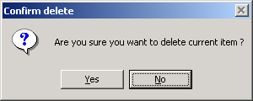
- Note: The ‘Edit’ and ‘Delete’ button will be enabled only when the Datagrid have at least 1 row of data is selected. When user select a row in Datagrid, all the information of the selected contact will be fill in the Input area (3 marks)
- When user clicked on ‘Save’ button, the data in the Input Area should be corresponding Insert/Update into Database and display the message box ‘Save successfully’, The ‘Add’, ‘Close’ button will be enabled, the ‘Save’, ‘Cancel’ button will be disabled. In addition, the Datagrid should be refreshed to display the new data. (7 marks)
- When user clicked on ‘Cancel’ button, all controls in the Input area should be disabled. The ‘Add’, ‘Close’ button will be enabled, the ‘Save’, ‘Cancel’ button will be disabled. (1 mark)
- When user clicked on ‘Close’ button, the application should be closed. (1 mark)

  

