- Question
Create a “UserManager” application with the following specifications:
- Create SQL Server Database name “UserManager” on LOCAL SQL-SERVER
- Student must generate the script of creating tables and write down script to insert data into tables. All scripts must be submitted in the file <Student Number>.SQL and save in the submitted folder.
- Given below is the “User” table structure to be used:
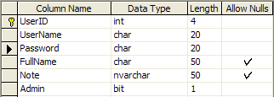

- This application will consist of 3 Forms: form Login, form Main and form UserDetail.
- The interface of form Login is shown below: (5 marks)

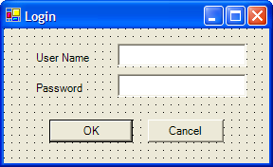

- This form checks the Username and Password if they match with the database. If the Username and Password are correct, the form Main will be opened. (3 marks)
- The form Login must be closed before the form Main is opened. (2 marks)
- The form Main must be a MDI parent form, it has a menu. The interface of form Main is shown below: (8 marks)

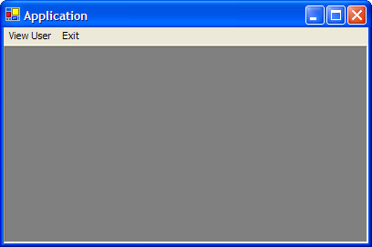
- When the “View User” option on the menu is selected, the form UserDetail will be opened.
- The form UserDetail has a datagrid to displays user details, this form has 3 button used to update, reset user detail and to close the form. The interface of form UserDetail is shown below:

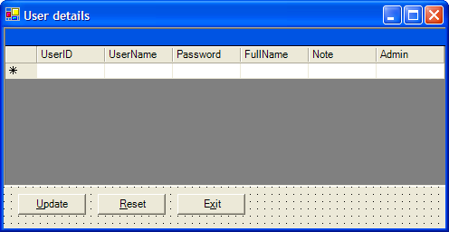

- This form must be an MDI child form. (2 marks)
- If the login user has the Administrator right, he can edit user details in this datagrid, otherwise this datagrid is read-only and the button Update, Reset is disabled. (2 marks)
- When the user clicks on the button Update, all changes will be updated to the database. When the user clicks on the button Reset, all user details will be reset from the database. (2 marks)
- This form can be resized. When this form is resized the datagrid and all buttons will be resized and relocated associatively. (2 marks)
- The Column “UserID” must be read-only. (2 marks)
- Each value in column “Username” must be unique. (2 marks)
- When a row is added, application must generate a new UserID which is the next number greater than the current max ID. (2 marks)

