You are required to develop the following modules of an online messenger system: | [30]
  - MDI Form with Toolbar: The toolbar will have the following buttons:
- Compose Message: To load Send Message Form
- Check Messages: To load or reload message inbox form.
- Close Message Box: To unload message listing form.
- Log out: To exit the application.

  - Login Form: This start up form, as shown in Figure 1, accepts login name and password and performs the user authentication. The user should not be able to use the application, if user authentication is failed.

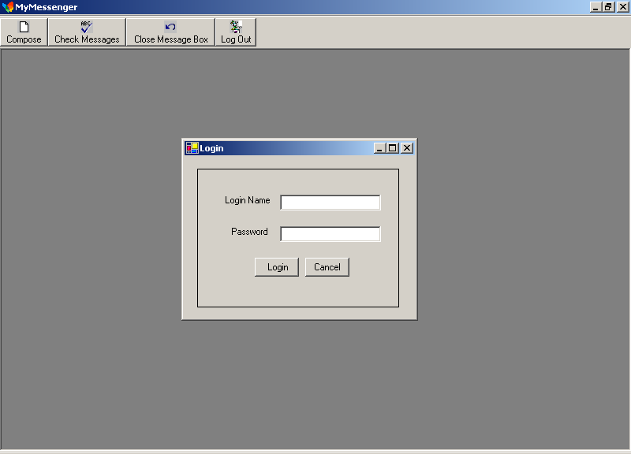
Figure 1

- Message List Form: This form is loaded immediately after the successful logon and will list all the messages addressed to the current user as shown in Figure 2.

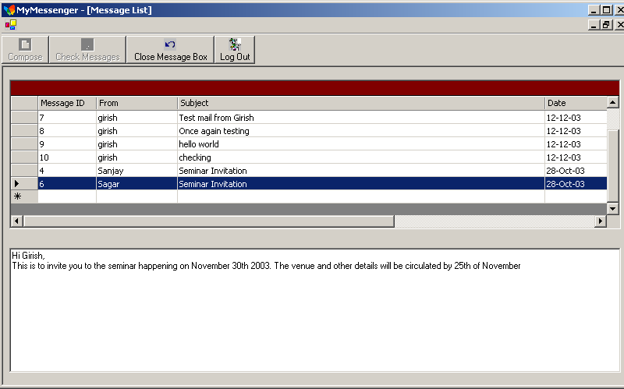
Figure 2

- Compose Form: This form is used to compose and send message as shown in Figure 3

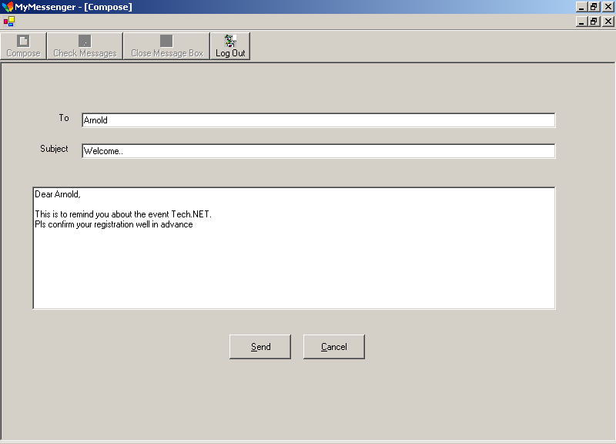
Figure 3

Notes:
- The user can use only one form at a time. So when a form is loaded, the tool buttons to load other forms must be disabled.

- It should be ensured that none of the input fields are left blank before sending a message by clicking on the Send button

- The database tables to be used for the above application are listed below:

 | Database name: | MSGDATA
 | Table: | MsgUsers
 | Column | Description
 | UserName | Login name
 | Password | Password
 | FullName | Full name of the user
 | Table: | MsgBox
 | Column | Description
 | MsgID | Message ID – Identity column
 | MsgFrom | Message from - user name
 | MsgTo | Message to - user name
 | MsgSub | Subject line
 | MsgBody | Body of the message
 | MsgDate | Message date

- The database must be created in SQL server, and student must generate the script of creating tables and write down script to insert data into tables. All scripts must be submitted in the file <Student Number>.SQL and save in the submitted folder.

