|  |  |
| --- | --- |
|  | **FPT ACADEMY INTERNATIONAL**  **FPT – APTECH COMPUTER EDUCATION** |

**Centre Name: ACE-HCMC-2-FPT.**

**Address: 590 Cach Mang Thang 8, District 3, Ho Chi Minh City, Viet Nam.**

**BARBERIA**

INSTALLATION GUIDE

|  |  |  |
| --- | --- | --- |
| **Supervisor:** | Mr. Ngo Phuoc Nguyen | |
| **Semester:** | IV | |
| **Batch No:** | T1.1908.E0 6715 | |
| **Group No:** | 1 | |
| **Order:** | **Full name** | **Roll No.** |
| 1. | Le Minh | Student1225645 |
| 2. | Nguyen Minh Thoai | Student1225526 |
| 3. | Hoang Thien An | Student1198581 |
| 4. | Luong Vinh Hien | Student1204494 |

July 2021

# SOFTWARE AND HARDWARE REQUIREMENT

## **Hardware, software requirement**

* **Hardware**

|  |  |
| --- | --- |
| **Component** | **Requirement** |
| **CPU** | Processor type:  Pentium IV-compatible processor or faster  Processor speed:  Recommended: 2.0 GHz or faster |
| **OS** | Window 7 or higher |
| **Memory (RAM)** | RAM:  Minimum: 4 GB  Recommended: 8 GB or more |
| **Hard Drive** | Free space:  Minimum: 30 GB  Recommended: 50 GB or more  Maximum: Operating system maximum |

* Software

|  |  |
| --- | --- |
| Component | Requirement |
| Database | MySQL Workbench 8.0 |
| IntelliJ IDEA | Community or Ultimate |
| Java Development Kit | Java Development Kit (JDK) 1.8 |
| Glassfish Server | Glassfish Server 4.0 |
| Web browser | Microsoft Edge, Chrome or Firefox |

## **Softwares**

**Github links:**

* **Source code:** [**https://github.com/thisisminh172/barberia-services**](https://github.com/thisisminh172/barberia-services)
* **Project documents:** [**https://github.com/thisisminh172/barberia-documents**](https://github.com/thisisminh172/barberia-documents)

**Download and install all the software as below:**

* MySQL Workbench 8: <https://dev.mysql.com/downloads/workbench/>
* IntelliJ IDEA: <https://www.jetbrains.com/idea/download/#section=windows>
* JDK 8: <https://www.oracle.com/java/technologies/javase/javase-jdk8-downloads.html>

# CONFIGURATION FOR DEVELOPER

After you have downloaded our project file, please extract it. There are …. sub-folders inside the folder:

-

-

-

Please read the installation guide and then the user guide before running our application.

## SETUP DATABASE

**step 1: Open MySQL Workbench**

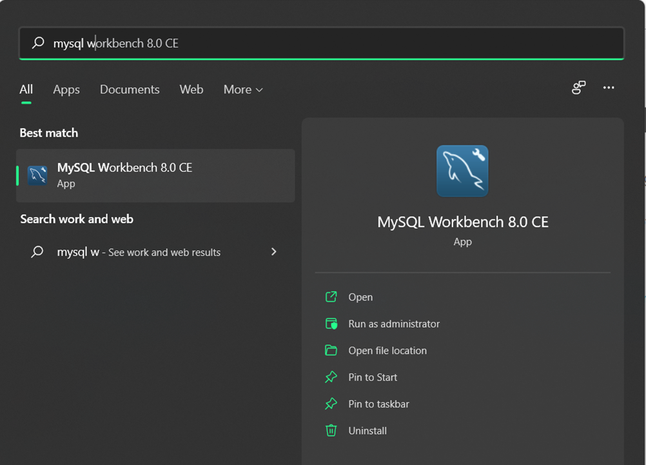

**Step 2: Chose MySQL Connections**

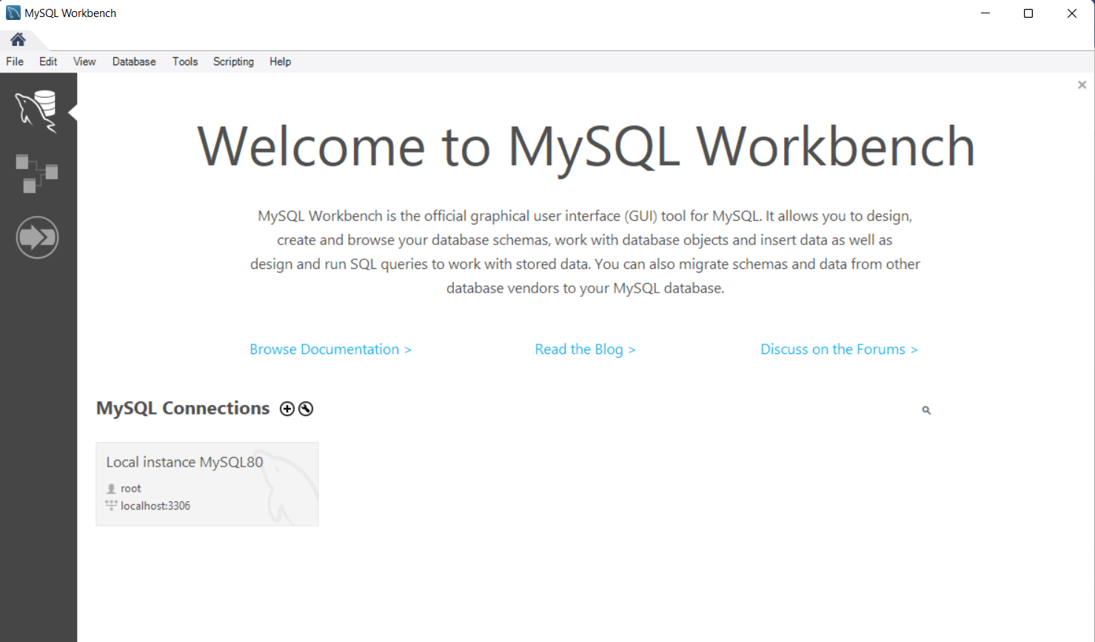

**Step 3: Type the password as run setup (password: admin)**

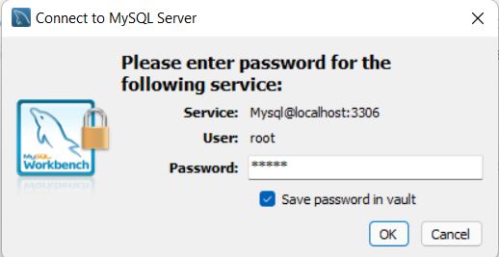

**Step 4: Click File -> Open SQL Script (or Ctrl+Shift+O)**

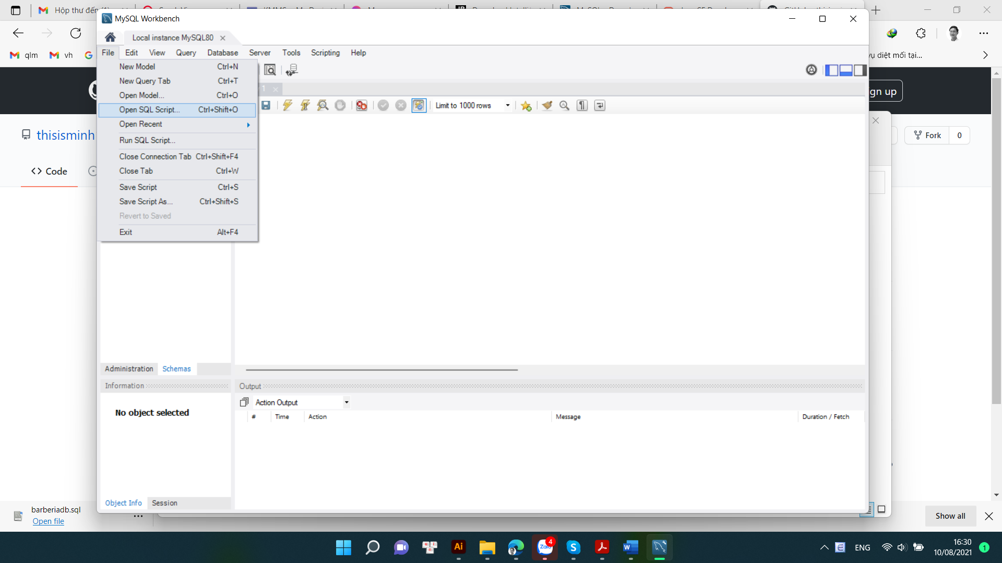

**Step 5: Chose “barberiadb.sql” (recommend: open this in visual studio code, and copy the sql query)**

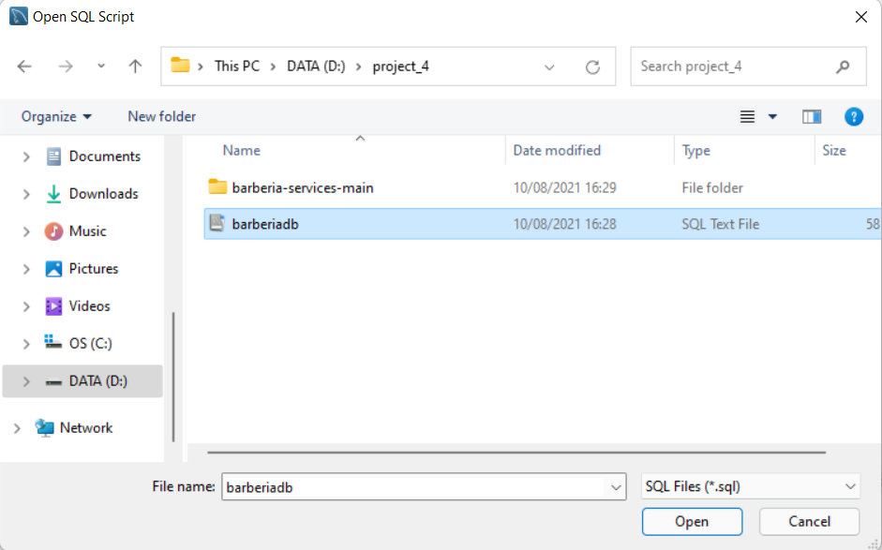

**Step 6:Open MySQL workbench, and paste the query. Execute “Create database barberiadb;” to create the databse**

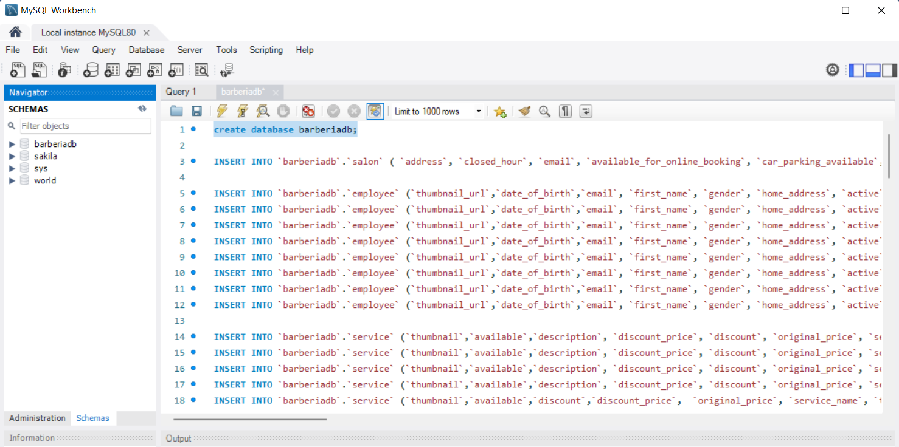

**Step 7: Open ItelliJ IDEA**

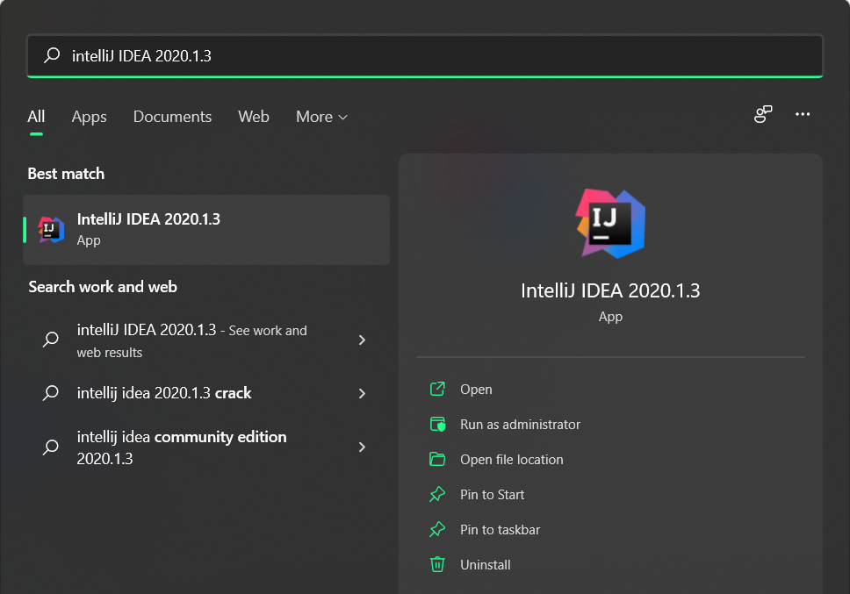

**Step 8: Click Open or Import**

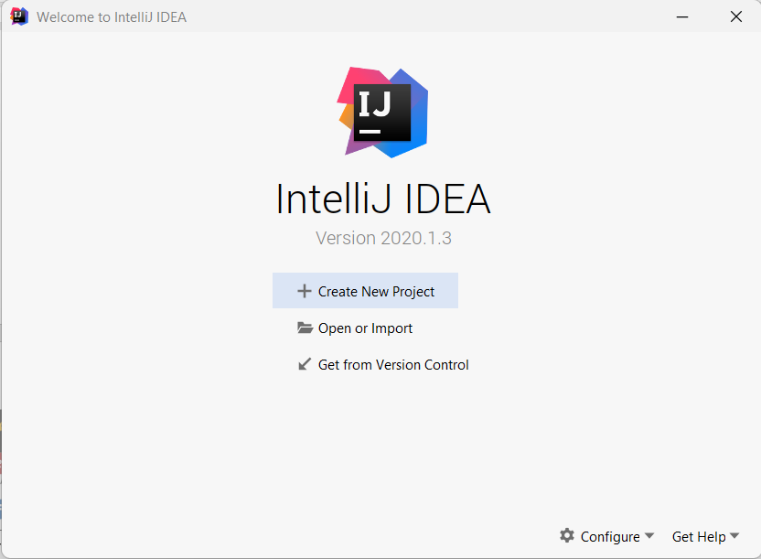

**Step 9: Chose source code “barberia-services-main”**

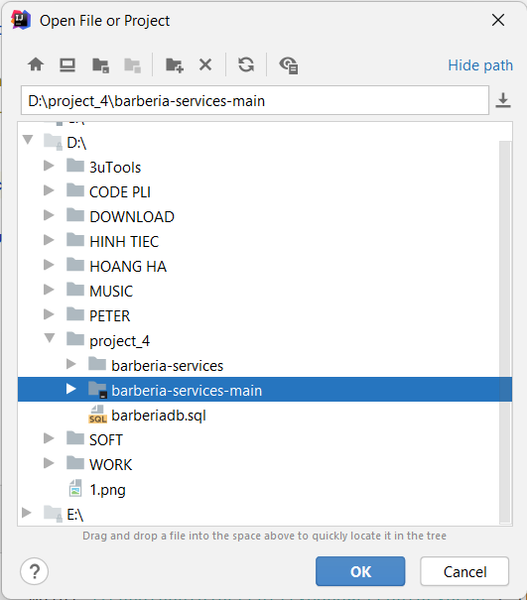

**Step 10: Open file “ AppApplication” follow “barberia-services-main -> src -> main -> java -> com.barberia.app” and Run AppApplication**

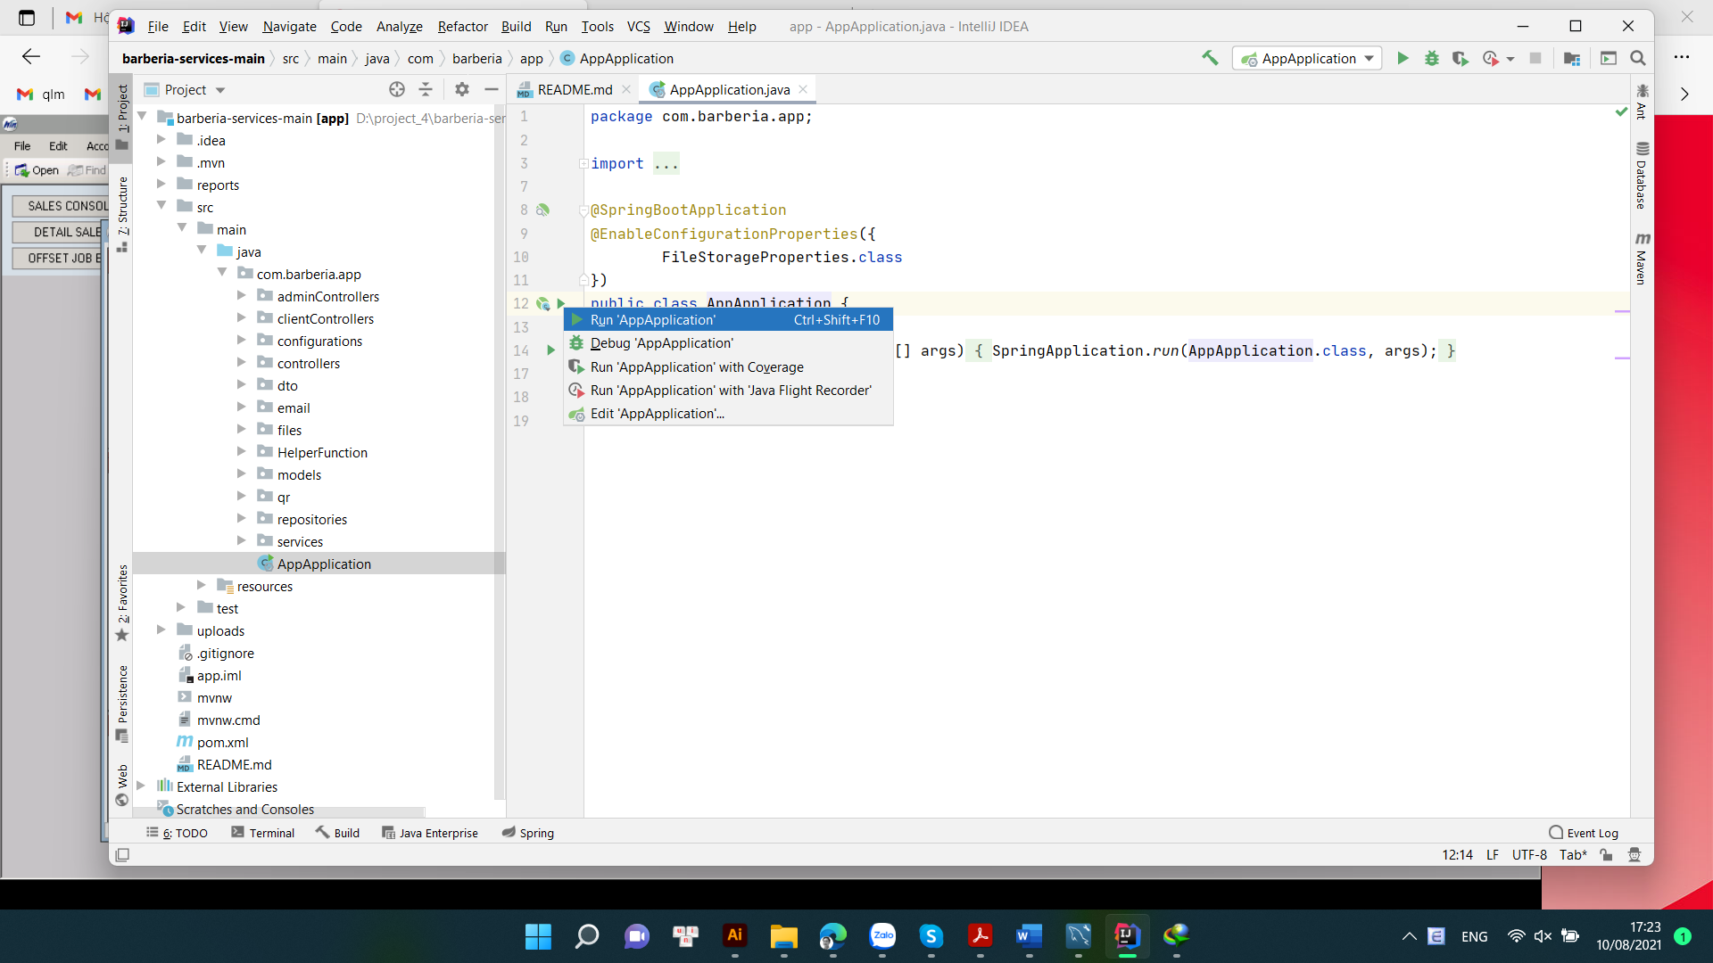

**Step 11: Come back the MySQL Workbench, all Table had created**

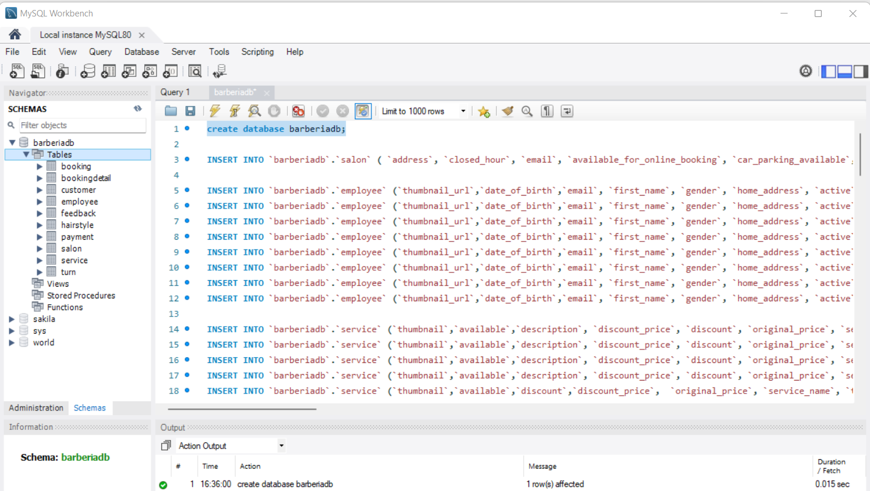

**Step 12: Select and Execute all remain database (INSERT INTO…)**

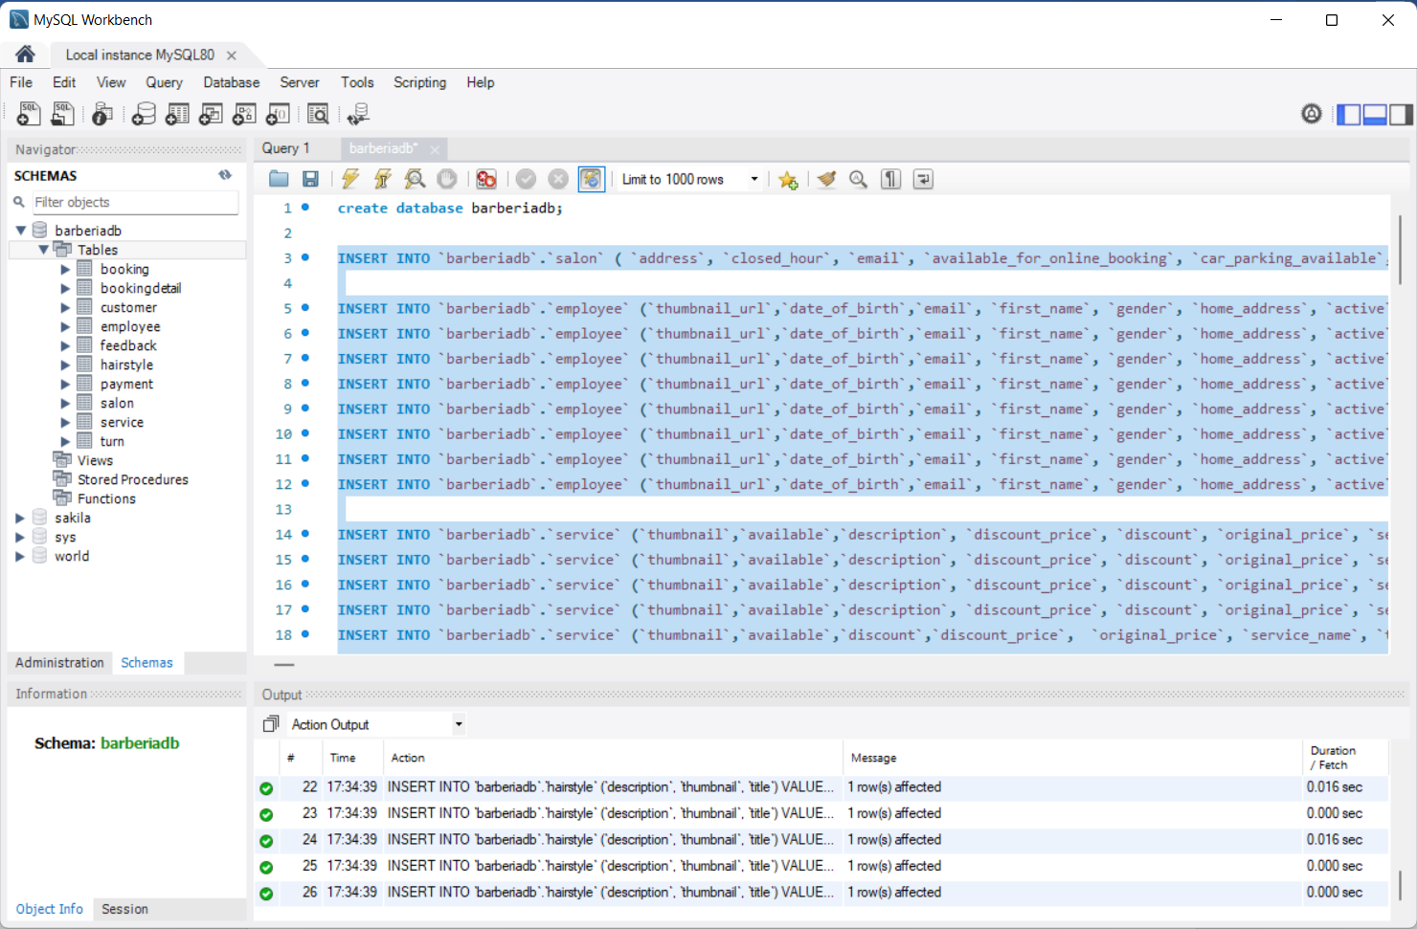

**And now, you open a new browser window and enter the following address**

[**http://localhost:8080**](http://localhost:8080) **– For Homepage**

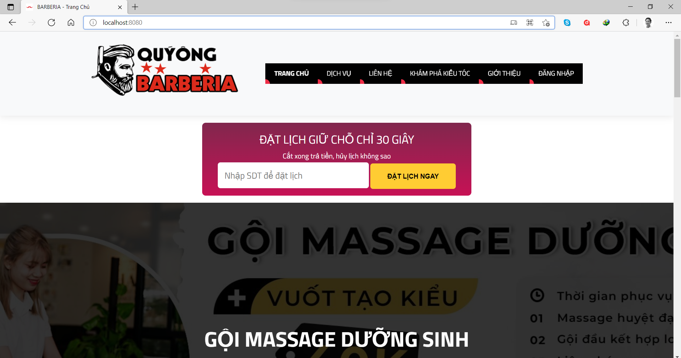

[**http://localhost:8080/admin/**](http://localhost:8080/admin/) **– For Adminpage**

**ID:** [minh123@gmail.com](mailto:minh123@gmail.com)

**Password:** Barberia123

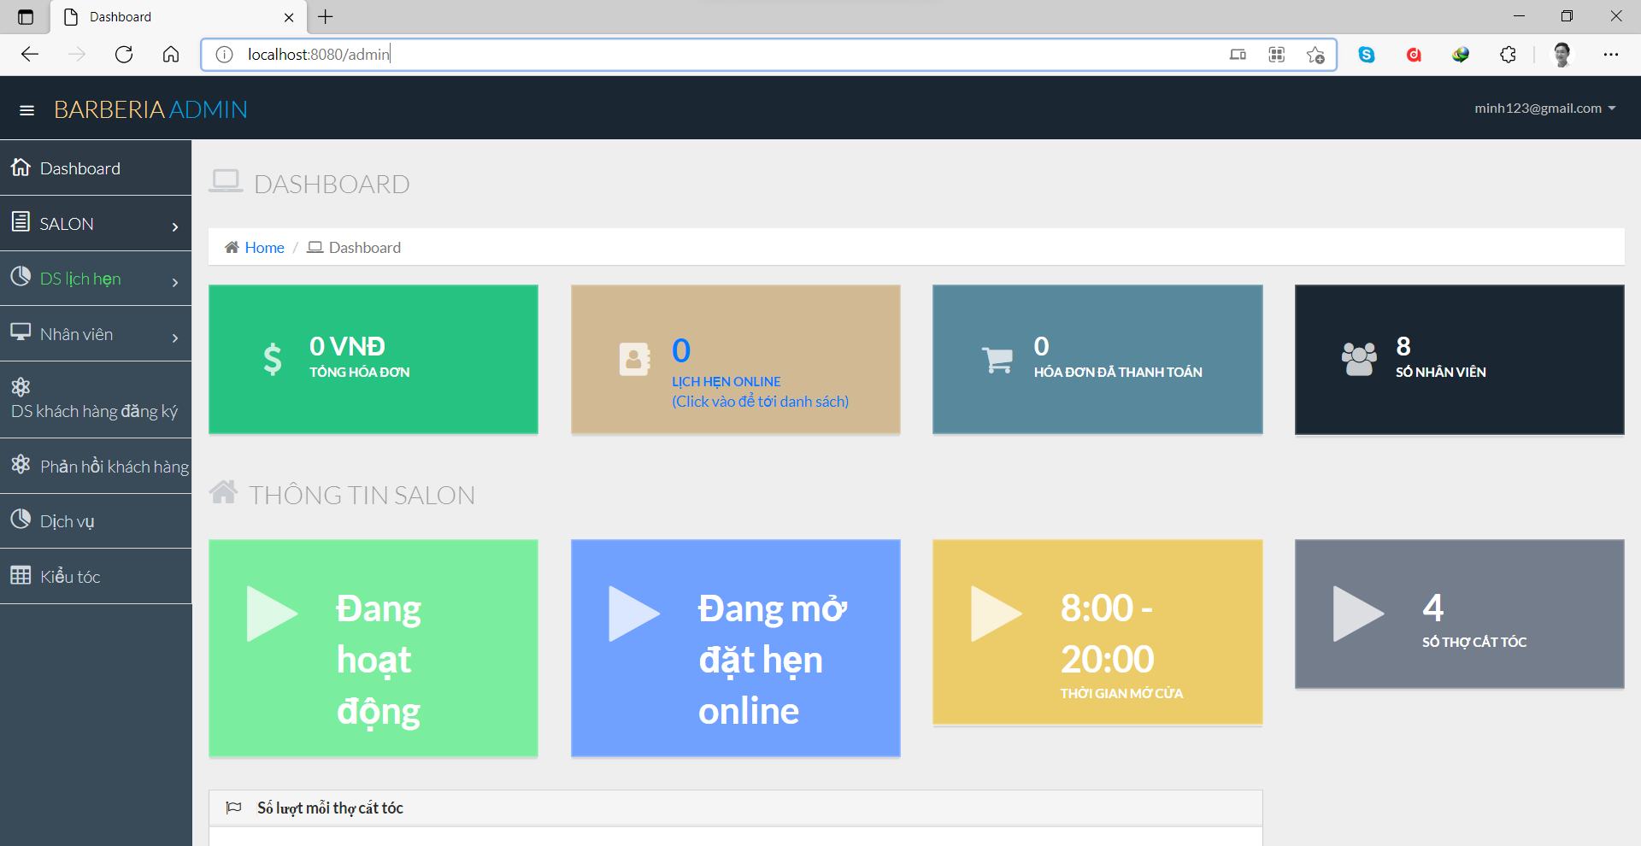

# CONFIGURATION FOR DEPLOYMENT

**To start deployment the project, you have to have:**

* Complete Step 10 (of CONFIGURATION FOR DEVELOPER above)
* Installed Apache Tomcat Server (version 9.0.44 or higher)
* File barberia.war

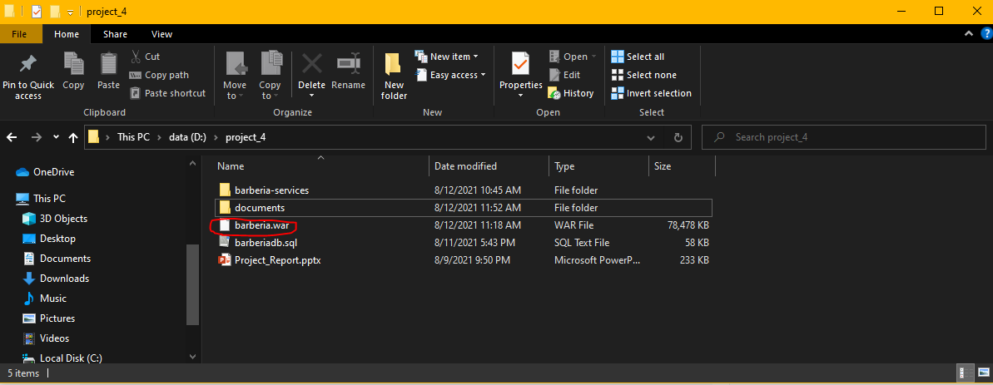

**Step 1: Set up environment**

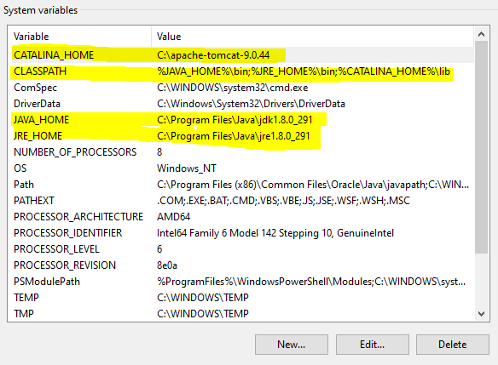

Make sure having these path to run tomcat server properly

**Step 2: Open cmd and go to “C:\ yourPath \ apache-tomcat \ webapps” and paste the barberia.war here**

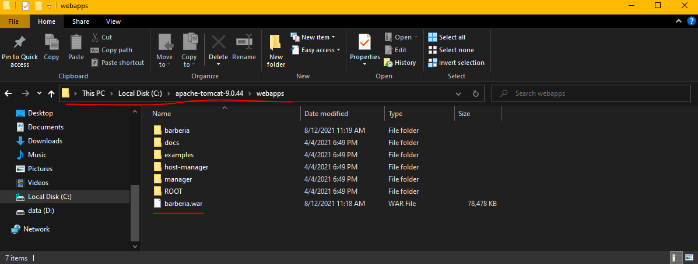

**Step 3: Run Tomcat server, Open cmd , go to “apache-tomcat-9.0.44\bin”, and run command catalina.bat run**

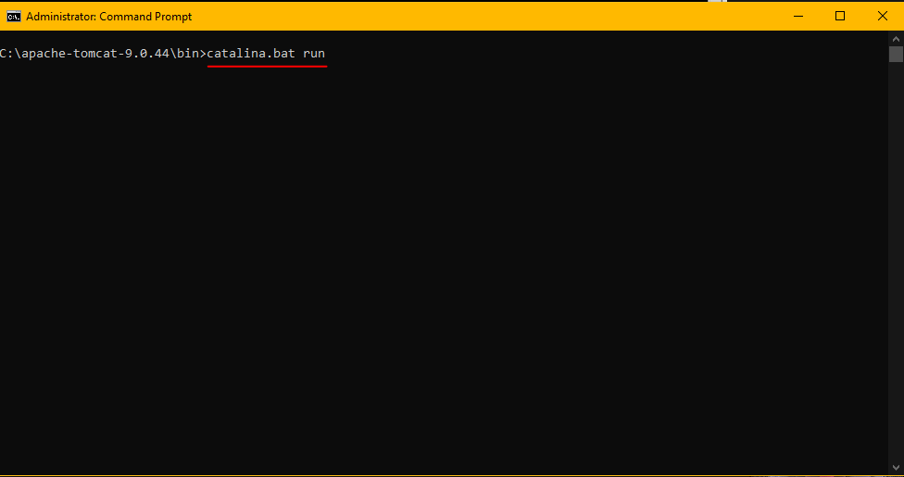

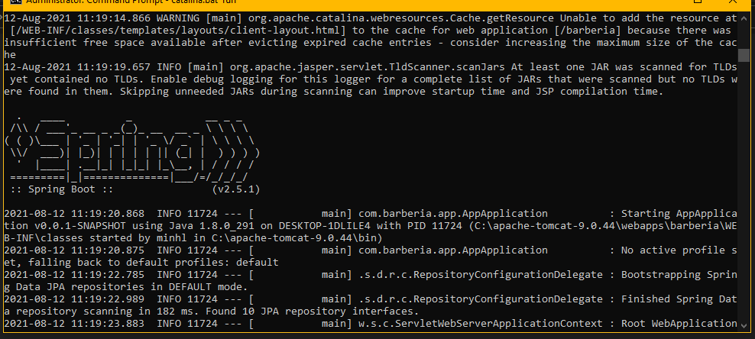

**Step 4: open Chrome brower and go “localhost:8082” (Port number may be different)**

**Step 5: Go to Manager App**

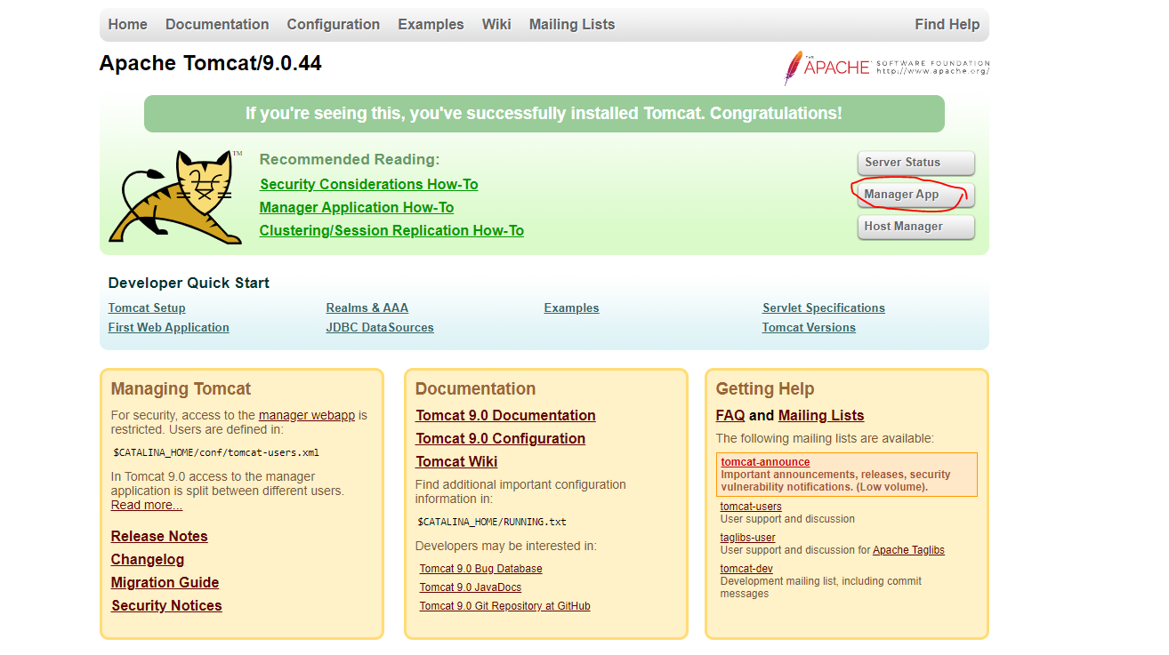

**Step 6: Click on /barberia, it will open the home page of Barberia**

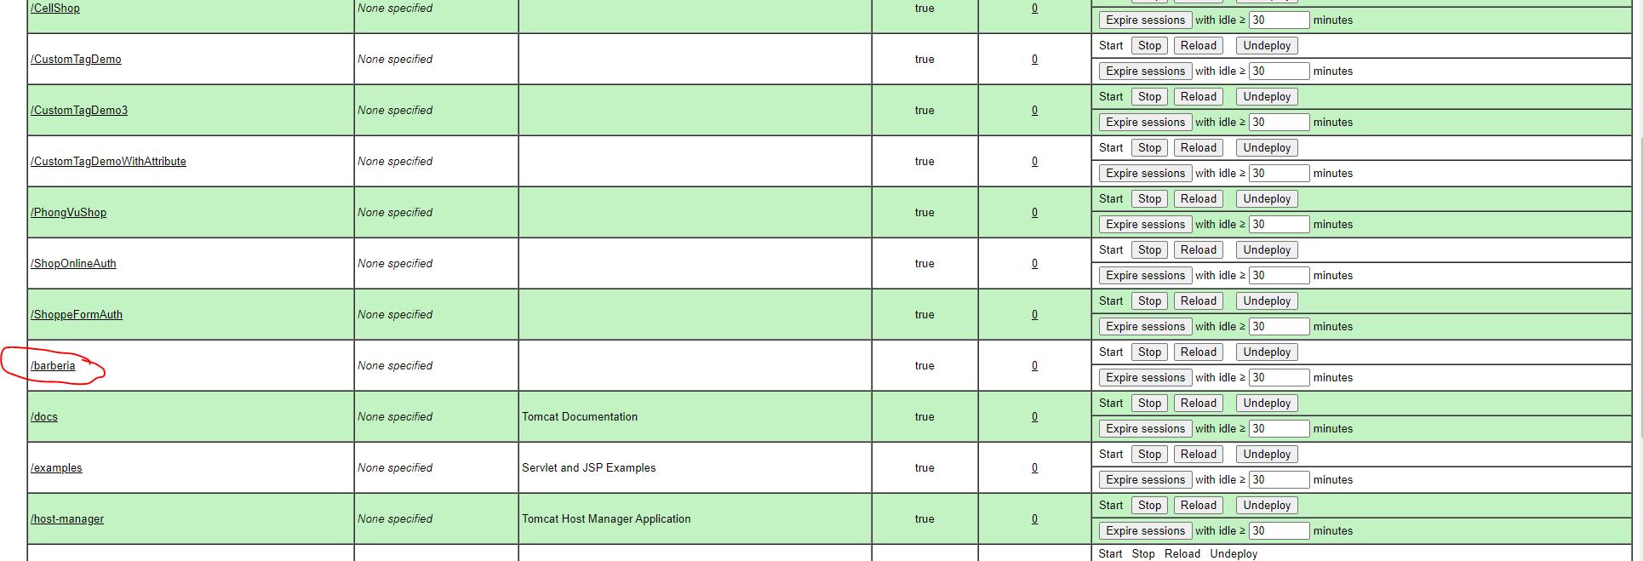

**Step 7 Finished**

**THANK YOU**