|  |  |
| --- | --- |
|  | **FPT ACADEMY INTERNATIONAL**  **FPT – APTECH COMPUTER EDUCATION** |

**Centre Name: ACE-HCMC-2-FPT.**

**Address: 590 Cach Mang Thang 8, District 3, Ho Chi Minh City, Viet Nam.**

**[Online Jewellery Shopping]**

|  |  |  |
| --- | --- | --- |
| **Supervisor.** | Ngo Phuoc Nguyen | |
| **Batch.** | T11910M1 | |
| **Group.** | 1 | |
| **Serial No.** | **Enrollment Number** | **Student Name** |
| 1. | Le Minh | Student1225645 |
| 2. | Phan Minh Cuong | Student1204492 |
| 3. | Phan Van Phuong | Student1198481 |
| 4. | Bui Quoc Tuan | Student1233868 |

**January 2021**

TABLE OF CONTENTS

**REVIEW I**

1 INTRODUCTION: 4

2 PROPOSED SOLUTION: 5

3 REQUIREMENT SPECIFICATION: 5

4 HARDWARE / SOFTWARE REQUIREMENTS: 6

5 DEVELOPMENT SOFTWARE: 8

6 TECHNOLOGY: 9

7 TASKSHEET REVIEW I 9

8 Use Case and Sequence Diagram 10

8.1 User 11

8.1.1 Register as Customer 11

13

8.1.2 Login as Customer 13

8.1.3 Update as Customer 14

8.1.4 Customer Ban (Admin) 15

8.2 Product 16

8.2.1 Search Product As Customer 16

8.2.2 Filter Product 17

8.2.3 Place Orders 18

8.2.4 Compare Product 19

8.2.5 Bookmark Product 20

8.3 Admin 21

8.3.1 Add Admin’s Account 21

8.3.2 Update Admin 22

8.3.3 Order (Update Order’s Status) 23

8.4 Report 24

8.4.1 View Report 24

8.4.2 View Order Report 25

8.4.3 View Customer Report 25

9 DFD’s 26

9.1 Level 0 26

9.2 Level 1 27

9.3 Level 2 28

10 Database Design 28

10.1 TABLE NAME: AdminLoginMst 28

10.2 TABLE NAME: BrandMst 28

10.3 TABLE NAME: CatMst 29

10.4 TABLE NAME: CertifyMst 29

10.5 TABLE NAME: DimMst 29

10.6 TABLE NAME: DimQltyMst 29

10.7 TABLE NAME: GoldKrtMst 29

10.8 TABLE NAME: ProdMst 30

10.9 TABLE NAME: StoneMst 30

10.10 TABLE NAME: StoneQltyMst 30

10.11 TABLE NAME: UserRegMst 30

10.12 TABLE NAME: ItemMst 31

10.13 TABLE NAME: DimQltySubMst 31

10.14 TABLE NAME: DimInfoMst 31

10.15 TABLE NAME: Inquiry 32

10.16 TABLE NAME: JewelTypeMst 32

10.17 TABLE NAME: CartList 32

11 TASKSHEET REVIEW 2 33

**REVIEW I**

# INTRODUCTION:

* **Mr. Robert D’costa** started the business from the scratch in 2005. The flagship company of **Yash Gems & Jewelleries (P) ltd** was formed to carry on the business of manufacturing and trading of Gold & Diamond Jewellery.
* To manufacture diamond Jewellery with ultimate brilliance, ***Yash*** has employed the latest and most advanced technologies for manufacturing diamond jewellery.
* As a supplier to some of the most exclusive retailers, ***Yash*** have intimate knowledge of the cultures and trends of the markets served. The national sales and distribution network team allows them to cultivate a close relationship with the customers and guarantees efficient services.
* ***Yash*** believes in reflecting their jewellery with special magic, conjured by melting of spirit and dedication, labour and craftsmanship, and art of work. The talented designers, skilled craftsmen and dedicated managers use state-of-the-art technology to produce the finest level of diamond jewellery for leading retailers.
* The company’s sincere desire is to give every client a reason to feel good. And policy is to offer top quality merchandise to the customers at the best possible price.
* With a vision and motto of providing its customers products of impeccable quality, ***Yash*** has outnumbered many in innovative design and quality, making itself the benchmark and hallmark of the Indian jewellery industry.

# PROPOSED SOLUTION:

**To develop a complete web-based solution for *Yash***

* The motive of this Online Jewellery Shopping Web Application is to allow the user to play with the search tool and create different combinatorial search criterion to perform exhaustive search.
* Provide Interactive interface through which a user can interact with different areas of application easily.
* A search engine that provides an easy and convenient way to search for products specific to their needs. The search engine would list a set of products based on the search term and the user can further filter the list based on various parameters.
* Provide Shopping Cart feature thereby allowing the user to add products to or remove products from the shopping cart by dragging the products in to or out of the shopping cart.
* Provides accurate level of security so that transactions can be made confidentially.
* People who are not much aware of the system can easily make purchase by easy to register interface.

# REQUIREMENT SPECIFICATION:

* In this system the vendor can launch his/her jewellery products with details of them on website. (Details needs to be captured are as per the table ItemMst below in data dictionary section.)
* He can keep these products for sale as well as can update his site with new ornaments time to time.
* Vendor on his server machine is able to take purchase orders from customers around the world and by validating the truth of orders with verification of customer details he may dispatch the delivery of ornaments to customers via post or courier.
* Vendor can also keep the records of all the customers in a database on his server machine.( UserRegMst in data dictionary)
* He also can create reports of his organization sales using database. He can collect bills form customers online using credit card numbers from customers.
* On the other hand customers on client machine can access the site for online jewellery shopping from any part of the world using internet service.
* Customer can select the ornaments from displayed ornaments and can give online orders for purchasing.
* Customer can provide his specific requirement as the weight of diamond, type, brand, carat for gold, name of gems, quality etc.
* Customer can pay his bills using credit card facility for shopping. The valid customers can send gift ornaments to their relatives and friends on other address through this system
* The Search option on the site is very useful for quick search for the ornaments which the customer needs. This reduces the search and browsing time of clients. Ornaments list is available to clients on this system.
* Customers are able to create their own accounts with individual secured passwords to the vendors. Account holder customer could log in directly by entering login name and password.
* A database should be maintained on the server machine. The database includes customer’s details, login details, product list, order details, Bill details, transaction details etc. the database is helpful in getting quick information reports
* In addition to the exclusive search for the jewellery, the site should also provide information about diamonds and various gems. Their history as well as benefits of using gems.
* The information about diamond certification should also be provided.
* The home page should be made attractive by posting the various discount schemes/gift offers/ festive offers/new launches etc.

# HARDWARE / SOFTWARE REQUIREMENTS:

1. **Server Requirement**

* **Hardware**

|  |  |
| --- | --- |
| **Component** | **Requirement** |
| **CPU** | Processor type:  Pentium IV-compatible processor or faster  Processor speed:  Recommended: 2.0 GHz or faster |
| **OS** | Microsoft Windows Server 2012 with IIS |
| **Memory (RAM)** | RAM:  Minimum: 512 MB  Recommended: 2 GB or more |
| **Hard Drive** | Free space:  Minimum: 200 MB  Recommended: 50 GB or more  Maximum: Operating system maximum |

* **Software**

|  |  |
| --- | --- |
| **Component** | **Requirement** |
| **Microsoft .NET Framework** | Version 4.6 or higher |
| **RDBMS** | Microsoft SQL Server 2017 |

1. **Client Requirement**

* **Hardware**

|  |  |
| --- | --- |
| **Component** | **Requirement** |
| **CPU** | Processor type:  Pentium III-compatible processor or faster  Processor speed:  Recommended: 1.0 GHz or faster |
| **OS** | All OS (Window, Linux, Android, Mac OS …) |
| **Memory (RAM)** | RAM:  Minimum: 512 MB  Recommended: 1 GB or more  Maximum: Operating system maximum |
| **Hard Drive** | Free space:  Minimum: 10 MB |

* **Software**

|  |  |
| --- | --- |
| **Component** | **Requirement** |
| **Web Browser** | Chrome, Opera (up to date) |

# DEVELOPMENT SOFTWARE:

* **Microsoft Window 10**
* **Visual Studio 2019**
* **Visual Studio Code**
* **Microsoft Sql Server 2018**
* **Git**
* **Zoom**

# TECHNOLOGY:

* **HTML/CSS**
* **BOOTSTRAP**
* **JQUERY**
* **AJAX**
* **ASP .NET CORE WEB**
* **ASP .NET CORE API**

# TASKSHEET REVIEW I

|  |  |  |  |  |  |
| --- | --- | --- | --- | --- | --- |
| **Project Ref. No: 3** | **Project Title:**  **Online Jewellery Shopping** | **Date of Preparation of Activity Plan** | | | |
| No. | Task | Actual Start Date | Actual Days | Team Member Names | Status |
| 01 | Acknowledgment | Jan 21, 2021 | 2 | All Members | Completed |
| 02 | Problem Definition | All Members | Completed |
| 03 | Customer Requirement | All Members | Completed |
| 05 | Hardware/Software | All Members | Completed |
| 06 | Task sheet | All Members | Completed |

|  |  |  |
| --- | --- | --- |
|  | **Prepare By: Group 1** | **Approved By: Faculty** |
| **Date: Jan 31, 2021** | Team Leader  Le Minh | Mr. Ngo Phuoc Nguyen |

REVIEW 2

# Use Case and Sequence Diagram

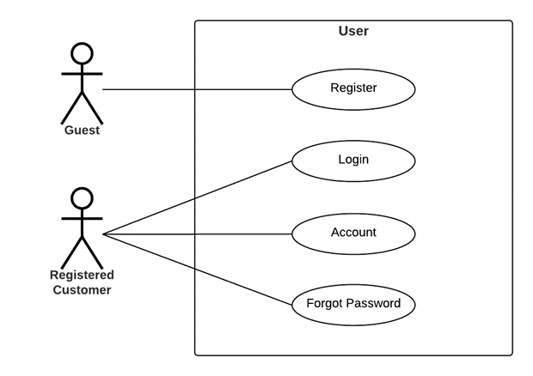

## User

### Register as Customer

|  |  |  |
| --- | --- | --- |
| **Author** | Le Minh | |
| **Use Case Name** | Register as Customer | |
| **Actors** | Guest | |
| **Description** | Guest registers an account on the website and becomes a member (customer) | |
| **Requirements** | Guest provides their register information | |
| **Pre-conditions** | N/A | |
| **Post-conditions** | Success: Guest creates a Customer account in this website | |
| Fail: Refill information | |
| **Basic flow** | **Actor’s actions:** | **System’s responses:** |
| 1. Actor clicks ‘Register’ link on Home Page.            3. Actor inputs register’s information and click ‘Register’ button. | 2. System redirects to Register page and displays Registration form with the following controls: - ‘Username’ text field - ‘Password’ text field - ‘Confirm Password’ text field - ‘First Name’ text field - ‘Last Name’ text field - ‘Email’ text field - ‘Phone1’ text field - ‘Register’ button - ‘Reset’ button 4. System validates the information. 5. System inserts the account into database  6. System show success message. |
|
|
|
|
|
|
|
|
|
|
|
|
|
|
|
| **Exceptions** | **Actor’s actions:** | **System’s responses:** |
| - Actor left ‘Username’ text field blank. - Username has already existed. - Actor left ‘Password’ text field blank. - Actor left ‘Confirm Password’ text field blank. - Password and confirm password don’t match. - Actor left ‘Name’ text field blank. - Actor left ‘Birthday’ field blank. - Input age is less than 16. - Actor left ‘Phone’ text field blank. - Input phone is not numeric format or phone length is not between 8 and 14 characters. - Actor left ‘Email’ text field blank or input an invalid email address. | System displays message to actor: - ‘Username cannot be blank’. - ‘This Username has already existed’. - ‘Password cannot be blank’’. - ‘Confirm Password cannot be blank’. - ‘Confirm Password does not match password.’ - ‘Name cannot be blank’. - ‘Birthday is invalid’. - ‘Age must be over 16’. - ‘Phone is invalid’. - ‘The phone number should be numeric only and must be between 8 and 14 digits’. - ‘Email is invalid’. |

### 

### Login as Customer

|  |  |  |
| --- | --- | --- |
| **Author** | Le Minh | |
| **Use Case Name** | Login | |
| **Actors** | Customer | |
| **Description** | Customer who has registered an account can login | |
| **Requirements** | Actor provides username and password | |
| **Pre-conditions** | Actor must register an account | |
| **Post-conditions** | Success: User is logged in to website | |
| Fail: Refill information | |
| **Basic flow** | **Actor’s actions:** | **System’s responses:** |
| 1. Actor clicks on ‘Login’ button.     3. Actor inputs Username (or email) and Password, then click the ‘Login’ button. | 2. System redirects to Login Page with the following controls - 'Username' text field - 'Password' text field - 'Login' button 4. System checks the information. 5. System redirects to User’s dashboard. |
|
|
| **Exceptions** | **Actor’s actions:** | **System’s responses:** |
| 1. Actor inputs invalid username (or email) and password. | System redirects to Login page with the following controls: - ‘Username’ text field - ‘Password’ text field - ‘Login’ button. System shows message: “Invalid Username and password”. |

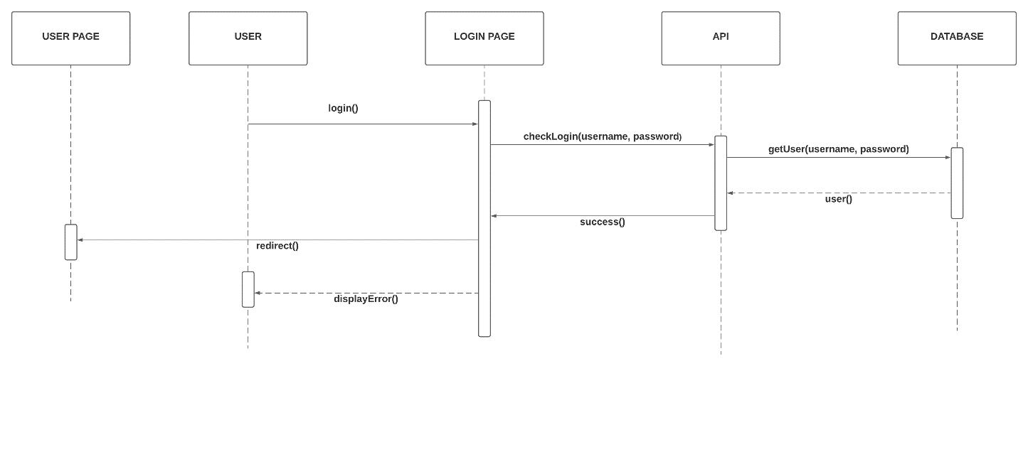

### Update as Customer

|  |  |  |
| --- | --- | --- |
| **Author** | Le Minh | |
| **Use Case Name** | Update Customer’s Profile | |
| **Actors** | Customer | |
| **Description** | Customer wants to Update their profile’s information. | |
| **Requirements** | Actor provides profile information | |
| **Pre-conditions** | Actor has logged in. | |
| **Post-conditions** | Success: Profile’s information of this user has been updated. | |
| Fail: Refill information | |
| **Basic flow** | **Actor’s actions:** | **System’s responses:** |
| 1. Actor clicks ‘Profile’ button in Actor’s Home page menu.              3. Actor updates information and click ‘Save’ button. | 2. System redirects to Update Profile page and displays Update Profile form with the following controls :  - ‘Old Password’ text field - ‘New Password’ text field - ‘New Password Confirm’ text field - ‘First Name’ text field  - ‘Last Name’ text field - ‘Birthday’ field  - ‘Gender’ radio button  - ‘Address’ text field - ‘Phone’ text field (x2) - ‘Email’ text field - ‘Save’ button - ‘Cancel’ button 4. System checks the information. 5. System updates the account in database and then redirects to User’s Dashboard |
|
| **Exceptions** | **Actor’s actions:** | **System’s responses:** |
| 1. Actor left ‘New Password’ text field blank. 2. Actor left ‘Confirm Password’ text field blank. 3. New Password and New Password Confirm do not match. 4. Actor left ‘Name’ text fields blank. 5. Actor left ‘Birthday’ field blank. 6. Input age in ‘Birthday’ field is less than 16. 7. Actor left ‘Address’ text field blank. 8. Actor left ‘Phone’ text fields blank. 9. Input phone is not in numeric or phone length is not in between 8 and 14 characters. 10. Actor left ‘Email’ text field blank or input an invalid email address. | System displays message to actor : - ‘Password cannot be blank’’. - ‘Confirm Password can’t be blank’. - ‘Confirm password does not match Password.’= - ‘Name cannot be blank’. - ‘Birthday is invalid’. - ‘Age must be over 16’. - ‘Address cannot be blank’. - ‘Phone is invalid’. - ‘The phone number should be numeric only and must be between 8 and 14 digits’. - ‘Email is invalid’. |

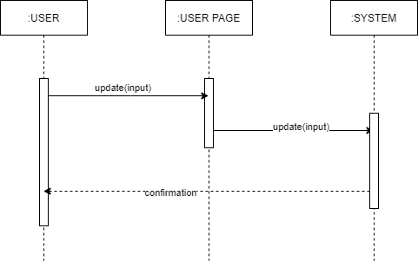

### Customer Ban (Admin)

|  |  |  |
| --- | --- | --- |
| **Author** | Bui Quoc Tuan | |
| **Use case name** | Ban a customer | |
| **Actors** | Administrator | |
| **Description** | When admin wants to ban a customer | |
| **Requirements** | Actor provides customer’s information | |
| **Pre-conditions** | Actor is logged in as admin or super admin | |
| **Post-conditions** | Success: set customer’s status into “Banned” and updated in database | |
| Fail: No changes are made | |
| **Basic flow** | **Actor’s actions:** | **System’s responses:** |
| 1. Actor chooses Customer row on Customer list and click “Ban” button. | 2. System updates customer’s status in database.  3. System displays confirmation message or error message. |

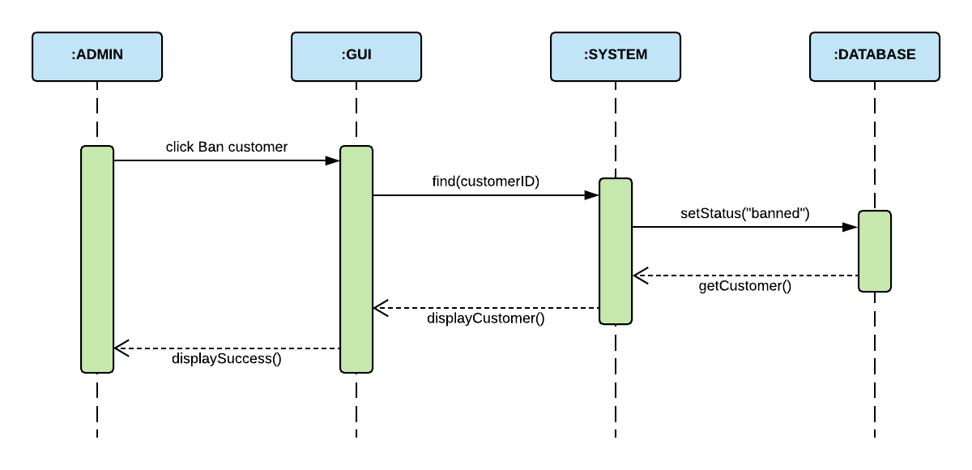

## Product

### Search Product As Customer

|  |  |  |
| --- | --- | --- |
| **Author** | Phan Van Phuong | |
| **Use case name** | Search products | |
| **Actors** | Guest/Customer | |
| **Description** | When Guest/Customer wants to search product | |
| **Requirements** | Actor provides search phrase | |
| **Pre-conditions** | N/A | |
| **Post-conditions** | Success: Show products that matches search phrase | |
| Fail: No product is show | |
| **Basic flow** | **Actor’s actions:** | **System’s responses:** |
| 1. Actor inputs search phrase.  3. Actor clicks product’s name in list or view every product that matches search phrase. | 2. System show list of products that match the search phrase.  4. System allows actor to sort products by:  - Oldest  - Newest  - Lowest Price  - Highest Price |

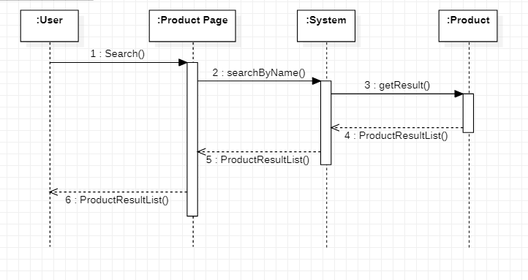

### Filter Product

|  |  |  |
| --- | --- | --- |
| **Author** | Phan Van Phuong | |
| **Use case name** | Product Filter | |
| **Actors** | Guest/Customer | |
| **Description** | Guest/Customer wants to filter products by one or multiple conditions | |
| **Requirements** | Actor chooses conditions by ticking checkboxes | |
| **Pre-conditions** | N/A | |
| **Post-conditions** | Success: Products that matches condition(s) are shown | |
| Fail: No product is shown | |
| **Basic flow** | **Actor’s actions:** | **System’s responses:** |
| 1. Actor ticks one or multiple of the following checkboxes:  - Categories  - Collections  - Attributes  - Price | 2. System show products that satisfy the condition(s)  3. System allows actor to sort products by:  - Oldest  - Newest  - Lowest Price  - Highest Price |

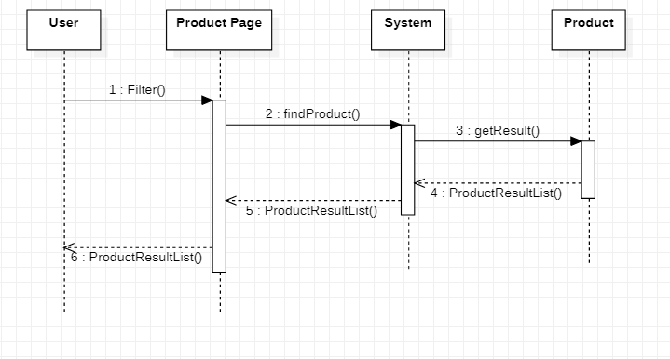

### Place Orders

|  |  |  |
| --- | --- | --- |
| **Author** | Phan Van Phuong | |
| **Use case name** | Check Out and Place Orders | |
| **Actors** | Guest/Customer | |
| **Description** | Guest/Customer wants to order products | |
| **Requirements** | Actor must choose at least one product to add to cart | |
| **Pre-conditions** | Cart has at least one product | |
| **Post-conditions** | Success: Actor order successfully | |
| Fail: Refill information | |
| **Basic flow** | **Actor’s actions:** | **System’s responses:** |
| 1. Actor chooses a product and click ‘Add to Cart’ button.  3. Actor clicks ‘Checkout’ button.  4. Actor inputs Voucher Code and clicks ‘Apply Voucher’ button.  8. Actor inputs order information, then click ‘Place Order’ button.  10. Actor inputs Card Owner’s Name, Card Number and Security Code. | 2. System adds product to cart by Sku ID.  4. System shows Cart and added products. 5. System verifies voucher code.  6. System shows all products in cart and calculate unit price.  7. System redirects to Order Information page and show the following controls:  - ‘Billing Name’ text field  - ‘Address’ text field  - ‘Required date’  - ‘Payment’ checkboxes  9. Systems show Payment Page if user chooses Pay with Card method.  11. System validates information. 12. System redirects to Order page and shows order’s status. |

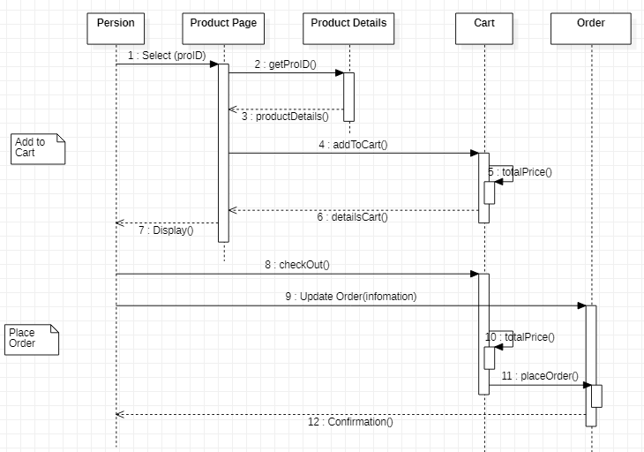

### Compare Product

|  |  |  |
| --- | --- | --- |
| **Author** | Phan Van Phuong | |
| **Use Case Name** | Compare products | |
| **Actors** | Guest/Customer | |
| **Description** | Customer compares products | |
| **Requirements** | Customer choose products they want to compare | |
| **Pre-conditions** | N/A | |
| **Post-conditions** | Success: show a list of compared products | |
| **Basic flow** | **Actor’s actions:** | **System’s responses:** |
| 1. Actor adds click ‘compare’ button on product.  3. Actor clicks ‘Compare List’ button in the menu. | 2. System adds product into compared list and shows the number of products which are added (default: 0).  4. System redirects to Compare List Page and shows all compared products. |
| **Alternative flow** | 1. Actor clicks ‘Remove this item’ button. | 2. System removes product form compared list. |
| **Exceptions** | **Actor’s actions:** | **System’s responses:** |
| 1. Actor added more than 5 products. | 2. System does not add product and redirects to Compare List Page. |

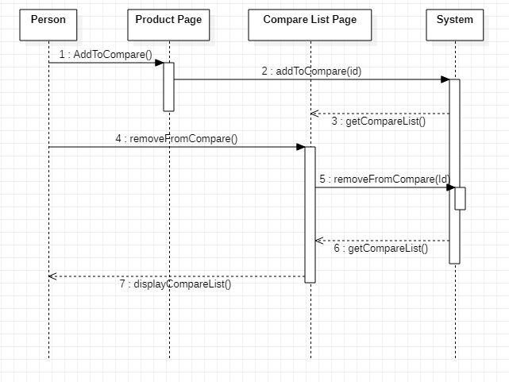

### Bookmark Product

|  |  |  |
| --- | --- | --- |
| **Author** | Phan Van Phuong | |
| **Use Case Name** | Bookmark product | |
| **Actors** | Customer | |
| **Description** | Customer wants to bookmark products to view it later | |
| **Requirements** | Customer choose products they want to bookmark | |
| **Pre-conditions** | Actor is logged in | |
| **Post-conditions** | Success: show bookmarked products in customer's bookmark list | |
| **Basic flow** | **Actor’s actions:** | **System’s responses:** |
| 1. Actor clicks ‘bookmark’ icon on each product in Product Page.  3. Actor clicks ‘Wish List’ link. | 2. System adds bookmark in database.  4. System shows list of bookmarked products. |

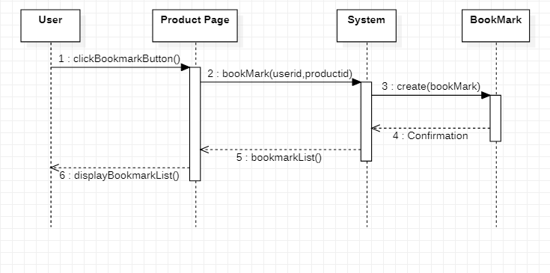

## Admin

### Add Admin’s Account

|  |  |  |
| --- | --- | --- |
| **Author** | Phan Minh Cuong | |
| **Use case name** | Add admin’s accounts | |
| **Actors** | Super Administrator | |
| **Description** | When admin wants to add a new admin’s account in the database | |
| **Requirements** | Super Admin provides admin information | |
| **Pre-conditions** | Actor is logged in as a Super Admin | |
| **Post-conditions** | Success: a new admin’s account is created in the database | |
| Fail: Refill information | |
| **Basic flow** | **Actor’s actions:** | **System’s responses:** |
| 1. Actor chooses Admin Tab on menu.  3. Actor chooses ‘Create an Admin Account’ button.  5. Actor inputs information to create admin. | 2. System redirects to 'Admin List' page and display a list of existing admin.  4. System displays admin form with the following fields. - Admin’s Username - Admin’s password  - Confirm password - Admin’s role  6. System validates inputs.  7. System adds new admin to database.  7. System displays confirmation message. |
| **Exceptions** | **Actor’s actions:** | **System’s responses:** |
| 1. Actor left ‘Username’ field blank.  2. Actor inputs an existing Username.  2. Actor left ‘Password’ field blank.  3. ‘Confirm password’ does not match ‘Password’. | System displays messages: - ‘Username’ cannot be blank’.  - ‘Username already exists’ - ‘Password cannot be blank’.  - ‘Confirm password does not match password’ |
|
|

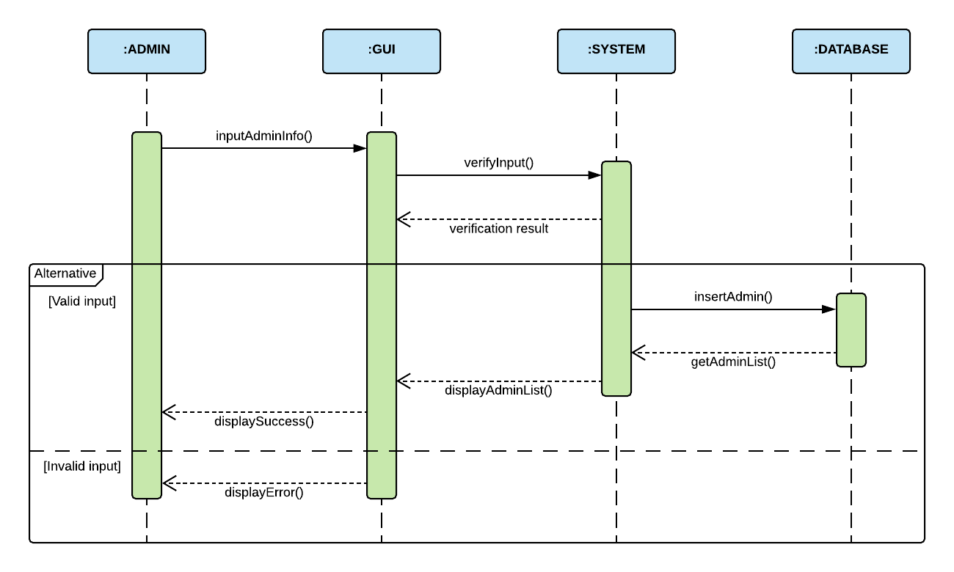

### Update Admin

|  |  |  |
| --- | --- | --- |
| **Author** | Phan Minh Cuong | |
| **Use case name** | Update admin’s accounts | |
| **Actors** | Super Administrator | |
| **Description** | When admin wants to update an admin’s account in the database | |
| **Requirements** | Super Admin provides admin information | |
| **Pre-conditions** | Actor is logged in as a Super Admin | |
| **Post-conditions** | Success: admin’s account is updated in the database | |
| Fail: Refill information | |
| **Basic flow** | **Actor’s actions:** | **System’s responses:** |
| 1. Actor chooses Admin Tab on menu.  3. Actor chooses Admin they want to update.  5. Actor inputs information to update admin. | 2. System redirects to 'Admin List' page and display a list of existing admin.  4. System displays admin form with the following fields. - Admin’s password  - Confirm password - Admin’s role  6. System validates inputs.  7. System updates admin in database.  8. System displays confirmation message or error message. |
| **Exceptions** | **Actor’s actions:** | **System’s responses:** |
| 1. Actor left ‘Username’ field blank.  2. Actor inputs an existing Username.  2. Actor left ‘Password’ field blank.  3. ‘Confirm password’ does not match ‘Password’. | System displays messages: - ‘Username’ cannot be blank’.  - ‘Username already exists’ - ‘Password cannot be blank’.  - ‘Confirm password does not match password’ |
|
|

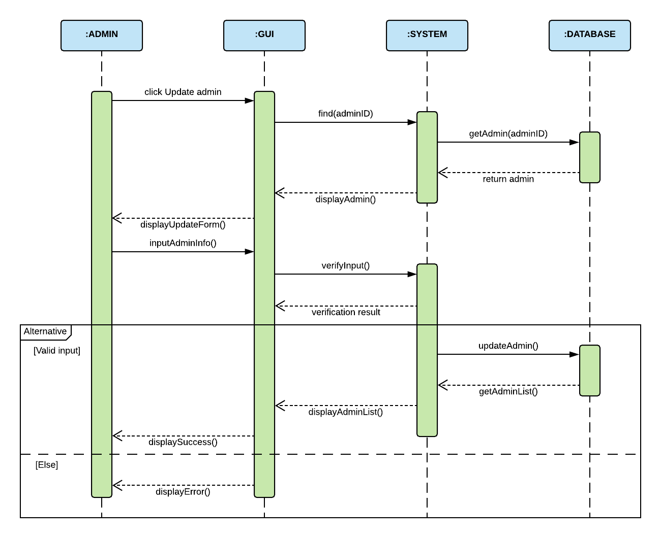

### Order (Update Order’s Status)

|  |  |  |
| --- | --- | --- |
| **Author** | Bui Quoc Tuan | |
| **Use case name** | Update Order’s Status | |
| **Actors** | Administrator | |
| **Description** | When admin wants to update order’s status | |
| **Requirements** | Actor provides order’s information | |
| **Pre-conditions** | Actor is logged in as admin or super admin | |
| **Post-conditions** | Success: order’s status is updated in the database | |
| Fail: refill information | |
| **Basic flow** | **Actor’s actions:** | **System’s responses:** |
| 1. Actor chooses Order Tab on menu.  3. Actor clicks ‘Update Status’ button on an order.  5. Actor chooses the status they want to update. | 2. System redirects to 'Order List' page and display a list of existing orders.  4. System displays a list of statuses: Pending, Confirmed, Canceled, Completed, On Delivery.  6. System updates collection in database.  7. System displays confirmation message. |

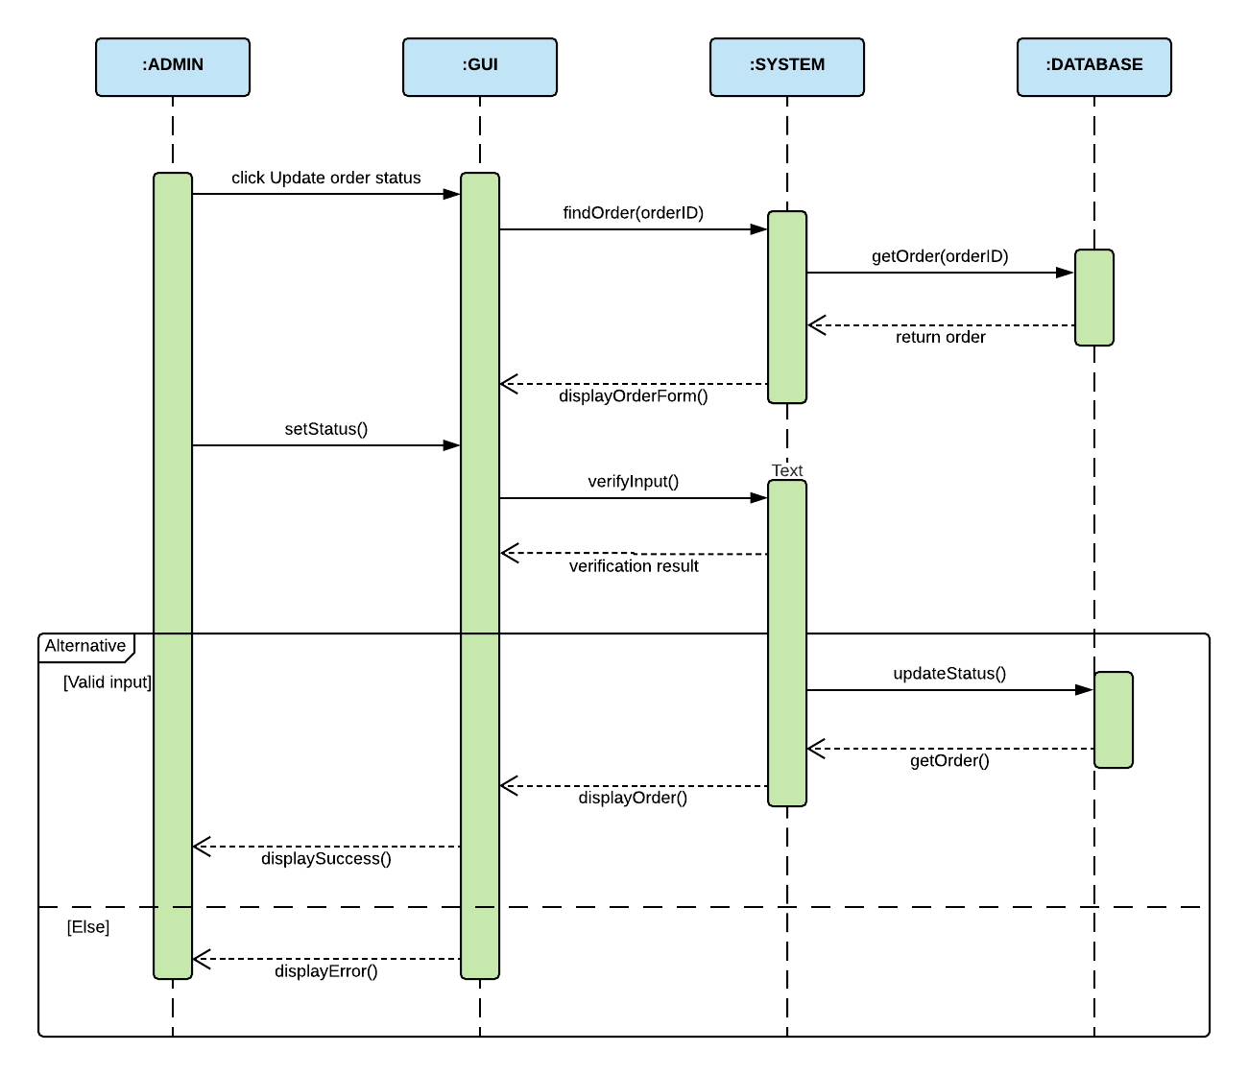

## Report

### View Report

|  |  |  |
| --- | --- | --- |
| **Author** | Phan Minh Cuong | |
| **Use case name** | View Product Report | |
| **Actors** | Administrator | |
| **Description** | When admin wants to view report on products | |
| **Requirements** | N/A | |
| **Pre-conditions** | Actor is logged in as admin or super admin | |
| **Post-conditions** | Success: Display a report on products | |
| **Basic flow** | **Actor’s actions:** | **System’s responses** |
| 1. Actor chooses ‘Product Report’ in menu. | 2. System redirects to ‘Product Report’ page. |

### View Order Report

|  |  |  |
| --- | --- | --- |
| **Author** | Bui Quoc Tuan | |
| **Use case name** | View Order Report | |
| **Actors** | Administrator | |
| **Description** | When admin wants to view report on orders | |
| **Requirements** | N/A | |
| **Pre-conditions** | Actor is logged in as admin or super admin | |
| **Post-conditions** | Success: Display a report on orders | |
| **Basic flow** | **Actor’s actions:** | **System’s responses** |
| 1. Actor chooses ‘Order Report’ in menu. | 2. System redirects to ‘Order Report’ page. |

### View Customer Report

|  |  |  |
| --- | --- | --- |
| **Author** | Nguyen Khai Nguyen | |
| **Use case name** | View Customer Report | |
| **Actors** | Administrator | |
| **Description** | When admin wants to view report on customers | |
| **Requirements** | N/A | |
| **Pre-conditions** | Actor is logged in as admin or super admin | |
| **Post-conditions** | Success: Display a report on customers | |
| **Basic flow** | **Actor’s actions:** | **System’s responses** |
| 1. Actor chooses ‘Customer Report’ in menu. | 2. System redirects to ‘Customer Report’ page. |

# DFD’s

## Level 0

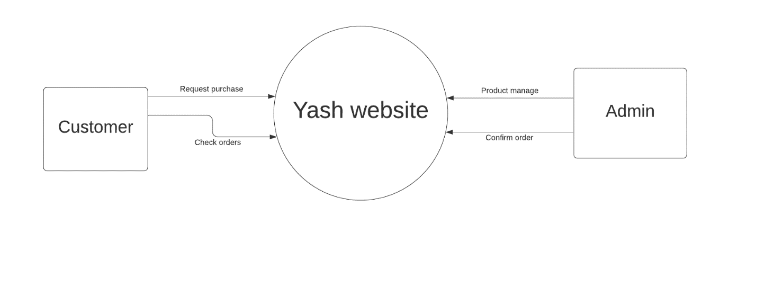

## Level 1

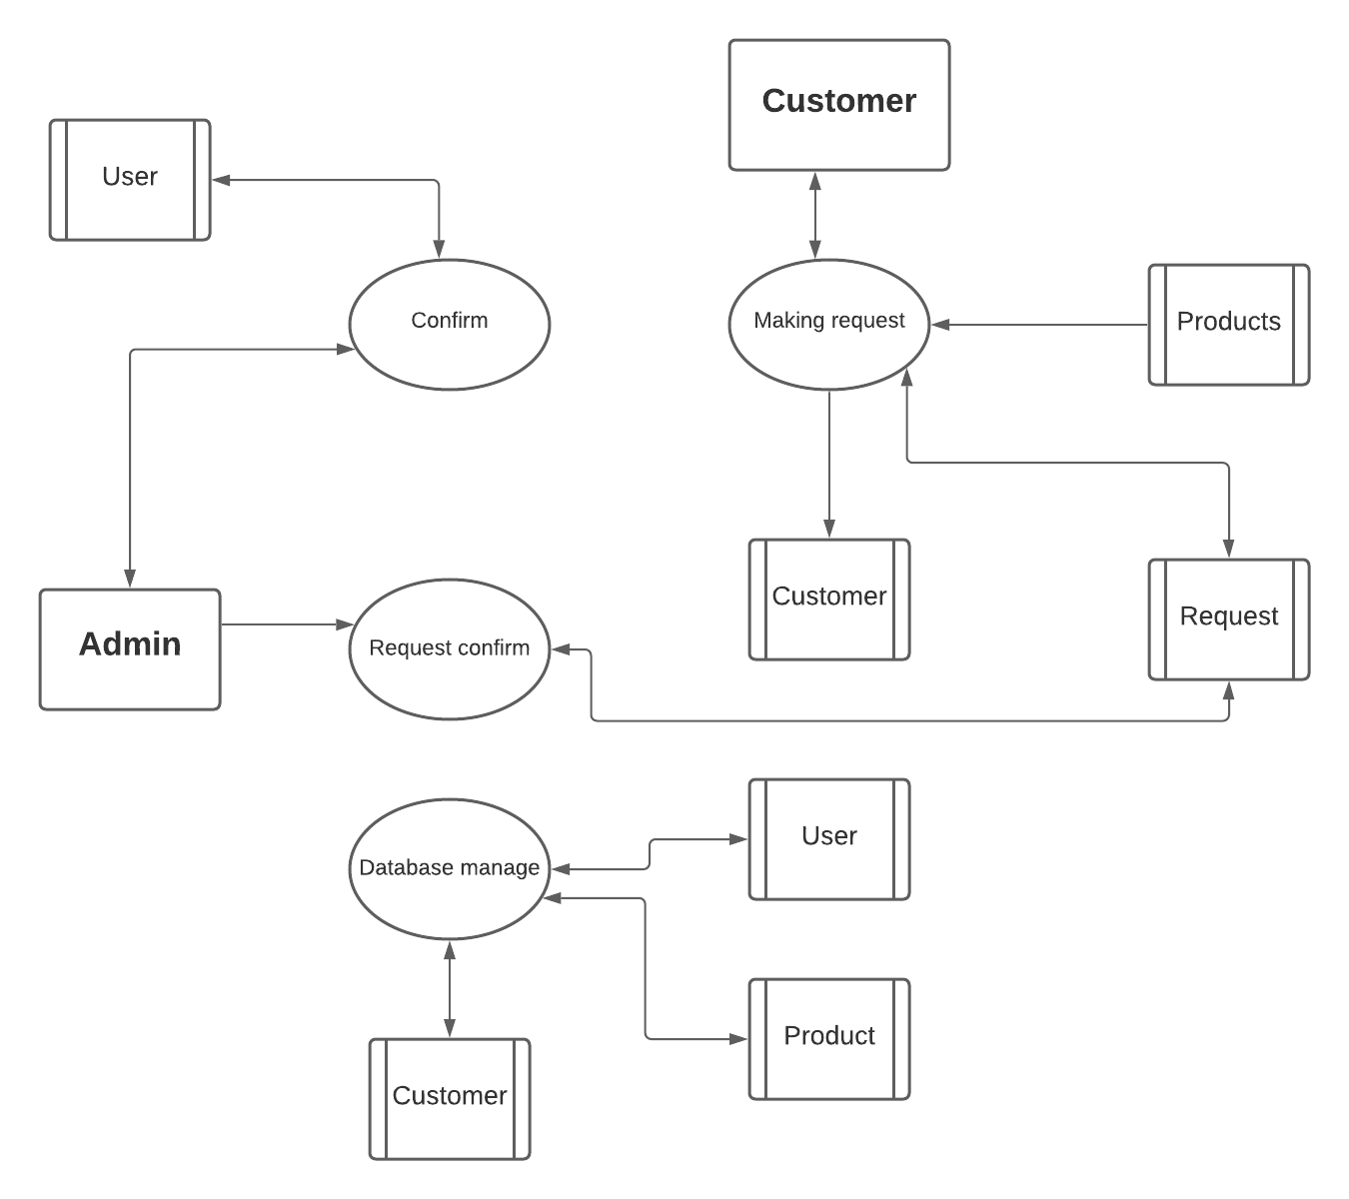

## Level 2

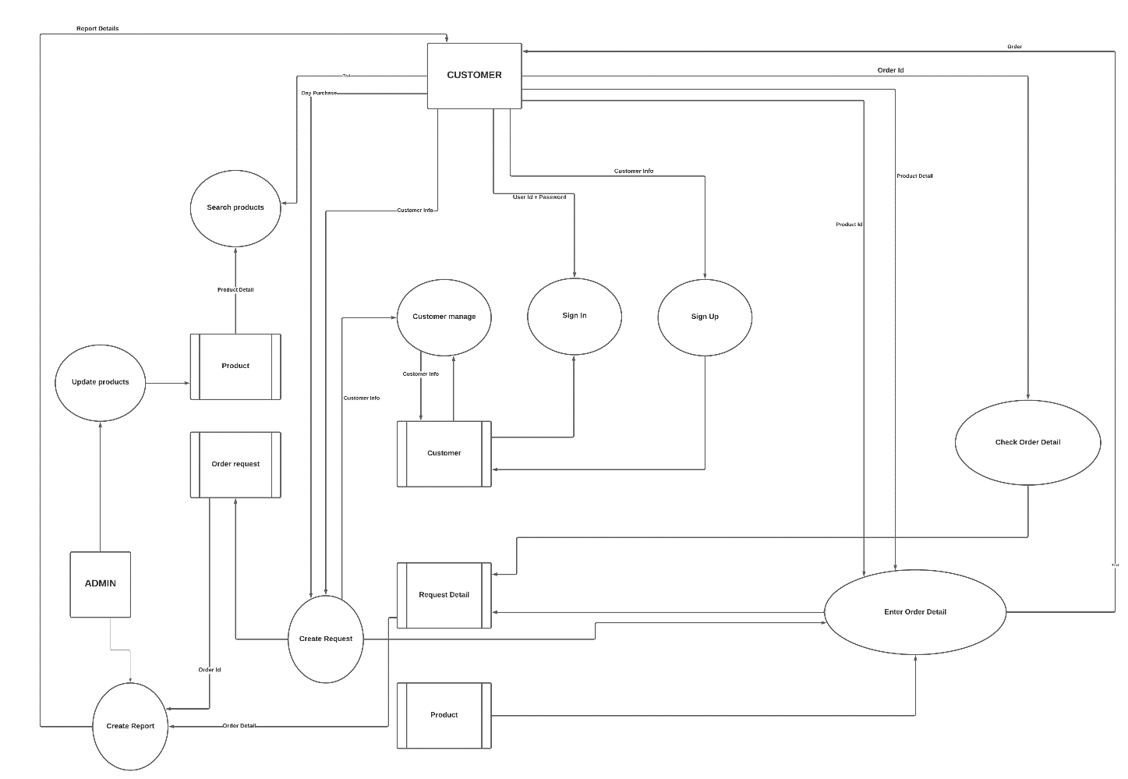

# Database Design

## TABLE NAME: AdminLoginMst

|  |  |  |  |
| --- | --- | --- | --- |
| **Field Name** | **Data Type** | **Key** | **Description** |
| UserName | Varchar(50) | Primary key | Administrator Name |
| Password | Varchar(50) | Not Null | Password Of Admin |

## TABLE NAME: BrandMst

|  |  |  |  |
| --- | --- | --- | --- |
| **Field Name** | **Data Type** | **Key** | **Description** |
| Brand_ID | Varchar (10) | Primary key | ID Of Particular Brand |
| Brand_Type | Varchar(50) | Not Null | Type Of Brand (Asmi,D’damas,etc…) |

## TABLE NAME: CatMst

|  |  |  |  |
| --- | --- | --- | --- |
| **Field Name** | **Data Type** | **Key** | **Description** |
| Cat_ID | Varchar (10) | Primary key | ID Of Category |
| Cat_Name | Varchar(50) | Not Null | Name Of Category |

## TABLE NAME: CertifyMst

|  |  |  |  |
| --- | --- | --- | --- |
| **Field Name** | **Data Type** | **Key** | **Description** |
| Certify_ID | Varchar (10) | Primary key | ID Of Certification |
| Certify_Type | Varchar(50) | Not Null | Name Of Certification (918,920,etc…) |

## TABLE NAME: DimMst

|  |  |  |  |
| --- | --- | --- | --- |
| **Field Name** | **Data Type** | **Key** | **Description** |
| Style_Code | Varchar(50) | Foreign Key | Code Of Style |
| DimQlty_ID | Varchar (10) | Foreign Key | ID Of Diamond Quality |
| DimSubType_ID | Varchar (10) | Foreign Key | Sub Type ID Of Diamond |
| Dim_Crt | Numeric(10,2) | Not Null | Carat Of Diamond  (18 Crt,22 Crt,etc…) |
| Dim_Pcs | Numeric(10,2) | Not Null | Total Pcs Of Diamond In Item |
| Dim_Gm | Numeric(10,2) | Not Null | Weight Of Each Diamond(Grams) |
| Dim_Size | Numeric(10,2) | Not Null | Size Of Each Diamond |
| Dim_Rate | Numeric(10,2) | Not Null | Rate Of Each Diamond |
| Dim_Amt | Numeric(10,2) | Not Null | Total Amount Of All Diamonds In Item |

## TABLE NAME: DimQltyMst

|  |  |  |  |
| --- | --- | --- | --- |
| Field Name | Data Type | Key | Description |
| DimQlty_ID | Varchar (10) | Primary Key | ID Of Diamond Quality |
| DimQlty | Varchar(50) | Not Null | Quality Of Diamond (AD,FD,VVS,etc…) |

## TABLE NAME: GoldKrtMst

|  |  |  |  |
| --- | --- | --- | --- |
| Field Name | Data Type | Key | Description |
| GoldType_ID | Varchar (10) | Primary Key | ID Of Gold Type |
| Gold_Crt | Varchar(50) | Not Null | Carat Of Gold  (18 Crt,22 Crt,etc…) |

## TABLE NAME: ProdMst

|  |  |  |  |
| --- | --- | --- | --- |
| Field Name | Data Type | Key | Description |
| Prod_ID | Varchar (10) | Primary Key | Product ID |
| Prod_Type | Varchar(50) | Not Null | Type Of Product |

## TABLE NAME: StoneMst

|  |  |  |  |
| --- | --- | --- | --- |
| **Field Name** | **Data Type** | **Key** | **Description** |
| Style_Code | Varchar(50) | Foreign Key | Code Of Style |
| StoneQlty_ID | Varchar(50) | Foreign Key | ID Of Stone Quality |
| Stone_Gm | Numeric(10,2) | Not Null | Weight Of Each Stone(Grams) |
| Stone_Pcs | Numeric(10,2) | Not Null | Total Pcs Of Stones In Item |
| Stone_Crt | Numeric(10,2) | Not Null | Carat Of Stone |
| Stone_Rate | Numeric(10,2) | Not Null | Rate Of Each Stone |
| Stone_Amt | Numeric(10,2) | Not Null | Total Amount Of Stones In Item |

## TABLE NAME: StoneQltyMst

|  |  |  |  |
| --- | --- | --- | --- |
| Field Name | Data Type | Key | Description |
| StoneQlty_ID | Varchar (10) | Primary Key | ID Of Stone Quality |
| StoneQlty | Varchar(50) | Not Null | Quality Of Stone  (Ruby,Meena,etc…) |

## TABLE NAME: UserRegMst

|  |  |  |  |
| --- | --- | --- | --- |
| **Field Name** | **Data Type** | **Key** | **Description** |
| userID | Varchar (10) | Primary key | User ID |
| userFname | Text | Not Null | First Name Of User |
| user:Lname | Text | Not Null | Last Name Of User |
| address | varchar(Max) | Not Null | Address Of User |
| city | nvarchar(50) | Not Null | City Of User |
| state | nvarchar(50) | Not Null | State Of User |
| mobNo | Text | Not Null | Mobile Number |
| emailID | Text | Not Null | EmailID Of User |
| dob | nvarchar(50) | Not Null | Birth Date Of User |
| cdate | nvarchar(50) | Not Null | Current Date |
| password | Varchar(50) | Not Null | Password Of Users |

## TABLE NAME: ItemMst

|  |  |  |  |
| --- | --- | --- | --- |
| Field Name | Data Type | Key | Description |
| Style_Code | Varchar(50) | Primary Key | Code Of Style |
| Pairs | Numeric(3,0) | Not Null | Pairs Of Product |
| Brand_ID | Varchar (10) | Foreign Key | ID Of Particular Brand |
| Quantity | Numeric(18,0) | Not Null | Available Quantity |
| Cat_ID | Varchar (10) | Foreign Key | ID Of Category |
| Prod_Quality | Varchar(50) | Not Null | Quality Of Product |
| Certify_ID | Varchar (10) | Foreign Key | ID Of Certification |
| Prod_ID | Varchar (10) | Foreign Key | Product ID |
| GoldType_ID | Varchar (10) | Foreign Key | ID Of Gold Type |
| Gold_Wt | Numeric(10,3) | Not Null | Weight Of Gold |
| Stone_Wt | Numeric(10,2) | Not Null | Weight Of Stone |
| Net_Gold | Numeric(10,3) | Not Null | Net Gold |
| Wstg_Per | Numeric(10,3) | Not Null | Wastage In Percentage |
| Wstg | Numeric(10,3) | Not Null | Wastage |
| Tot_Gross_Wt | Numeric(10,3) | Not Null | Total Gross Weight |
| Gold_Rate | Numeric(10,2) | Not Null | Rate Of Gold |
| Gold_Amt | Numeric(10,2) | Not Null | Amount Of Gold In Item |
| Gold_Making | Numeric(10,2) | Not Null | Gold Making Charges |
| Stone_Making | Numeric(10,2) | Not Null | Stone Making Charges |
| Other_Making | Numeric(10,2) | Not Null | Other Making Charges |
| Tot_Making | Numeric(10,2) | Not Null | Total Making Charges |
| MRP | Numeric(10,2) | Not Null | MRP Of Product (Including Stone Making,Gold Making And Other Making) |

## TABLE NAME: DimQltySubMst

|  |  |  |  |
| --- | --- | --- | --- |
| Field Name | Data Type | Key | Description |
| DimSubType_ID | Varchar(10) | Primary Key | Sub Type ID Of Diamond |
| DimQlty | Varchar(50) | Not Null | Quality Of Diamond |

## TABLE NAME: DimInfoMst

|  |  |  |  |
| --- | --- | --- | --- |
| **Field Name** | **Data Type** | **Key** | **Description** |
| DimID | Varchar(10) | Primary Key | Diamond ID |
| DimType | Varchar(50) | Not Null | Type Of Diamond |
| DimSubType | Varchar(50) | Not Null | Sub Type Of Diamond |
| DimCrt | Varchar(50) | Not Null | Carat Of Diamond |
| DimPrice | nchar(50) | Not Null | Price Of Diamond |
| DimImg | Varchar(50) | Not Null | Image Of Diamond |

## TABLE NAME: Inquiry

|  |  |  |  |
| --- | --- | --- | --- |
| **Field Name** | **Data Type** | **Key** | **Description** |
| ID | Varchar(10) | Primary Key | ID Of user. |
| Name | Varchar(50) | Not Null | Name Of User. |
| City | Varchar(50) | Not Null | City Of User. |
| Contact | Nchar(10) | Not Null | Contact Number |
| EmailID | Varchar(50) | Not Null | Email ID |
| Comment | Varchar | Not Null | Comments Of user |
| Cdate | Date | Not Null | Current Date |

## TABLE NAME: JewelTypeMst

|  |  |  |  |
| --- | --- | --- | --- |
| **Field Name** | **Data Type** | **Key** | **Description** |
| ID | Varchar(10) | Primary Key | ID Of Jewellery |
| Jewellery_Type | Varchar(50) | Not Null | Type Of Jewellery |

## TABLE NAME: CartList

|  |  |  |  |
| --- | --- | --- | --- |
| **Field Name** | **Data Type** | **Key** | **Description** |
| ID | Varchar (10) | Primary Key | ID Of Category |
| Product_Name | Varchar(50) | Not Null | Name Of Product |
| MRP | Numeric(10,2) | Not Null | MRP of product |

# TASKSHEET REVIEW 2

|  |  |  |  |  |  |
| --- | --- | --- | --- | --- | --- |
| No. | Contents | Member | Activity Plan | Preparation | |
| Start Date | Actual Days | Status |
| 1 | Use Case and Sequence Diagram | Le Minh,  Bui Quoc Tuan,  Phan Minh Cuong,  Phan Van Phuong | 1/02/2021 | 6 | Completed |
| 2 | Process Diagram |
| 3 | DFD |
| 4 | Database Design |

|  |  |  |
| --- | --- | --- |
|  | **Prepare By: Group 1** | **Approved By: Faculty** |
| **Date: Feb 9, 2021** | Team Leader  Le Minh | Mr. Ngo Phuoc Nguyen |