|  |  |
| --- | --- |
|  | **FPT ACADEMY INTERNATIONAL**  **FPT – APTECH COMPUTER EDUCATION** |

**Centre Name: ACE-HCMC-2-FPT.**

**Address: 590 Cach Mang Thang 8, District 3, Ho Chi Minh City, Viet Nam.**

**MYSTIC JEWEL**

**ADDITIONAL DESIGN DOCUMENT**

|  |  |  |
| --- | --- | --- |
| **Supervisor:** | Mr. Ngo Phuoc Nguyen | |
| **Semester:** | IV | |
| **Batch No:** | F2-13-1607-T1 | |
| **Group No:** | 2 | |
| **Order:** | **Full name** | **Roll No.** |
| 1. | Du Hue Phuong | Student948490 |
| 2. | Nguyen Khai Nguyen | Student935423 |
| 3. | Huynh Tan Phat | Student958915 |

**April 2018**

|  |  |
| --- | --- |
|  | **FPT ACADEMY INTERNATIONAL**  **FPT – APTECH COMPUTER EDUCATION** |

Table of Contents

REVIEW 2 3

1. Table Design 4

1.1 Social Account 4

1.2 Province 4

REVIEW 3 5

1. Site Map 6

1.1 Client’s Site Map 6

1.2 Admin’s Site Map 7

2. GUI Design 8

2.1 Admin’s Dashboard 8

2.2 Admin: Product Report 9

2.3 Admin: Order Report 10

2.4 Admin: Customer Report 11

REVIEW 3 – TASK SHEET 12

REVIEW 2

# Table Design

* 1. Social Account

|  |  |  |  |  |
| --- | --- | --- | --- | --- |
| **Table: SocialAccount** | | | | |
| **No.** | **Column Name** | **Data Type** | **Constraint** | **Description** |
| 1 | SocialAccountID | INT  IDENTITY(1,1) | NOT NULL PRIMARY KEY | Stores the ID of social account |
| 2 | CustomerID | INT | NOT NULL FOREIGN KEY | Stores the ID of customer |
| 3 | ProviderCustomerID | VACHAR(100) | NOT NULL | Stores the ID of customer from provider |
| 4 | Provider | VARCHAR(50) | NOT NULL | Stores the provider |
| 5 | DateCreated | DATETIME | NOT NULL | Stores created date |
| 6 | DateUpdated | DATETIME | NOT NULL | Stores updated date |

* 1. Province

|  |  |  |  |  |
| --- | --- | --- | --- | --- |
| **Table: Province** | | | | |
| **No.** | **Column Name** | **Data Type** | **Constraint** | **Description** |
| 1 | Code | VARCHAR(6) | NOT NULL PRIMARY KEY | Stores the code of province |
| 2 | Name | VARCHAR(50) | NOT NULL UNIQUE | Stores the name of province |

REVIEW 3

# Site Map

## **Client’s Site Map**

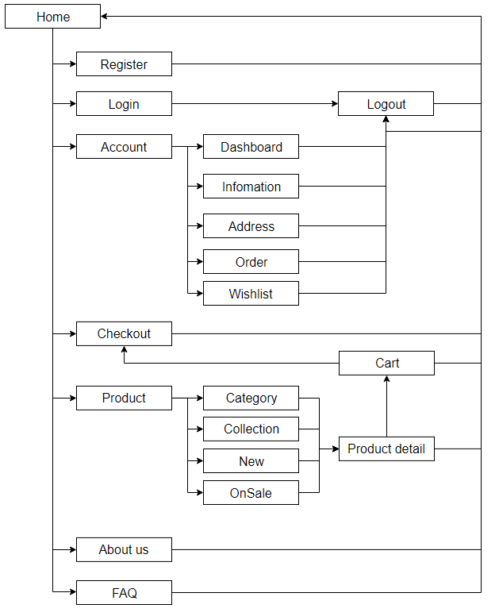

## **Admin’s Site Map**

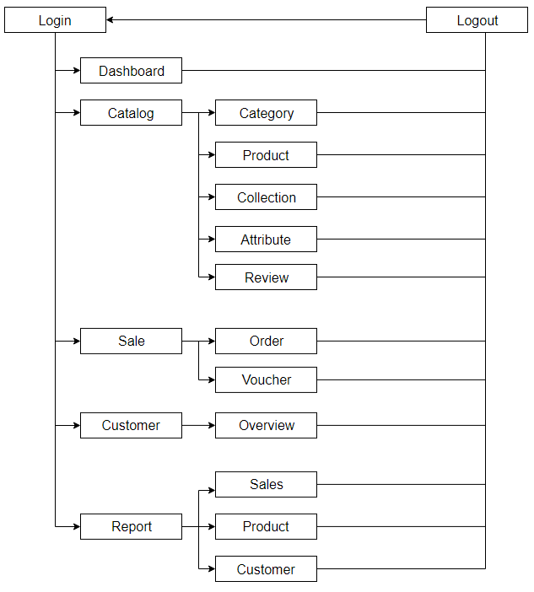

# GUI Design

## **Admin’s Dashboard**

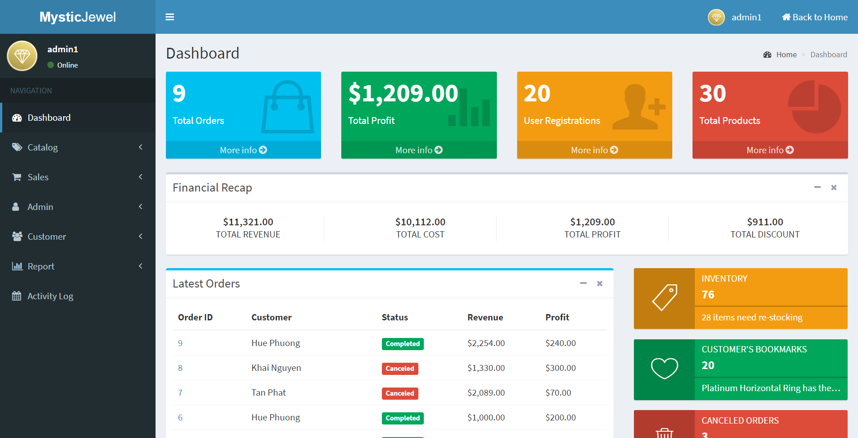

|  |  |
| --- | --- |
| Description | Admin’s Dashboard |
| Connect From | N/A |
| Connect To | All pages and forms |
| Validation | N/A |
| Initial Values | Total orders, total profit, total registrations, total products, inventory, bookmarks, canceled orders, reviews, latest orders, latest active products |
| Events | - Use side menu to navigate to different pages on admin’s site  - Click Back to Home to go to Client’s page |

## **Admin: Product Report**

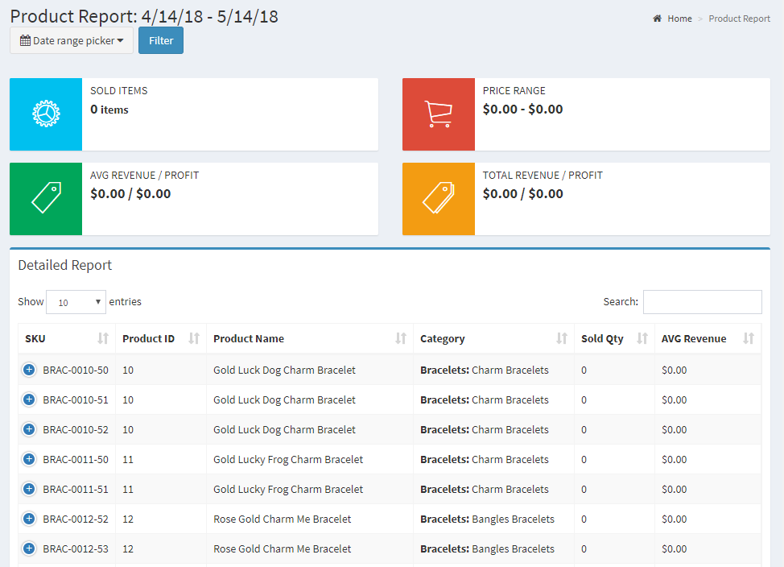

|  |  |
| --- | --- |
| Description | Show Report on Products by time |
| Connect From | Dashboard |
| Connect To | Product report print page |
| Validation | N/A |
| Initial Values | Product report in the last 30 days |
| Events | - When click Print Entire Report, print page will open.  - When choose different time range, report will reload accordingly. |

## **Admin: Order Report**

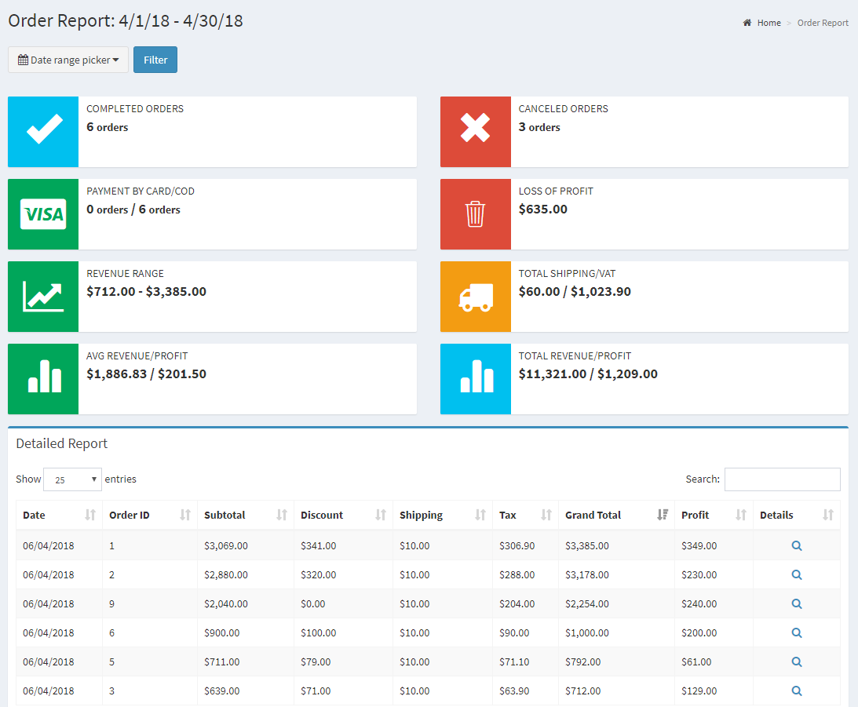

|  |  |
| --- | --- |
| Description | Show Report on Orders by time |
| Connect From | Dashboard |
| Connect To | Order report print page |
| Validation | N/A |
| Initial Values | Order report in the last 30 days |
| Events | - When click Print Entire Report, print page will open.  - When choose different time range, report will reload accordingly. |

## **Admin: Customer Report**

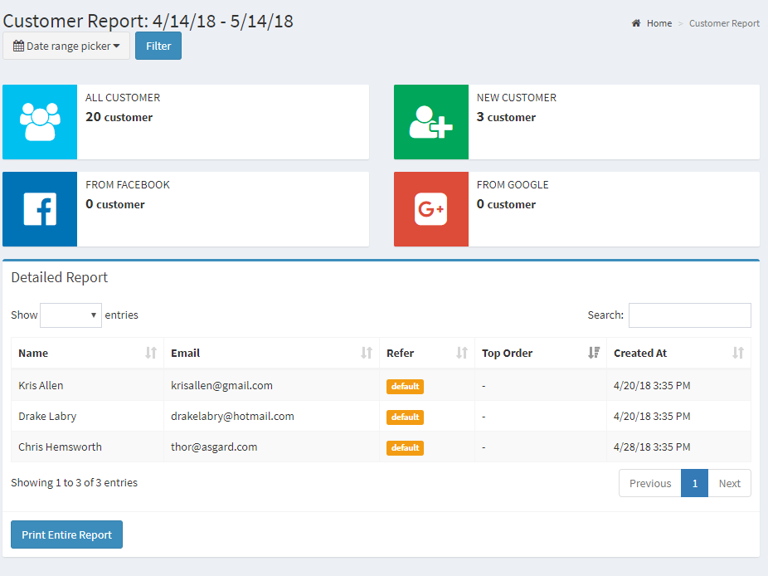

|  |  |
| --- | --- |
| Description | Show Report on Customers by time |
| Connect From | Dashboard |
| Connect To | Customer report print page |
| Validation | N/A |
| Initial Values | Customer report in the last 30 days |
| Events | - When click Print Entire Report, print page will open.  - When choose different time range, report will reload accordingly. |

REVIEW 3 – TASK SHEET

|  |  |  |  |  |  |
| --- | --- | --- | --- | --- | --- |
| **No.** | **Contents** | **Member** | **Activity Plan** | **Preparation** | |
| **Start Date** | **Actual Days** | **Status** |
| **Client** | | Du Hue Phuong | 10/05/2018 | 10 | Completed |
| 1 | Homepage |
| 2 | Product: new, hot, on sale |
| 3 | Product: view by Category, Collection |
| 4 | Product’s detail |
| 5 | Recommended products |
| 6 | Related products |
| 7 | Compare products |
| 8 | Place orders |
| 9 | Estimate shipping fee |
| 10 | Order history |
| 11 | View order’s receipt |
| 12 | Payment form |
| **Admin** | |
| 13 | Admin’s dashboard: general info |
| 14 | Category: view, add, update, delete |
| 15 | Collection: view, add, update, delete |
| 16 | Size: view, add, update, delete |
| 17 | Attribute/AttributeGroup: view, add, update, delete |
| 18 | Product: view, add, update |
| 19 | Sku: view, add, update, delete |
| 20 | ProductImage: view, add, update, delete |
| 21 | Order: view, update status |
| 22 | Report: Product |
| 23 | Admin’s Log: view, add |
|  | | | | | |
| **Client** | | Nguyen Khai Nguyen | 10/05/2018 | 10 | Completed |
| 1 | GUI Design |
| 2 | Login/Logout |
| 3 | Customer register |
| 4 | Product filtering |
| 5 | Forgot password/Reset password form |
| 6 | Customer’s profile: update |
| 7 | Customer’s address book: update |
| 8 | Cart: add, update, remove |
| 9 | Cart: check in-stock status |
| 10 | Send email to customer: share wish list, send password reset token |
| 11 | Calculate shipping distance (Google API) |
| 12 | Contact form (send email) |
| 13 | Login with Google/Facebook |
| 14 | Customer’s browsing history |
| **Admin** | |
| 15 | GUI Design |
| 16 | Login/Logout as admins |
| 17 | Admin permission |
| 18 | AdminAccount: view, add, update |
| 19 | Customer: view, ban (update) |
| 20 | CustomerAddress: view |
| 21 | Report: Customer |
|  | | | | | |
| **Client** | | Huynh Tan Phat | 10/05/2018 | 10 | Completed |
| 1 | Wish List: view, add, delete |
| 2 | Share wish list (email) |
| 3 | Review/Rating on product |
| 4 | Search products by relative name |
| 5 | Voucher form |
| 6 | Sort products by: newest/oldest, lowest/highest price, name (alphabet) |
| 7 | Validate product discount dates |
| 8 | Validate voucher (quantity, used voucher) |
| 9 | Product filter |
| **Admin** | |
| 10 | Review: view, response (update), delete |
| 11 | Bookmark: view |
| 12 | Voucher: view, add, update, delete |
| 13 | Forms validation |
| 14 | Report: Order |

Plan prepared by: Group 2 May 14th, 2018  
 **Group Leader Faculty**

**Du Hue Phuong Mr. Ngo Phuoc Nguyen**