**1) Write a python program to generate pandas data frame with 3 columns of random integers**

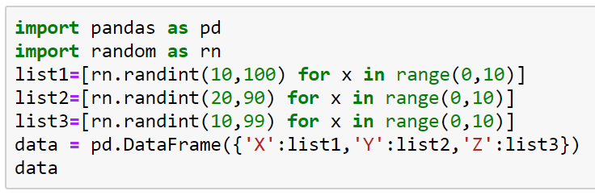

**2) Given a dataframe with one column 'A' of integers.**

**list1 = [x for x in range(1,6)]**

**data = pd.DataFrame({'A':list1})**

**data**

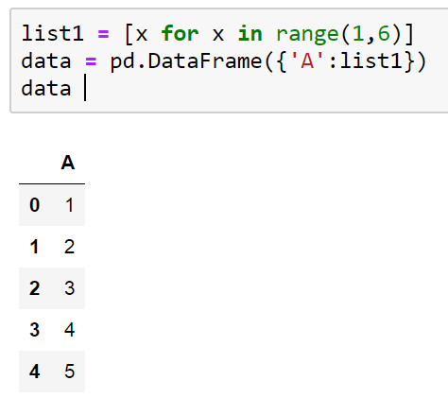

**Write code to generate the columns B and C . where column B is the square of Column A elements and Column C is the cube of Column A elements.**

**expected Output**

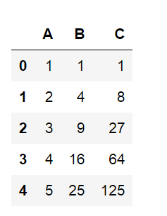

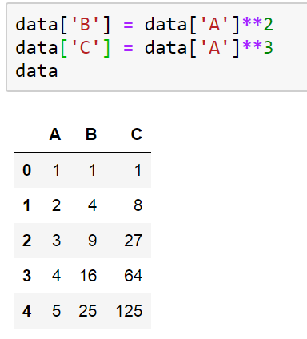

**3) Write a Python program to generate the Pandas DataFrame from .csv file**

**4) Write a python program to generate a derived column in DataFrame that contain coulmn A elements applied with user defined function**

**list1 = [x for x in range(1,6)]**

**data = pd.DataFrame({'A':list1})**

**data**

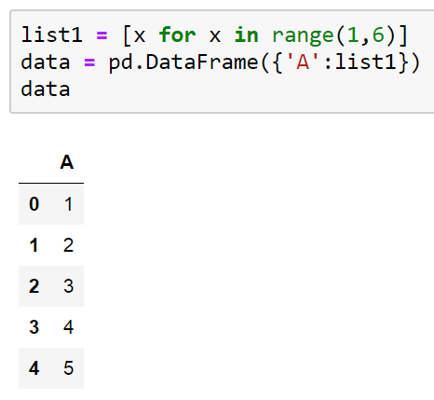

**def fun1(x):**

**return ((x**2)-(5*x)+6)**

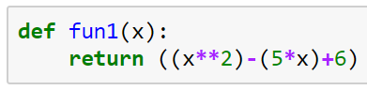

**Expected Output:**

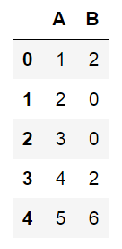

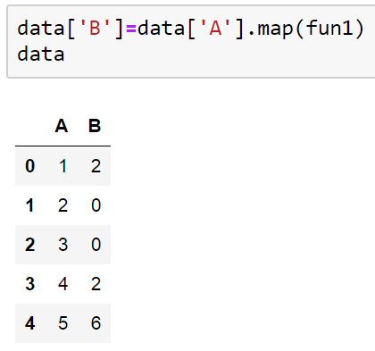

**data['B']=data['A'].map(fun1)**

**data**

**5) Python Program to filter the Pandas Dataframe row whose column 'A' value is an even number.**

****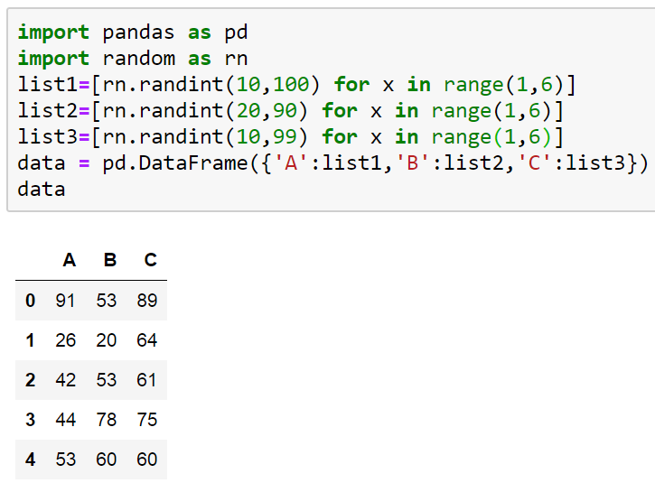

**Sample Output:**

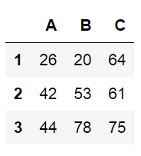

**Code:**

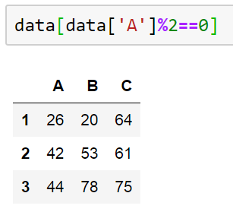

**6) Generate a derived column from the values of existing column 'A' and the dictionary of values.**

**Assign the dictionary value to derived column of dataframe if the dictionary key value matches to the existing column 'A' value.**

**Sample input**

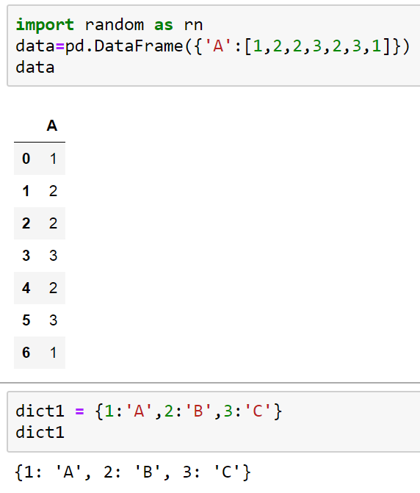

**Sample Output:**

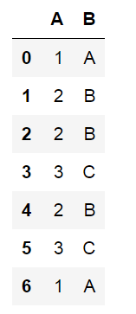

**7) Write a python program to generate column C as A+B , column D as A-B , column E as A*B and column F as A/B**

**8) Write a python program to generate column wise sum values of DataFrame**

**9) Write a program to generate a derived column B base column A. B is the Z score of column A values.**

**10) Write a python program to find the out liers in the column A of DataFrame.**

**11) Write a python program to update the values of column B with "0" where column A values is multiple of 7**

**IQ1) Difference between map , applymap and apply methods in python**

**iQ2) Difference between Map and Filter methods in python**