
PROJECT REPORT
BANK MARKETING
CAMPAIGN ANALYSIS
Project ID DA-014 | Marketing Analytics
Project detail | Information
University | Invertis University, Bareilly
Programme | BCA AI
Semester / Section | I / C
Group ID | BCA_AI_14
Mentor | Mr. Ankit
Academic year | 2026-27

Department and Course Details
The supplied team sheet identifies the programme as BCA AI, Semester I, Section C, Group ID BCA_AI_14.

Project team
No. | Student name | Student ID | Role
1 | Unnati Mishra | BCAI2026156
2 | Diya Gupta | BCAI2026158
3 | Vishal | BCAI2026159
4 | Asmit Singh Bhadouriya | BCAI2026160
5 | Aditya Gupta | BCAI2026161
6 | Nitanshi Devi | BCAI2026162
7 | Aastha | BCAI2026163 | Team Leader
8 | Jay Kishan Verma | BCAI2026164
9 | Vishal Verma | BCAI2026165
10 | Ranjeet Kashyap | BCAI2026166
11 | Prince Kashyap | BCAI2026167
12 | Sneha | BCAI2026168
13 | Tanu Gangwar | BCAI2026169
14 | Pallavi | BCAI2026170

Index / Table of Contents
The contents list is a Microsoft Word field. If it is not populated, select it and choose Update Table → Update entire table.
Update the Table of Contents in Word if needed.

System Architecture Diagram
A shared analysis module feeds the interactive dashboard and notebook, keeping target validation and rate calculations aligned.
Layer | Function
Public UCI data | bank-additional-full.csv; 41,188 contact records
Data preparation | Pandas parsing, normalization, and target validation
Shared analysis | KPIs, filtering, group rates, contact-frequency summaries
Interactive dashboard | Streamlit filters, Plotly charts, preview, findings
Deliverables | Notebook, dashboard, figures, report

Figure 1. System architecture of the DA-014 descriptive analytics prototype.

Project Workflow
Step | Activity
1 | Define the question: describe term-deposit campaign response patterns.
2 | Load and inspect the semicolon-delimited full UCI dataset.
3 | Normalize values and retain rows with valid y = yes/no.
4 | Calculate response counts/rates and group by available fields.
5 | Explore channel, month, previous outcome, frequency, and segments.
6 | Interpret with sample sizes; avoid causal claims.
7 | Demonstrate by filtering, reviewing charts, and clearing filters.

Figure 2. Data-to-insight workflow. No prediction model is trained or deployed.

1. Introduction
Bank telemarketing teams must organize outreach while balancing campaign resources and customer experience. This project examines a public record-level dataset of telephone contacts by a Portuguese bank to promote term deposits. It summarizes observed responses across communication channels, contact periods, prior outcomes, contact frequency, and customer segments.
The prototype combines reproducible Python analysis with an interactive Streamlit dashboard. A user can filter records, inspect recalculated KPIs and charts, preview data, and review descriptive findings.

Scope and interpretation
- The target y records whether a term deposit was subscribed (yes) or not (no).
- Each row is treated as a contact record. There is no unique customer identifier in the supplied file, so record counts are not verified counts of unique people.
- Rates describe historical associations; they do not establish that channel, month, or contact count caused an outcome.

2. Problem Statement and Objectives

Problem statement
Campaign comparisons can be misleading when percentages are presented without their denominators. This project provides an inspectable, filterable summary that pairs response rates with record counts and makes the selected cohort visible.

Objectives
- Document and inspect the public dataset and its provenance.
- Define the target and response-rate denominator consistently.
- Compare outcomes by segments, channel, contact period, previous outcome, and campaign contact count.
- Provide interactive filters, charts, data preview, and calculated findings.
- Keep notebook and dashboard calculations aligned.
- Avoid causal or predictive claims unsupported by the descriptive implementation.

3. Literature Review
UCI describes Bank Marketing as data from direct marketing campaigns of a Portuguese banking institution. The full additional dataset spans May 2008 to November 2010 and records term-deposit subscription as y. Although frequently used for classification research, this student project uses it for descriptive analysis.
Moro, Cortez, and Rita (2014) studied data-driven prediction of telemarketing success and temporal evaluation. Their research provides context only: its predictive models and performance results are not results of this project. The available project files contain no trained estimator, train/test split, or predictive score.

Approach in this project
The implementation emphasizes transparent group counts, response rates, filters, and limitations rather than predictive modeling or causal inference.

4. Dataset Description
The project uses UCI’s bank-additional-full.csv variant. The source CSV is semicolon-delimited and contains 41,188 records and 21 columns: 20 inputs and target y. The records concern a Portuguese bank and span May 2008 through November 2010. The supplied schema has no customer ID.
Field group | Examples / meaning
Target | y: yes = term deposit subscribed; no = not subscribed
Demographic | age, job, marital status, education
Financial / household | default, housing loan, personal loan
Current contact | channel, month, weekday, duration, campaign contacts
Previous campaign | pdays, previous contacts, poutcome
Economic context | employment variation, price/confidence indices, Euribor, employment count

Dataset property | Observed value
Variant | bank-additional-full.csv
Records retained | 41,188
Columns | 21
yes / no | 4,640 / 36,548
Context | Portugal; May 2008–November 2010
Unique customer ID | Not present

“Unknown” values are retained as explicit categorical labels. UCI reports no missing values in the published full file; the project cleaning converts literal “?” to missing if present.

5. Methodology
The project uses Python, Pandas, Streamlit, and Plotly. A shared analysis module reads and normalizes the data, validates the target, calculates KPIs, applies filters, and groups outcomes. Existing static Matplotlib charts provide an additional view of core comparisons.
Measure | Definition
Successful response | Count of records with y = yes
Overall response rate | yes records ÷ all valid yes/no target records in the cohort
Segment response rate | yes records in group ÷ records in the same group
Mean campaign contacts | Mean of campaign; includes last contact
Filter behavior | Selected categories and inclusive numeric ranges restrict the cohort before recalculation

Full-data calculation: 4,640 ÷ 41,188 = 11.2654%, displayed as 11.27% (11.27% to two decimal places). No confidence intervals or significance tests are implemented.

6. Data Preprocessing
Step / check | Observed handling
Delimiter | Semicolon; initial spaces skipped
Column names | Whitespace trimmed
Text fields | Whitespace trimmed; literal ? mapped to missing
Categories | unknown normalized to explicit Unknown; retained
Target | Normalized to lowercase and validated as yes/no
Invalid target rows | 0 excluded
Rows retained | 41,188
Missing cells after cleaning | 0
Exact duplicate rows | 12 observed; retained because no unique key identifies them as erroneous
Unknown category cells | 12,718 across 10 categorical fields; cell occurrences, not unique records

The full valid-target cohort is preserved. Exact duplicates are disclosed rather than silently removed because an identical row cannot be adjudicated without a customer or contact key.

7. Exploratory Data Analysis
EDA first checks the target distribution, then compares rates across selected fields. Percentages are interpreted with group sizes, particularly where monthly volume is uneven.
Measure | Observed value | Definition
Contact records | 41,188 | Valid yes/no target rows
Successful responses | 4,640 | y = yes
Non-success records | 36,548 | y = no
Overall response rate | 11.27% | 4,640 ÷ 41,188
Mean campaign contacts | 2.57 | Includes the last contact

Communication channel
Channel | Records | Responses | Rate
cellular | 26,144 | 3,853 | 14.74%
telephone | 15,044 | 787 | 5.23%

Campaign contact frequency
Contacts | Records | Responses | Rate
1 | 17,642 | 2,300 | 13.04%
2 | 10,570 | 1,211 | 11.46%
3 | 5,341 | 574 | 10.75%
4 | 2,651 | 249 | 9.39%
5+ | 4,984 | 306 | 6.14%

The displayed rate declines across the contact-count groups. This descriptive pattern is not evidence that repeated contacts cause lower response; outreach assignment and customer history may differ across groups.

8. Contact-Period Comparisons
Contact month and weekday comparisons are unadjusted. Group rates should be read with their denominators.

Month
Month | Records | Responses | Rate
mar | 546 | 276 | 50.55%
apr | 2,632 | 539 | 20.48%
may | 13,769 | 886 | 6.43%
jun | 5,318 | 559 | 10.51%
jul | 7,174 | 649 | 9.05%
aug | 6,178 | 655 | 10.60%
sep | 570 | 256 | 44.91%
oct | 718 | 315 | 43.87%
nov | 4,101 | 416 | 10.14%
dec | 182 | 89 | 48.90%

Monthly sizes range from 182 records in December to 13,769 in May. Because the groups are uneven, the high rates in smaller groups should be interpreted with counts. The table does not establish seasonality or explain the differences.

Weekday
Weekday | Records | Responses | Rate
mon | 8,514 | 847 | 9.95%
tue | 8,090 | 953 | 11.78%
wed | 8,134 | 949 | 11.67%
thu | 8,623 | 1,045 | 12.12%
fri | 7,827 | 846 | 10.81%

Previous campaign outcome
Outcome | Records | Responses | Rate
success | 1,373 | 894 | 65.11%
failure | 4,252 | 605 | 14.23%
nonexistent | 35,563 | 3,141 | 8.83%

9. Customer Segment Comparisons
These unadjusted comparisons are descriptive, not targeting rules. Different sample sizes and overlapping characteristics may affect observed rates.

Job category
Job | Records | Responses | Rate
student | 875 | 275 | 31.43%
retired | 1,720 | 434 | 25.23%
unemployed | 1,014 | 144 | 14.20%
admin. | 10,422 | 1,352 | 12.97%
management | 2,924 | 328 | 11.22%
Unknown | 330 | 37 | 11.21%
technician | 6,743 | 730 | 10.83%
self-employed | 1,421 | 149 | 10.49%
housemaid | 1,060 | 106 | 10.00%
entrepreneur | 1,456 | 124 | 8.52%
services | 3,969 | 323 | 8.14%
blue-collar | 9,254 | 638 | 6.89%

Age bands
Age band | Records | Responses | Rate
Under 30 | 5,669 | 922 | 16.26%
30–39 | 16,938 | 1,715 | 10.13%
40–49 | 10,526 | 834 | 7.92%
50–59 | 6,862 | 697 | 10.16%
60+ | 1,193 | 472 | 39.56%

The 60+ band contains 1,193 records with a 39.56% rate; Under 30 contains 5,669 records with a 16.26% rate. This does not show that age alone predicts an individual outcome.

10. Project Explanation and Dashboard Working
The Streamlit dashboard supports descriptive exploration. Categorical selections and numeric ranges in the sidebar define a cohort. KPI cards, response summaries, charts, preview rows, and findings are recalculated for that selection. Clearing filters returns the complete dataset.
Dashboard section | Purpose
Overview | Record count, responses, rate, mean contacts, response comparisons
Filters | Categorical values and ranges over available numeric fields
Charts | Channel, period, segment, and frequency comparisons
Data preview | Example rows from selected data
Findings | Sample-size-aware descriptive summaries
Methodology | Target, denominator, provenance, and limitations

The saved notebook example for cellular contacts and ages 30–60 inclusive was independently recalculated: 21,508 records, 2,670 yes responses, 12.41% response rate, and 2.44 mean campaign contacts.

11. Python Program and Important Code
The snippets below come from the actual shared analysis.py implementation used by the current dashboard package. They show the KPI denominator, segment aggregation, and contact-frequency grouping.

KPI calculation
def calculate_kpis(data: pd.DataFrame) -> dict[str, int | float]:
"""Calculate the headline metrics for the currently selected records.
Response rate = records with y == 'yes' / records with valid y in the
current cohort. Rows represent campaign contact records, not unique people.
"""
records = int(len(data))
responses = int(data[TARGET_COLUMN].eq("yes").sum()) if records else 0
rate = responses / records if records else float("nan")
average_contacts = (
float(data["campaign"].mean())
if records and "campaign" in data.columns
else float("nan")
)
return {
"records": records,
"responses": responses,
"response_rate": rate,
"average_campaign_contacts": average_contacts,
}

Segment rate calculation
def response_by_segment(data: pd.DataFrame, column: str) -> pd.DataFrame:
"""Return record counts, successful responses, and response rates by group."""
if column not in data.columns:
raise KeyError(f"Column '{column}' is not in the current dataset.")
if data.empty:
return pd.DataFrame(columns=["segment", "records", "responses", "response_rate"])
table = (
data.groupby(column, dropna=False, observed=True)[TARGET_COLUMN]
.agg(records="size", responses=lambda values: int(values.eq("yes").sum()))
.reset_index()
.rename(columns={column: "segment"})
)
table["response_rate"] = table["responses"] / table["records"]
table["segment"] = table["segment"].astype("string").fillna("Missing")
return table.sort_values(["response_rate", "records"], ascending=[False, False]).reset_index(drop=True)

Contact-frequency aggregation
def contact_frequency_table(data: pd.DataFrame) -> pd.DataFrame:
"""Summarize outcomes by campaign contact-frequency bands.
The UCI ``campaign`` field is the number of contacts to that record/client
during this campaign, including the last contact.
"""
if data.empty or "campaign" not in data.columns:
return pd.DataFrame(columns=["contact_band", "records", "responses", "response_rate"])
campaign = pd.to_numeric(data["campaign"], errors="coerce")
bands = pd.Series(
np.select(
[campaign.eq(1), campaign.eq(2), campaign.eq(3), campaign.eq(4), campaign.ge(5)],
CAMPAIGN_BUCKETS,
default="Missing/other",
),
index=data.index,
dtype="string",
)
temporary = data.assign(_contact_band=bands)
table = (
temporary.groupby("_contact_band", observed=True)[TARGET_COLUMN]
.agg(records="size", responses=lambda values: int(values.eq("yes").sum()))
.reset_index()
.rename(columns={"_contact_band": "contact_band"})
)
table["response_rate"] = table["responses"] / table["records"]
order = {label: index for index, label in enumerate(CAMPAIGN_BUCKETS + ["Missing/other"])}
table["_order"] = table["contact_band"].map(order)
return table.sort_values("_order").drop(columns="_order").reset_index(drop=True)

Invalid target rows are excluded during cleaning. The analysis computes frequencies and rates; it does not fit a machine-learning model.

12. Results and Discussion
Of 41,188 valid-target contact records, 4,640 have y = yes. The full-data response rate is 11.27%. Cellular records show 14.74%, compared with 5.23% for telephone records. These are historical, unadjusted associations, not causal channel effects.
Month-group rates vary, but sample sizes are unequal. May is the largest group (13,769 records) with a 6.43% rate. This analysis does not establish seasonal behavior. The contact-frequency rate ranges from 13.04% for one contact to 6.14% for five or more contacts, but group composition may explain part of the pattern.
Records with previous campaign success show a 65.11% rate, compared with 14.23% for previous failure and 8.83% for nonexistent prior outcome. These are descriptive associations. Direct data calculations match the analysis definitions, and saved notebook outputs were reviewed. The slide deck target label and all ten month groups were checked against the recalculations. A fresh complete notebook run was not performed because the available runtime lacked notebook/plotting dependencies.

13. Graphs and Explanations
These are the existing project chart files. Each rate uses the valid-target records in its group; the visuals do not show causal effects or model predictions. No dashboard screenshot was present in the accessible project files, so none is fabricated; the supplied charts and code excerpts are included as output evidence.
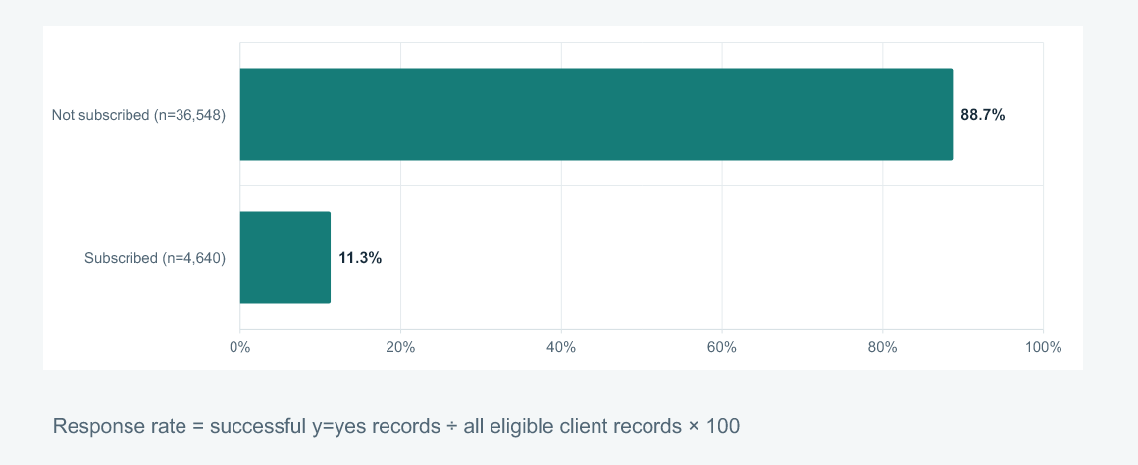
Figure 3. Overall outcome distribution: 4,640 of 41,188 records are y = yes (11.27%).
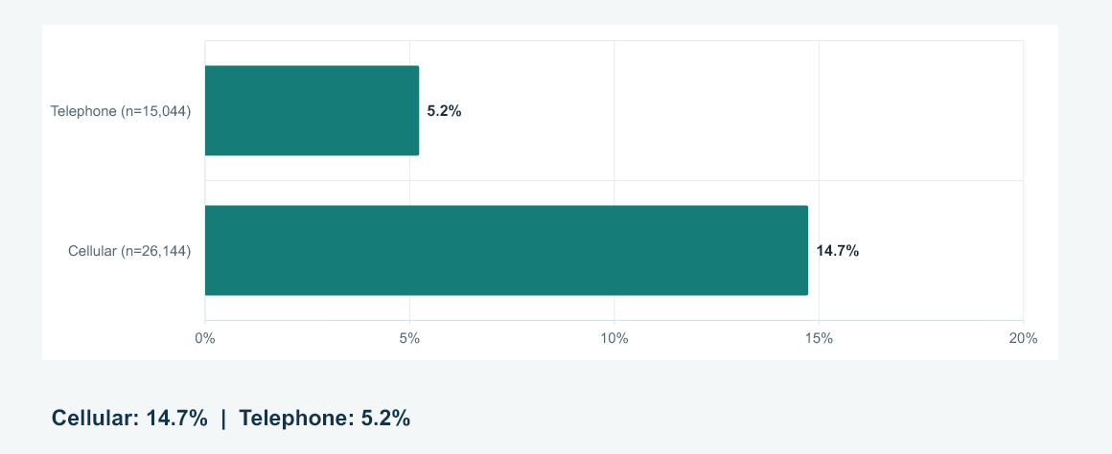
Figure 4. Channel comparison: cellular 14.74%; telephone 5.23%.
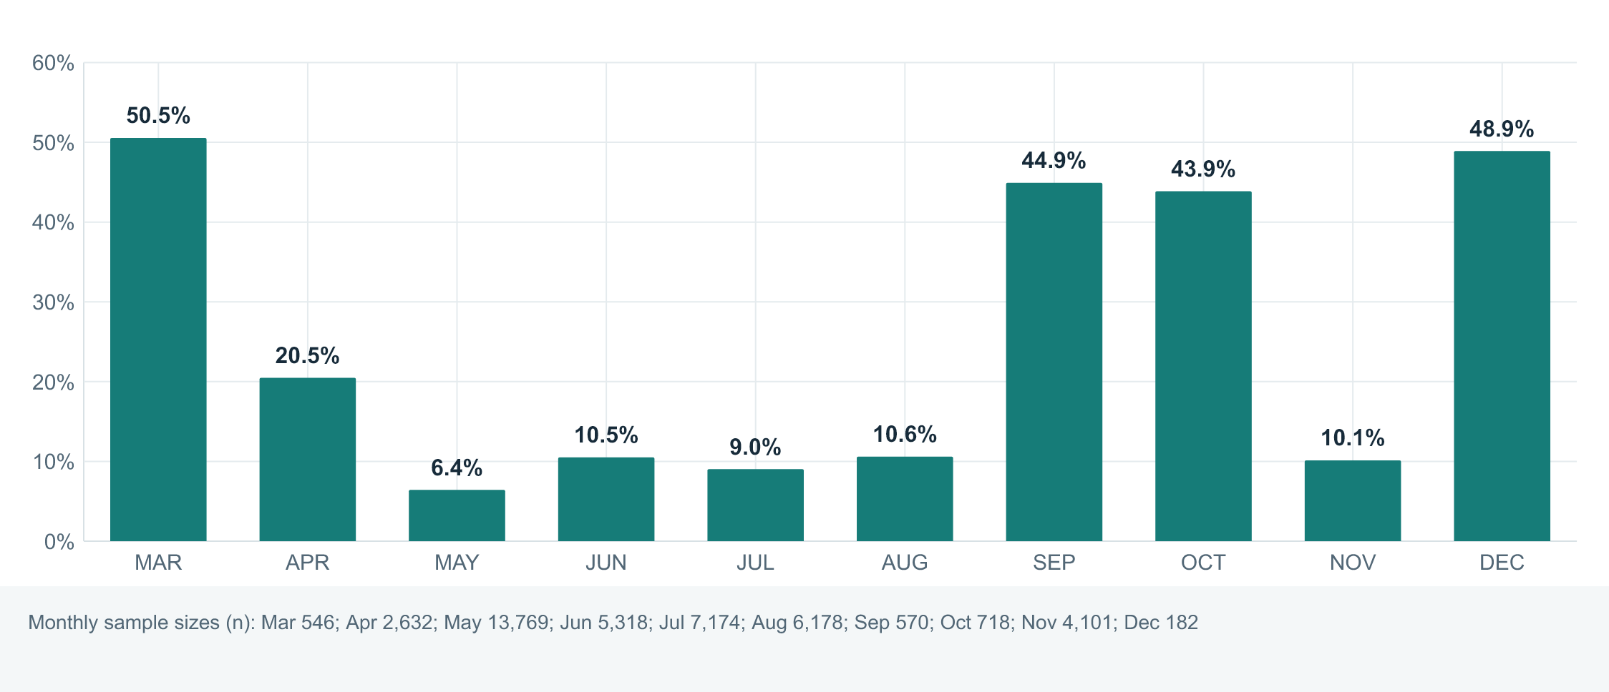
Figure 5. Response rate by month; monthly group sizes are unequal.
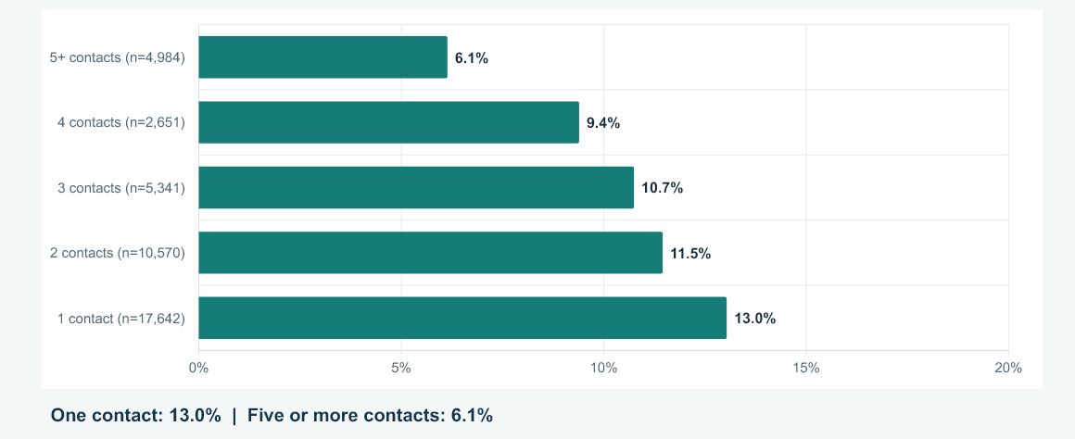
Figure 6. Response rate by current-campaign contact count, including last contact.
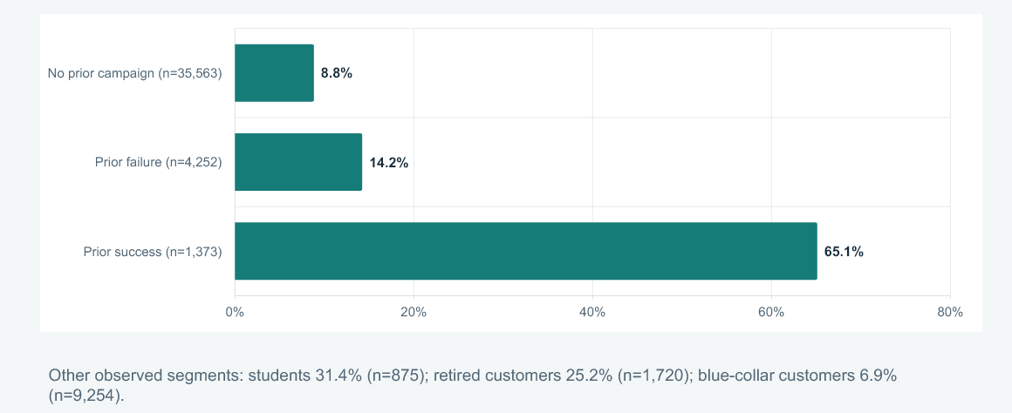
Figure 7. Response rate by recorded previous campaign outcome.

14. Findings and Recommendations

Calculated findings
- Overall rate: 11.27% (4,640 of 41,188 records).
- Cellular and telephone record rates are 14.74% and 5.23%, respectively.
- Contact-count bands range from 13.04% for one contact to 6.14% for 5+ contacts.
- Previous-success records have 65.11%; previous-failure, 14.23%; nonexistent-history, 8.83%.
- Monthly group volumes vary substantially; interpret percentages with counts.

Recommendations for analysis and demonstration
- Show counts with rates; do not rank small groups using percentages alone.
- Demonstrate filters, then clear them and confirm 41,188 records and 11.27% return.
- Treat observed gaps as hypotheses for further study, not policy directives.
- Before operational use, use recent data, study confounding, and review fairness, privacy, and contact safeguards.
- For any future model, define the prediction time and avoid information only known after a call, such as duration.

15. Challenges and Limitations
- The historical records cover Portugal from May 2008 to November 2010 and may not represent current campaigns.
- No unique customer ID is supplied; counts are records, not verified distinct people.
- 12 exact duplicate rows are retained because the available schema cannot establish whether they are erroneous.
- Unknown categories are retained; segment rates are unadjusted and group sizes differ.
- No uncertainty intervals, significance testing, causal design, or external validation is implemented.
- No machine-learning model or accuracy, precision, recall, or predictive score is in the verified project files.
- Call duration is measured after a call and could leak post-contact information in a pre-call prediction task.
- A full notebook re-execution and live hosted-dashboard retest were not performed during report generation; saved outputs and direct calculations were checked.
- Accessible history surfaced two related DA-014 Codex conversations; no additional DA-014 ChatGPT conversation or attachments appeared. No official faculty grading rubric was available; the supplied sample PDF was used as a structure reference only.

16. Future Scope
- Refresh with recent, approved campaign data and record definitions and date ranges.
- Add uncertainty intervals and appropriate statistical tests with assumptions explained.
- Study whether segment differences persist after accounting for overlapping attributes and fairness/privacy considerations.
- If prediction is introduced, use a time-aware design, avoid post-contact leakage, validate temporally, and report calibration and class-specific measures.
- Add accessibility, filtered exports, data-quality checks, and a deployment health check.
- Prepare an offline faculty-demo fallback and document hosting requirements.

17. Conclusion
The DA-014 prototype transforms a public bank marketing dataset into an inspectable descriptive dashboard and notebook analysis. It defines response rate consistently as yes records divided by valid-target records and reports 4,640 / 41,188 = 11.27%. Channel, month, prior-outcome, segment, and contact-frequency comparisons make historical patterns easier to explore.
The project contribution is a filterable summary with transparent counts and explicit limitations. Findings are descriptive, not causal, and no predictive model was implemented. Further analysis should use current data and evaluate uncertainty, confounding, and customer safeguards.

18. References
[1] Moro, S., Laureano, R., & Cortez, P. (2011). Using data mining for bank direct marketing: An application of the CRISP-DM methodology. European Simulation and Modelling Conference (ESM 2011), 117–121.
[2] Moro, S., Cortez, P., & Rita, P. (2014). A data-driven approach to predict the success of bank telemarketing. Decision Support Systems, 62, 22–31. https://doi.org/10.1016/j.dss.2014.03.001
[3] UCI Machine Learning Repository. Bank Marketing [Dataset]. https://archive.ics.uci.edu/dataset/222/bank+marketing. DOI: 10.24432/C5K306. Accessed 31 October 2026.
[4] DA-014 project artifacts reviewed: analysis.py, app.py, bank_marketing_analysis.ipynb, bank-additional-full.csv, README, and five chart images.
[5] IIOT Project Report Format.pdf, 36-page teacher reference. Used for organizational style only; unrelated project content was excluded.
[6] Supplied Invertis University BCA AI team-formation image: project metadata, names, student IDs, mentor first name.

