Template Creation Help

Template …............................................................................................ ..2
Theme.......................................................................................................2
How To Create A Template.......................................................................2-3
How To Define Contents In “templateDetails.xml” File …............................4-6
Things To Be Taken Care Of While Creating A Template …...................7

Template :

Template is a page layout or structure using which a site is built on. A template can have many structured pages which contain HTML contents to form finished web pages/web site.

Theme :

Theme constitutes color variance for a template. A template can have many color themes in which color,contents etc of the template varies but the structure remains the same.

How To Create A Template :

A template can have one main page, one subpage and more than one inner pages. Main page should be as “index.html” page and it should contain a subpage layout as “subpage.html” ( subpage.html page layout is used when creating/adding new page from editor). Can also create any number of inner pages namely contactus.html,services.html etc. Images of the templates can be kept in an “images” folder, style sheets in a “styles” folder (styles of all themes) and java-script files in “js” folder.

A page in a template is structured in such a way that it contains panels (Panels are the draggable sections used in editor) such as “header”, “topmenu”, “maincontent”, “footer” etc (panels can have any names) in which each section is separated by the following format :

Eg Format 1: Panel “header”

<!-- start header -->
contents here
<!-- end header -->

Eg :
<!--start header-->
<div class="header_wrapper">
<div class="logo_image">
<img src="images/logo.jpg" id="logo" data-type="logo" data-edit="true">
</div>

<div class="compnynamencaption">
<h1 id="heading" data-type="heading"> max<span>Buz</span></h1>
<h2 id="caption" data-type="caption">The smart Business company</h2>
</div>
</div>
<!--end header-->

Eg Format 2 : Panel “maincontent”

<!-- start maincontent -->
contents here
<!-- end maincontent-->

ie; define the panels inside <!-- start panelname --> tag
then comes contents and then end tag
<!-- end panelname -->

Each panel should be within a formatted html div with a starting and ending <div> tags.

Subpage should contain a “maincontent” panel as mandatory because during the site creation flow, guestbook content * is replaced with the maincontent panel.

Guestbook - A guestbook is a page which is added while creating the site, where a user or a guest can add their comments about the site. Added comments are listed on the top of the page. Below image ( image 1) shows the guestbook page in a created site.

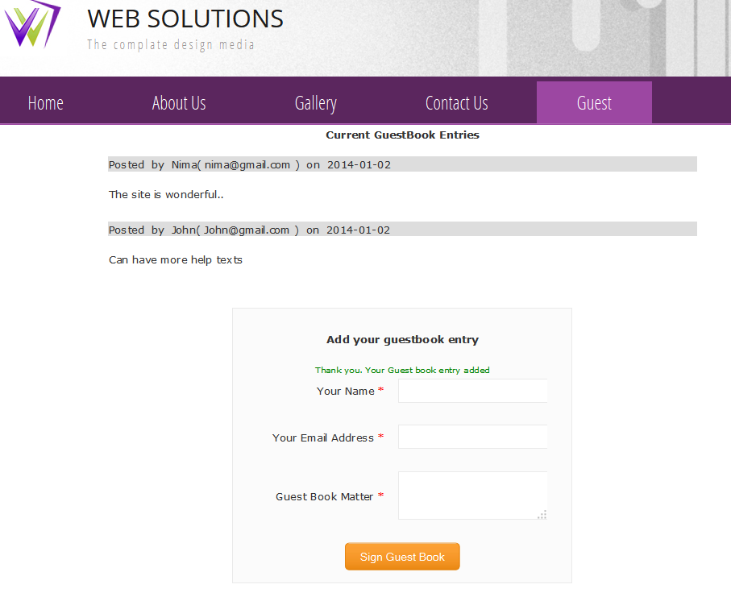
- Image 1 -

Once we create all the template pages, we should have to add the template related datas to an xml , called “templateDetails.xml” inorder to identify the template structure.

How to define contents in “templateDetails.xml” file :

“templateDetails.xml” mainly contains the details of number of files or pages used, number of themes used and different types of panels used in different pages of templates. ie;

    - Define what all files/pages used in the templates inside <files> tag :

Attributes of a file is defined inside a <filedate> tag. Ie;

<filename> - represents file name used in the template
<filealias> - represents a unique name to identify the page.

Eg: <files>
<filedata>
<filename>index.html</filename>
<filealias>index</filealias>
</filedata>
<filedata>
<filename>aboutus.html</filename>
<filealias>aboutus</filealias>
</filedata>
<filedata>
<filename>contactus.html</filename>
<filealias>contactus</filealias>
</filedata>
<filedata>
<filename>subpage.html</filename>
<filealias>subpage</filealias>
</filedata>
</files>

    - Define the themes used in the templates inside <themes> tag :

Eg: <themes>
<theme1>
<name>Blue Theme</name>
<style>styles/style.css</style>
<homepageimage>images/blue_home.jpg</homepageimage>
<thumbnail>images/blue_thumb.jpg</thumbnail>
<subpageimage>images/blue_sub.jpg</subpageimage>
<currenttheme>true</currenttheme>
<themecolor>#0033CC</themecolor>
</theme1>

<theme2>
<name>Green Theme</name>
<style>styles/style_green.css</style>
<homepageimage>images/green_home.jpg</homepageimage>
<thumbnail>images/green_thumb.jpg</thumbnail>
<subpageimage>images/green_sub.jpg</subpageimage>
<themecolor>#00CC33</themecolor>
</theme2>
</themes>

Explanation :

If there are 3 themes in the template, define each theme inside <theme1></theme1>
<theme2></theme2>
<theme3></theme3>

<name> tag – implies the name of the theme (Just to identify the theme)

<style> tag – refers to the theme style path inside the style folder

<homepageimage> tag and <subpageimage> tag – refers to the preview image of main page and subpage resp. ( of dimension 400 X 284 px ) path in the image folder. The preview image shows in template preview when clicking on the template thumbnail image during template selection in the site creation process.

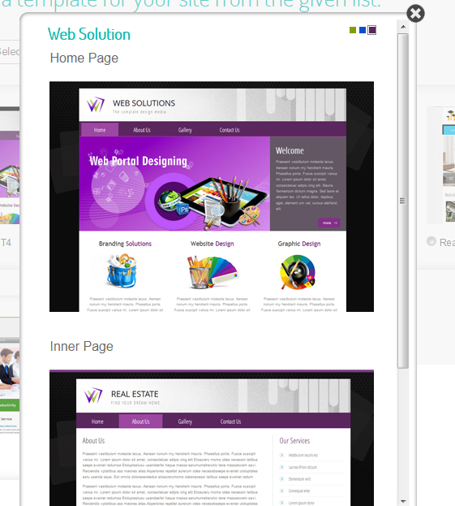

<thumbnail> tag - refers to the template theme thumbnail ( of dimension 215 X 145) path in the image folder. The thumbnail image shows in the template selection page during site creation process.

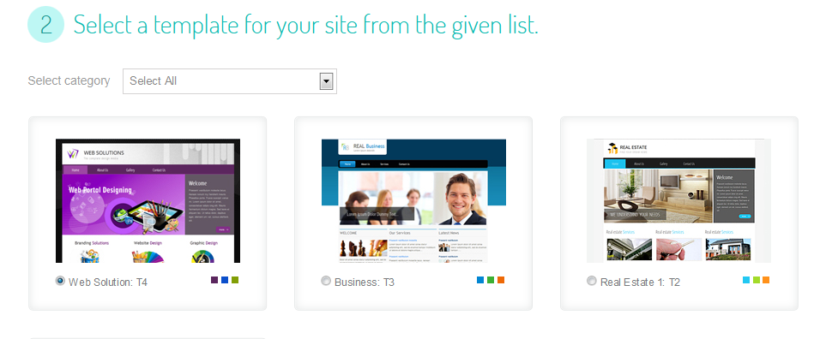

<currenttheme> tag – refers to the current default theme of the template. Make the tag value true of the theme which we wants to make the default theme of the template.

<<themecolor> tag – refers to the core color of the theme with which the theme varies.

3) Define different panels used in all the pages of the templates inside <panels> tag. Each panel name is used itself as tag name .

Eg: <panels>
<header>header</header>
<topmenu>topmenu</topmenu>
<banner>banner</banner>
<maincontent>maincontent</maincontent>
<featured>featured</featured>
<footer>footer</footer>
<box>box</box>
<box1>box1</box1>
<leftbox>leftbox</leftbox>
</panels>

Things To Be Taken Care Of While Creating A Template

Make sure the following requirements are met while creating template.

1) Add data-type="sitestyle" for site style

ie; <link data-type="sitestyle" href="style.css" rel="stylesheet" type="text/css">

2) Add id="sitecolor" for site background color :

ie; <div id="sitecolor" > - place the div as exterior div or just after the <body> tag (depends on the template. See the sample template pages)

3) Add id="logo" and data-type="logo" for site logo

ie; <img src="images/logo.jpg" id="logo" data-type="logo" data-edit="true">

4) Add id="heading" and data-type="heading" for site company and it should be in <h1> tag :

ie; <h1 id="heading" data-type="heading" >REAL ESTATE</h1>

5) Add id="caption" and data-type="caption" for site caption and it should be in <h2> tag :

ie; <h2 id="caption" data-type="caption" >FIND YOUR DREAM HOME</h2>

6) Add id="site_banner" and data-type ="site_banner" for site banner

ie; <div id="site_banner" data-type="site_banner" ></div> - This is for the footer banner. So place the div near the footer area.

7) Contact us form html (contactus.html page) - Form submission button type should be submit type.
Ie; <input name="" type="submit" class="submit" value="SUBMIT">

8) Add data-edit="true" in <img> tags if you want to edit images from the editor.

Ie; <img src="images/exp_icon.png" data-edit="true" />

9) Add data-type="slider" for the main banner div in the main page (index.html) if you want to create a image slider.

ie; <div data-type="slider">
<img src="images/banner.jpg" data-edit="true" title="Click here to update your gallery" />
</div>

10) Add data-type="menu" if you want to manipulate a menu in the pages. Also add data-alias=”uniquename” for each menu inside the <a> tag.

Ie;

<ul data-type="menu">
<li class="active"><a data-alias="index" >Home</a></li>
<li><a data-alias="aboutus" >About Us</a></li>
<li><a data-alias="services">Services</a></li>
<li><a data-alias="contactus">Contact Us </a></li>
</ul>

11) Add data-type="socialshare" if you want to manipulate social share icons in the pages

ie;
<div class="socialshare" data-type="socialshare">
<img src="images/ricon_facebook.png" data-edit="true">
<img src="images/ricon_twitter.png" data-edit="true">
</div>

After completing the above steps, zip the entire folder and then upload from
Admin > Template Manager > Add New Template.

-----------------------------------------------------------------------

