Feature Engineering

Despite the dataset being analytically rich there isn’t a respective respect measuring index in the dataset. Therefore, the need to engineer a feature depicting the respect which an employee feels in the workplace was needed.

Data Cleaning
After creating the Respect_Index, the next step is to clean or preprocess the dataset before the Analytics.
- Initially the dataset is loaded, and the data structure is inspected.
- Next, the missing values are detected and if have they are dropped or imputed (in our case no missing values were present)
- Duplicated rows are detected and removed.
- Useless columns with no variance are dropped and near-zero variance are identified so that they are not used in the predictive analysis part (EmployeeCount, StandardHours, Over18, EmployeeNumber).
- Categorical columns are converted to factors so that they become statistical-function-friendly.
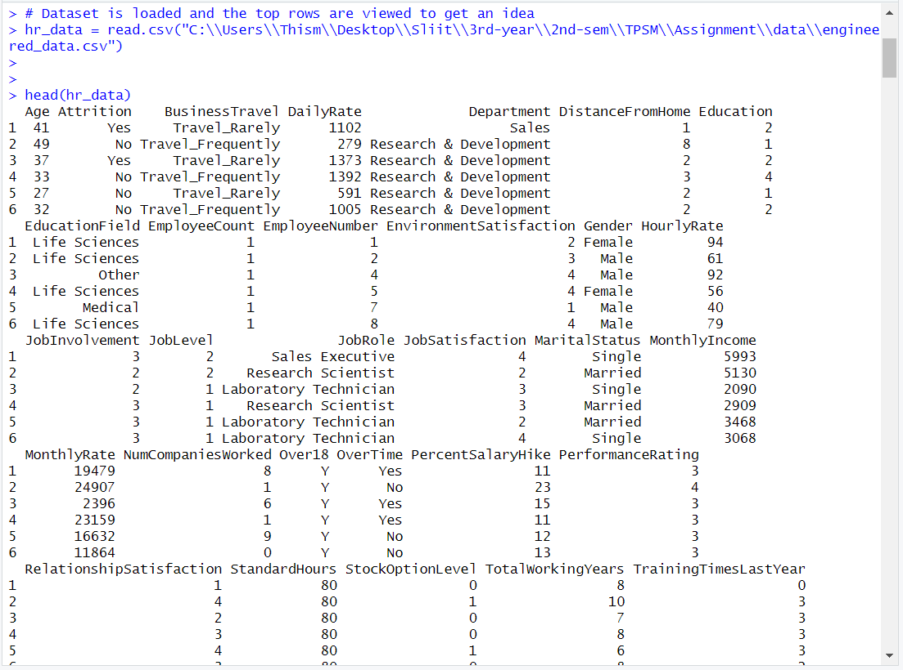
- Binary columns are created for the necessary columns, namely Attrition( Because regression model needs numerical versions), Respect_Index and JobSatisfaction(Needed for Chi Squared tests).

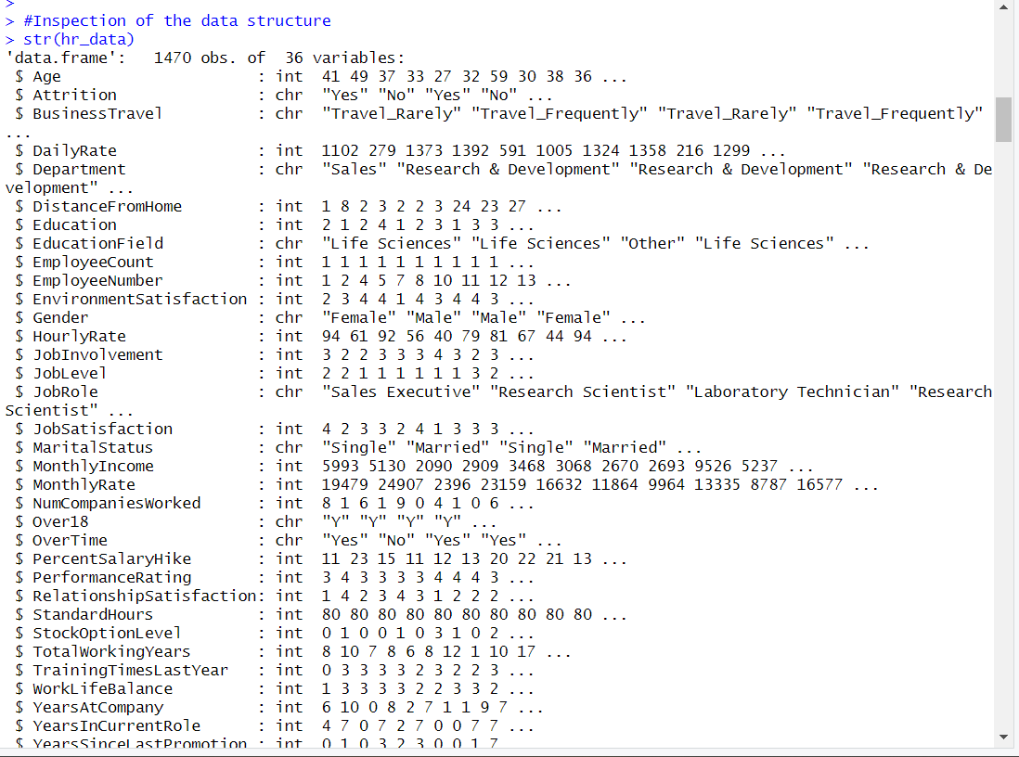

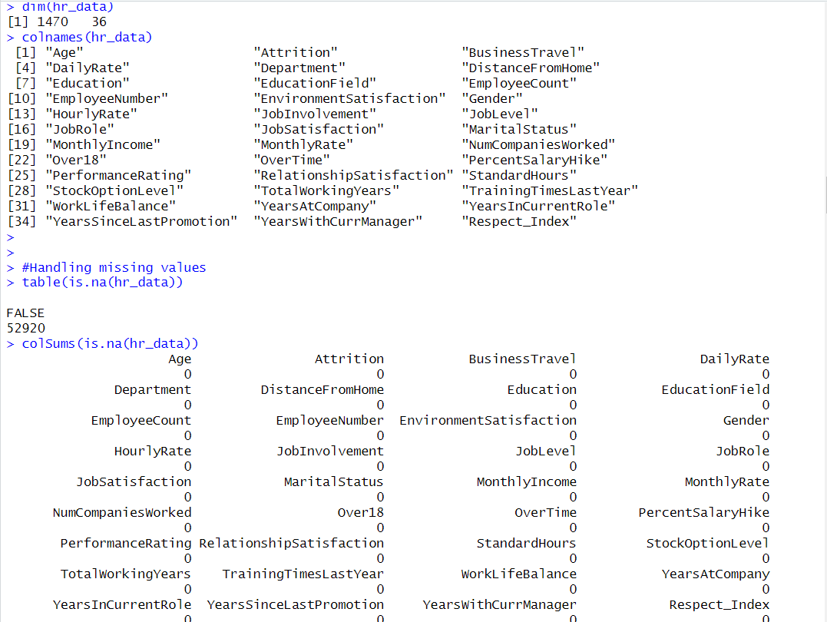

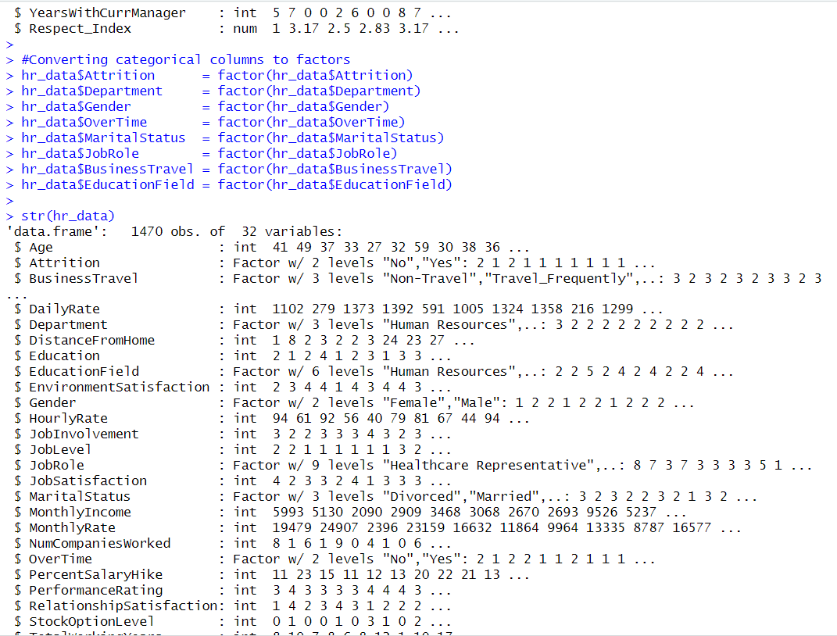
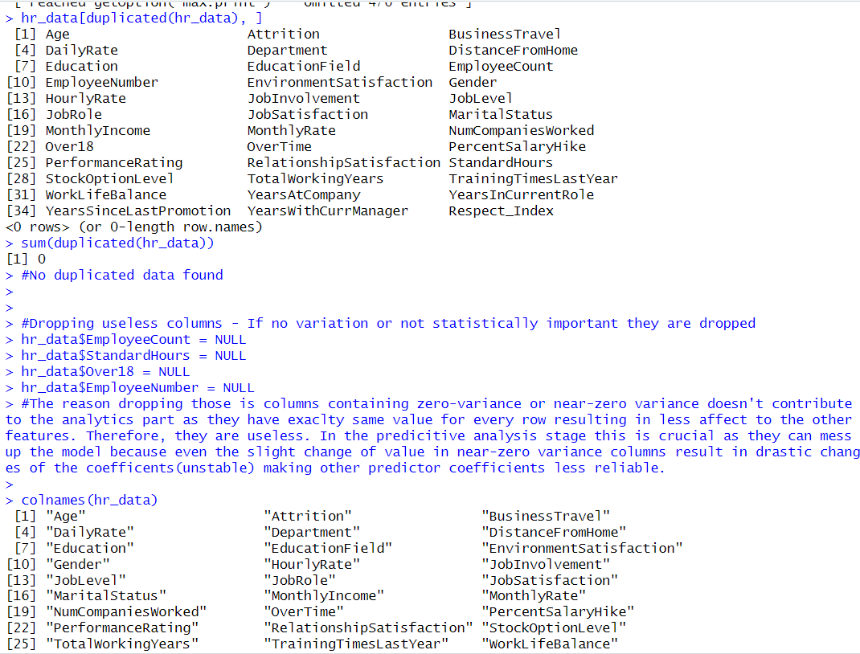
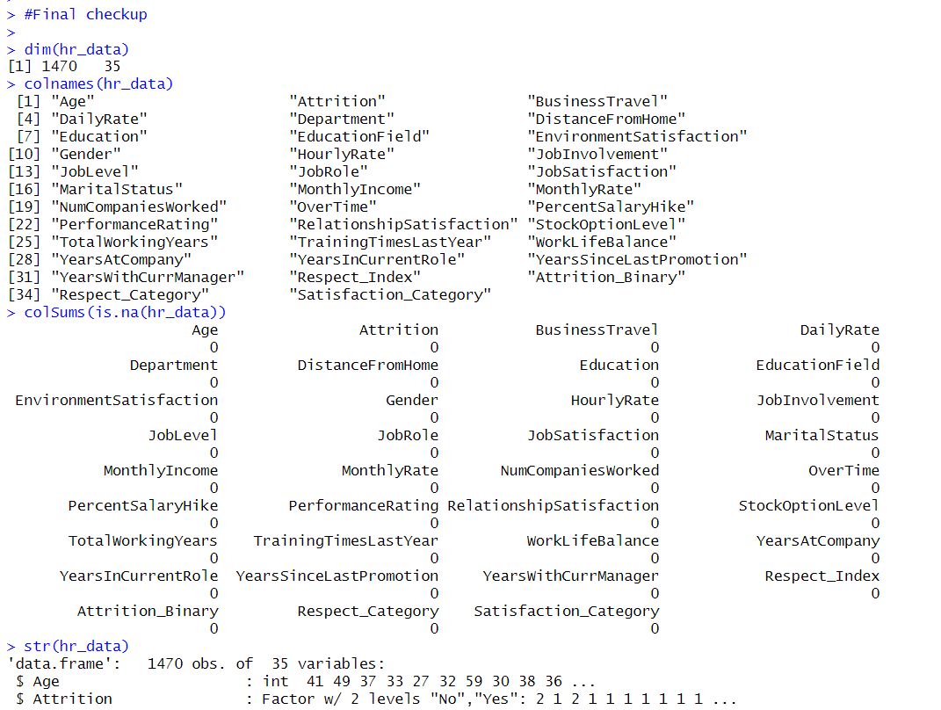
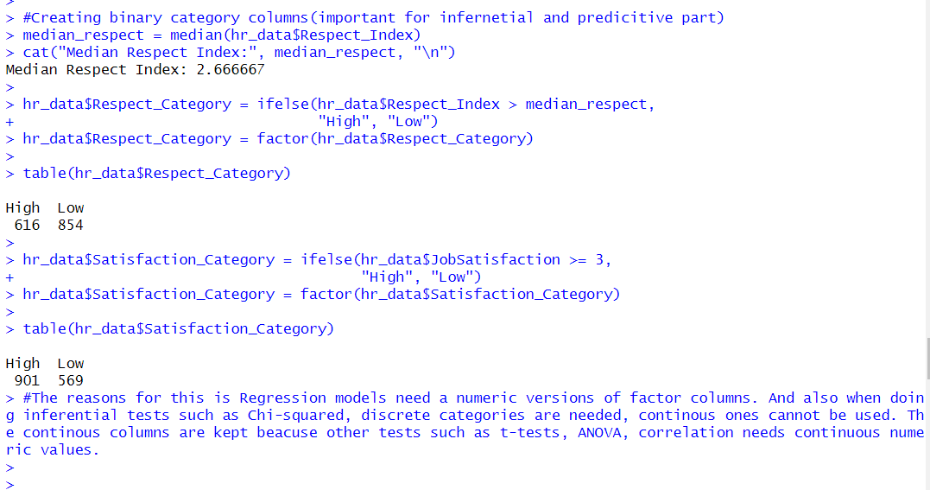
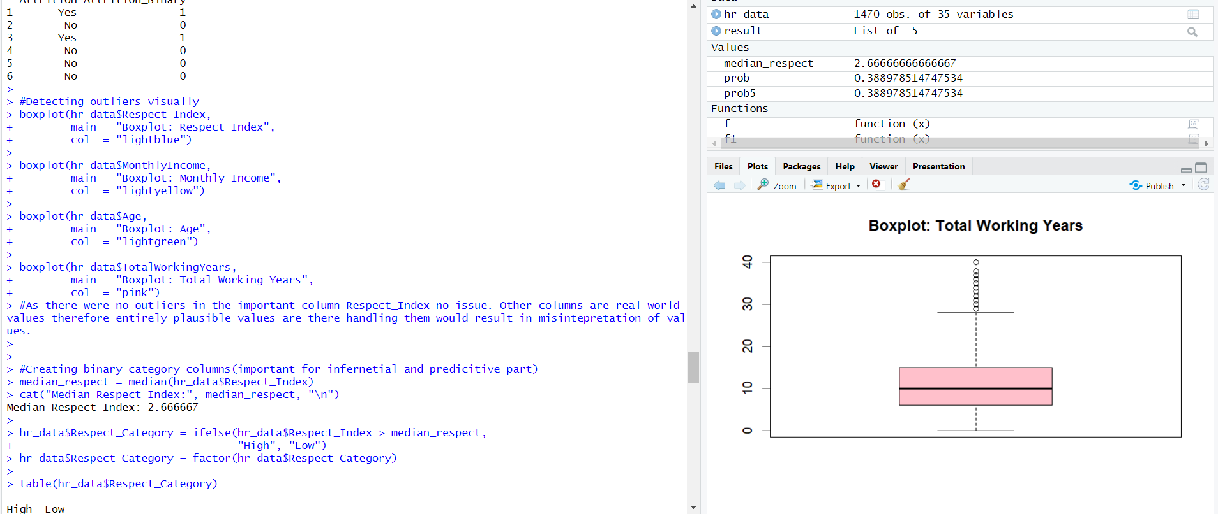

Predictive Analysis

Variable selection
The dependent variable is JobSatisfaction while the independent variable or the primary predictor is Respect_index.
The other variables chosen for prediction are (eventhough dataset has low correlation with the dependant variables these were the contextually related variables that could describe the JobSatisfaction):
- EnvironmentSatisfaction
- WorkLifeBalance
- MonthlyIncome
- Age
- YearsAtCompany
- JobLevel
- PerformanceRating

Satisfaction_Category and Respect_Category were derived from the target, therefore using them would mess up the predictions.
Attrition variable cannot be used as a predictor as it is a separate outcome.
DailyRate, HourlyRate, MonthlyRate all overlap with MonthlyIncome while YearsInCurrentRole, YearsWithCurrManager, YearsSinceLastPromotion overlap with YearsAtCompany.
Gender, MaritalStatus, Education, EducationField, DistanceFromHome have no strong relationship with the JobSatisfaction.
JobRole, Department adds complexity with no importance for the prediction part.

Train/Test Split

The 70/30 split is used so that model gets enough training data to learn patterns.
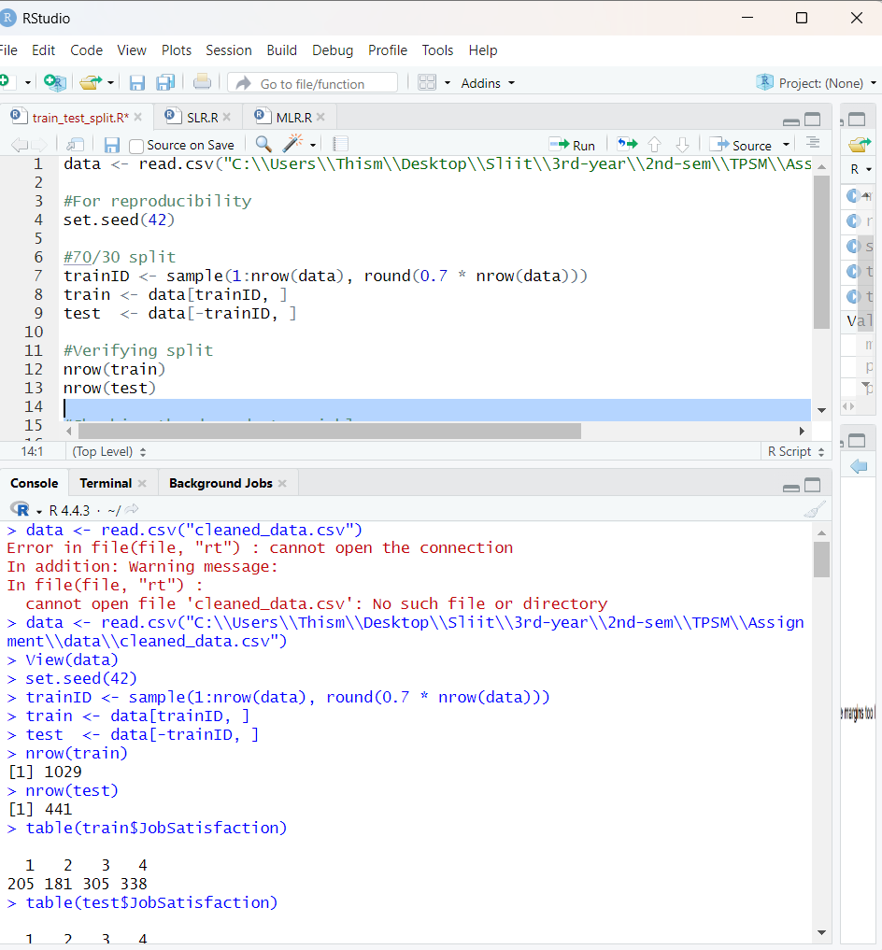

Simple Linear Regression

For the simple linear regression part Respect_Index alone was used to do the prediction

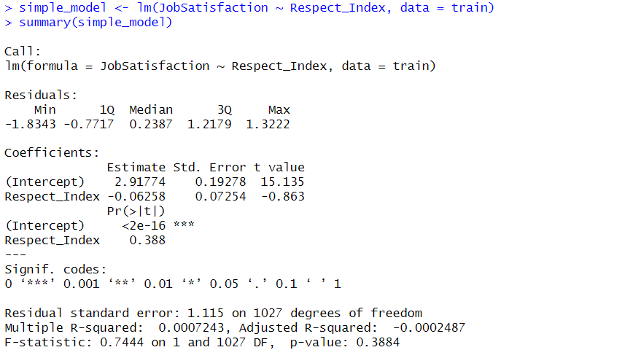
The Simple Linear Regression model showed that Respect_Index alone is not a statistically good predictor with R^2 value 0.007, ( less than 0.1% variation is explained of JobSatisfaction) p-value 0.388 (Not significant enough therefore fail to reject null hypothesis)

Multiple Linear Regression

The chosen variables even though really low correlation due to the synthetic dataset was used see if MLR would work.

Respect_Index: β = -0.083, p = 0.325
- For every 1 unit increase in Respect_Index, JobSatisfaction decreases by 0.083
- p = 0.325 — not significant, we cannot trust this effect
EnvironmentSatisfaction: β = -0.014, p = 0.661
- For every 1 unit increase, JobSatisfaction decreases by 0.014
- Not significant
WorkLifeBalance: β = 0.027, p = 0.641
- Only positive coefficient in the model
- For every 1 unit increase, JobSatisfaction increases by 0.027
- Not significant — p = 0.641
MonthlyIncome: β = -0.00002, p = 0.453
- Coefficient is practically zero — income has almost no effect
- Not significant
Age: β = -0.001, p = 0.751
- Negligible negative effect
- Not significant
YearsAtCompany: β = -0.001, p = 0.826
- Negligible negative effect
- Highest p-value in the model — least useful predictor
JobLevel: β = 0.092, p = 0.374
- Largest positive coefficient after intercept
- For every 1 level increase in job level, satisfaction increases by 0.092
- Still not significant
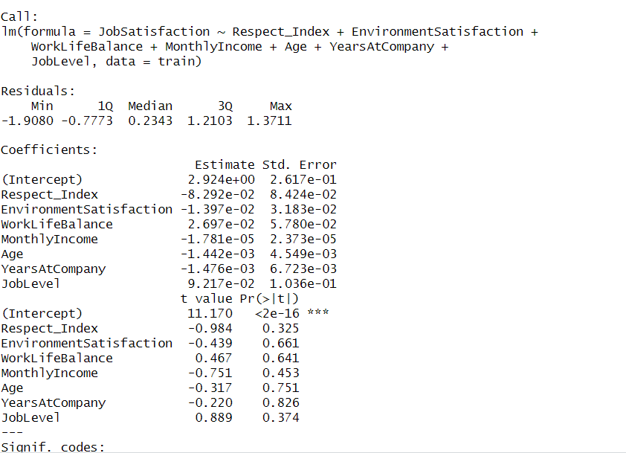

Overall Model Perfomance:
- R^2 value is 0.002 which means model explains 0.2% of the variation
- Adjusted R^2 values is -0.005 showing negative result.
- P-value is 0.957 ( Should be less than 0.0.5 to reject null hypothesis.

Regression Assumptions

Assumption 1:Linearity

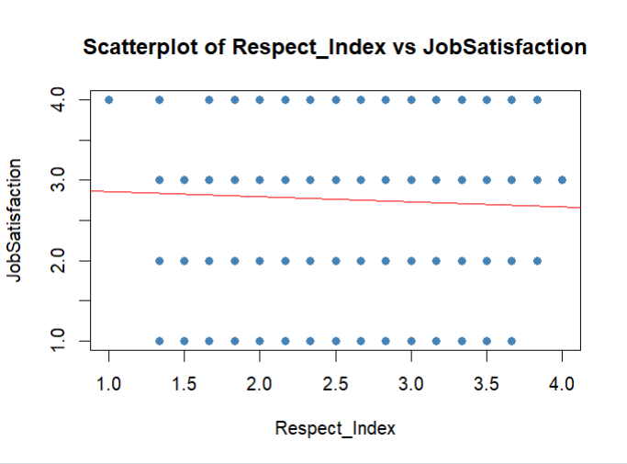
The relationship between Respect_Index and JobSatisfaction should be linear. This is checked using a scatter plot and the fitted regression line.

The scatter plot shows no linear relationship between Respect_Index and JobSatisfaction. The four layers represents the ordinal nature of JobSatisfaction. The co-efficient is -0.063 (Obtained in SLR). Therefore, it can be concluded the linearity assumption is not met.

Assumption 2: Independence

This checks if the residuals are independent of each other.
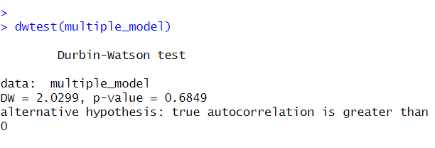

For this the Durbin_Watson test was used. It produced a result statistic of 2.030 (Idela value is 2) and p-value 0.6849 which means the independence assumption is met (no autocorrelation in the resiudals).

Assumption 3: Homoscedasticity

This checks if the residuals have constant variance across all fitted values.
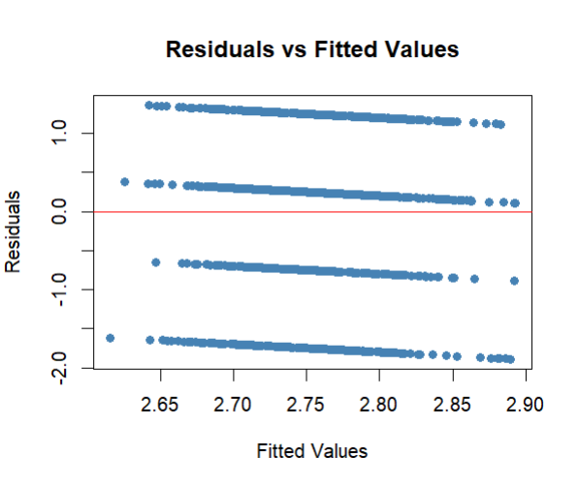

The plot shows four distinct layers which is a result of JobSatisfaction being an ordinal variable. This assumption is also not met. This is a limitation when applying linear regression to an ordinal dependent variable.

Assumption 4: Normality of Residuals

This is used to check if residuals follow a normal distribution.
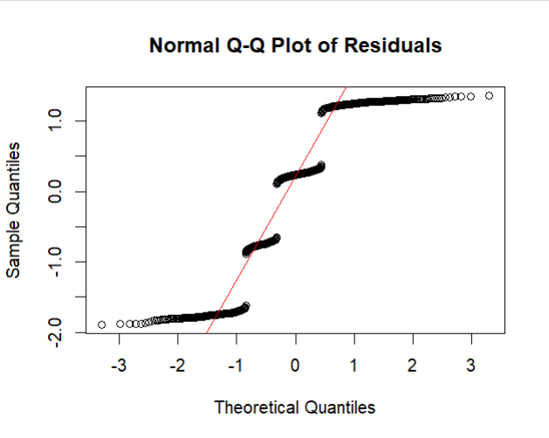

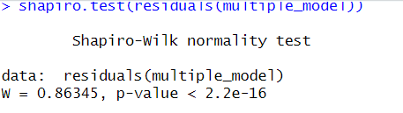

The plot shows four discrete cluster residuals. This is deviated from normal referral line. And also, p-value is < 0.05 rejecting the null hypothesis which is the distribution is normal. This assumption is also not met.

Assumption 5: Multicollinearity

VIF(Variance Inflation Factor) level below is acceptable and VIF above 5 flags significant multicollinearity.

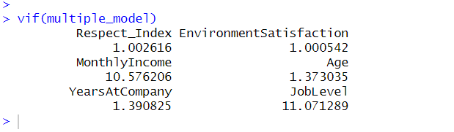

The multicollinearity assumption is not fully met as MonthlyIncome and JobLevel shows a significant multicollinearity. One of the variables must be removed.

Model Evaluation
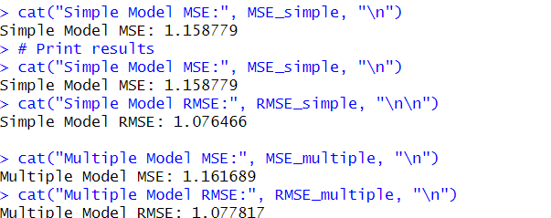
MSE and RMSE values was used to evaluate the model

The MLR produced much worse results when comparing to the SLR.
The RMSE value of 1.08 means that predictive performance is really poor showing that no variables carry linear predictive signal for JobSatisfaction in this dataset.

Predictive Conclusion

- Does Respect_Index predict JobSatisfaction?
- As per the above predictive analysis done, Respect_Index was not a statistically significant feature to predict the JobSatisfaction. The result of the SLR was β = −0.063, p = 0.388 and the MLR was β = −0.083, p = 0.325. The SLR model only explained a 0.07%(R^2 = 0.0007) variance of JobSatisfaction, while MLR only increased it to 0.2%(R^2 = 0.002). Therefore it can be concluded that Respective_Index has no meaningful prediction power in this dataset.

- Did MLR (introducing other related variables) fix it?
- No, it didn’t improve the model or the prediction power. P value was 0.957 meaning the predictors did no good job (Just simply prediciting the mean). The co-efficient of Respect_Index even stayed the same.

- The reasons for the above situation?
- IBM HR Employee Attrition dataset is a synthetic dataset developed in focus of attrition.
- Features like JobSatisfaction may have been assigned independently.
- When the correlation was tested the maximum was 0.103, confirming that the dataset has no meaningful linear signal towards the JobSatisfaction.
- JobSatisfaction distribution is a near-uniform, with low-variance.
- JobSatisfaction is an ordinal variable, but linear regression is for continuous variables. Even though an ordinal variable related model can be checked with the low correlations that yielded the same results, confirming that the problem is with the dataset, not the analytics part.

- What is the overall predictive conclusion?
- The predicitive analysis part concluded that this dataset does not support the analytical statement (H0 is not rejected). According to this dataset (Must acknowledge the limitations), Employees who feel respected at work does not tend to report higher JobSatisfaction.

- Why was this dataset chosen with the above limitations?
- IBM HR Analytics Employee Attrition and Perfomance dataset, which was created by IBM scientist was chosen due to the analytical richness (Correlation issue was not known at the beginning). Even though this is a synthetically generated data, it showed some variables which could be used up to build up a Respect_Index as those variables supported the psychological feeling of respect (WorkLifeBalance, RelationshipSatisfaction, TrainingTimesLastYear).
- After discovering the correlation issue, other datasets were also seeked to see if the dataset could be changed. But the issue remained the same. Public free HR datasets didn’t focus on satisfaction and most of them were synthetically generated. Out of them the IBM dataset was the most quality and analytically rich dataset.

Dataset | Author | Records | Variables | Nature | Description (Reasoning)
IBM HR Analytics Employee Attrition and Performance | IBM Data Scientists, hosted on Kaggle by Pavansubhasht (2017) | 1,470 | 35 | Synthetic | - Variables present for a Respect_Index construction.  - Analytical richness.
Human Resources Data Set (HRDataset_v13) | Dr. Rich Huebner & Dr. Carla Patalano, New England College of Business (2020) | 401 | 35 | Simulated | - Few records.  - No analytical richness.
HR Analytics Dataset | Ludovic Benistant, Kaggle (2017) | 14,999 | 10 | Synthetic | - Few features, cannot build up a Respect_Index.
Employee Attrition and Performance (Mosaic) | Ravindra Singh Rana, Kaggle (2023) | 4,410 | 35 | Synthetic | - Derived from IBM dataset.
Remote Work and Mental Health Dataset | Kaggle Community Dataset (2024) | 5,000 | 20 | Synthetic | - Focuses on remote work + mental health.  - Different aspect when taken with respect to the topic.  - No variables to construct Respect_Index.
Employee Productivity and Satisfaction HR Data | Aditya AB, Kaggle (2023) | 2,000 | 15 | Synthetic | - Few variable richness,  - No variables to construct Respect_Index.

