Inferential Analysis Part 2

Test 1 — Spearman Correlation
This test is performed to answer: "As Respect_Index increases, does JobSatisfaction tend to increase too?" It measures the strength and direction of the relationship between the two core variables in the analytical statement. Spearman is used instead of Pearson because normality was violated for both variables (confirmed by Shapiro-Wilk).

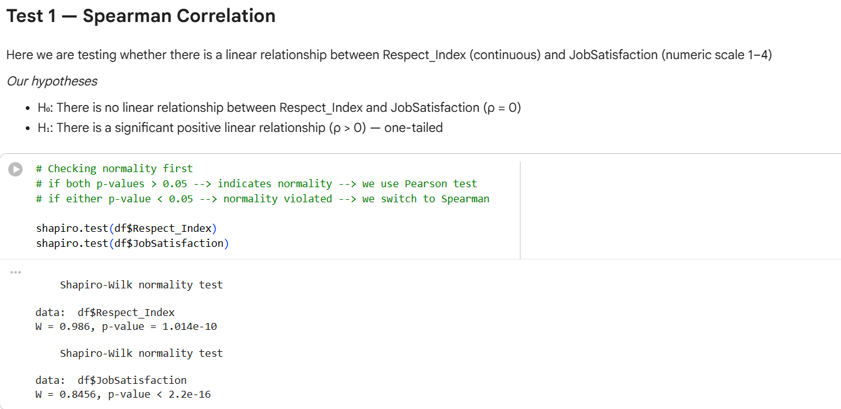
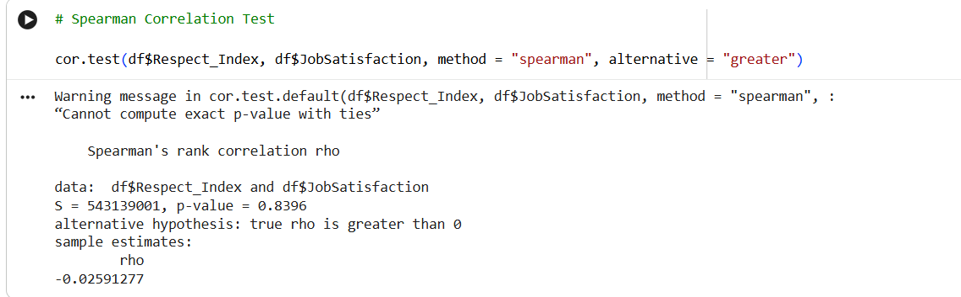
Results
- ρ (rho) = -0.0259
- p-value = 0.8396
- S statistic = 543,139,001
Interpretation
The correlation coefficient ρ = -0.0259 is extremely close to zero and slightly negative, which means there is virtually no monotonic relationship between Respect_Index and JobSatisfaction. The p-value of 0.8396 is far above α = 0.05, so we fail to reject H₀.
What this tells us about the statement: At the continuous level, higher respect does not correspond to higher job satisfaction in this dataset. This result does not support the analytical statement.

Test 2 — Correlation Matrix & Heatmap
Why this test?
This goes beyond just Respect_Index and JobSatisfaction. It maps how all six variables relate to each other simultaneously. The purpose is to understand the broader picture: is JobSatisfaction associated with any of these variables, and where does Respect_Index sit in that network?

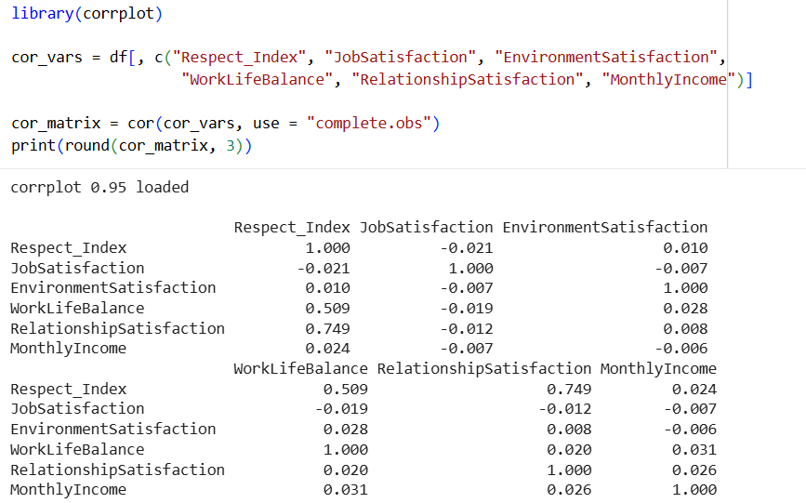

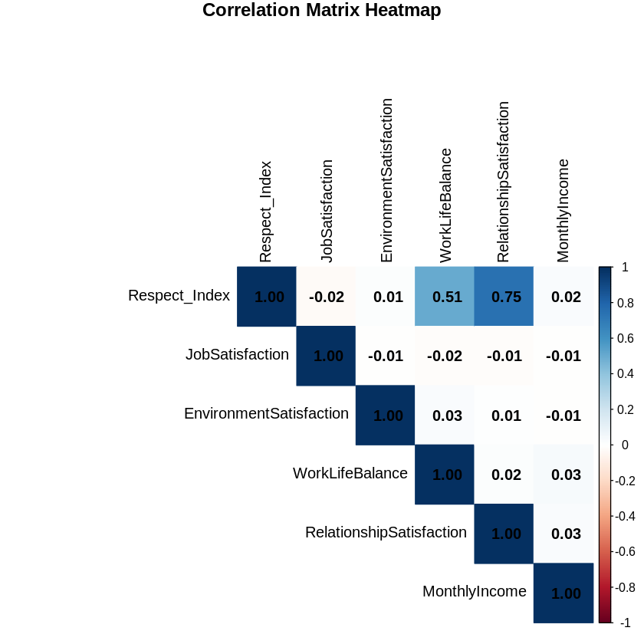

Results (key values from the matrix)
Variable Pair | r value | Strength
Respect_Index ↔ JobSatisfaction | -0.021 | Negligible
Respect_Index ↔ WorkLifeBalance | 0.509 | Moderate-Strong
Respect_Index ↔ RelationshipSatisfaction | 0.749 | Strong
JobSatisfaction ↔ EnvironmentSatisfaction | -0.007 | Negligible
JobSatisfaction ↔ MonthlyIncome | -0.007 | Negligible
WorkLifeBalance ↔ MonthlyIncome | 0.031 | Negligible

Interpretation
The most striking finding is that Respect_Index is strongly correlated with RelationshipSatisfaction (r = 0.749) and moderately with WorkLifeBalance (r = 0.509) , suggesting that Respect_Index is more a measure of interpersonal and work-life quality than job satisfaction specifically.
Meanwhile, JobSatisfaction shows negligible correlations with every single variable in the matrix, including Respect_Index (-0.021). This suggests JobSatisfaction in this dataset behaves as a largely independent variable not driven by the factors measured here.
What this tells us about the statement: The matrix reinforces the Spearman result, Respect_Index simply does not move with JobSatisfaction. However, Respect_Index does carry meaningful signal in the dataset, just directed at different variables.

Test 3 — One-Way ANOVA
Why this test?
Where correlation asks "do they move together?", ANOVA asks a different question: "Do employees at different satisfaction levels (1, 2, 3, 4) actually have different average Respect_Index scores?" It compares group means rather than measuring linear association, giving a complementary perspective.
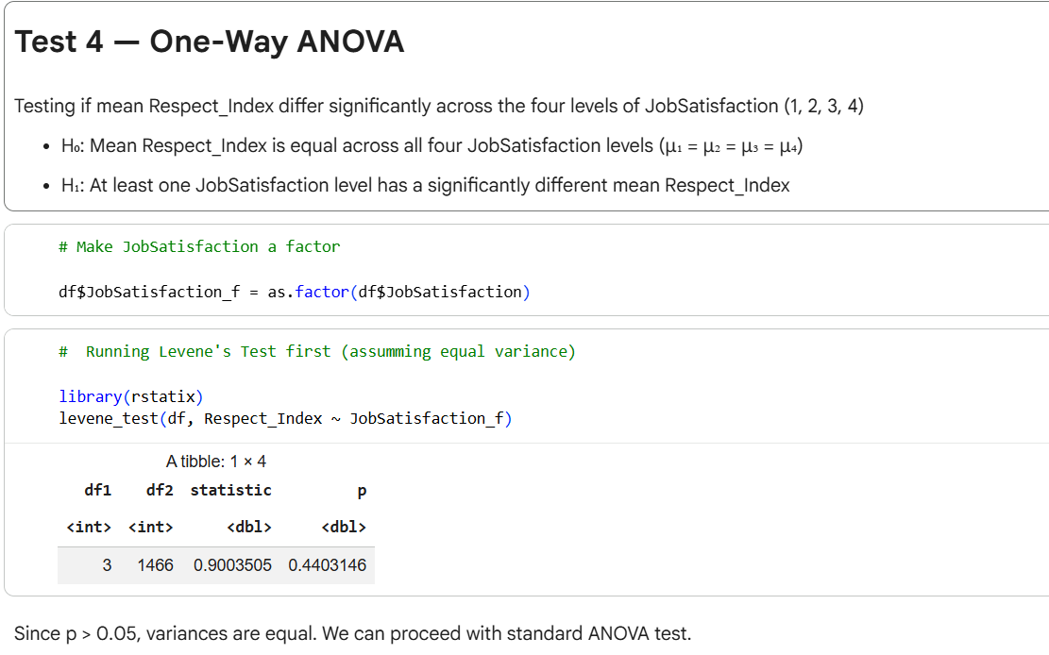
Levene's Test Result (prerequisite)
- F = 0.9004, p = 0.4403
- Since p > 0.05, variances across the four JobSatisfaction groups are equal → standard ANOVA is appropriate
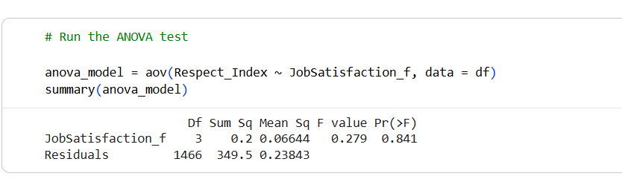

ANOVA Result
- F = 0.279, df = (3, 1466), p = 0.841
Since p = 0.841 is far above α = 0.05, we fail to reject H₀. There is no significant difference in mean Respect_Index across any of the four satisfaction levels.

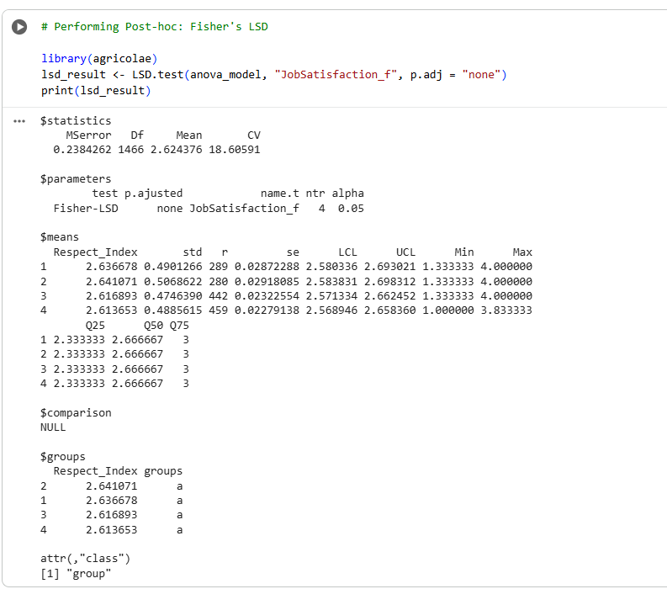
Post-hoc: Fisher's LSD
Technically post-hoc should only be run when ANOVA is significant. Since ANOVA was not significant here, the LSD result is expected to confirm no meaningful differences — and it does exactly that. All four groups fall into the same group "a", meaning no pair of satisfaction levels differs significantly in their mean Respect_Index:
JobSatisfaction Level | Mean Respect_Index | Group
1 | 2.637 | a
2 | 2.641 | a
3 | 2.617 | a
4 | 2.614 | a
The means are remarkably close to each other, all hovering around 2.62–2.64, which visually confirms the ANOVA conclusion.
What this tells us about the statement: Whether an employee rates their satisfaction as 1 or 4, their average Respect_Index is virtually identical. This provides no support for the analytical statement from a group comparison perspective.

Chi-Square Test Report — Respect Category vs Satisfaction Category
Hypotheses
- H₀: Respect_Category and Satisfaction_Category are independent (no association between them)
- H₁: There is a significant association between Respect_Category and Satisfaction_Category
Expected Frequency Check
All expected cell frequencies were well above the minimum threshold of 5 (ranging from 238.44 to 523.44), confirming that the Chi-Square test is appropriate and Fisher's Exact Test is not required.
Results
Statistic | Value
χ² (X-squared) | 3.4287
Degrees of Freedom | 1
p-value | 0.06407
Interpretation at α = 0.05
Since the p-value (0.06407) is greater than α = 0.05, we fail to reject H₀. There is insufficient statistical evidence to conclude that Respect_Category and Satisfaction_Category are significantly associated.
It is worth noting that the p-value is only marginally above the 0.05 threshold, suggesting a borderline trend — the association is not statistically significant at the conventional level, but the result is not entirely dismissive of a relationship either.
Connection to the Analytical Statement
At the categorical level, this test alone does not provide sufficient evidence to support the claim that employees with higher respect report higher job satisfaction. However, this result should be interpreted alongside the correlation and ANOVA results before drawing a final conclusion.

Overall Conclusion Across All Three Tests
Test | Key Statistic | p-value | Effect Size | Decision
Spearman Correlation | ρ = -0.0259 | 0.8396 | Negligible | Fail to reject H₀
Correlation Matrix | r = -0.021 (Respect_Index ↔ JobSatisfaction) | — | Negligible | No meaningful association
Chi-Square | χ² = 3.4287, df = 1 | 0.06407 | Cramér's V ≈ 0.048 (small) | Fail to reject H₀
One-Way ANOVA | F = 0.279, df = (3, 1466) | 0.841 | η² = 0.0006 (negligible) | Fail to reject H₀

Across all four inferential tests conducted, the evidence consistently fails to support the analytical statement that "employees who feel respected at work report higher job satisfaction."
The Spearman correlation (ρ = -0.026, p = 0.840) revealed virtually no monotonic relationship between Respect_Index and JobSatisfaction at the continuous level. The correlation matrix reinforced this finding, showing a near-zero correlation of -0.021 between the two variables, while also revealing that Respect_Index is more strongly associated with RelationshipSatisfaction (r = 0.749) and WorkLifeBalance (r = 0.509) — suggesting it captures interpersonal and work-life quality rather than job satisfaction directly.
The Chi-Square test (χ² = 3.4287, p = 0.064) found no statistically significant association between the categorical groupings of respect and satisfaction at α = 0.05, though the borderline p-value hints at a very weak trend that falls just short of significance. The effect size (Cramér's V ≈ 0.048) confirms the association is negligibly small even if interpreted generously.
The One-Way ANOVA (F = 0.279, p = 0.841) confirmed that employees across all four JobSatisfaction levels (1, 2, 3, 4) have virtually identical mean Respect_Index scores (ranging narrowly from 2.614 to 2.641), with η² = 0.0006 indicating that satisfaction level explains less than 0.1% of variation in Respect_Index.
Taken together, these results provide no statistical evidence that perceived workplace respect drives job satisfaction in this dataset. The analytical statement is not supported by the data at the conventional significance level of α = 0.05.

