**Work-Flow**

Welcome

Add Events

Home

Update

Save

Save

Welcome Page

WELCOME

Sign in

1. Validate if user logged on to google account.

* If logged on, go to Home Page, otherwise redirect to Welcome page.

**Home Page**

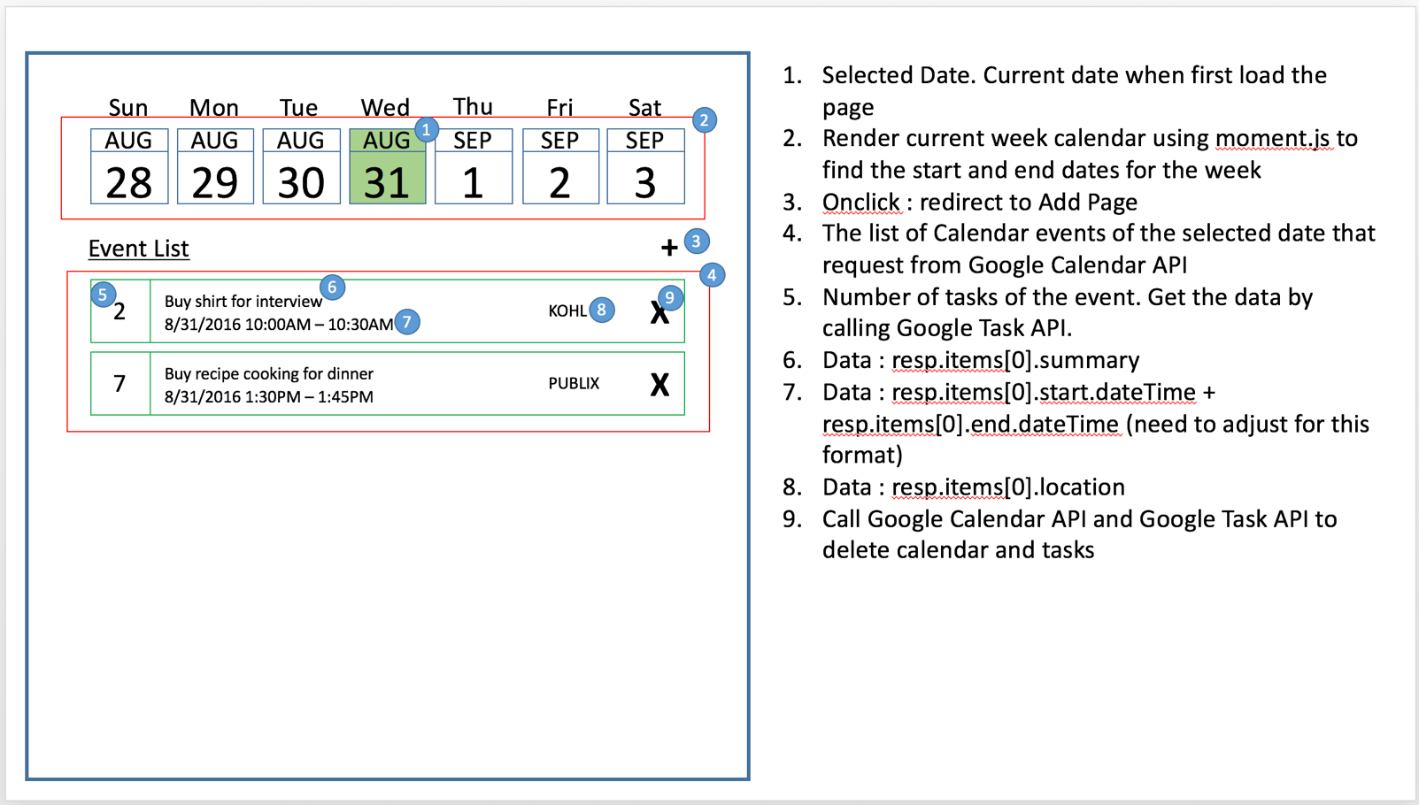

1. User will be able to see a current week calendar.
2. The application will set a default and focus at a current date.
   1. At a current date, the application will get information from Google Calendar API and Google Task API to display under Event List as below:
   * Calendar Event Title (using Google Calendar API)
   * Calendar Event Date Time (using Google Calendar API)
   * Number of Tasks (using Google Task API)
3. User can perform the following actions below:
   1. Add a new Calendar Event
   2. View detail of each Event
   3. Modify/Update each event
   4. Delete Calendar

**Add Page**

This page performed when user click add event from home page

New Event

Title

When

Where

To-do list

+ -

+ -

Cancel

Save

1. User will be able to fill-in this following information:
   1. Title
   2. Date Time Start
   3. Date Time End
   4. Location
   5. List of Tasks
2. User will be able to cancel and get back to the Home Page
3. User will be able to set date and time of event
4. User will be able to search location by entering the name of location textbox
5. The map will show under the location textbox when there is a response result back from Google Map API
6. User will be able to select the location on the map list
7. User will be able to add a task or multiple tasks by click (+) and (-) to delete task
8. User will be able to save the event
9. The cursor must be set automatically to the Title Textbox