Phase 2 : Spark Analysis: Figures and Findings
Each section explains one figure, lists the key results, and gives a findings paragraph (shaded) that can be used in the report. A1 and A2 are the required analyses; B1 and B2 are the optional bonus analyses. All analyses use PySpark DataFrame operations on the unified dataset only.

Weekly request volume (a1_weekly_volume.png)
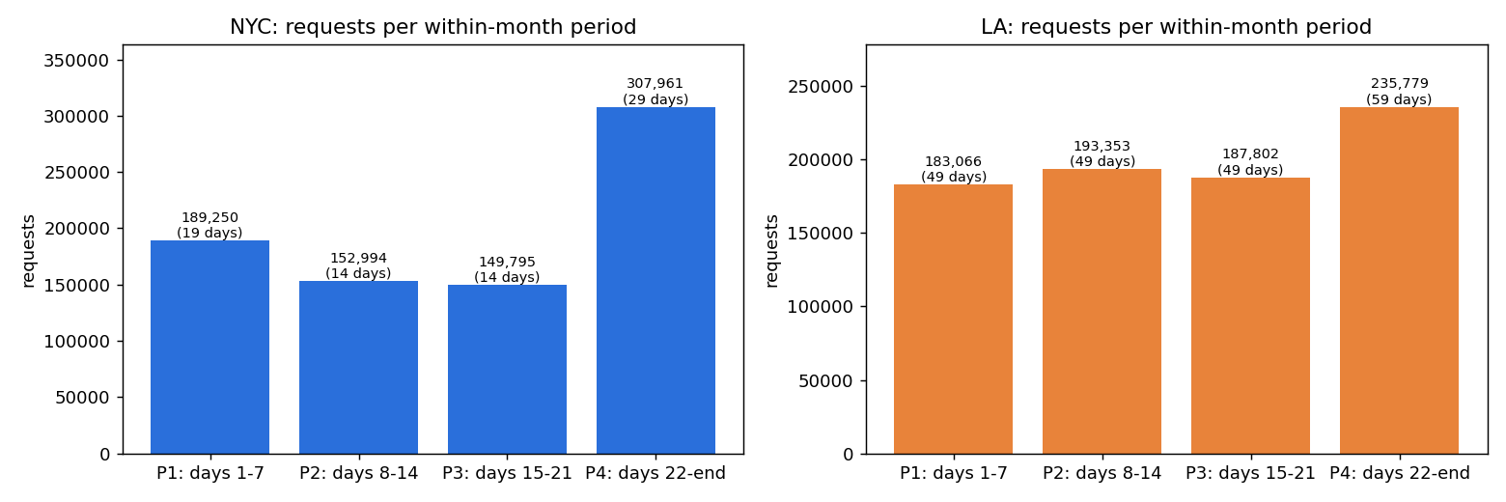
Figure 1. Requests per within-month period, NYC (left) and LA (right); label = requests and calendar days covered
What the figure shows
Every request is assigned to a period by the day of the month of its creation date: P1 days 1–7, P2 days 8–14, P3 days 15–21 and P4 days 22 to the end of the month. Each bar is the number of requests in that period, summed over all months of the data. The label under each count is the number of calendar days the period covers.
Key results
 | NYC | LA
Highest period (count) | P4: 307,961 requests (38.5%) | P4: 235,779 requests (29.5%)
Lowest period (count) | P3: 149,795 requests (18.7%) | P1: 183,066 requests (22.9%)
Days covered | P1 19 · P2 14 · P3 14 · P4 29 | P1 49 · P2 49 · P3 49 · P4 59
Requests per day | 9,961 – 10,928 (highest P2, lowest P1) | 3,736 – 3,996 (highest P4, lowest P1)

Service-request hotspots (a2_hotspots.png)
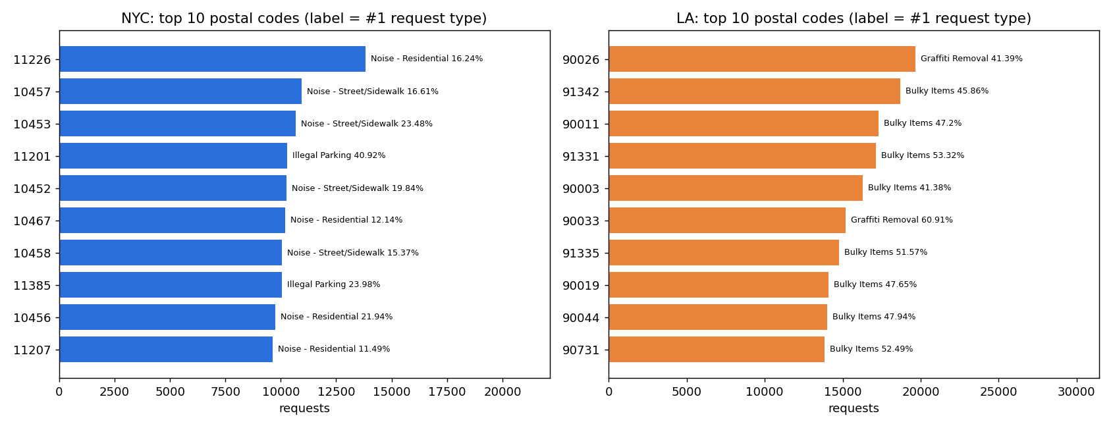
Figure 2. Ten postal codes with the most requests, NYC (left) and LA (right); label = most frequent request type and its share of the postal code
What the figure shows
The bars are the ten postal codes with the most requests in each city, ranked from top to bottom. The label shows each postal code's most frequent request type and its percentage of all requests in that postal code. The full table with the top three types per postal code is in a2_hotspots_top_zip_request_types.csv.
Key results
 | NYC | LA
Top 10 share of city | 13.2% of requests | 20.1% of requests
#1 postal code | 11226: 13,832 requests | 90026: 19,661 requests
Most frequent #1 type | Noise in 8 of 10 (Residential 4, Street/Sidewalk 4); Illegal Parking in 2 | Bulky Items in 8 of 10; Graffiti Removal in 2
Strongest single type | Illegal Parking, 40.9% of 11201 | Graffiti Removal, 60.9% of 90033
Top 3 types cover | 29–58% of a postal code's requests | 72–88% of a postal code's requests

Resolution performance (b1_slowest_request_types.png)
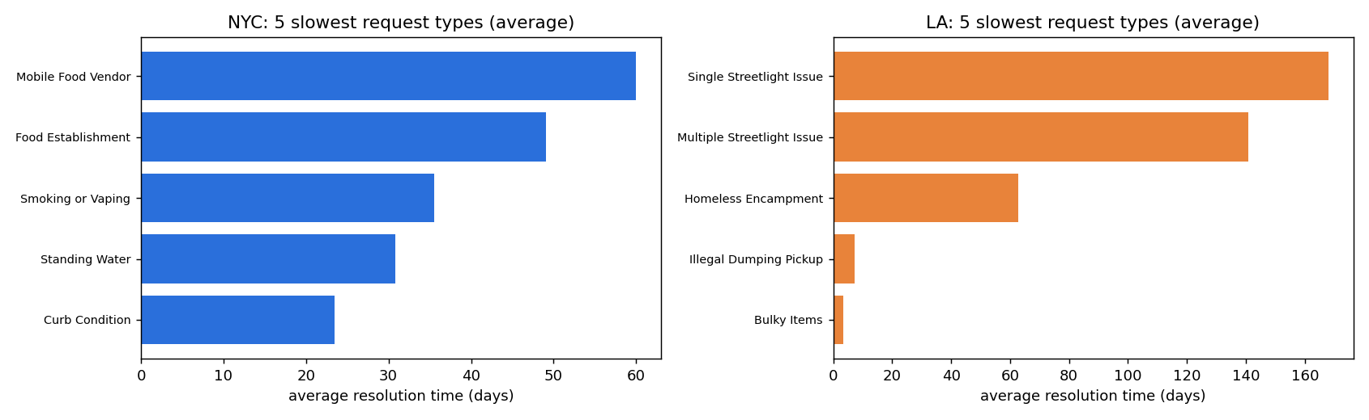
Figure 3. Five request types with the longest average resolution time (at least 30 valid requests), NYC (left) and LA (right)
What the figure shows
Only valid completed requests are used (resolution_valid = true: status Closed, with a closed date not earlier than the created date). The bars are the five request types with the longest average resolution time in each city, in days. Only request types with at least 30 valid requests are ranked, so no average depends on a handful of requests. The x-axes have different scales: LA's longest types take far longer than NYC's.
Key results
 | NYC | LA
Valid requests | 704,176 | 728,135
Average resolution | 89.0 h (3.7 days) | 229.4 h (9.6 days)
Median resolution | 4.9 h (0.2 days) | 46.5 h (1.9 days)
5 slowest types (average days) | Mobile Food Vendor 60.0 · Food Establishment 49.1 · Smoking or Vaping 35.5 · Standing Water 30.8 · Curb Condition 23.5 | Single Streetlight Issue 168.0 · Multiple Streetlight Issue 140.8 · Homeless Encampment 62.7 · Illegal Dumping Pickup 7.3 · Bulky Items 3.5

Standardized status and submission channel (b2_status_and_channel.png)
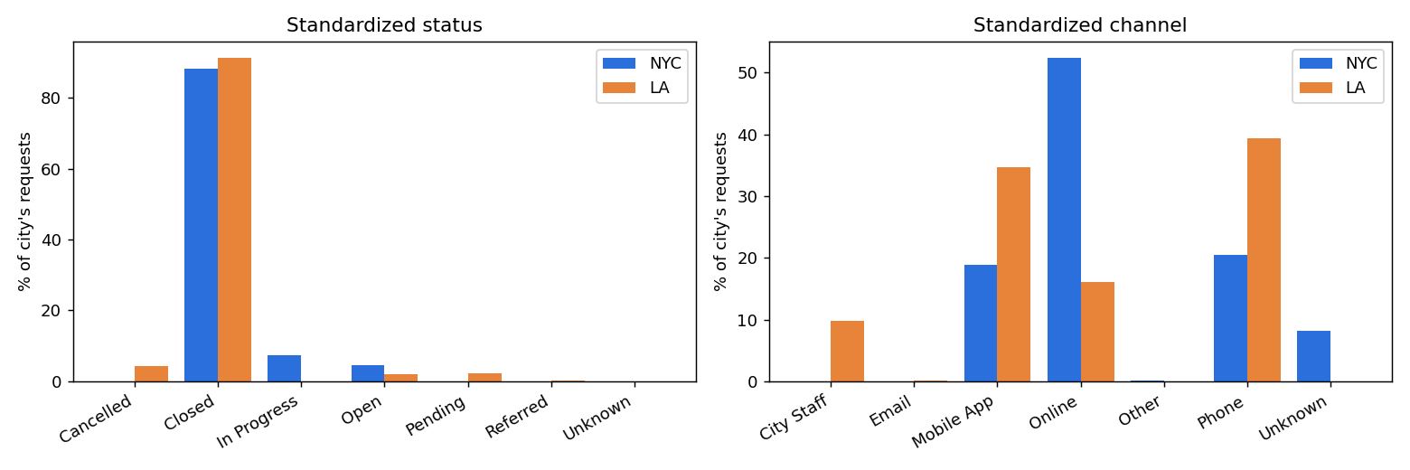
Figure 4. Share of each city's requests by standardized status (left) and standardized submission channel (right)
What the figure shows
Grouped bars compare the two cities on the shared categories created in Phase 1 (status_std and channel_std), as a percentage of each city's 800,000 requests. A missing bar means the city has no requests in that category (for example, NYC has no Cancelled status and LA no Unknown channel).
Key results
 | NYC | LA
Most common status | Closed: 704,789 (88.1%) | Closed: 730,126 (91.3%)
Other statuses | In Progress 7.3% · Open 4.6% · Pending 0.04% · Unknown 0.01% | Cancelled 4.3% · Pending 2.2% · Open 2.0% · Referred 0.1%
Most common channel | Online: 419,261 (52.4%) | Phone: 314,676 (39.3%)
Other channels | Phone 20.4% · Mobile App 18.8% · Unknown 8.2% · Other 0.1% | Mobile App 34.7% · Online 16.1% · City Staff 9.7% · Email 0.2% · Other (10 requests)

