Thi Thuy Tien Ho
HSC - 4933
10/11/2026
Lab 7 — Trends and OLS Regression
Figures 1–2: Maternal Weight and Infant Birthweight
Independent Variable (X): lwt (maternal weight)
Dependent Variable (Y): bwt (infant birthweight)
β₀ (Intercept): 2369.6235
β₁ (Slope): 4.4291
R²: 0.0345
Interpretation: Positive but weak association exists between maternal weight and infant birthweight. For every additional one pound in the maternal weight, there will be an increment of 4.43 grams in the birth weight of infants. About 3.45 percent of variance in the infant birth weight can be explained by the model.
Figure 1: Scatterplot of bwt vs. lwt
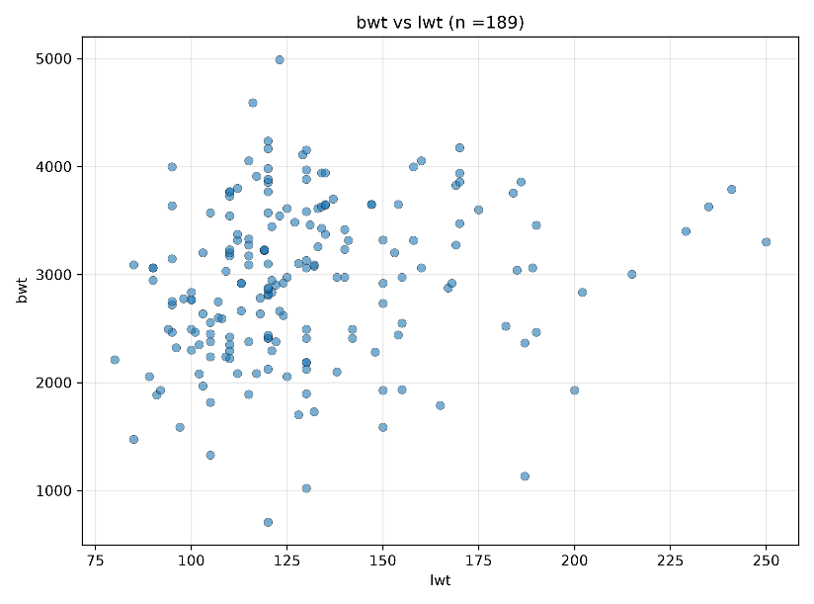

Figure 2: Scatterplot of bwt vs. lwt with OLS line
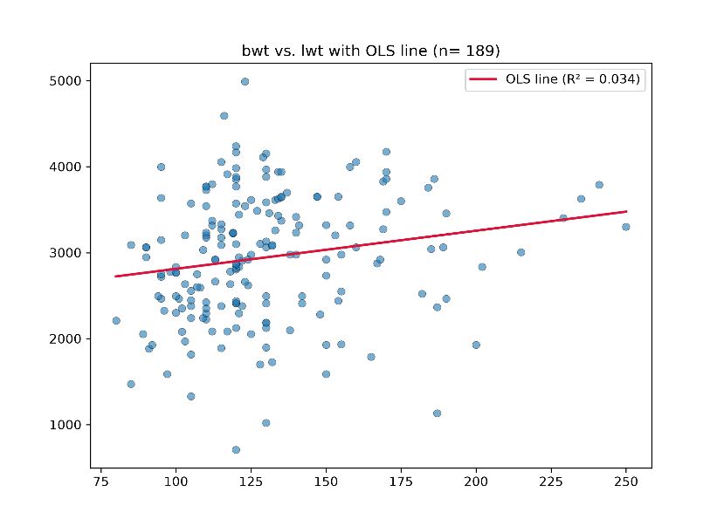

Figures 3–4: Total Population and Housing Insecurity
Independent Variable (X): totalpopulation
Dependent Variable (Y): housinsecu_crudeprev
β₀ (Intercept): 12.4181
β₁ (Slope): 4.45 × 10⁻⁷
R²: 0.0014
Interpretation: There is a very weak positive correlation between total population and housing insecurity prevalence. An addition unit of total population is associated with an increase in prevalence of housing insecurity by 0.000000445. Only 0.14% of the variability in prevalence of housing insecurity is explained by the model.

Figure 3: Scatterplot of totalpopulation vs. housinsecu_crudeprev
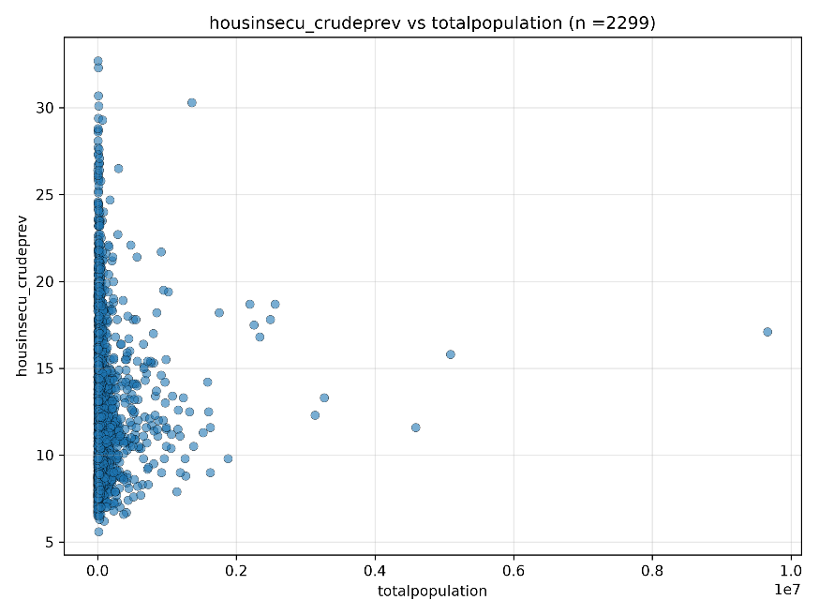
Figure 4: Scatterplot of totalpopulation vs. housinsecu_crudeprev with OLS line
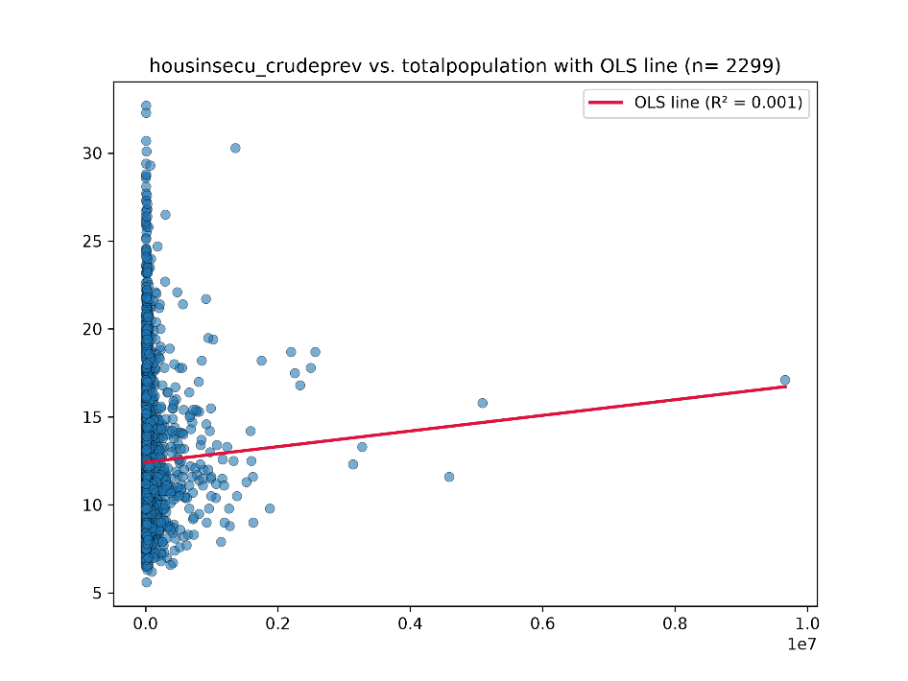

Figures 5–6: Obesity and Poor Mental Health
Independent Variable (X): obesity_crudeprev
Dependent Variable (Y): mhlth_crudeprev
β₀ (Intercept): 9.3830
β₁ (Slope): 0.2069
R²: 0.2418
Interpretation: There exists a positive association between the prevalence of obesity poor mental health prevalence, which is also stronger than the other two correlations. ne unit change in the prevalence of obesity results in an approximately 0.207 units change in the prevalence of poor mental health. This model accounts for 24.18% of the variance in poor mental health prevalence.

Figure 5: Scatterplot of mhlth_crudeprev vs. obesity_crudeprev
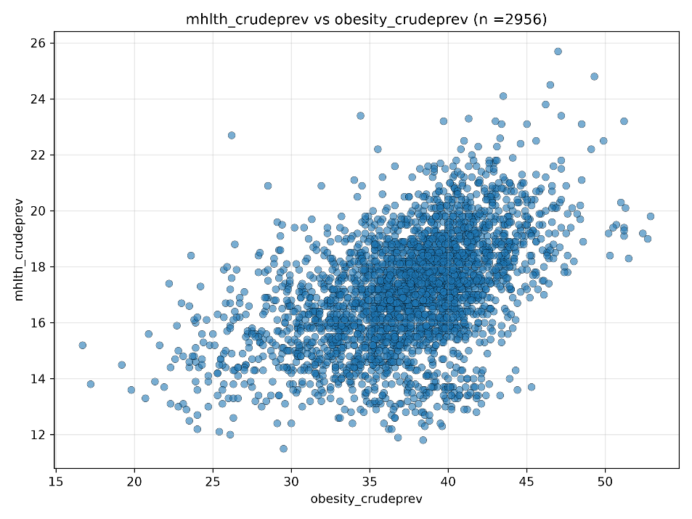

Figure 6: Scatterplot of mhlth_crudeprev vs. obesity_crudeprev with OLS line
