Case Study Report



**Tech Saksham**

“

**“**Analysis of Commercial Electricity Consumption in Indian State”

**THE MDT HINDU COLLEGE, PETTAI-TIRUNELVELI.**

|  |  |
| --- | --- |
| **NM ID** | **NAME** |
| C013AC3B2980D79AD07418376E80C4F4 | THIVAKARAN A |

Trainer Name: R.Uma Maheswari

Master Trainer: R.Uma Maheswari

|  |  |
| --- | --- |
|  |  |
|  |  |
|  |  |

**ABSTRACT**

Energy has been universally recognized as one of the most important input for economic growth and

human development. Generally, it has defined as “Capacity to do work” thereby, for bring out desirable design

on economic level there must be need of intensive of energy performance in various sectors of the country.

Perceiving commercial energy at the one of economic viability consumption has equip the present status of

economic level to be boost and reach global advance in due period with identification of which are highly

consumes among public and the statistics of this has brought out in this study. Electricity, LPG, kerosene, coal

and natural gas are the chosen commercial energy and data for the specified years have collected from central

electricity authority CAE and Energy statistics 2015 for 2007 – 2014.

**INDEX**

|  |  |  |
| --- | --- | --- |
| **Sr. No.** | **Table of Contents** | **Page No.** |
| 1 | Chapter 1: Introduction | 4 |
| 2 | Chapter 2: Services and Tools Required | 6 |
| 3 | Chapter 3: Project Architecture | 7 |
| 4 | Chapter 4: Modeling and Result | 9 |
| 5 | Conclusion | 18 |
| 6 | Future Scope | 19 |
| 7 | References | 20 |
| 8 | Links | 21 |

**CHAPTER 1**

**INTRODUCTION**

* 1. **Problem Statement**

In the recent past, several initiatives have been taken to address the challenges in the power sector.  These include structural changes in the regulatory framework as proposed by the Electricity (Amendment) Bill, 2014, and more recently, the UDAY scheme to address financial issues being faced by companies distributing electricity.  In this context, we present an overview of the status of the electricity sector and the challenges it continues to face..

* 1. **Proposed Solution**

1. A major power crisis has arisen in front of us today owing to shortage of coal, plunging entire world, including India, into complete darkness. Coal is crucial for India’s energy supply as 70% of India’s electricity generation depends on Coal. Every country is finding way out to deal with current power crisis which cannot be resolved overnight, especially for developed countries like India, which has 135 coal-fired power plants, but unfortunately, 70 amongst them reporting shortage, not having sufficient amount of coal supply resulting in running out of existing stockpiles within few days. Due to country’s severe shortage of coal, particularly in India, power generation in states like Punjab, Rajasthan, Delhi, and Tamil Nadu, has begun to suffer. Going by forecast, India was recently hit by power crisis when daily peak shortage rose to 10,778 MW, energy deficit reaching to 5% at national level, with some states experiencing steep deficits of upto 15%. Consequently, discoms resorted to load-shedding, leading to long duration of outage in many households and rationed supply for economic activities.
   1. **Feature**

* **Analysis**: The dashboard will provide **Analysis of Commercial Electricity Consumption in Indian State”**
* **Calculate consumption**: To calculate consumption, you multiply the power in kW by the hours you use the devices per day, per week or per month.
* **Trend Analysis**: The dashboard will identify and display trends in annual energy production
* **Predictive Analysis**: It will use historical data to predict future annual energy production
  1. **Advantages**

**Commercial energy cosumption**: Commercial energy use, which includes institutional energy use, is what gives businesses, schools (including universities), and public buildings like libraries the ability to serve the public.

* **Major source**:India still depends heavily on Coal as the major source of energy.
* **Industry Sector**; The industry sector accounted for the highest share of energy consumption across India in fiscal year 2022, at 41 percent.
  1. **Scope**

The scope of this project **India is the world’s third-largest energy consuming country, thanks to rising incomes and improving standards of living.**Energy use has doubled since 2000, with 80% of demand still being met by coal, oil and solid biomass.On a per capita basis, India’s energy use and emissions are less than half the world average, as are other key indicators such as vehicle ownership, steel and cement output. As India recovers from a Covid-induced slump in 2020, it is re-entering a very dynamic period in its energy development

**CHAPTER 2**

**SERVICES AND TOOLS REQUIRED**

**2.1 Services Used**

* **Data Collection and Storage Services**: Banks need to collect and store customer data in real-time. This could be achieved through services like Azure Data Factory, Azure Event Hubs, or AWS Kinesis for real-time data collection, and Azure SQL Database or AWS RDS for data storage.
* **Data Processing Services**: Services like Azure Stream Analytics or AWS Kinesis Data Analytics can be used to process the real-time data.
* **Machine Learning Services**: Azure Machine Learning or AWS SageMaker can be used to build predictive models based on historical data.

**2.2 Tools and Software used**

**Tools**:

* **PowerBI**: The main tool for this project is PowerBI, which will be used to create interactive dashboards for real-time data visualization.
* **Power Query**: This is a data connection technology that enables you to discover, connect, combine, and refine data across a wide variety of sources.

**Software Requirements**:

* **PowerBI Desktop**: This is a Windows application that you can use to create reports and publish them to PowerBI.
* **PowerBI Service**: This is an online SaaS (Software as a Service) service that you use to publish reports, create new dashboards, and share insights.
* **PowerBI Mobile**: This is a mobile application that you can use to access your reports and dashboards on the go.

**CHAPTER 3**

**PROJECT ARCHITECTURE**

**3.1 Architecture**

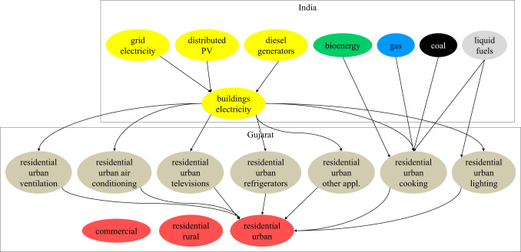

Here’s a high-level architecture for the project:

1. **Data Collection**: commercial electricity condumption data is collected from state level of production.
2. **Data Storage**: The collected data is stored in a database for processing.
3. **Data Processing**: The stored data is processed in real-time using serices .
4. **Machine Learning**: Predictive models are built based on processed data using Azure Machine Learning or AWS SageMaker. These models can help in predicting production level.
5. **Data Visualization**: The processed data and the results from the predictive models are visualized in real-time using PowerBI. PowerBI allows you to create interactive dashboards that can provide valuable insights into the data.
6. **Data Access**: The dashboards created in PowerBI can be accessed through PowerBI Desktop, PowerBI Service (online), and PowerBI Mobile.

**CHAPTER 4**

**MODELING AND RESULT**

**Manage relationship**

The “disp” file will be used as the main connector as it contains most key identifier (account id, client id and disp id) which can be use to relates the 8 data files together. The “district” file is use to link the client profile geographically with “district id”

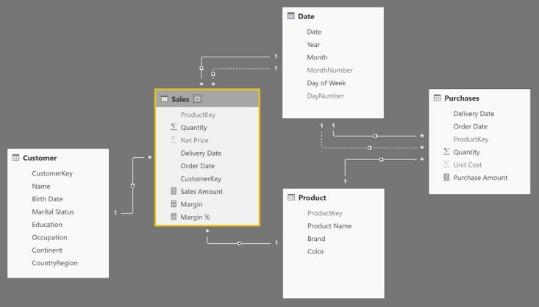

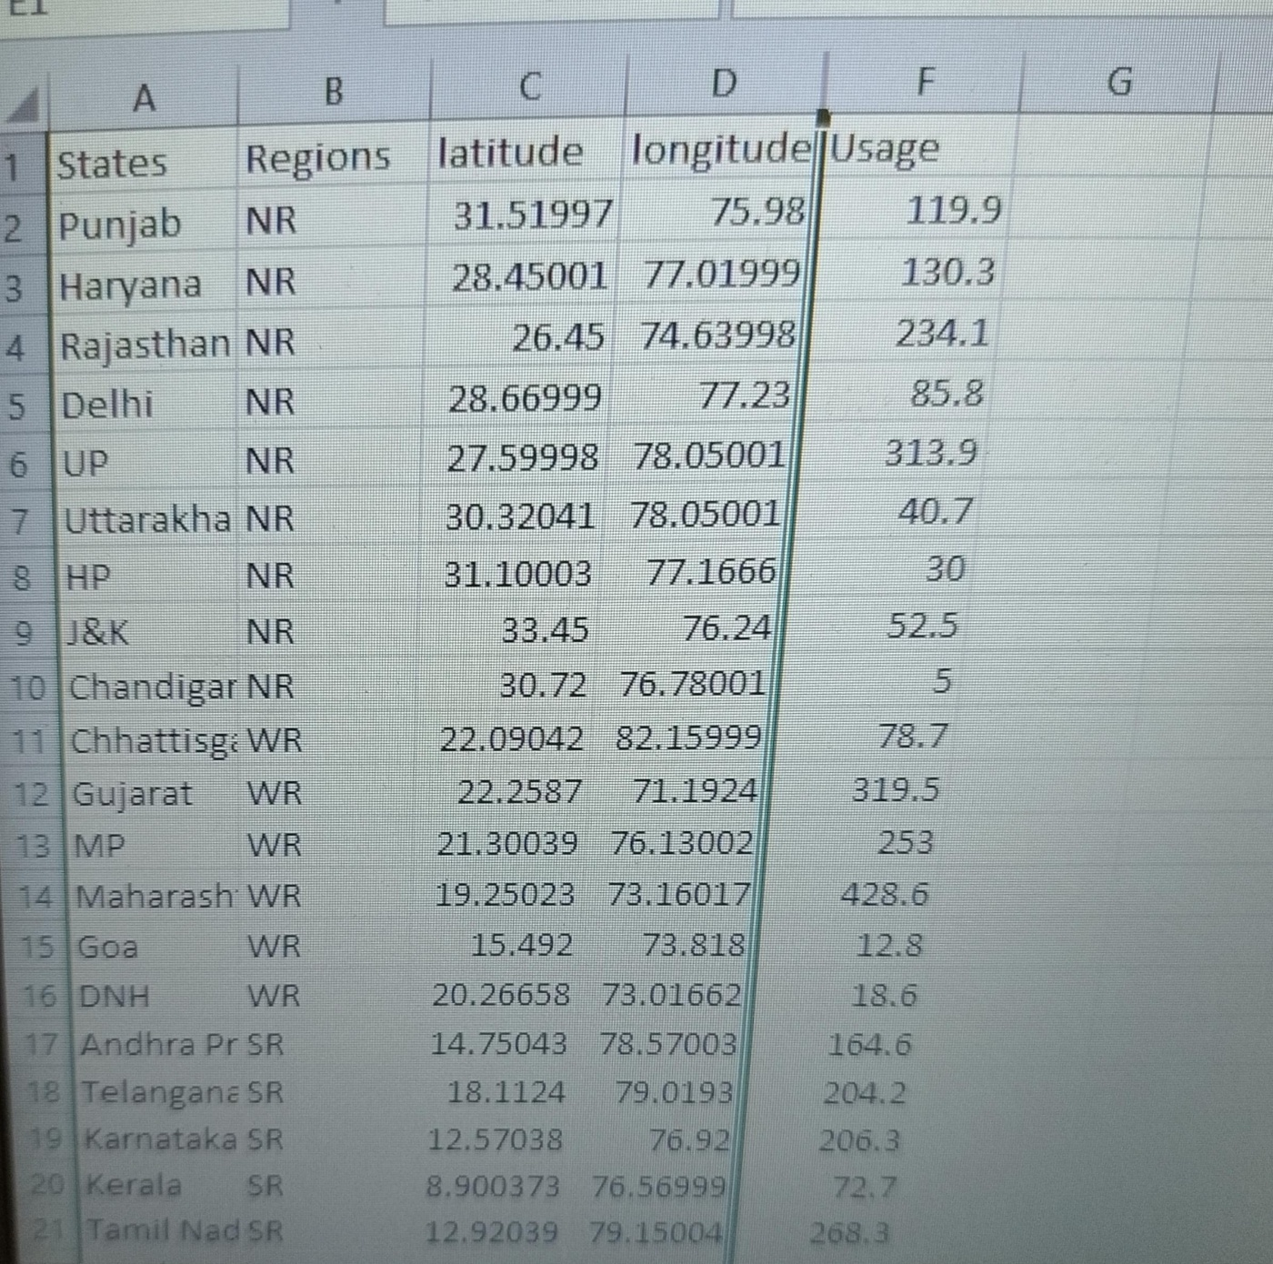

**Model for states and usage electricity**

Notice that the state and usage electricity are missing from the data.

For Age, we shall assume it is year 1999 as explain previously and use it to minus from the birth year.

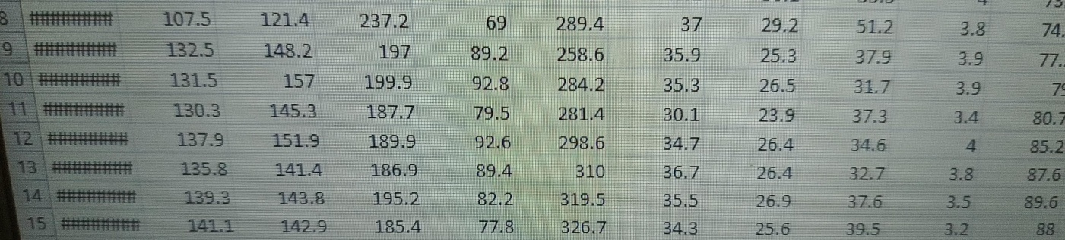

**Replacing values**

Set some fields to English for easy understanding, we replace values to English with the Power Query Editor.

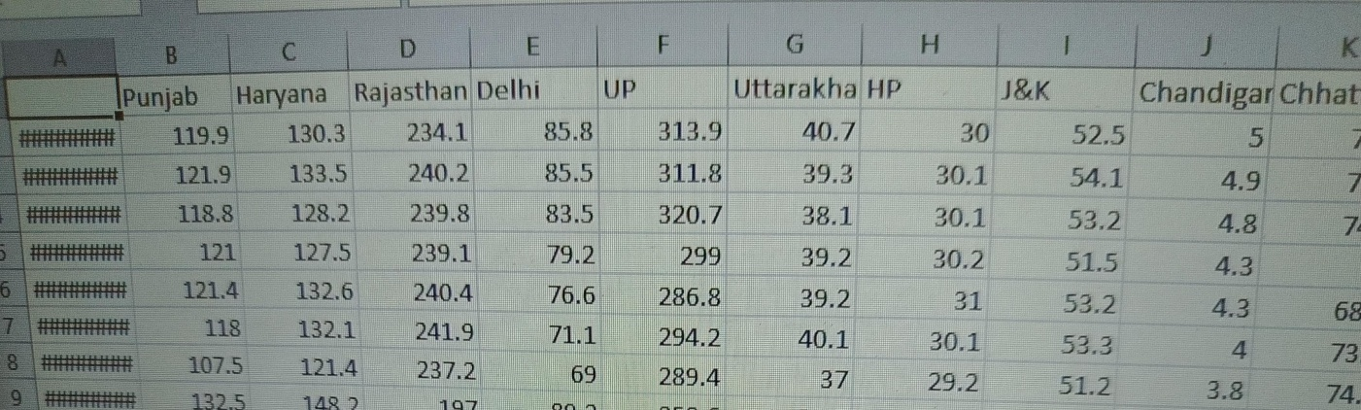

Changing the order of Region name at Power Query

Duplicate the “district /region” then split column using space as delimiter.

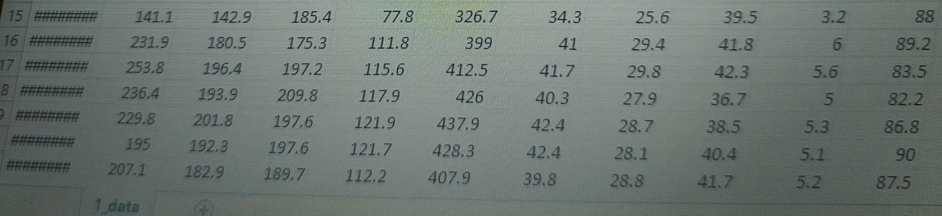

Then merge column by Region and direction. Refer to applied steps for details.

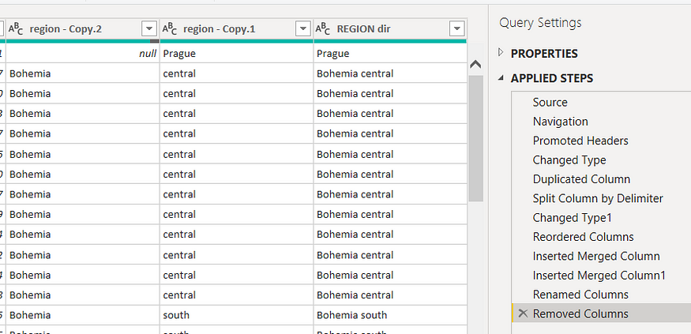

**Grouping of age by ranges**

As the customers’ age ranges from 12 to 88, we shall group them into different generation age range for easier profiling, we will group the ages into 5 groups.

The Gen Y are youths,

Gen X are young working adults, some starting their families

Baby Boomer are working adults with families.

The silent Generations some are working and retired, living on pensions.

The greatest Generation, retired elderly living on pensions.

**Credit Rating and Loan Status**

As the Loan status uses A, B, C, D which are not reader friendly. We can add a column to represent what it stands for, we also simplify the classification of those with late or default on payment as bad credit, refer to the table below for details on the new columns added.

Values of such as “account Id” have also been set as Text.

And District name have been categorized as place to be use for the map to show the sum of the inhabitants in each region.

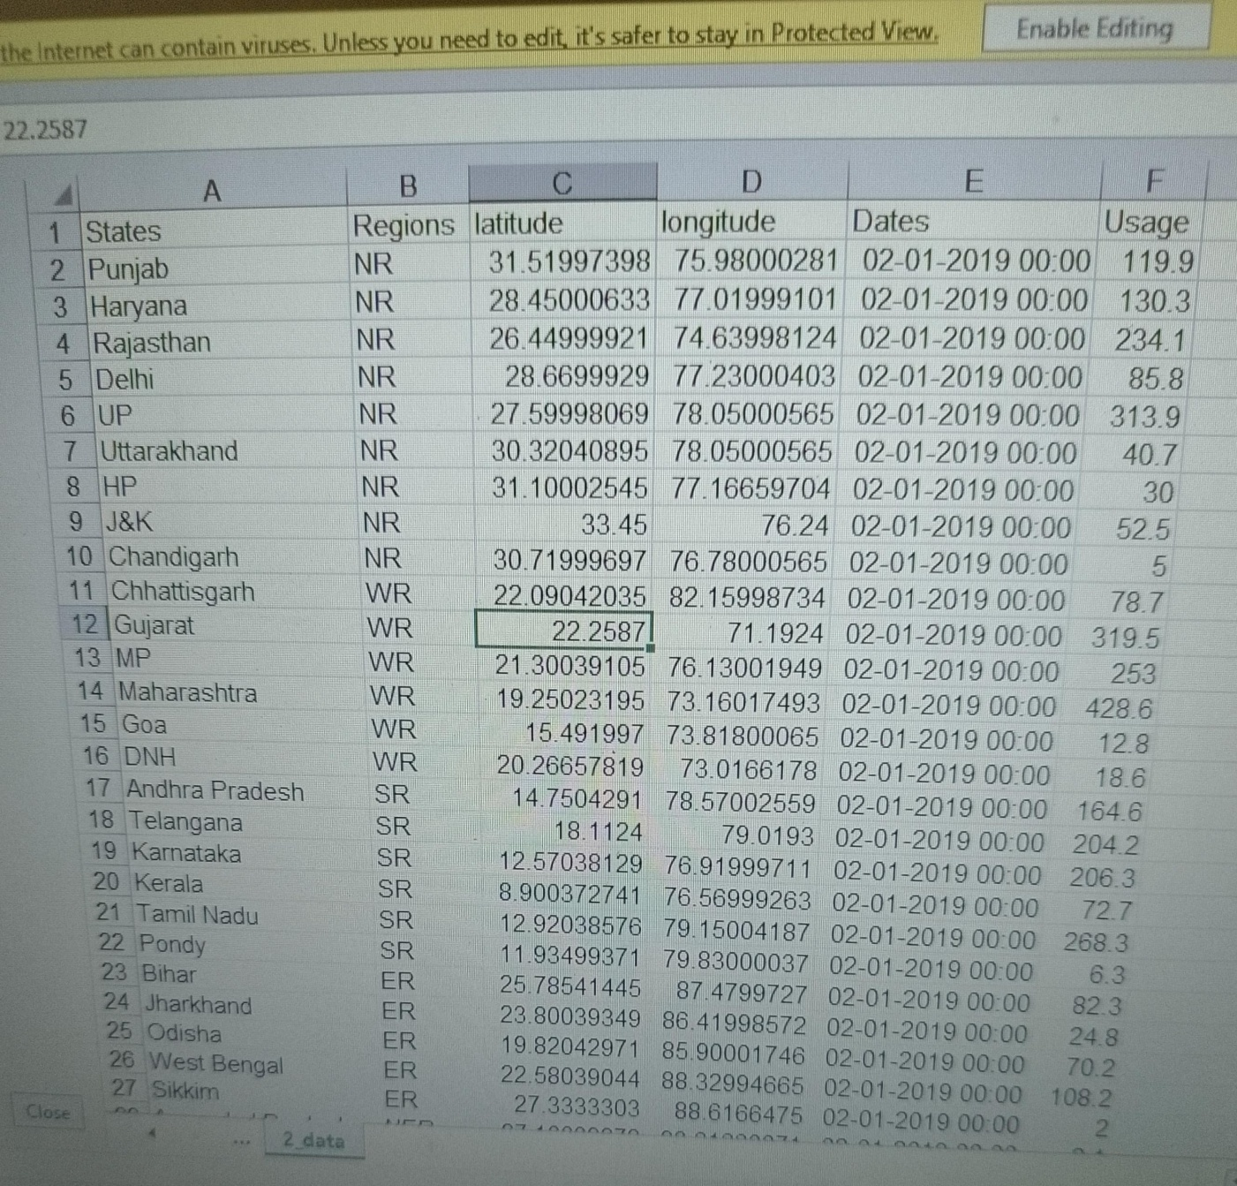

**Dashboard**

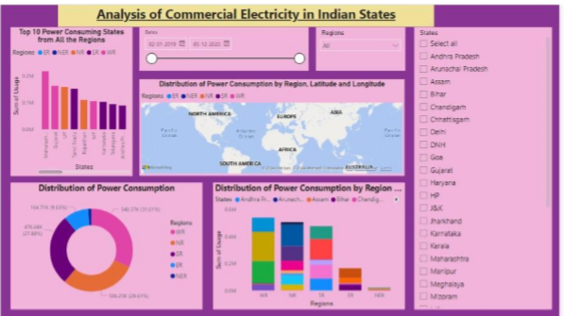

**CONCLUSION**

The project “Analysis of commercial electricity consumption in india” using PowerBI has successfully demonstrated the potential of data analytics in the banking sector. The analysis of commercial electricity data has provided valuable insights into customer behavior, preferences, and trends, thereby facilitating informed decision-making. The interactive dashboards and reports have offered a comprehensive view of customer data, enabling the identification of patterns and correlations. This has not only improved the efficiency of data analysis but also enhanced the bank’s ability to provide personalized services to its customers. The project has also highlighted the importance of data visualization in making complex data more understandable and accessible. The use of PowerBI has made it possible to present data in a visually appealing and easy-to-understand format, thereby aiding in better decision-making.

**FUTURE SCOPE**

The future scope of this project is vast. With the advent of advanced analytics and machine learning, PowerBI can be leveraged to predict future trends based on historical data. Integrating these predictive analytics into the project could enable the bank to anticipate customer needs and proactively offer solutions. Furthermore, PowerBI’s capability to integrate with various data sources opens up the possibility of incorporating more diverse datasets for a more holistic view of customers. As data privacy and security become increasingly important, future iterations of this project should focus on implementing robust data governance strategies. This would ensure the secure handling of sensitive customer data while complying with data protection regulations. Additionally, the project could explore the integration of real-time data streams to provide even more timely and relevant insights. This could potentially transform the way banks interact with their customers, leading to improved customer satisfaction and loyalty.

**REFERENCES**

[https://medium.com/analytics-vidhya/analysis-of--commercial - electricity -consumption-using-dashboard-in-power-bi-a366f2b3e563](https://medium.com/analytics-vidhya/analysis-of--commercial%20-%20electricity%20-consumption-using-dashboard-in-power-bi-a366f2b3e563)

**LINK**