**Abstract**

Here in this project, we are dealing with a complexity measuring tool, called by the name CDE IT Solution. We have developed a web application for this tool by considering its requirements. Those are size, method, variable, inheritance, coupling, and control structure.

The above-mentioned computer-based information system is an ideal solution for improving the tool standard than having a manual system. It will help to calculate the complexity by inserting or importing the code.

Although there are many complexity measure tools exists most of them do not have the ability to calculate the complexity when a folder structure containing a list of files is scanned and apart from that our solution shows the complex details of each and every line in all the files which will help the programmer to calculate the complexity of the program.

Here, the users have to login or signup to the website to calculate the complexity.

**Introduction**

Nowadays software development is the most important thing in modern society, there are many kinds of software’s help us to complete our day-to-day needs. In worldwide, there are many software development companies developed their software products and projects with millions of developers. Most of the companies scaled up with step by step. Also, a single software project will have many developers work on a single codebase in the software development lifecycle. We need mechanisms to check have any changes in the codebase and can be measured. Since codebase is not larger and not complex we can measure easily, but the codebase is very complex, and doing a full review it will be very time consuming and waste a lot of resources. If we use some kind of tool to analyze code, we can do it easily and we can save resources. That tool will go each line by line and identify the different elements, notations, standards and then measure the complexity of the code. Then we can compare code with before the changes and after the changes. But the problem is what kind of tool help us to solve this problem, how to measure the complexity of the code, how to choose perfect technology for the tool, and how to identify the different logics in the code. We trying to find a solution to this problem and found the most common technology previously used. “That technology called as Cyclomatic Complexity. It’s found by Thomas McCabe in 1976” [1]. It measures the number of linearly independent paths of the program. This model is only measured control complexity of program not the statement complexity furthermore it gives the same value for nested and non-nested loops. So we developed a new solution to overcome some of these drawbacks. So we introduced a new tool to measure different aspects of the code. The key concepts in our solution that made our solution a unique tool when compared to other products in the market. In our design we are finding total complexities as a result of the occurrence of following complexities such as complexity due to size, complexity due to variables, complexity due to methods, complexity due to inheritance, complexity due to coupling, complexity due to control structures and total complexity of a program. These calculations are very helpful for the developers to make decisions and comparisons.

**Description**

The group work in which I participated took place over this semester. The first week was spent in collaborating on a variety of group activities. The participants in these groups were all from the same group.

In order to tackle the task, we decided to separate it into smaller tasks according to the functions, dividing ourselves into three smaller groups and working on one target project. We decided to have meetings at the university once a week but because of the country’s situation we decided online video call.

The work progressed in this way for most of the week until on the last day, the group joined together for once a week for key sessions in the evening. At this time, we worked together to tell our progress of work, issues for which we had a 15-20 minute window. We also made use of this final discussion session to voice whether we agreed or disagreed with several assertions that had been raised through working on the project. This session went well in general and was successful. Overall, I experienced that all of the group members came to know each other on a personal level through working together over the semester to complete our tasks.

Complexity of a codebase is a measure of the quality of the code that the programmer writes it help to see vulnerabilities, duplication happen in code and help to reduce the redeclaration in a program. So, since it’s a very important aspect to every programmer to verify the code quality we have made it easy through our solution. [2]

**Gantt chart**

Gantt charts are line diagrams, with lines representing both time and activate. It can be used to estimate the number of resources required for a project. Where activates are a continuous chain with one activity able to follow immediately after the other, these can be drawn as a continuous line on the chart (Figure 1.0)

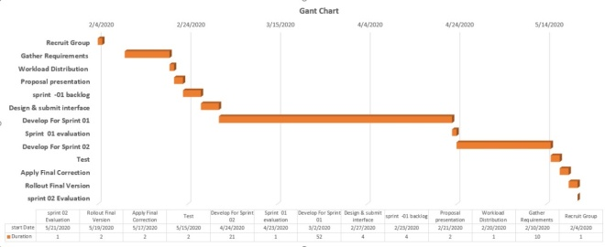

**Figure 1.0**

**Literature review**

**Proposed system**

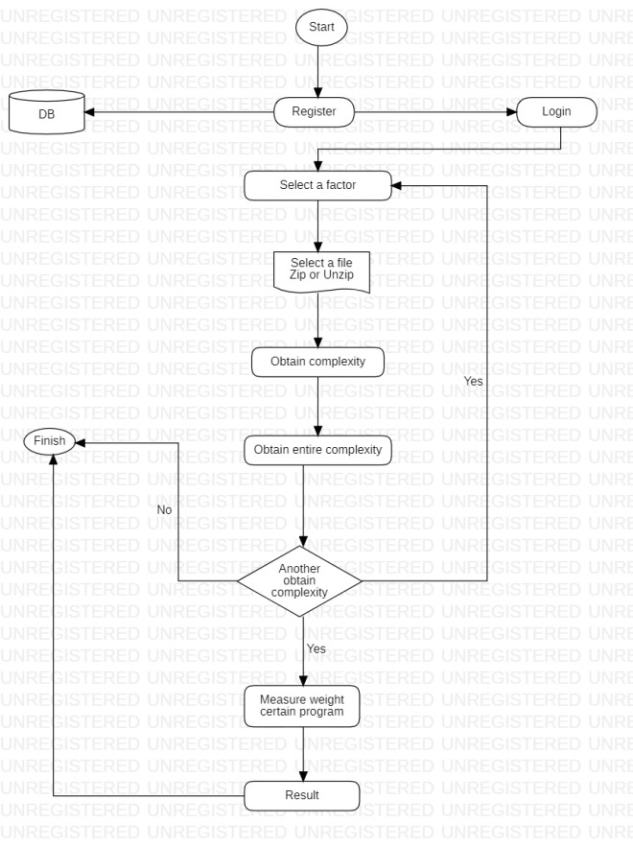

**Methodology**

**Implementation**

We used the Eclipse IDE for the implementation. The technology we used to develop the system is Java Fx. The implementation is done following the MVC architecture. MySQL workbench is used to implement the database of the system

**Requirements & Analysis**

According to the code complexity measuring tool requirements and analysis section is the most important to the user and same as the development team.

Because system must operate in correct way consider to the user’s requirements. So there are functional and non functional requirements. Code complexity measuring tool handled 6 functions.

**Functional requirements**

User can calculate the complexity due to size.

User can calculate the complexity due to variable.

User can calculate the complexity due to method.

User can calculate the complexity due to inheritance.

User can calculate the complexity due to coupling.

User can calculate the complexity due to control structure.

**Non-functional requirements**

User friendliness

Speed

Availability

Security

Reliability

Performance

Maintainability

Methodology is the systematic, theoretical analysis of the methods applied to a field of study (Figure 2.0).

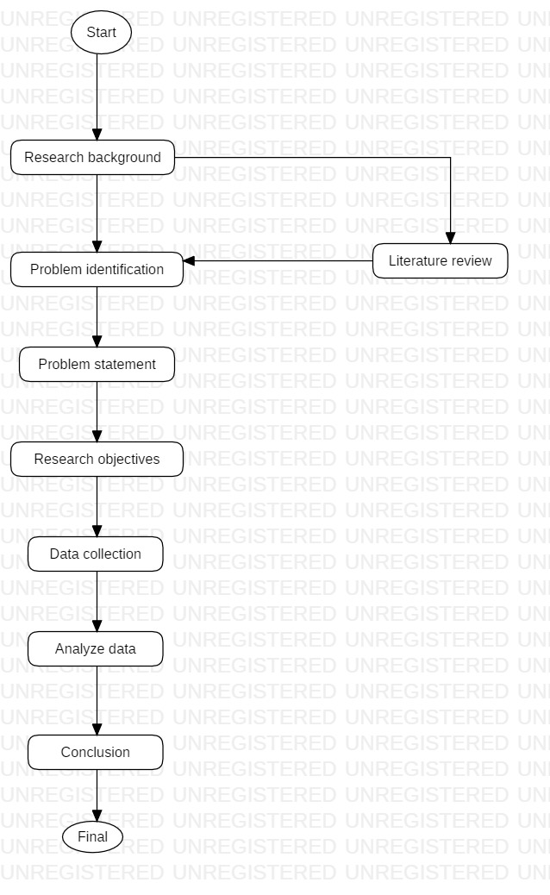

**Figure 2.0**

**Results and Discussion**

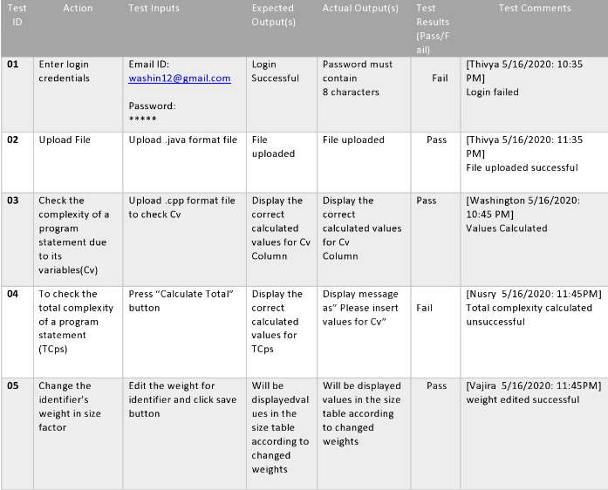

**Evaluation**

Overall, we found that the experience of group work was very useful in that it gave us the opportunity to learn a great deal about the topics being discussed as well as helping to illuminate our weaknesses when working with unfamiliar groups. The importance of experiential learning is that it entails organizing and developing learning through reflection on practical situations, such that they can lead to improved action. My experience of the group work has made this developmentally valuable reflection possible.

The tasks also gave me the opportunity to come into contact with a variety of people from different professional backgrounds. Working in a multi-professional group allowed us to benefit from a number of different perspectives on the task as well as a wide variety of knowledge and experience. This made our project much more well-rounded and multi-faceted. As the group work progressed, we also began to realize that we were in fact more than capable of fulfilling our parts and this gradual self-confidence enabled me to overcome the feelings of intimidation that being on unfamiliar territory had initially elicited within us. Towards the end of the project we began to wish that we could begin the session a second time to allow us to contribute more and be perceived as active members of the group. Looking back we would attribute our regrets regarding the group task to this inability to contribute more.

Initially we were somewhat skeptical about the idea of the group sessions as we did not appreciate that there was anything valuable to be learned from the collaborative process. However by the end of the process we had learned a great deal about the complexities of group work and the way in which people from different mindsets can complement the task by offering a much greater depth of experience. We also increased our knowledge of a number of topics to which we may never have exposed otherwise.

The group work also revealed that we rarely make a substantial contribution to group discussions or volunteer for leadership roles in group tasks, preferring instead of avoiding the limelight and allow other group members to take the lead.

**Ethical concerns**

The main ethical concern that we had when embarking on this group work exercise was to ensure that each member of the group, would be treated with respect and in a polite manner. As stated by Dubrin:

“Showing respect for team members is a general technique for building teamwork” [6]

Our experience of treating others with respect, for example by asking whether someone has managed to finish their part of the task rather than demanding that it be ready, certainly reinforced this theory as we were marked highly by our peers for facilitating communication and cohesion within the group

**Team Working**

According to the Belbin theory of team roles, we would assess ourselves occupying the roles of team worker, implementer, finisher, and coordinator [2]. The reason why we have divided roles as an implementer is based firstly on the fact that whose responsibility for carrying out the tasks as efficiently as possible [3]. The role of the finisher is most effectively used at the end of tasks to polish and scrutinize the work for errors [4]. Every team member’s responsibility to have the qualities of team workers like help the co-team member, using their versatility to identify the work required, and completes it on behalf of the team [5].

**Conclusion**

In conclusion we found the group work to be a very educational experience concerning the importance of being able to work well in a team. We have been alerted to aspects of our behavior and personality particularly with regards to interactions with unfamiliar people. The main aspect that we would like to improve is our confidence, which will enable us to contribute more of our ideas to group work. This will help us at university as well as in our future work as a professional software engineering. Overall the module helpful in focusing on each of the different areas of the experience in order to evaluate our strengths, such as good teamwork and carrying out tasks in a systematic way.

**Acknowledgement**

The success and outcome of this assignment required a lot of guidance and assistance from many people and we extremely fortunate to have got this all along with the completion of our assignment work. Whatever we have done is only due to such guidance and assistance and we would not forget to thank them. We respect and thank Mr.Dilshan De Silva for giving an opportunity to do this assignment work and providing us all support and guidance which made us complete the assignment on time, we are extremely grateful to her for providing such a nice support and guidance.

We are really grateful because we managed to complete this assignment within the time given by Mr.Dilshan De Silva. This assignment cannot be completed without the effort and co-operation from the group members. Group member’s Vajira, Washington, Nusry, and Thivyaroopy. Last but not least we would like to express our gratitude to our friends and respondents for support and willingness to spend some time with us.

**References**

[1] A Complexity Measure by Thomas McCabe<http://www.literateprogramming.com/mccabe.pdf> [Accessed 16 May 2020]

[2] What is code quality? How to measure and improve code quality <https://www.perforce.com/blog/sca/what-code-quality-and-how-improve-code-quality> [Accessed 16 May 2020]

[6] Dubrin, A.J., 2011. Essentials of management. Andover: Cengage Learning [Accessed 14 May 2020]

[2] Belbin, M., 2010. Management teams: why they succeed of fail. 3rd edition. Oxford: Butterworth-Heinemann [Accessed 15 May 2020]

[3][4][5] Belbin team roles <https://www.belbin.com/about/belbin-team-roles/> [Accessed 15 May 2020]