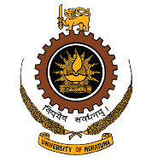**DEPARTMENT OF MECHANICAL ENGINEERING**

##### FACULTY OF ENGINEERING

Telephone: + 94-11-2650-301/534/441/671/340 University of Moratuwa + 94-11-2650621 (Direct Line) Katubedda,

Fax: + 94-11-2650622 Moratuwa,

Sri Lanka

Web url: <https://uom.lk/mech>

Email: head-[mech@uom.lk](mailto:mech@uom.lk) Date: