ZUSTAND

- In a react application, we need to manage state, an we can pass through props to child component But in a large scale application, this becomes a problem and we use context api for which we need wrap the component with provider which may lead to performance problems. Or we will go for Redux.
- Zustand is a library that allows global state management in React application.
- Store in zustand is a place where we store our state and the function that will update the state
- Every hook will start with ‘use’ including custom hooks. In zustand when we create a store, it is actually a custom hook, that we can use in react component without having to wrap anything in a provider and without having to pass any props
- 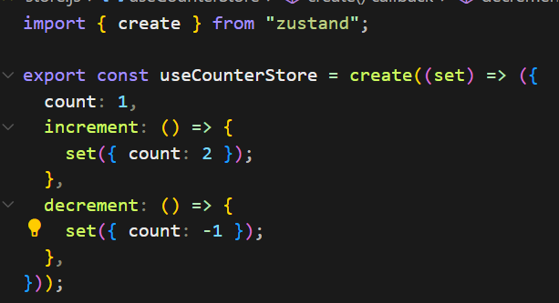
- Above, we gave increment and decrement functions.
- 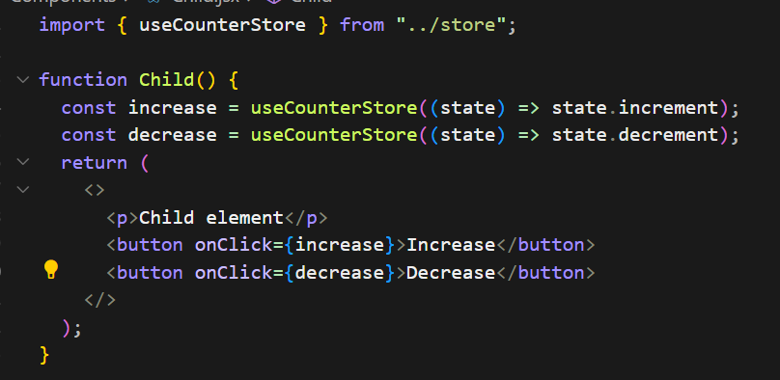
- Above, we r updating the value in child component. And the value is displayed in App component. So we can do all the action is any component
- 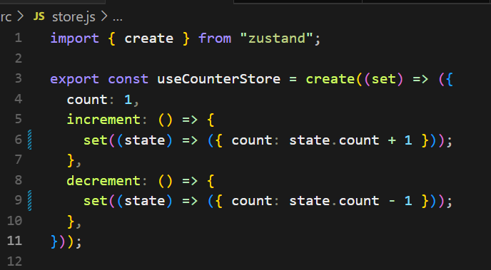
- Above, is synchronous, In reality, asynchronous oprtns will be there. We may call an api and we need to wait to get the response back and then we have to update the state.
- Lets say we don’t have api, in that case we will mock it by waiting for 1 or 2 sec

- Above, we don’t want to define the function inside the component

- Above, we wrote code to both getCount and setCount

- So, even if we want to access the state or to update the state, we don’t need to write every code inside the component, we can write it outside, and then we can use it in react component lifecycle. Coz it is integrated with the help of zustand

- 1. We wrote code in store to fetch and update state
2. We wrote code for async operations
3. We wrote code outside the component

- 1st best practice

- 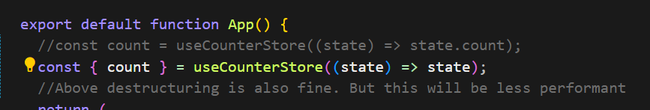

- Above, whatever we r returning, that only the App component will listen to

- 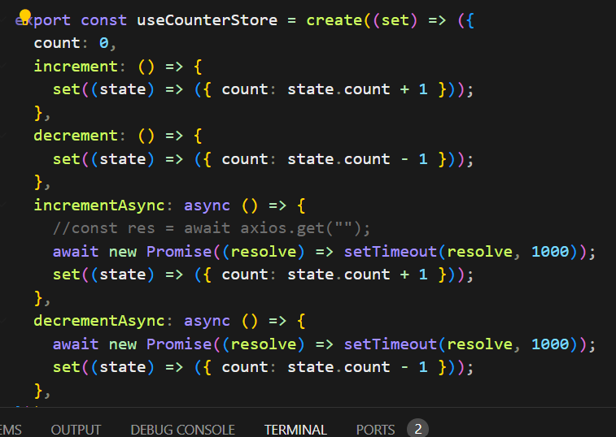

- Above, right now in our store we have only one state. But as soon as we have more variables, the component is going to rerender every time for any of those changes. So it is always better to access only what we need directly, instead of destructuring, and only render what is needed.

- 2nd best practice

- Whenever we r defining our stores, we always want to group them by specific features.

- 

- Above, this store has evenrything with respect to state and updating it and nothing else

- For example. If we want to add authentication, we would have to create our own store, and call it authstore and the give state related to authentication and the functions that will update the state

- We can write it in separate files, and all of the components that want to access the specific data, they can access by importing it.

