Heart Disease Risk Prediction
An End-to-End MLOps Pipeline
MLOps Assignment 01 — AIMLCZG523
Machine Learning Operations
Thiyagesh Dhandapani
GitHub: https://github.com/<your-username>/heart-disease-mlops

Table of Contents

1. Project Overview
This project builds and deploys a machine-learning system that predicts a patient's risk of heart disease from routine clinical measurements, and wraps that model in a complete, production-style MLOps lifecycle: reproducible data processing, tracked experimentation, automated testing, containerised serving, cloud-style deployment, and live monitoring.
The emphasis is not only on model accuracy but on the engineering discipline around it — the parts that make a model dependable in production: reproducibility, automation, observability, and clean rollback.

Problem statement
Given 13 clinical features (age, sex, chest-pain type, resting blood pressure, cholesterol, and others), classify whether a patient has heart disease. The trained model is exposed as a JSON REST API and deployed to a Kubernetes cluster with request monitoring.

Dataset
Heart Disease UCI dataset (Cleveland processed subset): 303 records, 13 features, and a binary target (presence/absence of heart disease). After cleaning, 302 records remain; the classes are mildly imbalanced (~54% positive).

2. System Architecture
The pipeline spans three lanes — development, CI/CD, and serving/operations — each feeding the next. Training produces a single serialised pipeline artifact that is baked into a Docker image; CI validates and rebuilds on every push; and the container is deployed to Kubernetes and monitored with Prometheus and Grafana.
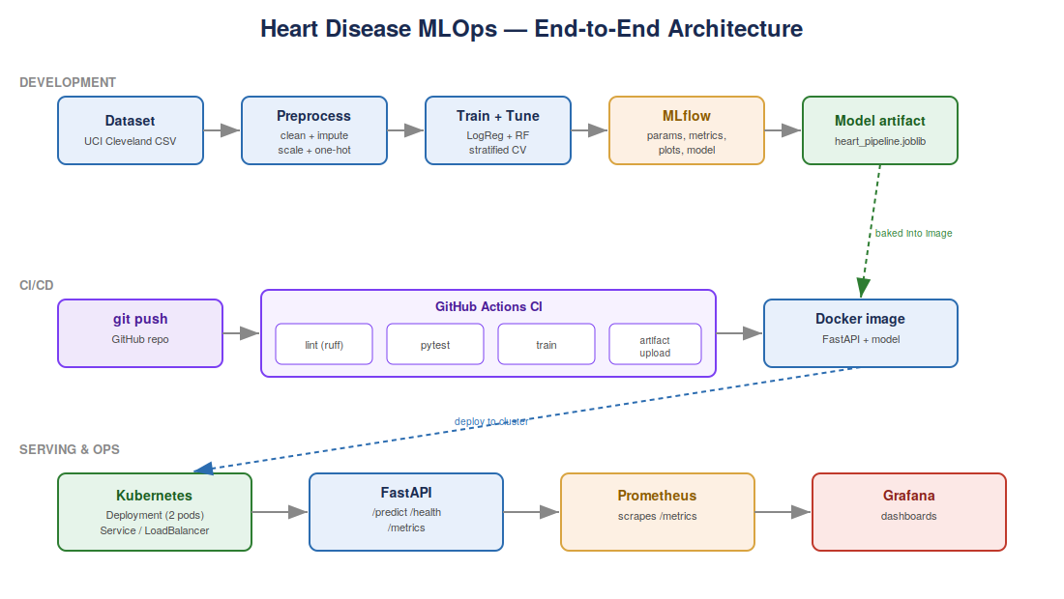
Figure 1. End-to-end MLOps architecture across development, CI/CD, and serving/ops.

3. Data Acquisition & Exploratory Data Analysis
Data is fetched by src/download_data.py, which targets the canonical UCI repository with a stable mirror fallback and writes data/heart_disease_raw.csv. Cleaning is deterministic and applied before any train/test split:
- Invalid encoding artifacts (ca == 4, thal == 0) are coerced to missing for later imputation.
- Exact duplicate rows are dropped (one found).
- Statistical imputation and scaling are deferred to the fitted pipeline so they are learned only from training folds — avoiding data leakage.

Class balance
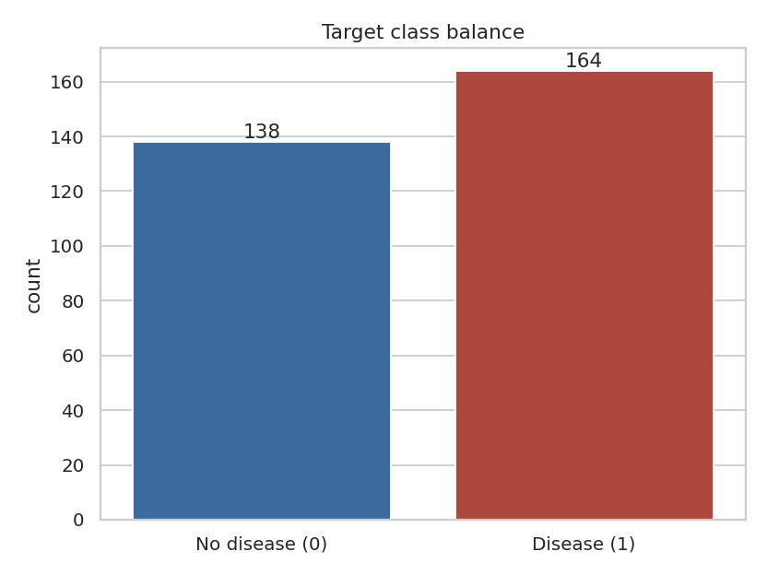
Figure 2. Target class distribution — mildly imbalanced (~54% positive).
Because the imbalance is mild, accuracy is not badly misleading, but precision, recall and ROC-AUC are still reported. In a clinical screening context, recall (catching true cases) is prioritised.

Feature distributions and correlations
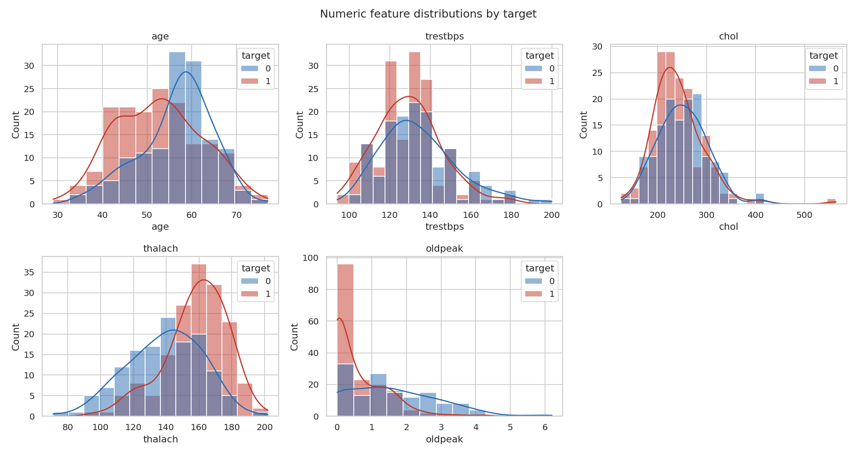
Figure 3. Numeric feature distributions split by target.
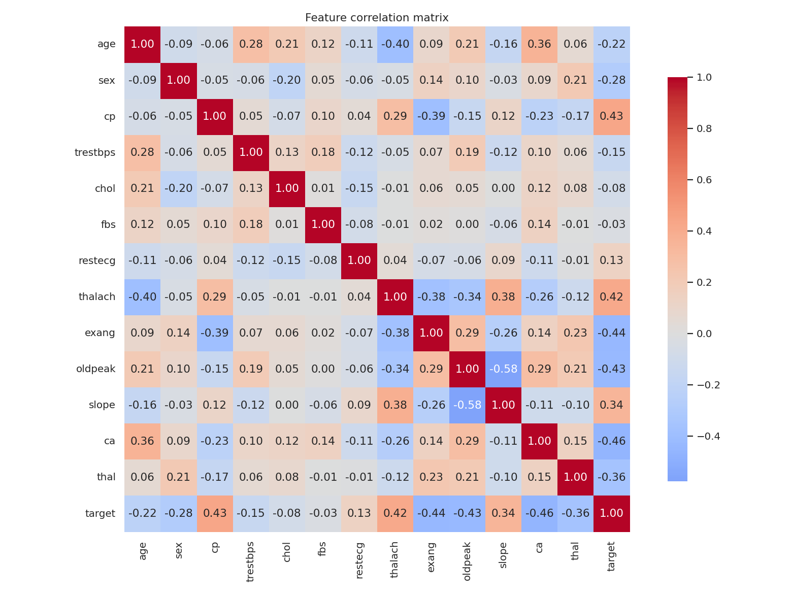
Figure 4. Feature correlation matrix. Strongest target associations: ca, exang, oldpeak, cp, thalach.

4. Feature Engineering & Model Development
Features are grouped and transformed inside a single scikit-learn ColumnTransformer, ensuring identical processing at train and inference time:
- Numeric (age, trestbps, chol, thalach, oldpeak): median imputation then standard scaling.
- Categorical (cp, restecg, slope, thal, ca): most-frequent imputation then one-hot encoding.
- Binary (sex, fbs, exang): passed through unchanged (already 0/1).
Two classifiers were trained and tuned with 5-fold stratified GridSearchCV, scored on ROC-AUC: Logistic Regression (a strong, interpretable linear baseline) and Random Forest (captures non-linear interactions).

Results
Model | Accuracy | Precision | Recall | F1 | ROC-AUC
Logistic Regression (selected) | 0.820 | 0.824 | 0.848 | 0.836 | 0.894
Random Forest | 0.770 | 0.744 | 0.879 | 0.806 | 0.893

Logistic Regression was selected on ROC-AUC and accuracy; its tuning independently chose class_weight='balanced', directly addressing the imbalance. Random Forest achieved higher recall (0.879), a defensible alternative when minimising missed cases matters most.
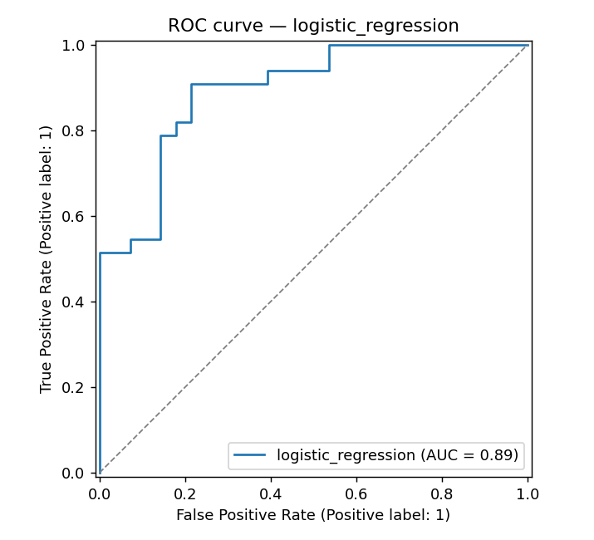
Figure 5. ROC curve for the selected Logistic Regression model.
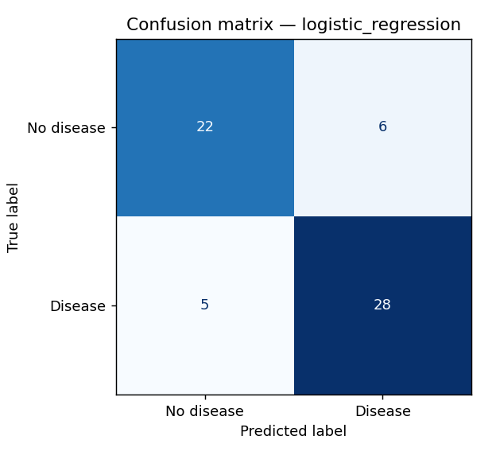
Figure 6. Confusion matrix (test set) for the selected model.

5. Experiment Tracking (MLflow)
Every training run is logged to MLflow (SQLite backend) with hyper-parameters, cross-validated and test metrics, the ROC curve, the confusion matrix, a classification report, and the serialised model. Runs are compared in the MLflow UI:
mlflow ui --backend-store-uri sqlite:///mlflow.db
[ SCREENSHOT: MLflow run comparison view (both runs, metrics columns) ]
[ SCREENSHOT: MLflow single-run page showing logged params, metrics, and artifacts ]

6. Model Packaging & Reproducibility
The winning pipeline (preprocessing + classifier in one object) is persisted to models/heart_pipeline.joblib, with a models/model_metadata.json sidecar recording the winner, metrics, best parameters, feature order, and cleaning notes. All dependencies are pinned in requirements.txt. Because the API imports this exact artifact, there is zero train/serve skew.

7. Model Serving API (FastAPI)
The model is served by a FastAPI application exposing:
- GET /health — liveness probe returning model metadata (used by Kubernetes).
- POST /predict — single-patient prediction returning label, probability, and confidence.
- POST /predict/batch — multiple patients in one request.
- GET /metrics — Prometheus metrics.
Input is validated with Pydantic (clinically sensible ranges), so malformed requests receive a clear 422 error. Interactive OpenAPI docs are available at /docs.
[ SCREENSHOT: Swagger /docs page showing the endpoints ]
[ SCREENSHOT: Successful POST /predict response (JSON with prediction + confidence) ]

8. Containerisation (Docker)
The service is packaged in a slim python:3.11 image that installs serving-only dependencies, runs as a non-root user, and defines a container HEALTHCHECK against /health. Build and run:
docker build -t heart-disease-api .
docker run -p 8000:8000 heart-disease-api
[ SCREENSHOT: docker build output (successful image build) ]
[ SCREENSHOT: docker run + curl /predict returning a prediction ]

9. CI/CD Pipeline (GitHub Actions)
On every push and pull request to main, the workflow runs: dependency install, ruff lint, dataset fetch, pytest (15 unit tests across preprocessing, the model artifact, and the API), a model-training smoke run, and artifact upload. The pipeline fails loudly on any lint or test error, satisfying the production-readiness requirement.
[ SCREENSHOT: GitHub Actions run: all steps green (lint, test, train) ]
[ SCREENSHOT: pytest output showing 15 passed ]

10. Production Deployment (Kubernetes)
The container is deployed to a local Kubernetes cluster (Minikube) using manifests in k8s/: a Deployment (2 replicas, readiness/liveness probes on /health, resource requests/limits) and a LoadBalancer Service. Deploy with:
minikube image load heart-disease-api:latest
kubectl apply -f k8s/
minikube service heart-disease-api
[ SCREENSHOT: kubectl get pods/svc showing running pods and the service ]
[ SCREENSHOT: Prediction against the deployed cluster endpoint ]

11. Monitoring & Logging
The API emits structured request logs and Prometheus metrics (request counts, latency histograms, response sizes per endpoint) at /metrics. A docker-compose stack brings up the API, Prometheus (scraping /metrics), and Grafana (auto-provisioned Prometheus datasource) together:
docker compose up --build
[ SCREENSHOT: Prometheus targets page showing the API target UP ]
[ SCREENSHOT: Grafana dashboard with request-rate / latency panels ]

12. How to Run (Quick Reference)
Step | Command
Install | pip install -r requirements.txt
Get data | python src/download_data.py
EDA | jupyter notebook notebooks/01_eda.ipynb
Train | python src/train.py
Track | mlflow ui --backend-store-uri sqlite:///mlflow.db
Serve | uvicorn src.api:app --port 8000
Test | pytest tests/
Docker | docker build -t heart-disease-api . && docker run -p 8000:8000 heart-disease-api
Monitor | docker compose up --build
Deploy | kubectl apply -f k8s/

13. Conclusion
The delivered system demonstrates a complete MLOps lifecycle: from a reproducible data pipeline and tracked experimentation, through automated testing and containerised serving, to Kubernetes deployment and live monitoring. The selected Logistic Regression model achieves 0.89 ROC-AUC with balanced precision and recall, and the surrounding engineering ensures the model can be retrained, validated, deployed, and observed reliably.

Repository
https://github.com/<your-username>/heart-disease-mlops

