Executive Summary
Sunrise Dental Clinic currently relies on paper files and notebooks to manage appointments, patient details, treatment records and billing. The assessment brief identifies double bookings, lost records, long waiting times and billing errors as the main operational problems. The proposed solution is a computerized appointment and patient management system implemented using Java, a web-based interface, REST web services and a relational database. The system provides secure login, new appointment registration, appointment search, patient and appointment viewing, automated billing, receipt printing, staff guidance and safe exit. The design also introduces additional reports to support clinic management.
The proposed system follows a three-tier architecture consisting of a presentation tier, application/service tier and data tier. A REST API separates the client from the business logic and database, satisfying the requirement for a distributed application with web services. Object-oriented principles are applied through domain classes, encapsulation, interfaces and separation of responsibilities. The design uses the Service Layer, Repository and Factory-oriented approaches, with dependency injection used to reduce coupling. Input validation and centralized exception handling are included to prevent invalid or inconsistent data.
Testing is designed around test-driven development (TDD). Unit tests verify billing calculations, appointment conflict detection, authentication and validation, while integration tests verify service-to-database interactions and API tests verify important endpoints. The report also defines representative test data, expected results and acceptance criteria. Git and GitHub are proposed for version control, with feature branches, meaningful commits, pull requests and a GitHub Actions workflow for automated build and test execution. This approach supports traceability from requirements through design, implementation and testing.

1. Introduction
The assessment scenario describes a busy private dental centre in Colombo that needs to replace manual appointment and patient record handling with a computerized system. The brief requires an interactive application, validation mechanisms, suitable reports, a proper database, web services, appropriate design patterns, UML documentation, automated testing, test-driven development, Git/GitHub version control and a documented workflow. It also specifies Java as the programming language and a target report length of approximately 4,000 words.
The purpose of this project is therefore not simply to digitize a paper appointment book. The system must address the underlying operational problems by preventing duplicate appointments, making patient information searchable, reducing manual billing calculations and providing reliable records. The design should also be maintainable so that future features such as SMS reminders, online patient registration or integration with payment services can be added without rewriting the whole application.
The report presents the analysis and proposed implementation of the system, including requirements, assumptions, UML diagrams, architecture, database design, design patterns, validation, testing, security, GitHub workflow, critical evaluation and traceability.

2. Problem Analysis and Requirements
The existing manual process creates several risks. Paper records can be misplaced, handwriting can be difficult to interpret, and staff may not know whether an appointment slot has already been allocated. Billing calculations performed manually may also result in arithmetic errors or inconsistent fees. These problems become more significant as the number of patients increases. A centralized database and controlled application workflow provide a more reliable alternative.

2.1 Functional Requirements
ID | Requirement | Description
FR1 | User authentication | The system shall require a username and password and allow only authorized staff to access protected functions.
FR2 | Register appointment | Staff shall create a unique appointment number and record patient, dentist, treatment, date and time information.
FR3 | Validate input | The system shall reject missing, malformed or invalid values and display understandable messages.
FR4 | Prevent double booking | The system shall check whether the selected dentist already has an appointment at the requested date/time.
FR5 | Search appointment | Staff shall search by appointment number and retrieve the associated patient and appointment details.
FR6 | Calculate bill | The system shall calculate treatment cost plus consultation fee and display the total.
FR7 | Print receipt | The system shall generate a printable patient receipt.
FR8 | Reports | The system shall provide useful operational reports such as daily appointments, treatment revenue and dentist workload.
FR9 | Help | The system shall provide step-by-step instructions for new staff.
FR10 | Exit/logout | The system shall provide a safe logout/exit operation.

2.2 Non-Functional Requirements
- Security: credentials and protected functions must not be exposed to unauthorized users.
- Usability: forms should use clear labels, validation messages and a consistent navigation structure.
- Performance: appointment searches and normal CRUD operations should return within an acceptable interactive response time.
- Reliability: database transactions should preserve appointment and billing consistency.
- Maintainability: business logic should be separated from UI and persistence code.
- Scalability: REST services and a relational database should allow the clinic to add users, dentists and patients without redesigning the entire system.
- Testability: business rules should be isolated so that automated unit tests can be executed without relying on the user interface.

2.3 Assumptions
- Each appointment belongs to one patient and one dentist, while a patient may have many appointments.
- An appointment number is unique and generated by the application rather than manually entered.
- A dentist cannot have two active appointments at the same date and time.
- Treatment prices are maintained in a treatment catalogue. The consultation fee is configurable.
- Only authenticated clinic staff can create, search or bill appointments.
- An administrator can manage staff accounts and treatment prices; ordinary staff can perform day-to-day appointment and billing operations.
- Patient records are retained in the database and are not deleted merely because an appointment is cancelled.
- Printing means generating a printer-friendly receipt; physical printer configuration is outside the core business logic.

3. System Design and UML
The UML design translates the requirements into actors, use cases, classes and interactions. The design deliberately separates user interaction from business rules and data persistence. This supports the assessment criterion requiring clear object-oriented design, access modifiers, relationships, multiplicity, navigability and appropriate use of UML notation.

3.1 Use Case Diagram
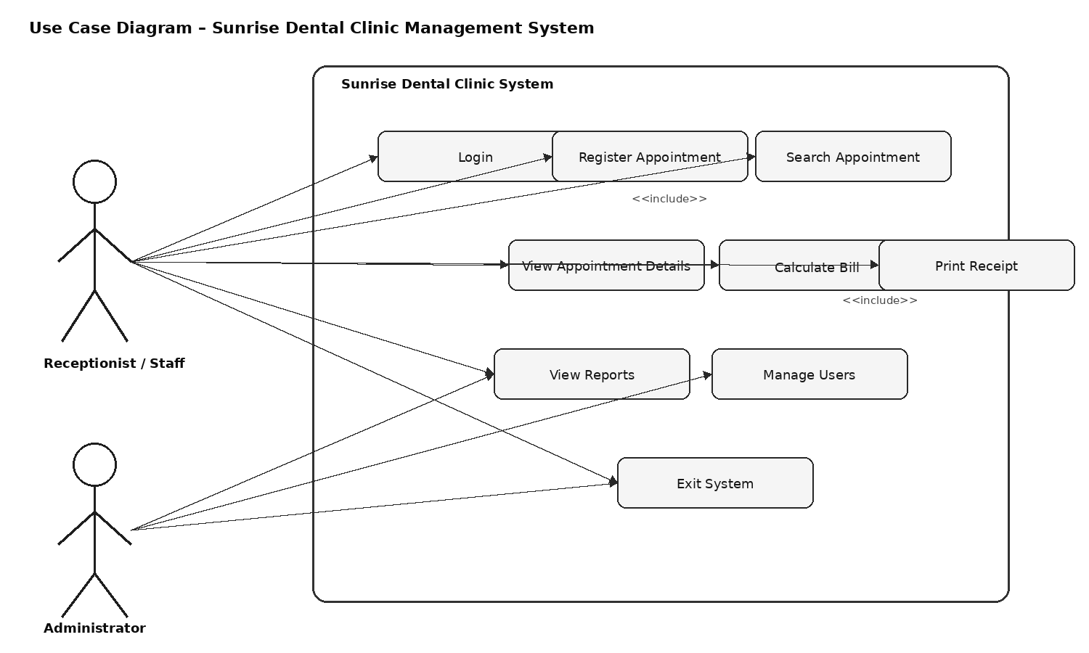
Figure 1: Use Case Diagram
The primary actor is the Receptionist/Staff user because day-to-day appointment registration, searching and billing are operational activities. The Administrator is a specialized user with additional access to reports and user management. Login is treated as a prerequisite for protected functions. The register appointment use case includes input validation and appointment-conflict checking because these activities must occur as part of a valid registration. Printing a receipt is included in the billing workflow because the total must be calculated before the receipt is produced.

3.2 Class Diagram
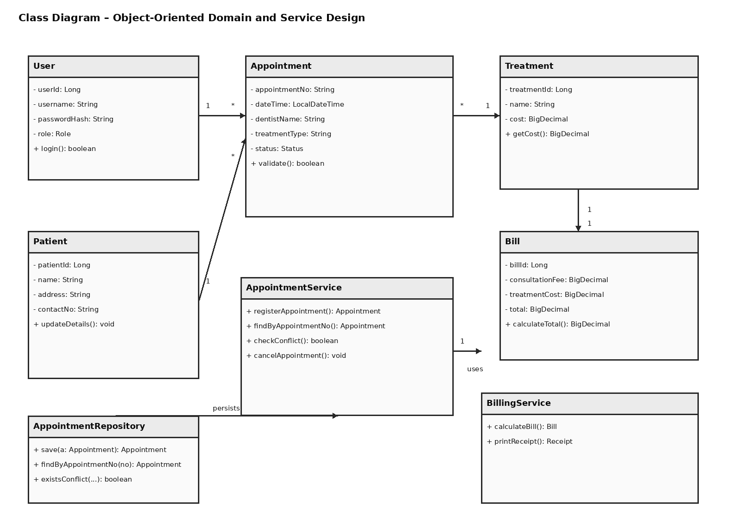
Figure 2: Class Diagram
The class diagram separates domain entities from service and persistence responsibilities. Patient, Appointment, Treatment, Bill and User represent important business concepts. AppointmentService contains appointment-related business rules, while BillingService contains billing logic. AppointmentRepository abstracts database operations. Private fields are used to preserve encapsulation and public methods provide controlled access. The one-to-many relationship between Patient and Appointment reflects the realistic case where a patient can attend the clinic many times.

3.3 Sequence Diagram
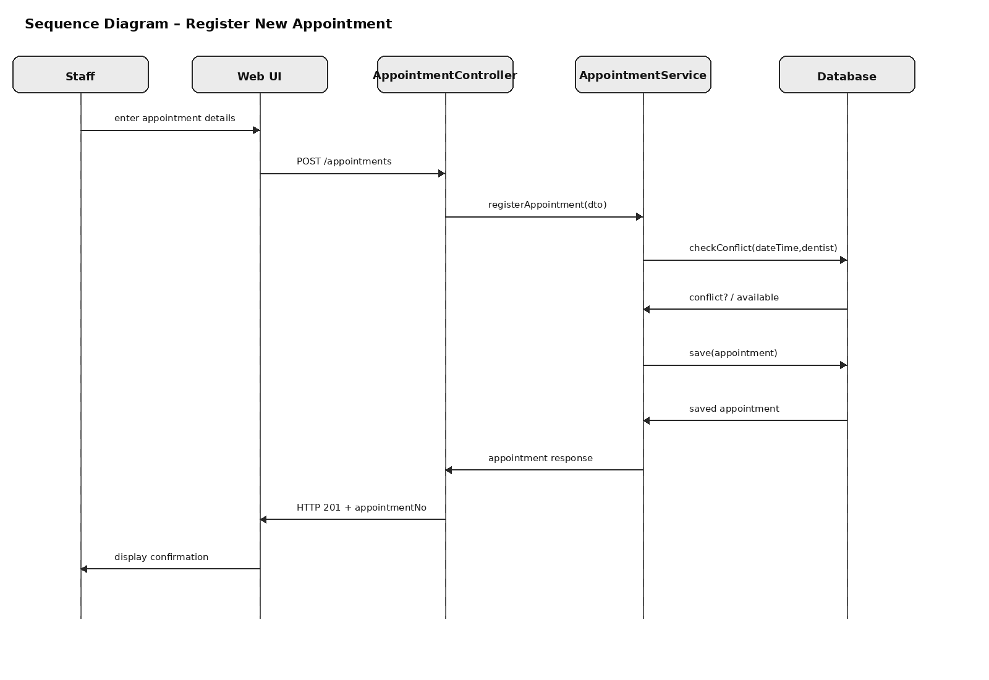
Figure 3: Sequence Diagram – Register New Appointment
The sequence begins when staff enters appointment details. The web interface sends a POST request to the controller, which passes the validated request to the service layer. The service checks for scheduling conflicts before saving the appointment through the repository. A successful response returns the generated appointment number to the user interface. This sequence demonstrates lifelines, messages and object responsibilities and provides a direct bridge between the use case and implementation.

3.4 Three-Tier Architecture
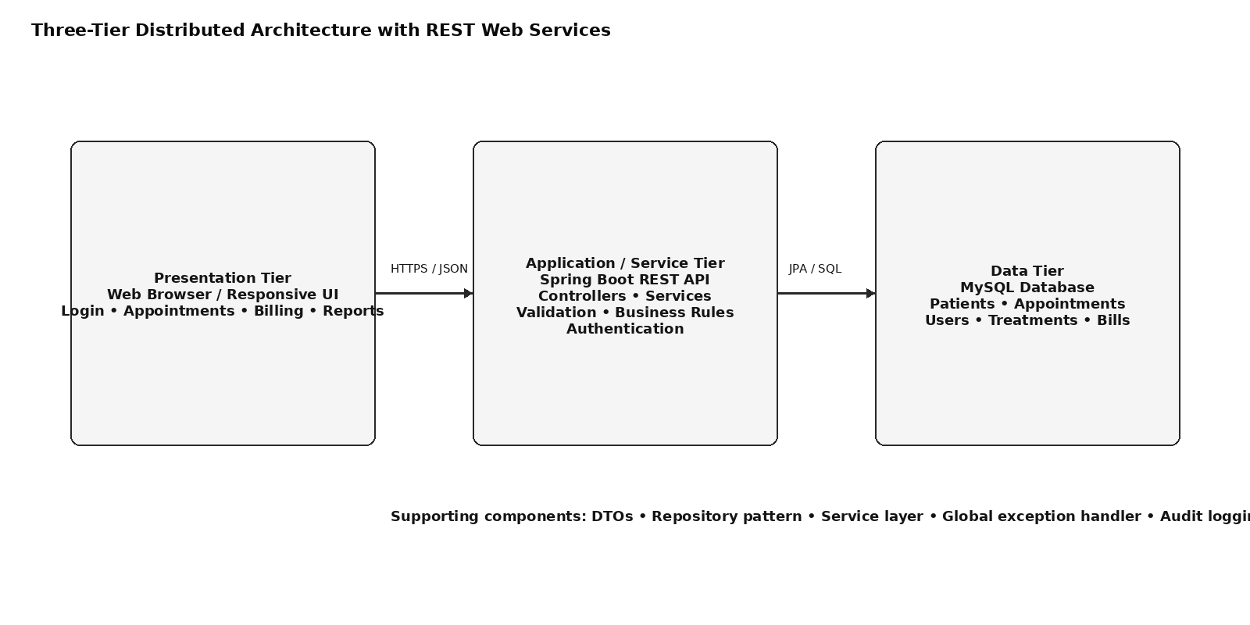
Figure 4: Proposed Distributed Three-Tier Architecture
The presentation tier communicates with the application tier through HTTPS and JSON REST requests. The application tier contains controllers, validation, services, authentication and business rules. The data tier contains the relational database. This architecture meets the requirement that the program be a distributed application with web services while keeping database access away from the presentation layer.

4. Database Design
A relational database is appropriate because appointments, patients, treatments, users and bills have structured relationships and require transaction consistency. The proposed schema is normalized to reduce unnecessary duplication.
Table | Important attributes | Purpose
users | user_id, username, password_hash, role, active | Stores authorized staff accounts.
patients | patient_id, name, address, contact_no | Stores reusable patient information.
dentists | dentist_id, name, specialization | Stores dentist information.
treatments | treatment_id, name, base_cost | Stores the treatment catalogue.
appointments | appointment_no, patient_id, dentist_id, treatment_id, appointment_datetime, status | Stores each patient visit.
bills | bill_id, appointment_no, consultation_fee, treatment_cost, total, issued_at | Stores billing information.
audit_log | log_id, user_id, action, entity, entity_id, created_at | Supports traceability of sensitive operations.
Primary keys uniquely identify records. Foreign keys connect appointments to patients, dentists and treatments, and connect bills to appointments. A unique constraint is recommended for appointment_no. A database-level conflict rule or transactional service check should also be used so that two concurrent requests cannot create the same dentist/time slot. The application should use parameterized queries or JPA rather than string concatenation to reduce injection risk.

5. Technology Stack and Implementation
The proposed implementation uses Java with Spring Boot for the web-service layer, a relational database such as MySQL, JPA/Hibernate for persistence, HTML/CSS/JavaScript or a lightweight web client for the interface, Maven for dependency and build management, JUnit 5 for automated testing and Git/GitHub for source control. Spring MVC supports REST controllers that map HTTP requests to Java methods, making it suitable for the distributed web-service requirement (Spring, 2026).
The application can be organized into packages such as controller, service, repository, entity, dto, security, exception and configuration. DTOs prevent the web layer from directly exposing database entities. The service layer contains business rules such as conflict detection and bill calculation. Repositories handle persistence. A global exception handler converts validation and business exceptions into consistent HTTP responses.
A representative REST interface is shown below.
Method | Endpoint | Purpose
POST | /api/auth/login | Authenticate a staff user.
POST | /api/appointments | Register a new appointment.
GET | /api/appointments/{appointmentNo} | Retrieve appointment details.
GET | /api/appointments?date=YYYY-MM-DD | List daily appointments.
POST | /api/bills/{appointmentNo} | Calculate and create a bill.
GET | /api/bills/{appointmentNo}/receipt | Return a printable receipt.
GET | /api/reports/daily | Return daily operational statistics.
POST | /api/users | Create a staff account; administrator only.

5.1 Design Patterns
Pattern / technique | Application and benefit
Service Layer | Encapsulates application business rules such as conflict checking and bill calculation. It prevents controllers from becoming large collections of business logic.
Repository | Provides an abstraction over database access. AppointmentService can depend on an interface instead of knowing SQL or database-specific details.
DTO | Transfers only required request/response data between the web client and application layer, reducing coupling and accidental exposure of sensitive entity fields.
Factory-oriented creation | A small factory can select receipt formatting or notification implementation without changing billing logic. This is useful if the clinic later supports PDF, thermal-printer or email receipts.
Dependency Injection | Dependencies are provided to classes rather than constructed internally. This supports loose coupling and easier unit testing.
The most important patterns are Service Layer and Repository because they directly support separation of concerns and testability. The impact is positive for maintainability, although excessive abstraction can make a small system unnecessarily complex. Therefore, patterns are used only where they solve a real design problem rather than being added for appearance.

5.2 Validation and Error Handling
- Appointment number: generated by the system and checked for uniqueness.
- Patient name: required, trimmed and restricted to a sensible maximum length.
- Address: required for registration and length-limited.
- Contact number: required and checked against an agreed Sri Lankan telephone-number format.
- Dentist: required and must refer to an active dentist record.
- Treatment: required and must exist in the treatment catalogue.
- Appointment date/time: required and cannot be invalid or in a prohibited past period.
- Double booking: rejected if an active appointment already exists for the same dentist and time.
- Login failure: a generic message is displayed rather than revealing whether a username exists.
- Database errors: handled centrally and logged without exposing internal stack traces to users.
These controls address the brief's requirement for proper validation mechanisms. Authentication and authorization are deliberately separated: authentication verifies identity, while authorization determines what an authenticated user is permitted to do. This distinction is recommended by OWASP (OWASP, 2026). Passwords should be stored as strong password hashes rather than plain text, and authenticated traffic should use TLS.

6. User Interface and Help Section
The interface should be menu-driven and consistent. The first screen is the login form. After successful authentication, the dashboard provides navigation to Register Appointment, Search Appointment, Billing, Reports, Help and Logout. Each screen should show the current user and provide a clear way to return to the dashboard.

6.1 New Appointment Workflow
- 1. Log in using an authorized staff account.
- 2. Select Register Appointment.
- 3. Enter patient details or select an existing patient where supported.
- 4. Select dentist and treatment.
- 5. Choose appointment date and time.
- 6. Submit the form.
- 7. The system validates all values and checks for an existing appointment conflict.
- 8. If valid, the appointment is saved and a unique appointment number is displayed.
- 9. Give the appointment number to the patient and return to the dashboard.

6.2 Search and Billing Workflow
- 1. Select Search Appointment and enter the appointment number.
- 2. The system retrieves and displays patient, dentist, treatment and appointment information.
- 3. Select Calculate Bill.
- 4. The system obtains the treatment cost and adds the configured consultation fee.
- 5. Review the total and select Print Receipt.
- 6. The receipt displays the clinic name, appointment number, patient, treatment, fees, total and date/time.

6.3 Help and Error Messages
Messages should be specific enough to help staff correct an error. Examples include “Contact number is required”, “Appointment time is already booked for this dentist”, “Appointment number was not found” and “Login failed. Please check your credentials.” Success messages should confirm the action without displaying sensitive information.

7. Reports and Decision Support
The assessment permits additional functionality where it adds value. Three management reports are proposed.
Report | Contents | Management value
Daily Appointment Report | Appointment number, patient, dentist, treatment, time and status | Helps reception staff manage the daily schedule and identify gaps.
Treatment Revenue Report | Treatment type, quantity, treatment revenue, consultation revenue and total | Supports financial monitoring and identifies high-demand treatments.
Dentist Workload Report | Dentist, number of appointments, completed appointments, cancelled appointments and utilization | Supports staff planning and workload balancing.
Reports should be filterable by date range and should be generated from the database rather than manually compiled. The system can later add CSV/PDF export and dashboard charts.

8. Testing Strategy and Test-Driven Development
Testing is a major part of the assessment. The recommended approach is test-driven development (TDD), where a failing test is written before the implementation is completed, the minimum code is implemented to make the test pass, and then the code is refactored while keeping the tests green. JUnit 5 provides a standard platform for writing and executing Java tests (JUnit Team, 2026).

8.1 Test Levels
- Unit testing: verifies isolated business rules such as bill totals, validation and conflict detection.
- Integration testing: verifies services and repositories against a test database.
- API testing: verifies HTTP status codes, request validation and JSON responses.
- System testing: verifies complete workflows such as login → appointment registration → search → bill → receipt.
- Regression testing: reruns automated tests after changes to ensure existing behaviour remains correct.

8.2 Test Plan
ID | Scenario | Test data | Expected result | Acceptance criterion
TC01 | Valid login | staff01 / correct password | Dashboard shown | Pass when authenticated user reaches dashboard
TC02 | Invalid login | staff01 / wrong password | Generic authentication error | Pass when access is denied without user enumeration
TC03 | Valid appointment | Complete valid patient, dentist, treatment and slot | Appointment created with unique number | Pass when record persists
TC04 | Missing patient name | Blank name | Validation message | Pass when no record is saved
TC05 | Invalid contact | Alphabetic/invalid number | Validation message | Pass when request is rejected
TC06 | Double booking | Same dentist/date/time as active appointment | Conflict message | Pass when second appointment is not saved
TC07 | Appointment search | Existing appointment number | Complete details returned | Pass when correct record is displayed
TC08 | Unknown appointment | Non-existent number | Not-found message | Pass when 404/appropriate error is returned
TC09 | Bill calculation | Treatment cost 5,000 + consultation 1,000 | Total 6,000 | Pass when arithmetic is correct
TC10 | Receipt | Valid billed appointment | Printable receipt | Pass when required receipt fields appear
TC11 | Authorization | Staff attempts user management | Access denied | Pass when administrator-only operation is blocked
TC12 | Logout | Authenticated user selects logout | Session invalidated/login shown | Pass when protected endpoint cannot be accessed afterward

8.3 TDD Example – Bill Calculation
A representative TDD cycle is: (1) write a test expecting treatment cost 5,000 and consultation fee 1,000 to produce 6,000; (2) run the test and observe failure; (3) implement calculateTotal(); (4) rerun and obtain a pass; (5) refactor if required; and (6) repeat for zero values, decimal values and invalid negative charges. This approach keeps the calculation rule executable as a regression test.
Test automation should be run through Maven locally and through GitHub Actions on every push or pull request. GitHub describes Actions as a CI/CD platform capable of automating build, test and deployment workflows (GitHub, 2026).

8.4 Test Evidence Requirement
The assessment specifically expects evidence that tests were carried out and that the code passes. The student should therefore insert screenshots from the actual project showing the JUnit test suite, successful test execution, application screens and relevant validation results. This report does not fabricate those screenshots because they must represent the student's real implementation.

9. Git, GitHub and CI/CD Workflow
Version control is required by the assessment and should demonstrate more than uploading a single final project. The recommended repository should be public if permitted by the institution and should contain the source code, README, database setup instructions, test results and this report or a report link.

9.1 Proposed Version History
Version | Example commit scope | Evidence
v0.1 | Project setup, base Spring Boot application and README | Initial repository commit
v0.2 | Database entities and repository layer | Entity/repository commits
v0.3 | Authentication and authorization | Security commits and login screenshot
v0.4 | Appointment registration and validation | Feature commit and UI screenshot
v0.5 | Appointment search and conflict detection | Feature commit and test screenshot
v0.6 | Billing and printable receipt | Feature commit and receipt screenshot
v0.7 | Reports, help and UI improvements | Feature commit and report screenshot
v1.0 | Final testing, documentation and deployment | Release tag and CI/CD evidence

9.2 Workflow
- Create a feature branch from main.
- Implement a small change using a descriptive commit message.
- Write or update automated tests.
- Run tests locally.
- Push the branch and open a pull request.
- GitHub Actions automatically builds the project and runs tests.
- Merge only when checks pass and review is complete.
- Deploy the merged version to the chosen hosting environment.
- Tag significant releases such as v1.0.
The final submission should replace the placeholders with the real public repository address and deployment address. A README should explain how to configure the database, run the application, run tests and access the deployed version.

10. Security and Privacy Considerations
Dental systems process personal information and therefore require careful access control. The system should collect only the information required by the stated business purpose. Staff should use individual accounts rather than sharing one password. Administrator functions should be protected by role-based authorization. Sessions should expire after inactivity and logout should invalidate the session.
OWASP recommends secure session management and warns that weak authentication and inconsistent authentication responses can expose systems to attacks such as credential guessing and user enumeration (OWASP, 2026). The proposed design therefore uses generic login failure messages, password hashing, TLS for network communication, authorization checks and audit logging. Database credentials should be stored outside source code using environment variables or a secure configuration mechanism.
Patient data should not be placed in public GitHub repositories. Test datasets should use fictional names and non-real contact information. Backups should be protected and access should be restricted to authorized clinic personnel.

11. Critical Evaluation
The proposed design has several strengths. First, it directly addresses the main problems identified in the scenario: a centralized database reduces the risk of lost records, conflict checking reduces double bookings, automated billing reduces arithmetic errors, and appointment search reduces the time required to locate paper records. Second, the three-tier design separates responsibilities and therefore makes future changes easier. Third, automated tests provide a repeatable way to verify business rules after modifications.
The design also introduces trade-offs. A Spring Boot REST architecture is more sophisticated than a small standalone Java application and therefore requires additional configuration, deployment and security knowledge. However, the assessment explicitly requires a distributed application with web services, making the additional complexity justified. Similarly, repositories and DTOs introduce more classes, but they reduce coupling and make the system easier to test and maintain.
A further limitation is that this report cannot prove deployment, Git history or actual test execution without the student's project artifacts. Those are evidence-based assessment requirements. They must be demonstrated using the student's own repository, application screenshots, CI/CD run and deployment. Another limitation is that the current scope does not include SMS reminders, online patient self-service or payment integration. These are intentionally treated as future enhancements so that the core system remains achievable within the assessment scope.
The design can be improved in future by adding automated appointment reminders, patient-facing online booking, encrypted backups, richer management dashboards, electronic payment integration and integration with a national or clinic-specific health-record system where legally and technically appropriate.

12. Requirements Traceability
Requirement | Design component | Implementation / test evidence to provide
Authentication | Login use case; User entity; security layer | Login screenshot + authentication tests
Appointment registration | Register Appointment use case; AppointmentService | Registration screenshot + TC03/TC04/TC06
Patient details | Patient entity and database table | Database screenshot + search result
Appointment search | GET /api/appointments/{appointmentNo} | Search screenshot + TC07/TC08
Billing | Bill entity; BillingService | Bill screenshot + TC09
Receipt printing | Receipt endpoint/UI | Receipt screenshot + TC10
Validation | DTO validation + global exception handling | Invalid input screenshots + TC04/TC05
Reports | Report endpoints and report UI | Report screenshots
Help | Help page/menu | Help screenshot
Exit/logout | Logout/session management | Logout screenshot + TC12
Web services | REST controllers and HTTP/JSON | API/client evidence
Database | MySQL + JPA repositories | Schema screenshot + integration tests
Design patterns | Service Layer, Repository, DTO, DI | Source-code/package evidence
TDD/testing | JUnit 5 automated tests | Test-run screenshot + CI result
Git/GitHub | Branches, commits, pull requests, Actions | Repository history + Actions screenshot
Deployment | CI/CD workflow and hosted version | Deployment URL + workflow screenshot

13. Conclusion
The Sunrise Dental Clinic Appointment and Patient Management System provides a structured solution to the operational weaknesses identified in the assessment scenario. The proposed system centralizes patient and appointment data, enforces authentication and validation, prevents dentist scheduling conflicts, automates billing and provides useful reports. The use of Java, REST web services, a relational database and a three-tier architecture satisfies the core technical constraints of the brief.
The UML models establish a clear relationship between requirements and implementation. The use case diagram identifies the actors and system services, the class diagram demonstrates object-oriented structure and access control, and the sequence diagram explains the interaction required to register an appointment. Design patterns such as Service Layer and Repository improve separation of concerns, while automated JUnit testing and a TDD process provide repeatable verification.
Finally, GitHub and CI/CD provide traceability throughout development. The project should be submitted with the actual repository, deployment, screenshots and test evidence attached. When those real artifacts are added, the report provides a strong basis for demonstrating the assessment criteria across system design, architecture, testing, design patterns, documentation and version control.

References
GitHub (2026) ‘Understanding GitHub Actions’. GitHub Docs. Available at: https://docs.github.com/en/actions/get-started/understand-github-actions (Accessed: 4 September 2026).
JUnit Team (2026) ‘JUnit 5 User Guide’. JUnit. Available at: https://junit.org/junit5/docs/current/user-guide/ (Accessed: 4 September 2026).
Oracle (2026) ‘Java SE APIs & Documentation’. Oracle. Available at: https://www.oracle.com/java/technologies/java-se-api-doc.html (Accessed: 4 September 2026).
OWASP (2026) ‘Authentication Cheat Sheet’. OWASP Cheat Sheet Series. Available at: https://cheatsheetseries.owasp.org/cheatsheets/Authentication_Cheat_Sheet.html (Accessed: 4 September 2026).
OWASP (2026) ‘Authorization Cheat Sheet’. OWASP Cheat Sheet Series. Available at: https://cheatsheetseries.owasp.org/cheatsheets/Authorization_Cheat_Sheet.html (Accessed: 4 September 2026).
Spring (2026) ‘Building REST services with Spring’. Spring Guides. Available at: https://spring.io/guides/tutorials/rest/ (Accessed: 4 September 2026).
Spring (2026) ‘Spring Boot Reference Documentation’. Spring. Available at: https://docs.spring.io/spring-boot/reference/ (Accessed: 4 September 2026).

