**Leap Monitor SDK**

**Dependencies**

1. Visual Studio 15 2017
2. CMake <https://cmake.org/download/>
3. Python 3

**How to build**

1. Download SDK Leap Motion Orion 4.0.0 and unzip it

<https://developer.leapmotion.com/releases>

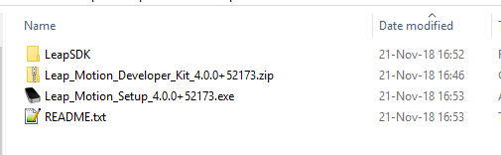

1. Install Leap_Motion_Setup_4.0.0+52173.exe
2. Run **LeapSDK_build_samples.bat** to build samples

set LEAP_SDK_DIR=.\LeapSDK

cd %LEAP_SDK_DIR%\samples || exit /B 1

mkdir build

cd build || exit /B 1

cmake .. -G "Visual Studio 15 2017 Win64" -DCMAKE_INSTALL_PREFIX=install

cmake --build . --target "ALL_BUILD" --config "Release"

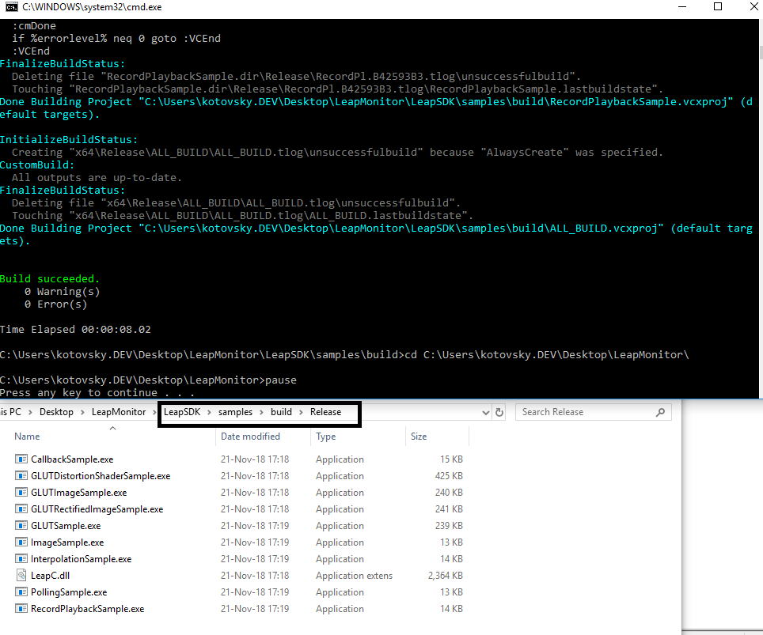

1. Download and install SWIG which includes a prebuild executable

<http://www.swig.org/download.html>

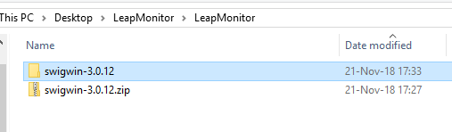

1. Download LeapCxx and unzip it

https://github.com/leapmotion/LeapCxx

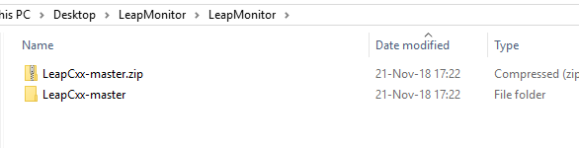

1. Run **LeapCxx_build.bat** to build LeapCxx (includes python module)

set ROOT_DIR=%~dp0

set LEAP_SDK_DIR=%ROOT_DIR%LeapSDK\lib\cmake\LeapSDK

set LEAP_CXX_DIR=%ROOT_DIR%LeapCxx

set SWIG_EXE=%ROOT_DIR%swigwin-3.0.12\swig.exe

cd %LEAP_CXX_DIR%* || exit /B 1

mkdir build

cd build || exit /B 1

cmake .. -G "Visual Studio 15 2017 Win64" -DCMAKE_INSTALL_PREFIX=install -DLeapSDK_DIR=%LEAP_SDK_DIR% -DBUILD_SWIG=ON -DSWIG_EXECUTABLE=%SWIG_EXE% -DUseSWIG_TARGET_NAME_PREFERENCE=STANDARD || exit /B 1

cmake --build . --target "ALL_BUILD" --config "Release" || exit /B 1

cmake --build . --target "INSTALL" --config "Release" || exit /B 1

copy /B /Y bin\Release\_LeapPython.pyd bin\Release\LeapPython.pyd

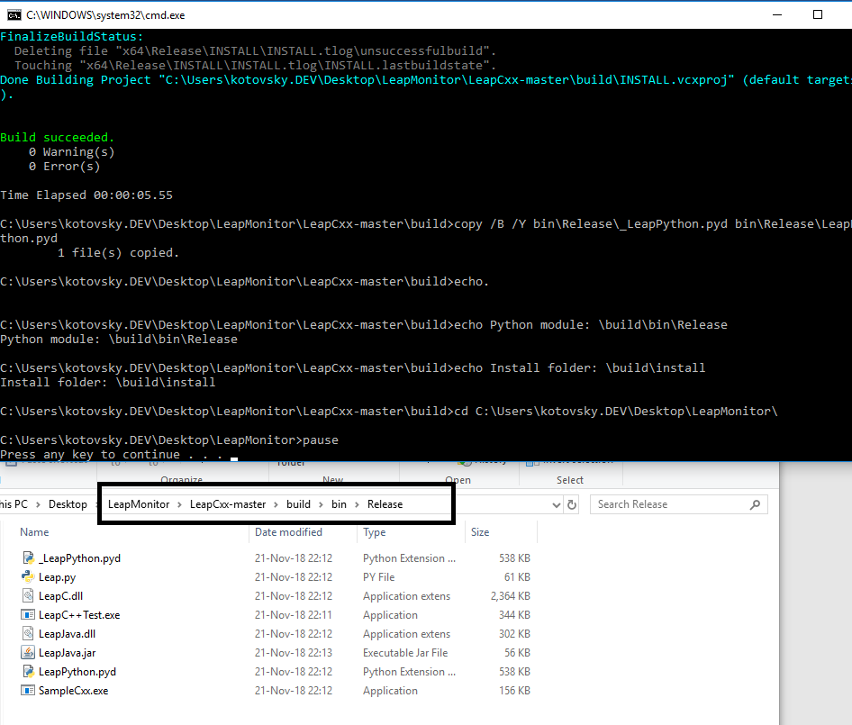

1. To install python module for **default** pythonuse **LeapCxx_install_python.bat**

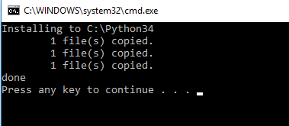

Or copy built files to python folder:

* Python3**\DLLs\**_LeapPython.pyd
* Python3**\DLLs\**LeapPython.pyd
* Python3**\DLLs\**LeapC.dll
* Python3**\Lib\**Leap.py

1. Use the next Leap Monitor python samples to check how it works:

LeapMonitor1.py

LeapMonitor2.py