1. Open Wordpress application by hitting http://<Web_Server_public_IP>/ . Page will redirect to install page at first time.

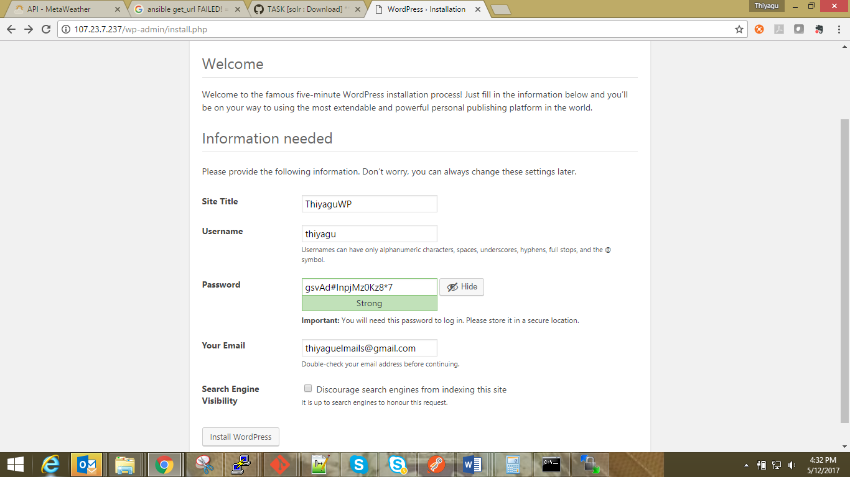

1. Enter required details and press Install WordPress button. You will see Success page. Then press Log in button to proceed.

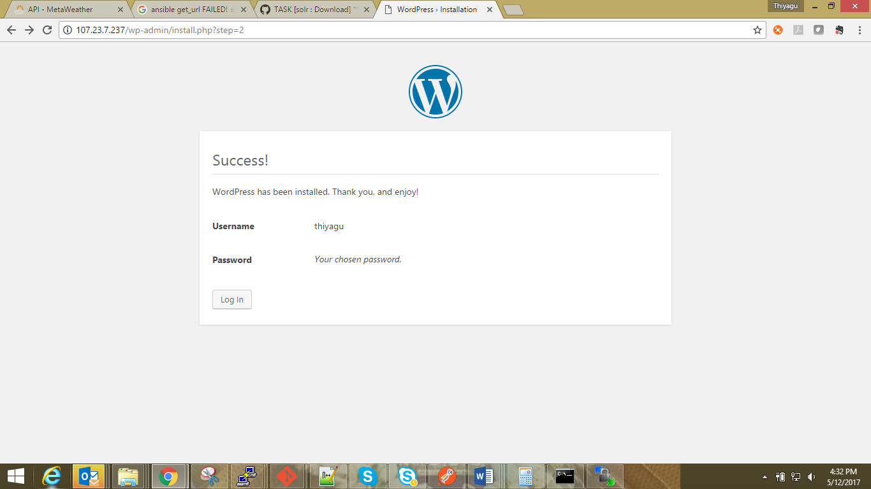

1. Enter Login credentials and press Login

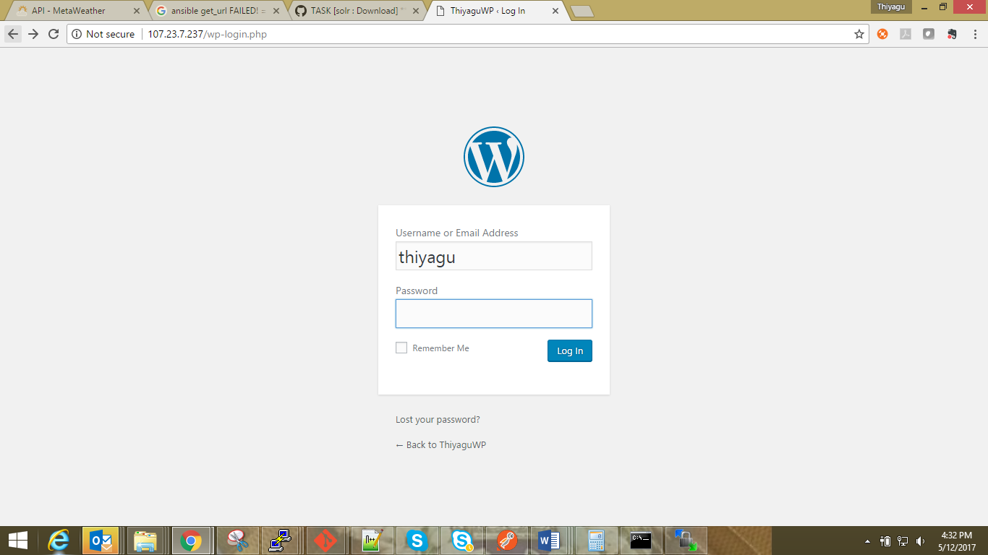

1. You will see Dashboard after successful login.

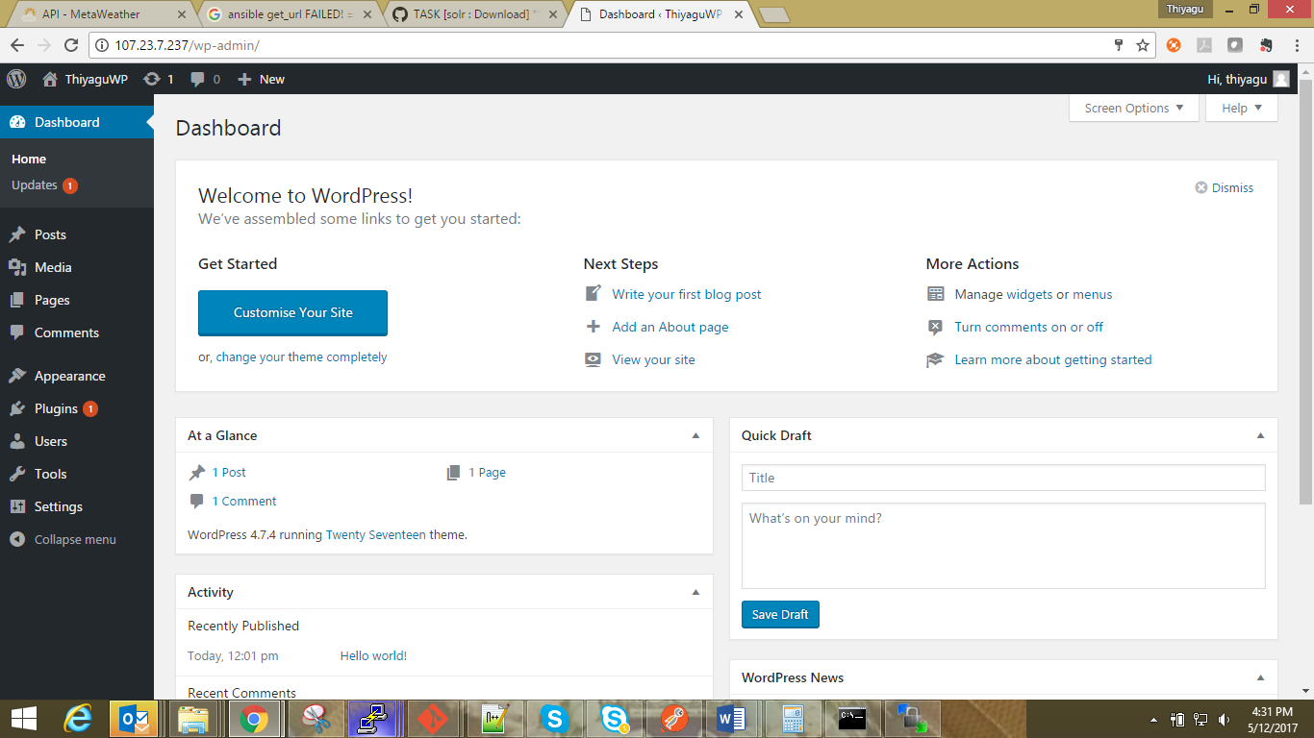

1. Click on Pages -> Add Page. Add content page and save then publish page.

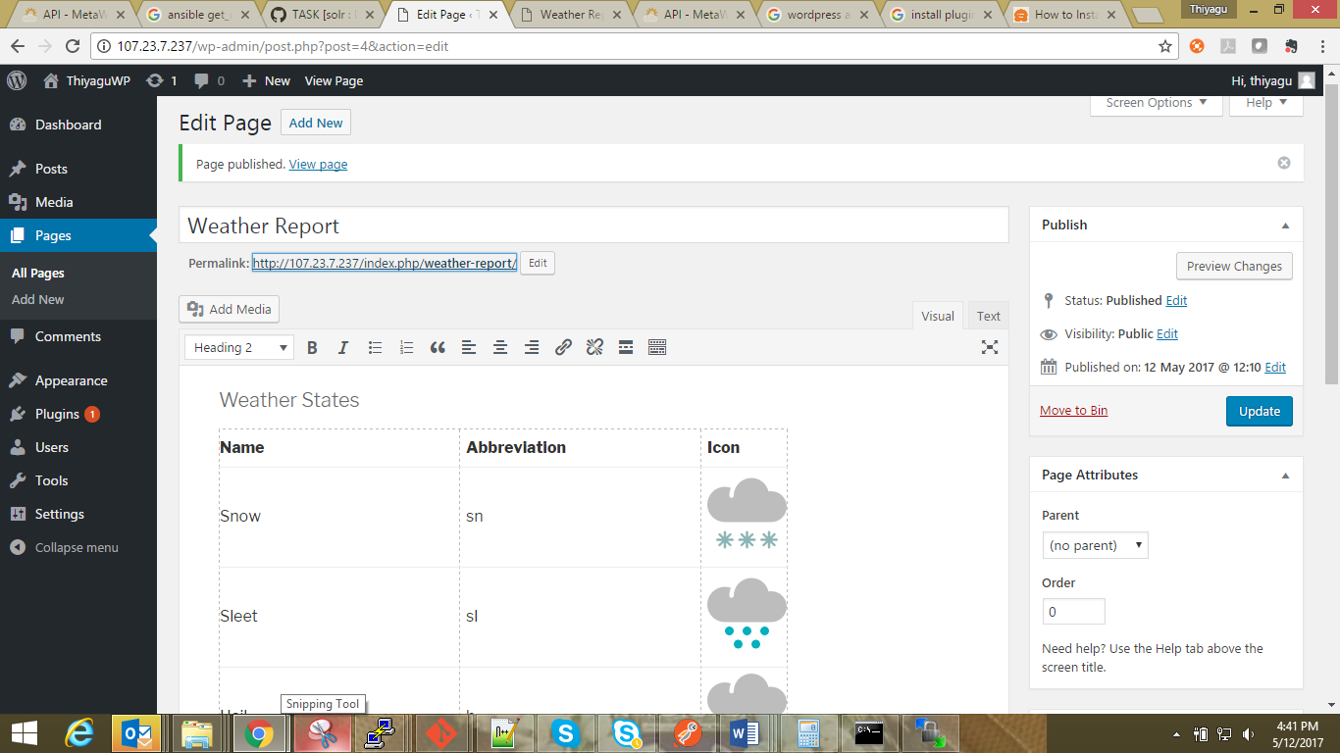

1. Access the page by clicking on Page URL shown on above screen shot.

