ShopNest Retail Dashboard Report

Power BI Capstone Project

Introduction
This report presents the analysis of a retail dataset using Power BI. The dashboard was designed to extract meaningful insights related to sales performance, delivery efficiency, customer behavior, and product quality. Each section below explains the visuals created and the insights derived.

1. Top Categories by Total Sales
- Question Statement:
Identify the top 10 product categories based on total sales value.
- Visualization:
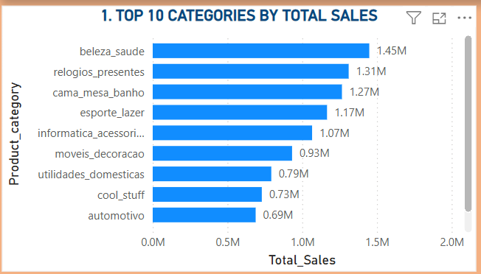
- Explanation:
From the visual, it is clear that a few categories contribute significantly to overall revenue. This indicates that customer demand is concentrated in specific product groups, and focusing on these categories can help improve business performance.

2. Delayed Orders Analysis
- Question Statement:
Determine the number of delayed orders in each category.
- Visualization:
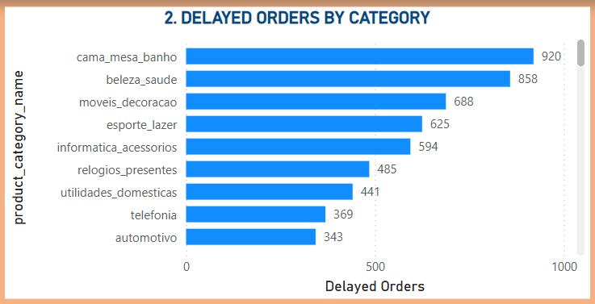
- Explanation:
The chart shows that some categories have higher delays compared to others. This suggests possible logistical challenges or supplier issues that need attention to improve delivery efficiency.

3. Monthly Delivery Performance
- Question Statement:
Compare delayed and on-time orders across months.
- Visualization:
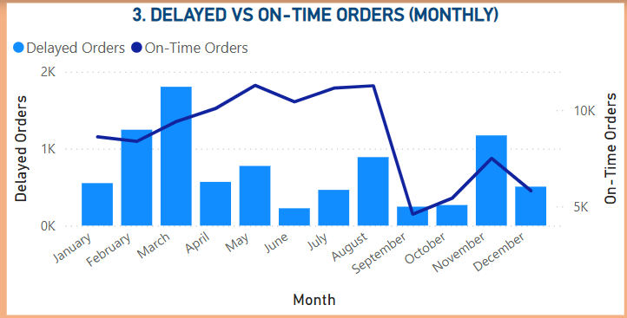
- Explanation:
By observing the monthly trend, it can be seen that delivery performance fluctuates over time. This helps in identifying specific months where delays are higher and corrective actions can be taken.

4. Payment Method Analysis
- Question Statement:
Analyze the most frequently used payment methods.
- Visualization:
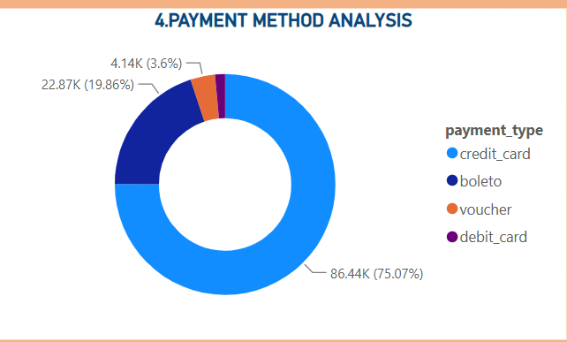
- Explanation:
The majority of customers seem to prefer a few payment methods. This insight can help the business optimize and promote the most commonly used payment options.

5. Product Rating Analysis
- Question Statement:
Identify top and bottom rated products.
- Visualization:
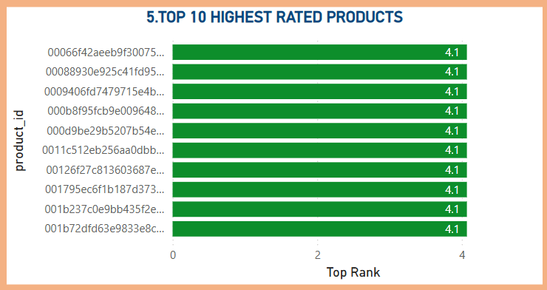
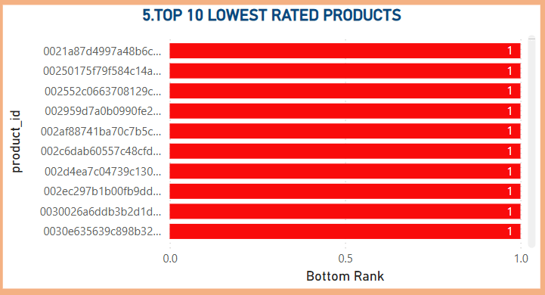
- Explanation:
The top-rated products reflect high customer satisfaction, while the low-rated products highlight areas that need improvement. This can guide product enhancement and quality control decisions.

6. State-wise Sales Analysis
- Question Statement:
Analyze sales performance across different states.
- Visualization:
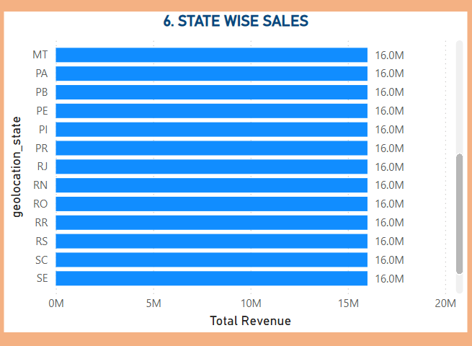
- Explanation:
This shows that sales are not evenly distributed across regions. Some states generate significantly higher revenue, indicating strong markets, while others may require targeted marketing strategies.

7. Seasonal Sales Patterns
- Question Statement:
Analyze quarterly sales trends.
- Visualization:
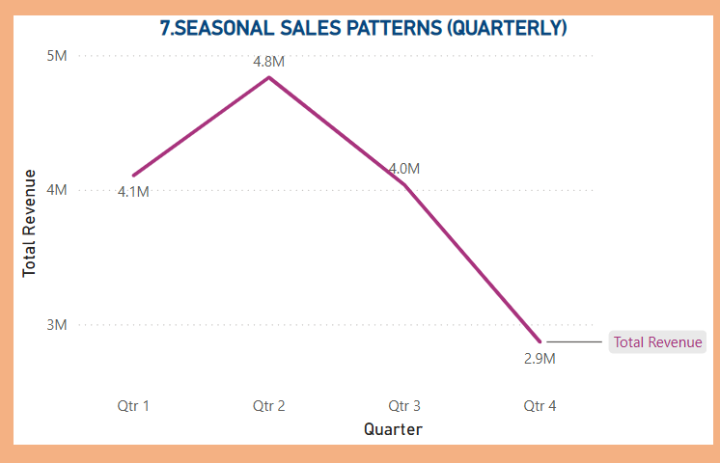
- Explanation:
The quarterly trend indicates that sales vary across different periods of the year. This suggests the presence of seasonal demand, which can be useful for planning inventory and promotions.

8. Yearly Revenue Analysis
- Question Statement:
Analyze total revenue generated each year.
- Visualization:
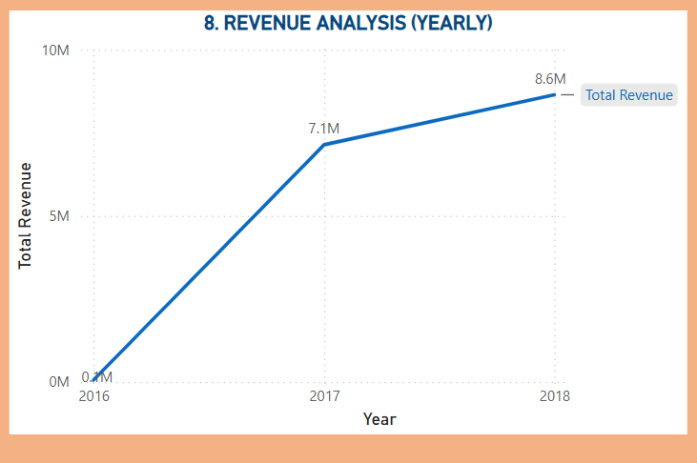
- Explanation:
The yearly trend shows how the business has grown over time. A steady increase indicates positive growth, while any decline highlights the need for further investigation.

Conclusion
In conclusion, the Power BI dashboard provides valuable insights into various aspects of the business. It helps in understanding sales trends, improving delivery performance, enhancing customer satisfaction, and making data-driven decisions. Overall, the analysis demonstrates how business intelligence tools can be used effectively in real-world scenarios.

