NextGen AI Bootcamp — The AI-Driven Development Workflow
Stop writing code line-by-line. Start orchestrating systems.

This guide set documents the complete workflow we use to take a product from a raw idea to a deployed SaaS using AI — the exact process used to build Nexus-CRM (The Agentic Sales Hub), which you can follow for your own micro-SaaS.

The philosophy
You = Architect. AI = Lead Developer.

We don't guess — we architect. Your job is to give the AI structure (documents, specs, rules, plans) and to review at the gates (the decision points where a human must approve before work continues). The AI's job is to execute between those gates at 10x speed. Every step in this workflow follows that division of labor:

You decide → AI produces an artifact → You review at the gate → next step

The workflow is document-driven: each phase produces named files that the next phase consumes. The documents — not chat history — are the source of truth. That's why every step starts a fresh AI chat: the agent reads the artifacts on disk, not a long, drifting conversation.

The pipeline at a glance
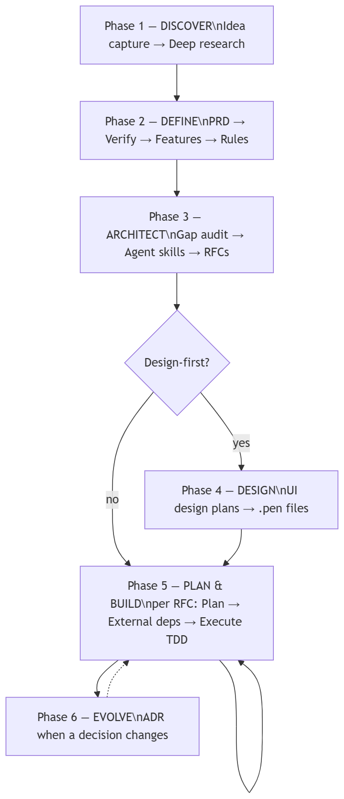

Phase | What happens | Artifacts produced | Guide
1 — Discover | Capture the idea, research it deeply once | docs/basic-idea.txt, docs/research/*.md | 02-phase-1-discover.md
2 — Define | Interview-driven PRD, verification, feature inventory, coding rules | PRD.md, FEATURES.md, rules file | 03-phase-2-define.md
3 — Architect | Audit tooling gaps, install agent skills, break product into RFCs | updated rules, installed skills, docs/rfcs/ | 04-phase-3-architect.md
4 — Design (optional) | Design every surface before code, as the visual source of truth | docs/plans/ui/*.md, designs/*.pen | 05-phase-4-design.md
5 — Plan & Build | Per RFC: TDD implementation plan, external setup, execution | docs/plans/PLAN-RFC-*.md, *-external-setup.md, working code | 06-phase-5-plan-build.md
6 — Evolve | When a planning decision changes mid-build, record it traceably | docs/rfcs/ADR-*.md, migration checklist | 07-phase-6-evolve.md

Phases 1–3 run once per project. Phase 4 is an optional fork you take once. Phase 5 loops — once per RFC — until the product is built. Phase 6 fires whenever reality forces a decision change (it will).

The artifact map
This is what your repo looks like when the workflow has run (Nexus-CRM shown):

nexus-crm-bootcamp/

├── PRD.md ← Phase 2: product source of truth

├── FEATURES.md ← Phase 2: feature inventory (F01–F44)

├── AGENTS.md ← Phase 2: rules for any AI agent

├── .github/copilot-instructions.md ← Phase 2: rules, auto-loaded by Copilot

├── docs/

│ ├── basic-idea.txt ← Phase 1: idea capture

│ ├── research/ ← Phase 1: research references

│ ├── rfcs/ ← Phase 3: RFC-000-index + RFC-001…015

│ │ └── ADR-001-*.md ← Phase 6: decision changes live with specs

│ ├── plans/ ← Phase 5: PLAN-RFC-* + *-external-setup

│ │ ├── ui/ ← Phase 4: UI design plans

│ │ └── adr-checklist/ ← Phase 6: migration checklists

│ ├── prompts/ ← the reusable prompt library (00–12)

│ └── guide/ ← you are here

├── designs/ ← Phase 4: .pen design files

├── supabase/ ← migrations, config

└── src/ ← Phase 5: the actual product

Anatomy of a workflow prompt
You'll use ~13 prompts across the pipeline (prompt library). They look long, but every one of them has the same six parts — learn the pattern once and each prompt is just a new instance of it:

- Role — who the AI acts as ("You are a senior software architect…")
- Inputs — which artifacts to read (PRD.md, FEATURES.md…)
- Process — numbered steps for the analysis or generation
- Output format — the exact structure of the artifact to produce
- Rules — guardrails ("no placeholders", "don't invent features", "cite, don't copy")
- Approval gate — "present the table and STOP for approval"

The gates are the whole point. When a prompt stops and shows you a grouping table, an impact analysis, or a surface inventory — that is the architect's moment. Read it. Push back. Then approve.

The golden rules
- One step = one fresh chat. Agents work from artifacts on disk, never from a stale conversation. If a step went wrong, fix the input artifact and re-run.
- Never skip an approval gate. AI output unreviewed is technical debt with good grammar.
- Artifacts are the source of truth. If it isn't in a committed document, it isn't a decision.
- Downstream traces upstream. Every plan task traces to an RFC, every RFC to feature IDs, every feature to the PRD. No orphan work.
- Never rewrite history. When a decision changes, write an ADR and changelog entries — don't silently edit old specs (Phase 6).
- TDD is non-negotiable. Every implementation task is Red → Green → Refactor, with commits at each green.
- Commit after every artifact. Git is your undo button and your audit trail.

Tools you'll use, and where
Step type | Tool | Notes
Research (Phase 1) | Perplexity / Gemini Deep Research (browser) | Pro subscriptions give better output
Everything that reads/writes repo files | IDE agent: VS Code + Copilot, Cursor, or Claude Code | Pick one and stick with it
Design (Phase 4) | Pencil.dev via MCP in the IDE agent | .pen files live in the repo
Deployment | Vercel + Supabase + GitHub Actions | Wired up via external-setup guides

Attach-file syntax differs per IDE agent — when a prompt says "attach PRD.md":

- VS Code Copilot: #PRD.md
- Cursor: @PRD.md
- Claude Code: just mention the path PRD.md

A note on the Nexus-CRM stack: the project started with AWS Bedrock as the AI provider and switched mid-build to the Vercel AI SDK + AI Gateway — recorded in docs/rfcs/ADR-001. That switch is not an accident of the course; it's the Phase 6 case study. Current stack: Next.js, Supabase, Vercel, Vercel AI SDK.

Reading order
- 01-setup.md — tools, accounts, project skeleton
- 02-phase-1-discover.md
- 03-phase-2-define.md
- 04-phase-3-architect.md
- 05-phase-4-design.md (optional fork)
- 06-phase-5-plan-build.md
- 07-phase-6-evolve.md

