The King’s Academy – Advanced Math Name ________________________ Period ___
A B HW 14

- [PS21 #7] Which of the following sets of ordered pairs are functions?

- { (4,6), (5,7), (3,-2), (1,3) }

- { (2,3), (6,1), (2,-3) }

- { (1,-1), (4,-1), (-1,-1), (3,-2), (1,2) }

- { (1,2), (2,3), (4,4), (7,-2) }

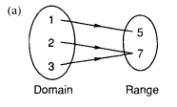
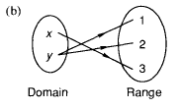
- [PS22 #9] For each diagram, determine whether or not it designates a function:

- [PS24 #11] Determine if each graph represents the graph of a function. If so, also determine whether or not it is a one-to-one function.
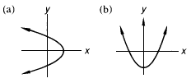

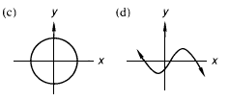

- [PS23 #12] Find the domain of the function defined by each equation:
- f(x) = x² + 4

- g(x) = |x – 2|

- h(x) = 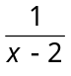

- [PS23 #11] Which of the following sets of ordered pairs are functions?

- { (2,–1), (5,2), (3,–2), (2,1), (6,1) }

- { (-1,2), (8,3), (5,1) }

- { (9,3), (1,6), (1,3) }

- { (7,2), (11,3), (13,-1), (-1,-1) }

- [PS21 #8] For each diagram, determine whether or not it designates a function (write “function” or “not a function”):
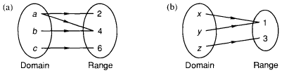

- [PS22 #10] Determine if each graph represents the graph of a function. If so, also determine whether or not it is a one-to-one function.
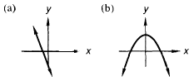

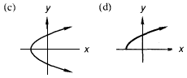

- [PS24 #12] Find the domain of the function defined by each equation:
- f(x) =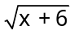

- g(x) = |x + 2|

- h(x) = 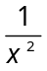

- [PS18 #15] Convert to polar coordinates (write two forms): -15î + 3ĵ

- [PS18 #17] Convert to rectangular coordinates:
-32 /–50˚

- [PS21 #3] The number of greens exceeded the sum of the reds and blues by 9. The sum of the blues and greens exceeded 4 times the number of reds by 1. How many of each kind were there if there were 2 more reds than blues?

- [PS23 #6] A 27-gallon solution is created by mixing 9 gallons of acid and 18 gallons of water. How much water should be added to get a solution that is 25% acid? (Hint: Start by determining the % makeup of the original solution.)

- [PS18 #16] Convert to polar coordinates (write two forms): 14î - 3ĵ

- [PS18 #18] Convert to rectangular coordinates:
46 /215˚

- [PS21 #4] There were 35 nickels, dimes, and silver dollars in the pile, and their value was $12.25. How many coins of each kind were there if there were twice as many silver dollars as nickels?

- [PS24 #6] How many mL of a 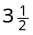% salt solution should be mixed with 176 mL of a 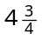% salt solution to get a solution that is 4% salt?

- [PS24 #17] Solve: 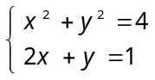

- [PS22 #19] Simplify: 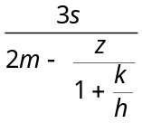

- [PS21 #23] Solve for d: 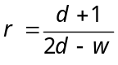

- [PS21 #21] Simplify: 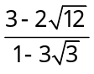

- [PS19 #21] Simplify: 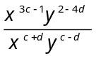

- [PS23 #18] Solve: 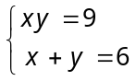

- Simplify: 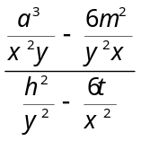

- [PS21 #16] Factor: 64a³b⁹ - 8p³
(Hint: Don’t forget to check for GCF first!)

- [PS21 #22] Simplify: 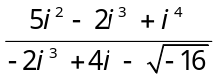

- [PS21 #20] Simplify:

A Problem Answers:
1. (a) and (d) 2. (a) Function, (b) Not a function
3. (a) Not a function, (b) Function, not 1-to-1, (c) Not a function, (d) Function, not 1-to-1
4. (a) 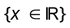 (b) (c) 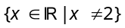
5. Any two of the following: 15.30 /168.69º ; 15.30 /-191.31º ; -15.30 /348.69º ; -15.30 /-11.31º
6. -20.57î + 24.51ĵ 7. R = 4 reds, B = 2 blues, G = 15 greens 8. 9 gallons
9. 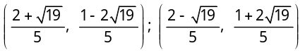 10. 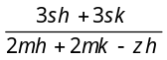 11. 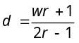
12. 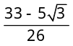 13. 