Name : Tan Hou Gim Samuel, Rayner Liew Rui Heng Comments :

Group : Team 27 Lab 02

**Proposal/Report : Assignment 2 (Collaborative AI)**

________________________________________________________________________

**Instructions**

Create 2 FSMs ( minimum 3 state) each with trigger conditions and responses.

Design the FSMs to support or help each other in team play through message boarding.

Each FSM( its object) should send 1 message and respond to 1 message.

Responses can be seen via HUDs or other forms of suitable notifications.

Things to consider

The two different waiter fsm, can use cascading

The generic entity base class

States

**Old scenario**

The simulation starts with the idle state. When customers enter the restaurant, they will find a suitable seat to dine at. After a certain time, the waiter will approach a ready customer to take their order.  
When there are orders, the chef will prepare the food. Else he will be idle.   
When the dishes are done, the waiter will serve the food to the customer's table.   
When there are no ready customers and there are no food to be served, the waiter will be idle.  
Cleaner will clean up left behind trays by customers. When the cleaner has cleaned 3 trays or there are no more trays left behind, he will empty his trash bag into the trash bin. When the trash bin is full, the cleaner will empty the trash bin. When the trash bin is empty and his trash bag is empty and there are no trays left behind, the cleaner will be idle.  
Customers will come in groups. When there are no available number of seats for a group, they will wait for the waiter to arrange the tables.   
When all the seats in the restaurant are taken up, waiting customers will form a line outside the restaurant.

**New scenario**

The customers enter solo or in groups(random number). Customers will have to form a line and **wait** if there are no more tables left.

Waiter outside **communicates** with waiter inside, waiter inside **place/arrange** different tables and chairs depending on the number of customers. If the max number of tables and chairs are placed and there is a group who needs a number of chairs not currently available, the waiter can look for extra chairs in the storeroom and place near an existing table.

Waiter outside gives food orders to Waiter inside who then gives them to chef who can then **cook** when orders are received.

Waiter inside **collects** order if ready and **serves**. When there are no customers, waiter is **idle**.

When customers finish eating, they will either **return their tray** or leave their tray on their table and **pay** at the cashier. When there are customers ready to pay, a close by waiter or cleaner will **take the role of a cashier**. When customers have paid, they will **leave** the restaurant.

Cleaner **cleans** up tables if they are trays are left behind by customers. When the cleaner has cleaned 3 tables, he will **empty his trash bag** into the trash bin. When the trash bin is full, he will **empty the trash bin**. If the trash bag and trash bin are empty and there are no tables to clean, he will be idle.

All staff may have to **relief** themselves at the toilet at some point if urgent meter is filled and a staff is asked to fill in for them (no one will fill in for the chef)

Conditions

The customers enter solo or in groups. Customers will have to form a line and wait if there are **no more tables left**.

Waiters outside communicate with waiters inside, waiter inside **place/arrange** different tables and chairs **depending on the number of customers**. If the max number of tables and chairs are placed and there is a group who needs a number of chairs not currently available, the waiter can look for extra chairs in the storeroom and place near an existing table.

Waiter outside gives **food orders** to Waiter inside who then gives them to chef who can then cook when **orders are received**.

Waiter inside collects **order if ready** and serves. When there are **no customers**, waiter is idle.

**When customers finish eating**, they will either return their tray or leave their tray on their table and payat the cashier. **When there are customers ready to pay**, a close by waiter or cleaner will take the role of a cashier. **When customers have paid**, they will leave the restaurant.

Cleaner cleans up tables if they are **dirty**. When the cleaner has **cleaned 3 tables** or the **trash bin is full**, he will empty the trash bin. If the **trash bag and trash bin are empty** and there are **no tables** to clean, he will idle.

All staff may have to relief themselves at the toilet at some point if **urgent meter is filled** and a staff is asked to fill in for them (no one will fill in for the chef)

**Layout**

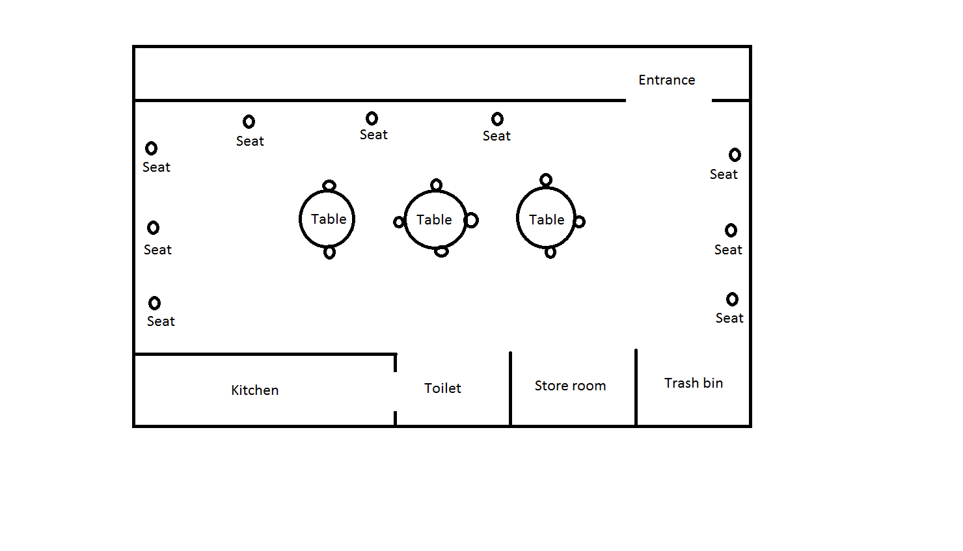

Chairs/seats are placed by following the wall for solo customers and group tables are placed in the middle randomly.

**Samuel Tan Hou Gim**

**FSM # 1**  State Transition Diagram

**Waiter(Cascade)**

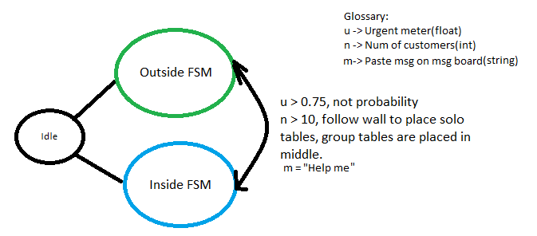

**Waiter Outside**

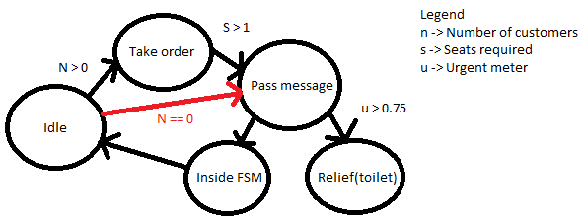

**Waiter Inside**

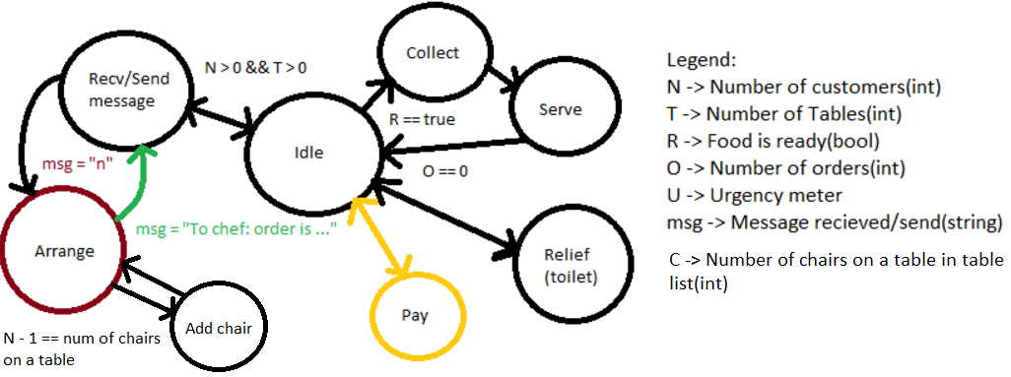

**FSM # 2**  State Transition Diagram

**Chef**

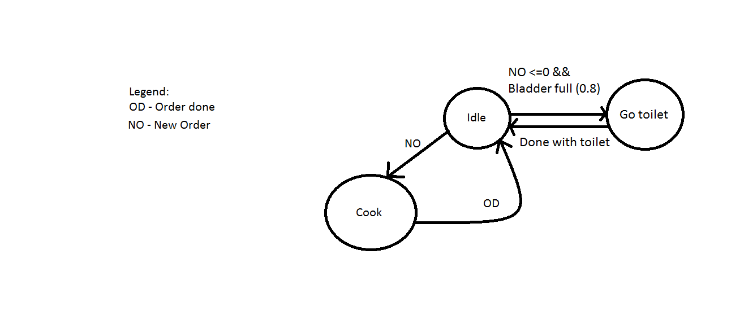

**Rayner Liew**

**FSM # 3**  State Transition Diagram

**Cleaner**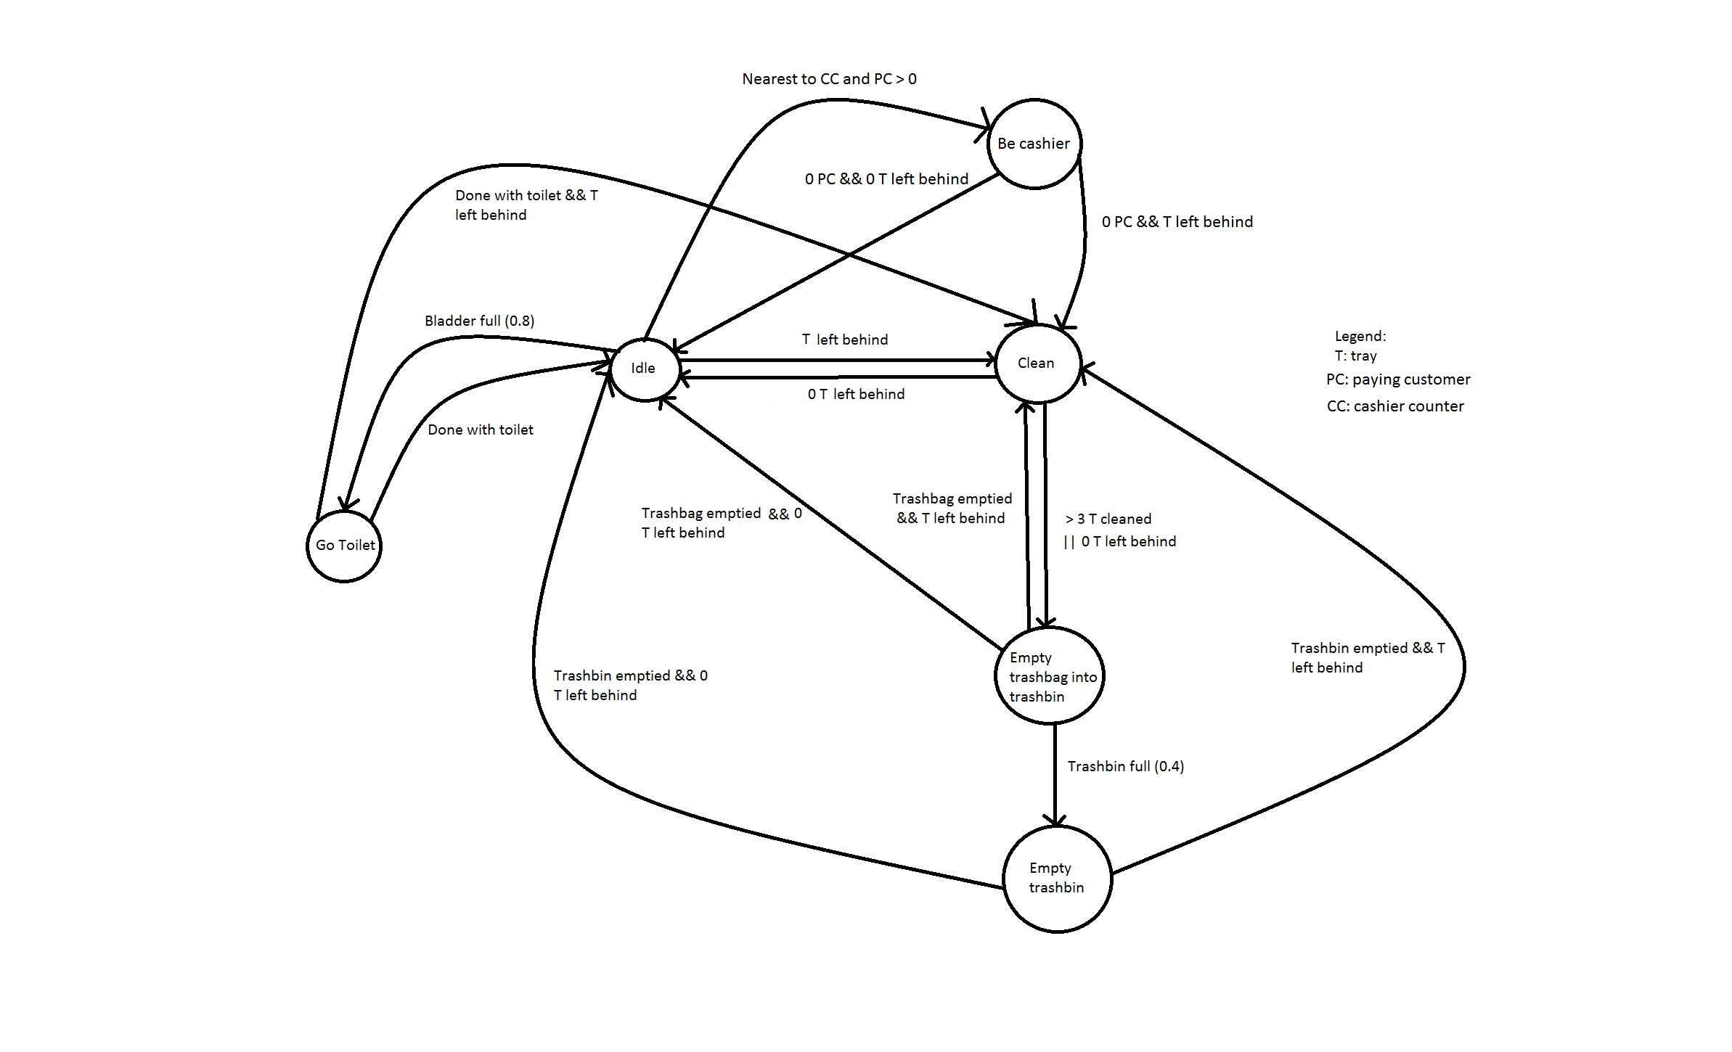

**FSM # 4** State Transition Diagram

**Customer**

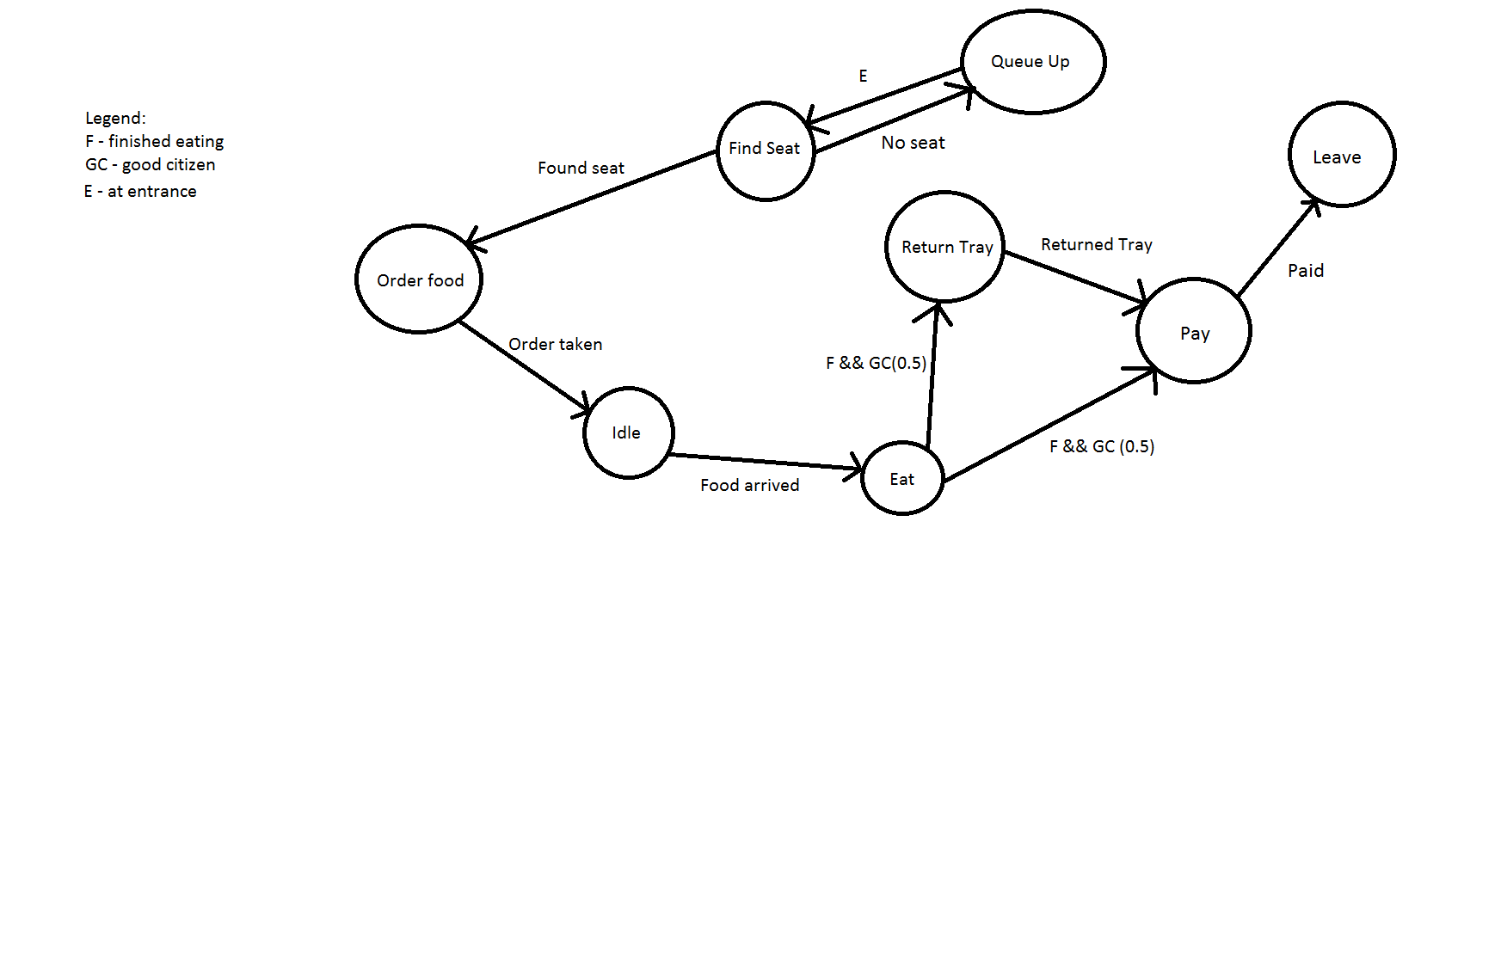

Message Board

Text From To Response(Output) Remarks

|  |  |  |  |  |
| --- | --- | --- | --- | --- |
| I have too many customers to handle. | Waiter inside | Waiter outside | Change to Waiter inside role |  |
| I am going to the toilet. | Any restaurant staff | Nearest proximity, first staff to receive message | Change role to the toilet business role, receiver changes to his role |  |
| Food is ready for collection | Chef | Waiter | Waiter goes to collect from chef |  |
| There are ‘n’ number of customers | Waiter outside | Waiter inside | Waiter inside places different types of table | int Number of customer |
| The following are for the customers  aka enemy message board | Text | Observation  (which person saw) | Response | Remarks/Resources needed |
|  | I want to order | Waiter/Other customer, change role to Call state | Waiter goes to customer if he saw customer (maybe use proximity or circle radius) or if he is approached by customer | int Table index |
|  | Clean table | Cleaner is in proximity | Cleaner goes to clean table | int table index and whether there is any leftovers, bool |
|  | We have …(n) people | Approach waiter | Waiter arranges appropriate group tables | int of number of customers |
|  | I want to pay | Each of them will pay the usher | Customer pays for food and leaves | int of price (not implemented) |
|  | Here’s your food (from waiter to customer) |  | Customer changes to eat state |  |

Task list

Rayner Liew:

- Cleaner: clean, go toilet, empty trash bin, empty trash bag, idle

- Chef: cook, idle

- Waiter inside: take order, serve food, arrange seats and tables, idle

Arrange seat remarks:

- If seats and tables are set and customers using it has left the table, the waiter will remove them and place them in the store room

- If a table is currently being used, the waiter will arrange a new table with seats for the new group of customers

- Customer: finding seat, order food, return tray, leave, idle

- Single customer generation

- Message board for all entities

Samuel Tan Hou Gim:

* Change from waiter outside to waiter inside
* Flocking(using seperation/repel)
* Queueing in groups
* Cashier
* Random placement of waypoints to place tables

Only thing not done in the end was make the customer angry and leave. Also didn't add in Neural net