Name : Rayner Liew Rui Heng, Tan Hou Gim Samuel Comments :
Group : 2 (Team 27)

Proposal/Report : Assignment 1 (Finite State Machine)
________________________________________________________________________

Design 2 FSMs ( minimum 3 states) for your game scene by bolding states, conditions in written descriptive text in the space below. Draw the State Transition Diagram.

States

The simulation starts with the idle state. When customers enter the restaurant, they will find a suitable seat to dine at. After a certain time, the waiter will approach a ready customer to take their order.
When there are orders, the chef will prepare the food. Else he will be idle.
When the dishes are done, the waiter will serve the food to the customer's table.
When there are no ready customers and there are no food to be served, the waiter will be idle.
Cleaner will clean up left behind trays by customers. When the cleaner has cleaned 3 trays or there are no more trays left behind, he will empty his trash bag into the trash bin. When the trash bin is full, the cleaner will empty the trash bin. When the trash bin is empty and his trash bag is empty and there are no trays left behind, the cleaner will be idle.
Customers will come in groups. When there are no available number of seats for a group, they will wait for the waiter to arrange the tables.
When all the seats in the restaurant are taken up, waiting customers will form a line outside the restaurant.

Conditions

The simulation starts with the idle state. When customers enter the restaurant, they will find a suitable seat to dine at. After a certain time, the waiter will approach a ready customer to take their order.
When there are orders, the chef will prepare the food. Else he will be idle.
When the dishes are done, the waiter will serve the food to the customer's table.
When there are no ready customers and there are no food to be served, the waiter will be idle.
Cleaner will clean up left behind trays by customers. When the cleaner has cleaned 3 trays or there are no more trays left behind, he will empty his trash bag. When the trash bin is empty and his trash bag is empty and there are no trays left behind, the cleaner will be idle.
Customers will come in groups. When there are no available number of seats for a group, they will wait for the waiter to arrange the tables.
When all the seats in the restaurant are taken up, waiting customers will form a line outside the restaurant.

Rayner’s FSMS

State Transition Diagram of Waiter
FSM # 1
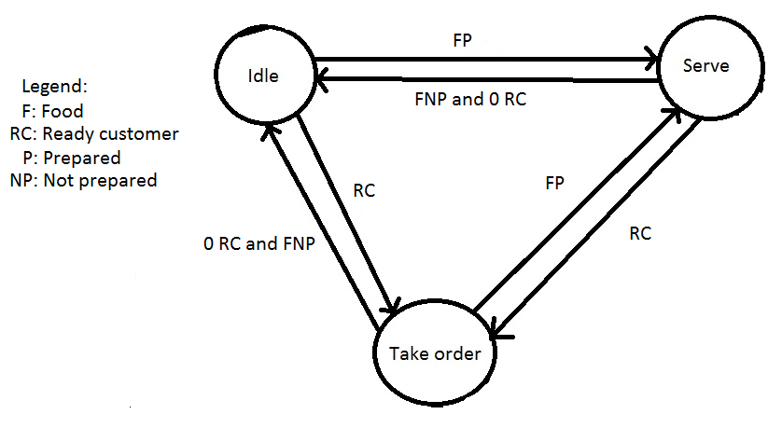

FSM # 2

State Transition Diagram of Cleaner

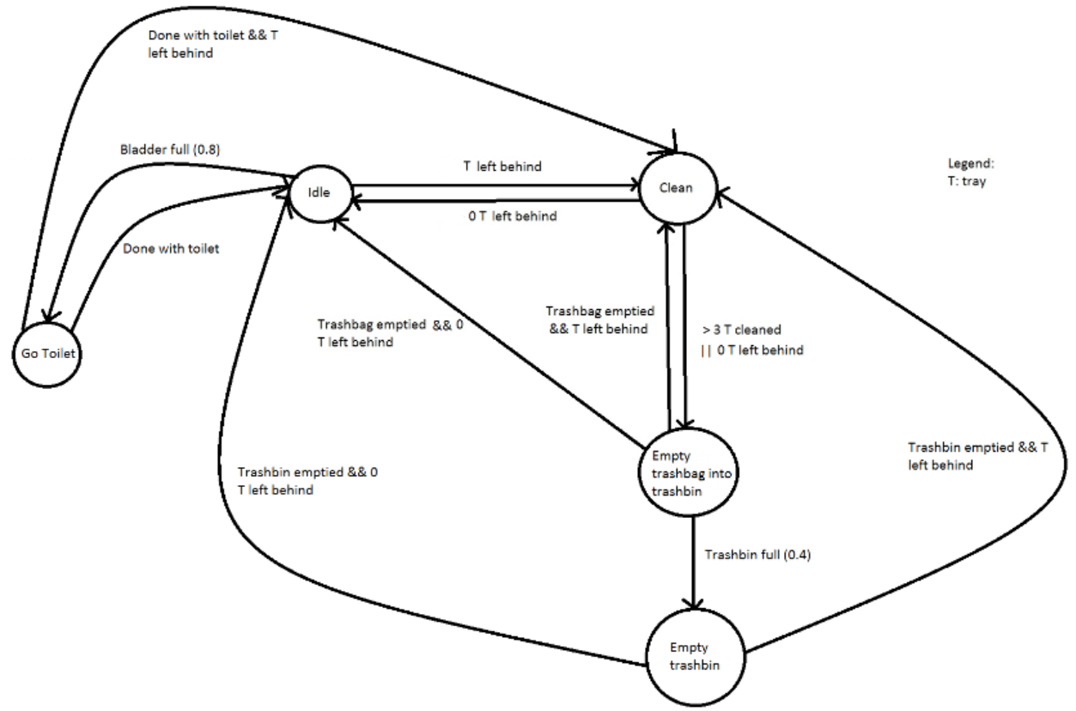

State Transition Diagram of Customer
FSM #3

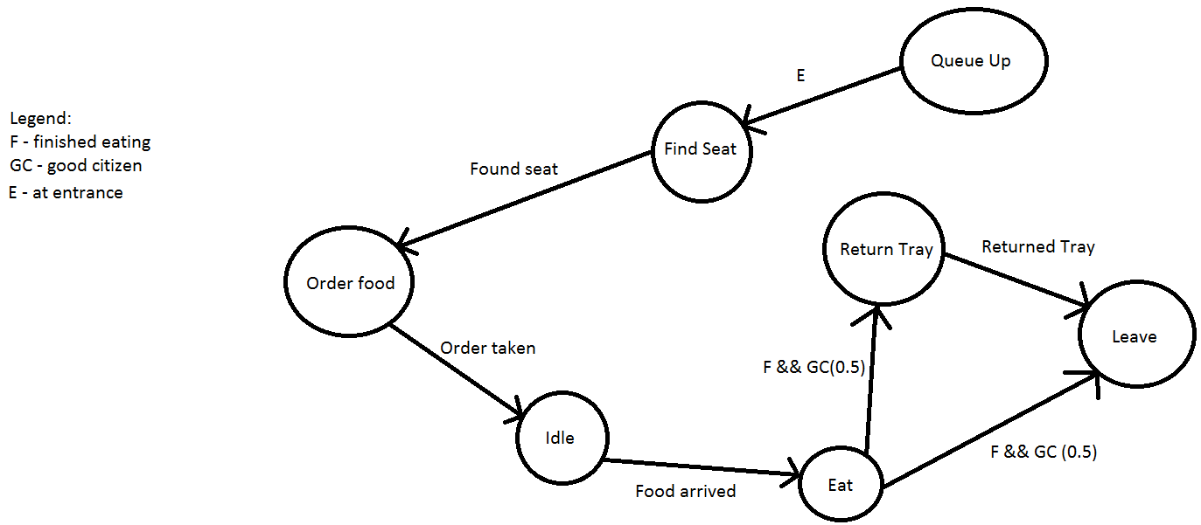

State Transition Diagram of Chef
FSM #4

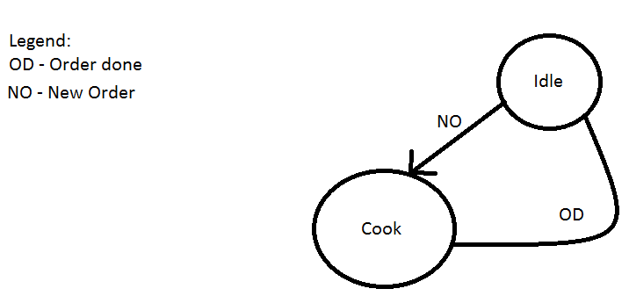

Samuel’s FSMs
State Transition Diagram of Waiter
FSM # 1
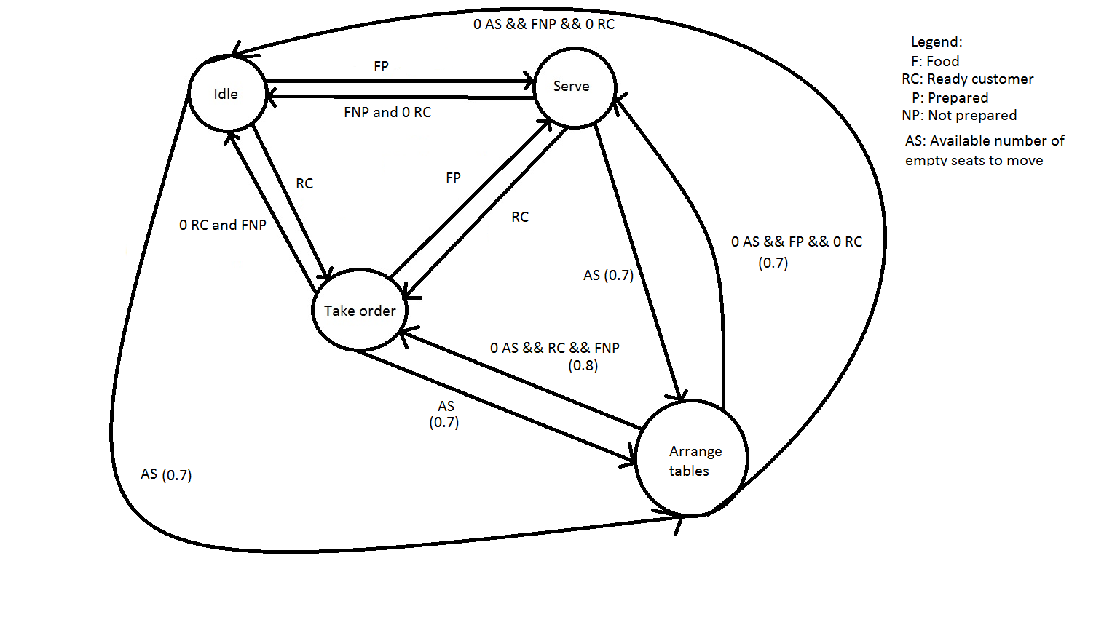

FSM # 2

State Transition Diagram of Cleaner

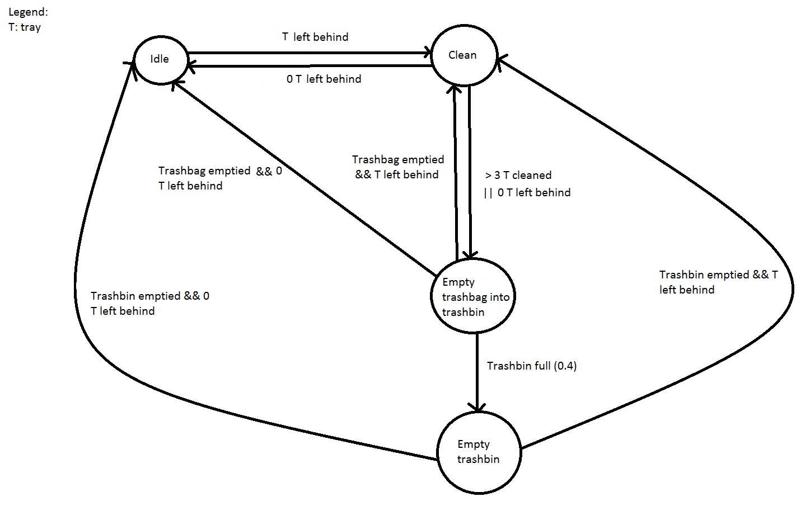

State Transition Diagram of Customer
FSM #3

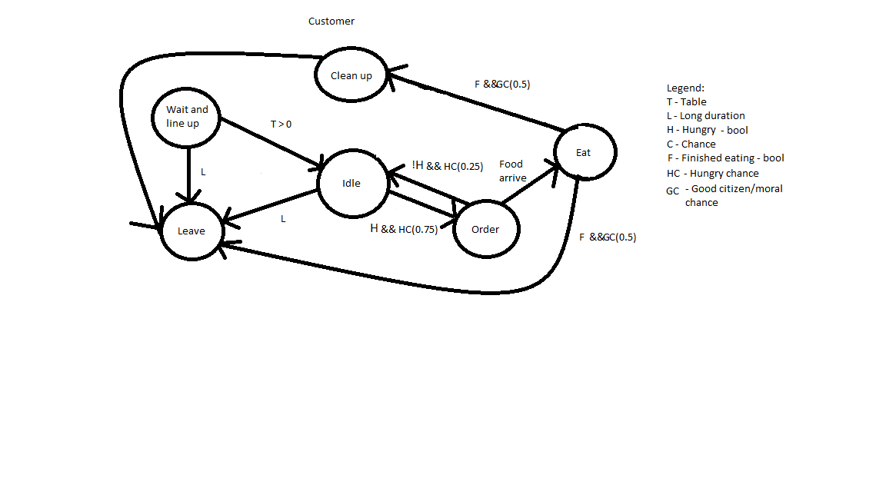

State Transition Diagram of Chef
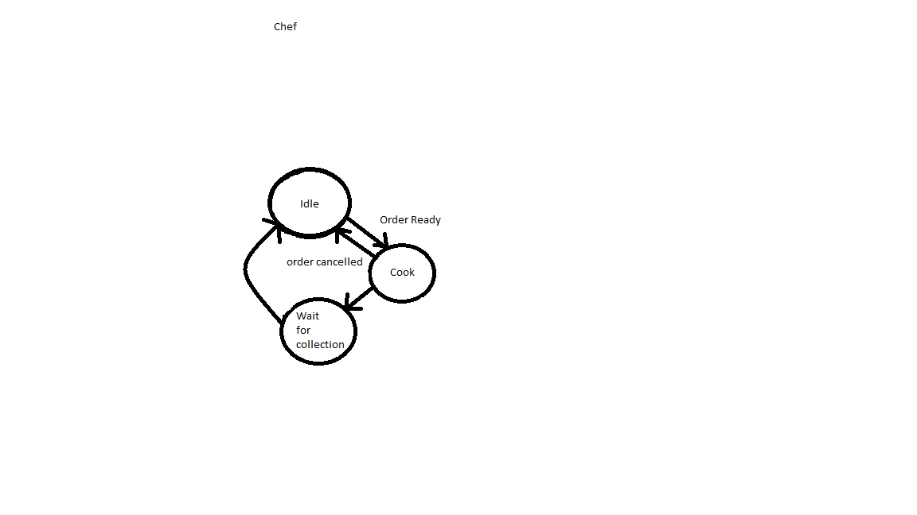
FSM #4

Additional Information

State Transition Table for easier programming structure
State | Input | New state
Idle | H(Hungry) | Order
Idle | L(Long wait) | Leave
Order | A(Food arrived) | Eat
Eat | G > 50%(Good moral chance) | Clean then leave
Eat | G <= 50% | Leave
Wait | T > 0(Table) | Idle(Entered the restaurant area and animation plays)
Wait | L | Leave

Customer:

State | Input | New state
Idle | H(Hungry) | Order
Idle | L(Long wait) | Leave
Order | A(Food arrived) | Eat
Eat | G > 50%(Good moral chance) | Clean then leave
Eat | G <= 50% | Leave
Wait | T > 0(Table) | Idle(Entered the restaurant area and animation plays)
Wait | L | Leave

Chef:
State | Input | New State
Idle | Order ready | Cook
Cook | Order cancelled | Idle
Cook | Dish time is completed | Wait
Wait | Waiter/Waitress collects | Idle

Does the AI think like Pong?
Does the AI know your player's previous actions and can calculate the possibility of something happening?
Pointers slide
Different colors for diff customer state, green for neutral, red for anger
Port everything to physics
Run hungry fsm, run not hungry fsm(solo hunt and group hunt fsm)
Decision tree, if my dir vec/proximity is a customer, go to him and take his order, if he is leaving hungry and angry, move twice as quickly to bring him back
Use bayesian rules - write in proposal
change your customer and waiter fsm

4 rules
A - Probability of going to customer who seems most urgent
B - Go to first customer then sequentially depending who came first
C - If customer is leaving, zao to him first
D - Closest proximity customer using getDist()
E - Customer is impatient
N - Number of customers

Use a decision tree

P(A) = P(C/E) P(D)
P(B) = P(D)

P(C) = 0.25
P(E) = 0.6
P(C/E) = 0.2
P(D) = 0.4
P(A) = 0.8

List of Features
- Markov and Cascade model multi fsm
- Map of vectors containing game objects like door and chef's table

