TRANSPORTSE: Richards Flow Equation for Variably Saturated Flow
Branch: feature/richards-flow · Status: implemented and benchmark-verified

1 Overview
TRANSPORTSE was extended by a variably-saturated flow mode based on the mixed-form Richards equation (Celia et al., 1990). The mode is activated with UNSATURAT = True in the configuration file and replaces the saturated flow solver (compute_P) by a modified-Picard solution of the mixed-form Richards equation (compute_P_RICH, compute_P_RICH_CG). Heat and species transport remain fully functional and use the saturation-dependent Darcy fluxes of the Richards solution.
All existing saturated-flow capabilities are unchanged: with UNSATURAT = False the code behaves bit-identically to master (verified by regression, Section 4.4).

2 Conceptual change: compute_P → compute_P_RICH

2.1 Governing equation
The saturated pressure equation of compute_P,
phi*rho*(P - Pn)/dt * c_t = div(rho * K/mue * (grad P + rho*g*grad z)) + WP
is replaced by the mixed-form Richards equation
phi*rho*(S(P) - Sn)/dt + Sn*rho*c_t*(P - Pn)/dt
= div(rho * kr * K/mue * (grad P + rho*g*grad z)) + WP
with the saturation S(P) from the soil-water retention curve and the relative permeability kr(P). The mixed form stores the water content change (S(P^{n+1}) − Sn) rather than the pressure change and is exactly mass-conservative for arbitrary retention curves — the key requirement for infiltration into dry soil, where head-based forms lose mass.

2.2 Solution strategy
The solver follows the same pattern as compute_P:
- Outer loop — modified Picard iteration on the saturation. The storage accumulation is linearised around the current iterate, phi*rho/dt * [S^m + dS/dP|(P^m) * (P^{m+1} - P^m) - Sn], and all coefficients (S^m, dS/dP, face kr) are frozen, so each pass solves a linear system. Convergence on the saturation L2 norm (CONV_S). At Picard convergence the linearisation error vanishes and the discretised equation is the exact mass-conservative mixed form.
- Inner loop — solution of the linearised system, either red-black SOR (compute_P_RICH) or a symmetric-Gauss-Seidel preconditioned conjugate gradient solver (compute_P_RICH_CG, selected with PSOLVER = 'CG'). The CG converges on the residual of the linearised system, which is the cell-wise mass balance error — the correct criterion for the nearly elliptic saturated zone (dS/dP = 0, c_t ≈ 0), where change-based SOR criteria are unattainable.
- Time step control — non-convergence of either loop halves dt and restarts the time step from Pn/Sn; on convergence dt grows by 1.25, capped by dt_max. For UNSATURAT the advective CFL limit of the previous step is applied before the flow solve ("CFL first"), and the mid-step CFL reduction is disabled.

2.3 Face relative permeability
The face kr values are upstream-weighted with respect to the pressure head (the wetter cell's kr). A harmonic-mean face kr was tested first and rejected: at saturations near the residual saturation the Mualem/vG conductivity vanishes (kr ~ 1e-6), so the harmonic mean blocks imbibition fronts completely — the wetting front cannot advance into dry cells. The upstream rule is the standard treatment for Richards wetting fronts (Vauclin's FE model, HYDRUS, MODFLOW-SURFACT) and reduces exactly to kr = 1 for saturated cells, preserving the saturated-flow discretisation of master.

2.4 Transport coupling
compute_q_RICH computes the Darcy fluxes with the same frozen face kr values used in the flow solve, so the advective and dispersive transport solvers (species, heat) operate on fluxes consistent with the flow solution. The saturation enters the transport storage terms (phi·S) directly.

3 New configuration variables
All new parameters are per-cell numpy arrays of model size (nx, ny, nz), so each cell can have individual hydraulic properties (lithology).
Variable | Type / unit | Description
UNSATURAT | bool | Activate Richards (variably saturated) flow mode. Default: False
KRMODEL | str | Retention/conductivity model: 'mualem-vg' (van Genuchten retention + Mualem conductivity) or 'haverkamp' (Haverkamp et al. 1977 retention and conductivity). Default: 'mualem-vg'
alpha_vg | array, 1/m (vG) or m^beta (Haverkamp) | Retention curve shape parameter
n_vg | array, – | Retention curve shape parameter (vG n, Haverkamp beta)
S_r | array, – | Residual saturation (theta_r/theta_s)
S_s | array, – | Maximum saturation, default 1
A_vg | array, m^gamma | Haverkamp conductivity parameter (only KRMODEL='haverkamp')
gamma_vg | array, – | Haverkamp conductivity exponent (only KRMODEL='haverkamp')
CONV_S | – | Modified-Picard convergence criterion (saturation L2 norm). Default 1e-6
PSOLVER | str | Pressure solver: 'SOR' or 'CG'. 'CG' recommended for UNSATURAT. Default 'SOR'
CG_OMEGA | – | Over-relaxation of the SGS preconditioner. Default 1.0

Existing variables reused unchanged: SOR_P, CONV_P, MAXIT_P, dt, dt_max, WP, BP, Kx/Ky/Kz, phi.
Initial condition note: the initial saturation is computed consistently from the initial pressure field via the retention curve, so hydrostatic-equilibrium initial conditions yield the corresponding equilibrium saturation profile automatically.

4 Benchmark verification
All benchmarks are in benchmarks/richards/ with configuration, analysis scripts and reference data.

4.1 Celia et al. (1990) 1D infiltration (celia1990/)
Infiltration into a 1-m dry sand column (vG: theta_r = 0.102, theta_s = 0.368, alpha = 1.611 1/m, n = 2.435; Ks corresponding to theta_s), surface head fixed at h = −0.75 m, 24 h simulated, N = 40 cells, dt = 60 s. Compared against an independent mixed-form finite-difference reference solver on the identical grid.
Quantity | TSE | Reference
max abs theta deviation | 2.59e-4 | —
storage change (m) | 2.340961e-2 | 2.342144e-2 (−0.05 %)
reference mass error (m) | — | −5.5e-14 (machine precision)
dt reductions | 0 | —

The classic wetting front position and shape are reproduced; the run needs ~300 time steps without a single dt reduction.
The classic wetting front position and shape are reproduced; the run needs ~300 time steps without a single dt reduction.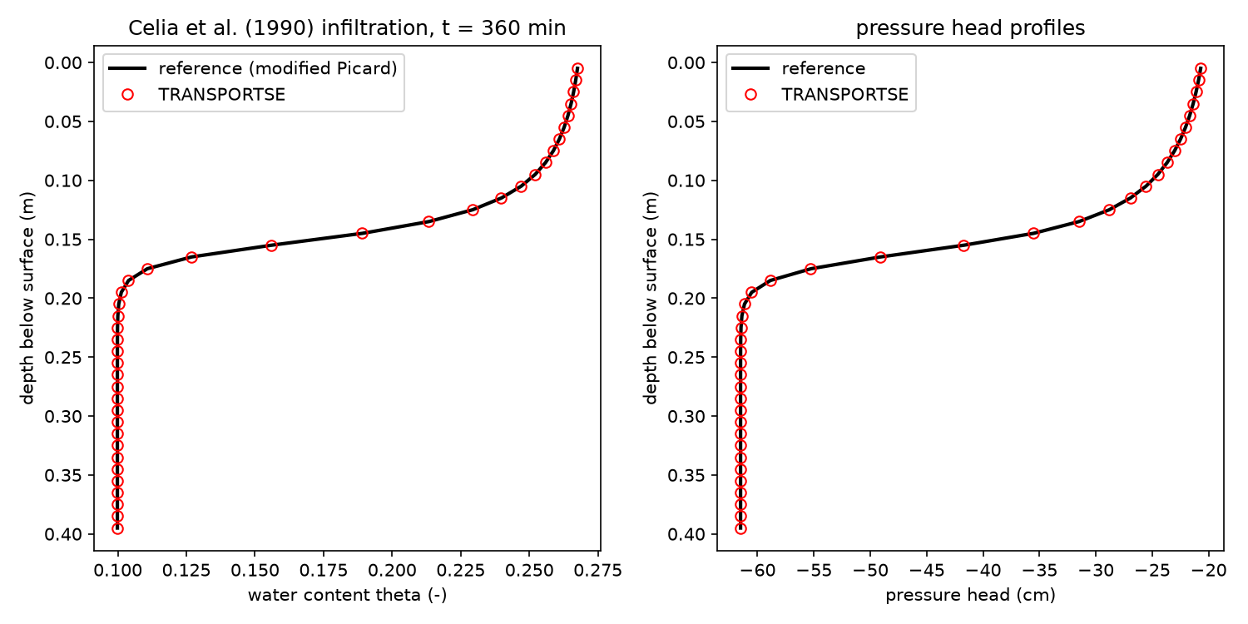

4.2 Hydrostatic equilibrium test (static/)
Uniform initial state P = −6031 Pa (h = −0.615 m) with consistent retention saturation, no-flow boundaries, 120 s simulated. The state is preserved to 1e-12 Pa — the discretisation has no spurious gravity or capillary fluxes.

4.3 Point-source mass balance test (wptest/)
3×1×3 column with a volumetric water source (WP = 0.0822 kg/m³/s) and no-flow boundaries. The storage change equals the source input exactly (ratio 1.000000) — the mixed-form discretisation is mass-conservative to machine precision.

4.4 Regression against master
The simple_flow benchmark run with master (34-element pickles) and with feature/richards-flow at UNSATURAT = False (35-element pickles, S appended): 0.0 deviation in all 26 fields across all 11 output files. The saturated-flow path is bit-identical.

4.5 Vauclin et al. (1979) 2D water-table recharge (vauclin1979/)
Laboratory sandbox 3 m × 2 m × 0.05 m, water table initially at 0.65 m, constant irrigation 1.48 cm/h over the left 0.5 m of the surface, measured water table at 2/4/6/8 h. Grid 60×1×40 (dx = dz = 0.05 m), CG solver, dt ≤ 60 s, 8 h simulated.
Setup findings (important for reproducibility): comparison of published benchmark descriptions (SHUD/GMD 2020, Underworld3, original experiment) showed that two intuitive setup choices are wrong:
- No drainage boundary. The sandbox walls are impervious; the right side is open to the atmosphere (seepage face), not a constant-head drain. A Dirichlet column suppresses the mound: the model then drains the recharge as fast as it arrives and the water table stays flat. The experiment's water balance (input = mound storage) proves that no outflow occurred.
- Gravity-drained initial moisture. A hydrostatic-retention equilibrium initial condition (theta ≈ 0.01–0.13) gives the vadose zone a storage capacity (≈ 0.135 m water) as large as the entire irrigation input (0.118 m) — the mound never forms. The experiment started from the gravity-drained profile (theta_i ≈ 0.10, uniform initial head h_i ≈ −0.37 m, the unit-gradient state of the irrigation flux).
With the corrected setup and the classic Haverkamp parameterisation (theta_r = 0.075, theta_s = 0.287, Ks = 9.44e-5 m/s, alpha = 1.611e6 cm^3.96, beta = 3.96, A = 1.175e6 cm^4.74, gamma = 4.74):
t | TSE max water table (m) | Experiment (m) | Vauclin FE (m) | rms deviation (m)
2 h | 0.630 | 0.786 | 0.784 | 0.125
4 h | 0.816 | 1.027 | 0.985 | 0.134
6 h | 0.906 | 1.121 | 1.089 | 0.142
8 h | 0.960 | 1.211 | 1.215 | 0.209

- Mass balance: storage change = irrigation input exactly (0.000 % residual at 8 h).
- The water table rises monotonically with the correct magnitude and timing; the simulated water table is flatter than the experiment (mound shape under-predicted by ≈ 0.2 m at 8 h). The mound shape is controlled by the retention curve near saturation (effective specific yield); published simulations of this benchmark likewise require calibration of these parameters (SHUD: "a mismatch exists", calibrated alpha/beta).
- The van Genuchten/Mualem parameterisation of Shen & Phanikumar (2010) (alpha = 3.3 1/m, n = 4.1, theta_r = 0.01, theta_s = 0.30) was also tested and gives a systematically lower mound (rms 0.35 m at 8 h); the Haverkamp set is closer to the experiment.
- The van Genuchten/Mualem parameterisation of Shen & Phanikumar (2010) (alpha = 3.3 1/m, n = 4.1, theta_r = 0.01, theta_s = 0.30) was also tested and gives a systematically lower mound (rms 0.35 m at 8 h); the Haverkamp set is closer to the experiment.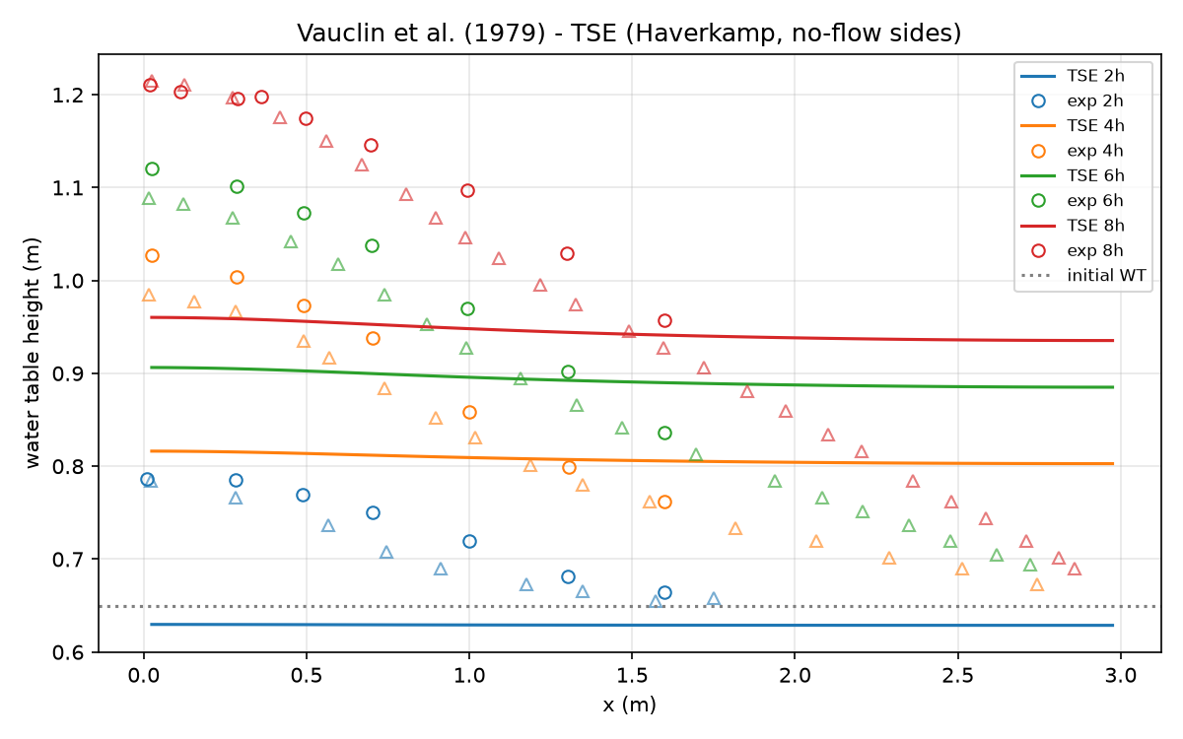

5 Numerical notes
- Inner solver choice. The saturated zone of a Richards problem is nearly elliptic (dS/dP = 0, c_t ≈ 0). Change-based SOR criteria stall there (the iteration change decays with a spectral radius ≈ 0.9999 per sweep, independent of dt and SOR over-relaxation), which makes the SOR path grind at MAXIT_P sweeps per Picard pass. The CG path (PSOLVER = 'CG') converges on the residual — the cell-wise mass balance error — and completes the 8 h Vauclin run in about one minute with a single dt reduction.
- Numba. All new kernels are @njit with the same parallel/nogil flags as the existing solvers; the red-black SOR closure captures only once-assigned arrays (preallocated bS/coef_C/coef_P refilled in place per Picard pass).
- Mass conservation. The mixed form with the Picard linearisation is exactly mass-conservative at convergence; the WP source test (4.3) and the Vauclin mass balance (4.5) confirm this to machine precision.

6 Files
Path | Content
tse.py | Richards implementation: config block, constitutive functions (sat_kr_point, dsdp_point), compute_P_RICH, compute_P_RICH_CG, richards_stencil, compute_q_RICH, update_S_kr_faces, main-loop integration
tse2pvd.py | ParaView export extended to the 35-element pickles (S appended)
benchmarks/richards/celia1990/ | 1D benchmark: config.py, analyze.py (independent reference solver), plot
benchmarks/richards/static/ | Hydrostatic equilibrium test
benchmarks/richards/wptest/ | WP source mass balance test
benchmarks/richards/vauclin1979/ | 2D benchmark: config.py, analyze.py, ref/ (digitised experiment and FE data), plot

References
- Celia, M.A., Bouloutas, E.T., Zarba, R.L. (1990): A general mass-conservative numerical solution for the unsaturated flow equation. Water Resources Research 26(7), 1483–1496.
- Vauclin, M., Khanji, D., Vachaud, G. (1979): Experimental and numerical study of a transient, two-dimensional unsaturated– saturated water table recharge problem. Water Resources Research 15(5), 1089–1101.
- Haverkamp, R., Vauclin, M., Touma, J., Wierenga, P.J., Vachaud, G. (1977): A comparison of numerical simulation models for one- dimensional infiltration. Soil Science Society of America Journal 41(2), 285–294.
- van Genuchten, M.Th. (1980): A closed-form equation for predicting the hydraulic conductivity of unsaturated soils. Soil Science Society of America Journal 44(5), 892–898.
- Shen, C., Phanikumar, M.S. (2010): A process-based, distributed hydrologic model based on a large-scale method for surface– subsurface coupling. Advances in Water Resources 33(12), 1524–1541.
- Shu, L. et al. (2020): SHUD v1.0. Geoscientific Model Development 13, 2743–2762.

