DEPARTMENT OF COMPUTER SCIENCE AND INFORMATiON TECHNOLOGY

UNITED INSTITUTE OF TECHNOLOGY

A PROJECT SYNOPSIS

ON

**TIGEN**

SUBMITTED IN PARTIAL FULLFILMENT OF THE REQUIREMENT FOR THE AWARD OF DEGREE

BATCH - 2018-2022



SUBMITTED BY:

ABHAY SHANKAR PATHAK

PRAGATI SRIVASTAVA

TARUN SINGH

UNDER THE SUPERVISSION OF

<GUIDE NAME HERE>

INTRODUCTION

Tigen is a scheduler which works on the algorithm namely genetic algorithm which is a part of evoltuionary searching and optimization problem in the field of Artificial Intelligence.

* In this project automatic time table scheduler application is created named as mention tigen.
* The manual time table scheduling demands considerable time and efforts along with lots of paperwork.
* While scheduling even the smallest constraints can take a lot of time and the case is even worse when the number of constraints or the amount of data to deal with increases or when the number of Faculties (Teaching Staff) are less, resulting in rescheduling of time table.
* This will become more hassle when the addition of new courses and newly enrolled students add to fresh batches. This may result in rescheduling the entire time table once again for its entire batches with keeping all constraints in mind.
* Thereupon, reducing the complexity of manual timetable Project Tigen will make it much easier and less workable.

Problem Statement

* As we know in universities , school, colleges etc alike organizations for the smooth arrangement of work they relies on time tables focus on tha case of the school or colleges where number of classes have to run on daily basis so an individual have the task to schedule all the classes such that their should be no clashes between two or more classes for 1 or 2 classes it is a easy task but think where every day approximayely 50 classes run on daily basis then scheduling all of them is a very regreous task so here our project comes into context it can schedule thes types of classes on daily basis with data provided suc as no of rooms , class timings ,description of courses, instructors as many constraints we can add to it.
* The difficulty faced during timetabling can be represented as a constraint satisfaction problem with loose parameters and many constraints.
* These constraints can be replicated in a format which can be managed by the scheduling algorithm in an organized manner.
* This Project will intend to display the Timetable as per the faculty is been  allotted for the respective subject in accordance to that rooms will be available

OBJECTIVE

1. The final system should able to generate time tables in completely automated way which will save a lot of time and effort of an institute administration .

2. User defined constraints handling.

3. Ease of use for user of system so that he/she can make automatic time table.

4. Focus on optimization of resources ie teachers, labs and rooms etc.

5. Generate multiple of generations for given particular data set without any conflict.

6.we tried to developed it for open source such that it can run on both windows and linux oprating system.

7.we have uses pure version control approach and usea git to manage all the versions and for the track of our works.

**Working :**

Genetic algorithm works on the method of bilogocal process how genes works in a living being there are various genetic operators such as selection , cross over , mutation all of them we are using in our algorithm developement , we have some of the hard constraints as well as aoft constraints which we have to manage when we ganerate a schedule hence we have taken care of many of these constraints.

CLASS DAIGRAM

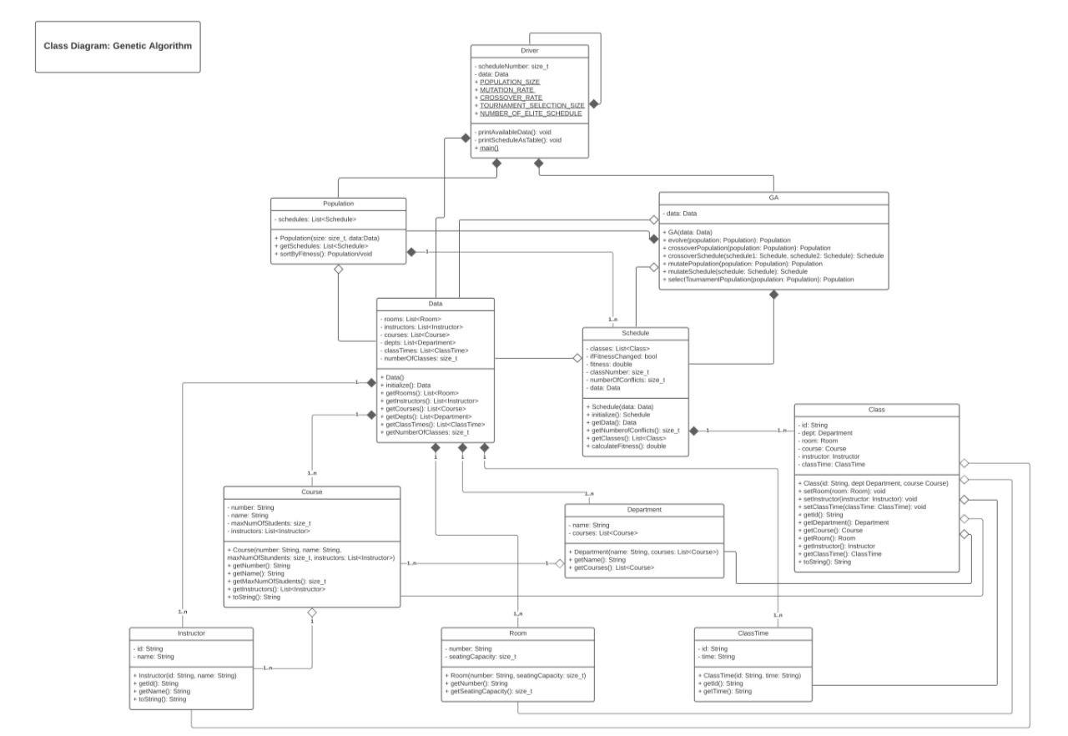

HARDWARE AND SOFTWARE REQUIREMENTS.

HARDWARE REQUIREMENTS:

1. Processor - corei3
2. Windows or Linux.

SOFTWARE REQUIREMENTS:

1. Windows 7 or above

2. Front-End:

* Wxwidgets (GUI)
* ncurses (Linux TUI)
* pdcurses (Windows TUI)

3. Back-End:

* C++

4.Database:

* MYSQL

5. Tools:

* Cmake (Building tool)
* Git (for version control)

FUTURE SCOPE

* This project can be streched to work for different organizations where scheduling is important.

For example :

1. Schools where Number of classes run according to schedule.

2. Coaching institutes.

3. It can also be help in medical organiztion where patient doctor scheduling can be possible.

* Hardware Interaction of the project is also possible in several ways.