**Documentation**

**Predish version 2.0**

October 2024

F. Pétronin, S. Lévy, M. Thomas, T. Lecocq

**Contents**

Installing Predish 2

Starting the application 4

Preparing the data 6

Using the application 8

Data upload 8

Data completion (facultative) 8

Choose the output dir 9

Run the predation risk calculation 9

# **Installing Predish**

1. Unpack the Predish.zip file (which you have already done!)
2. If R is not installed, download and install R and Rstudio at <https://posit.co/download/rstudio-desktop/>. Then go directly to «Starting the application.»
3. **If R is already installed, make sure it’s at least at the 4.0.5 version.** (Type «version» and press enter in your R gui). If not, an easy way to upgrade is to uninstall and reinstall it. A slightly more complicated way is to type in Rgui or Rstudio :

install.packages("installr")

library(installr)

updateR()

An installation wizard opens up. Follow its instructions.

Then, in Rstudio, you’ll need to change which R version to use. Go to Tools> Global Options.

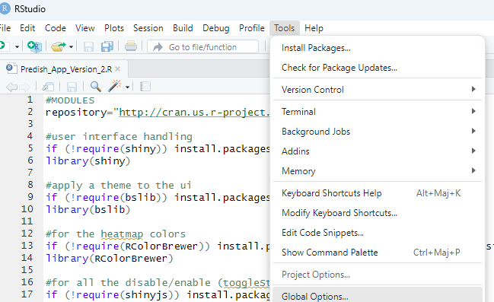

Then click on the «Change...» button, «Choose a specific version R» and click the latest one. Click « Ok »

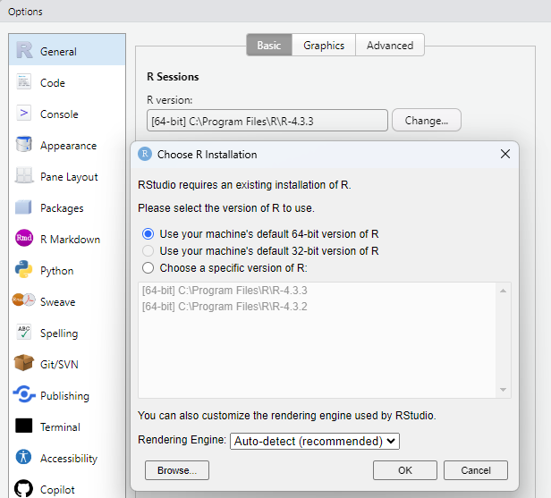

# **Starting the application**

1. Open Rstudio
2. In RStudio, use the file selector (located at the bottom the right) to navigate to the predish directory.

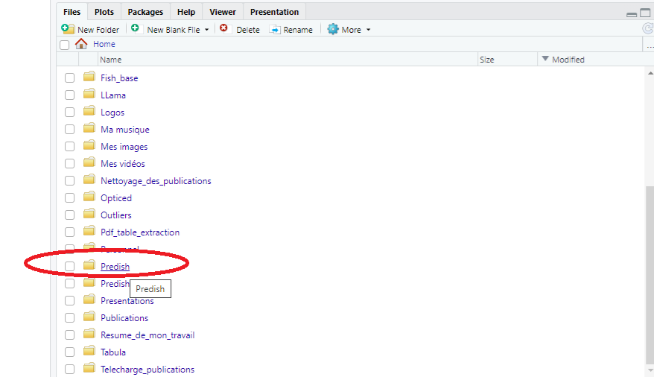

1. Open the file Predish_App_Version_2.R.

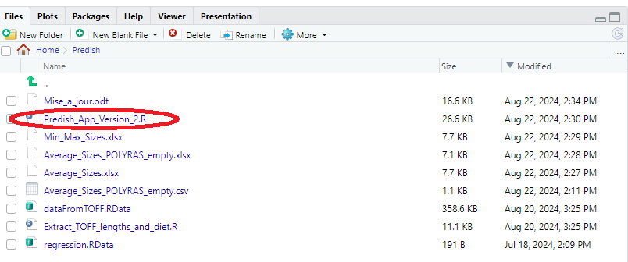

1. Click on "Run App" (the green arrow at the top of the screen) to launch the application.

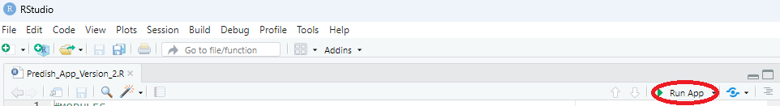

The first time you use the Predish application, any required packages will be automatically downloaded if they are not already installed. (Which can take a few minutes)

Even with the packages installed, the app can take a few seconds to load.

Once loaded, you should see the following window:

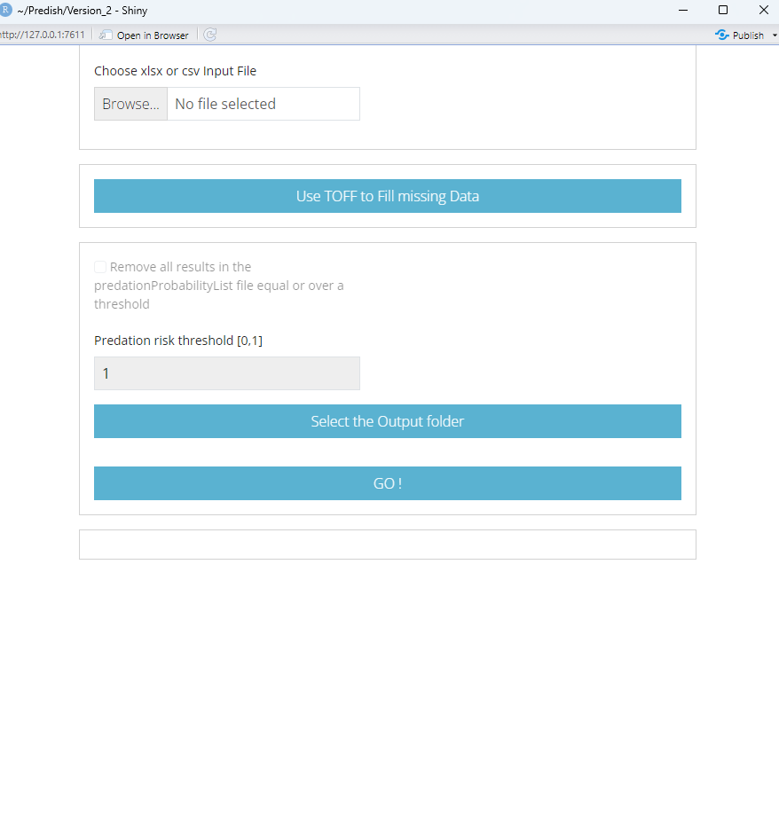

# **Preparing the data**

The Predish.zip file contains example input data files.

These files can be in either in xlsx or csv format (comma-separated) and should follow this structure:

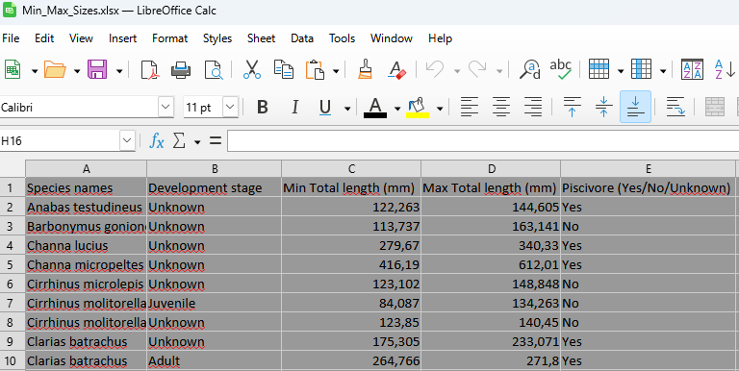

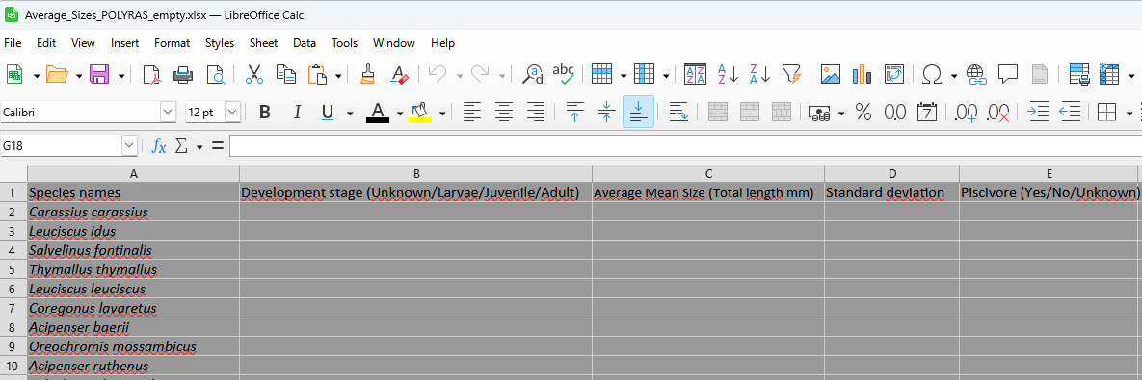

* The 3rd and 4th columns must be named labelled as either “Min Total length (mm)” and “Max Total length (mm)”, or “Average Mean Size (Total length mm)” and , “Standard deviation”.
* The species names column is mandatory, while the other columns can be left blank if necessary.
* The development stage must be one of the following: "Unknown,","Juvenile," "Adult," or left empty.
* The piscivore information must be "Yes," "No," "Unknown," or left empty.
* **Size data must be complete—for example, if you provide a minimum size, you must also provide a maximum size.**
* **Size data must be in total length of the fish (in mm).**

# **Using the application**

## Data upload

Import your data using the “Browse” button. If the upload is successful, the next two buttons will unlock. If there is an issue with your data, the interface will provide a warning and guide you through the correction process of your input files.

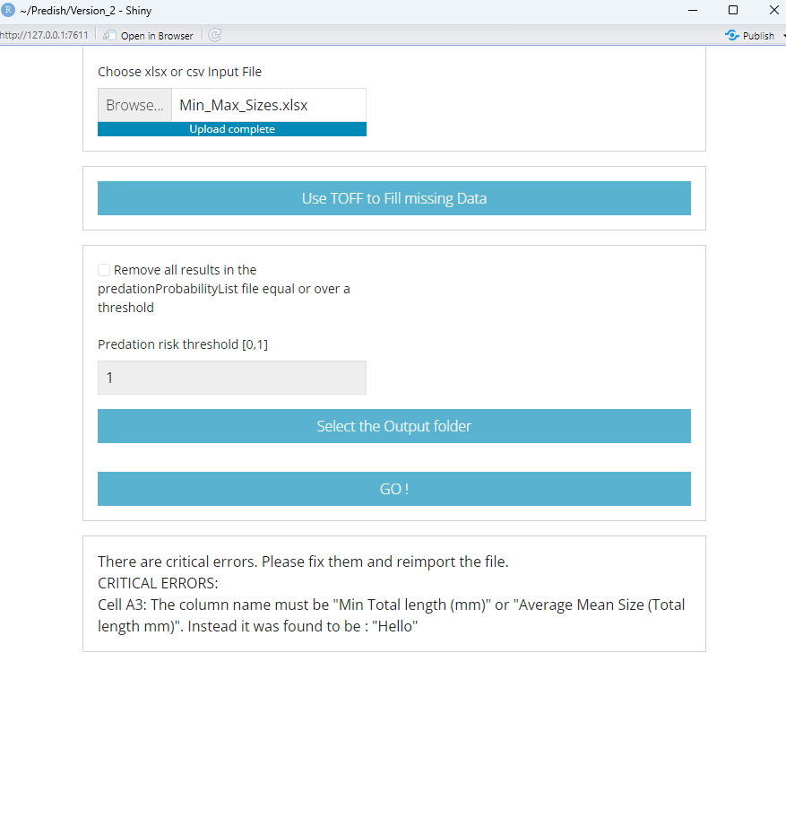

*An error example where «Min Total length (mm)» was replaced by «Hello».*

## Data completion (facultative)

If your data file is incomplete, you can choose to complete your data using TOFF dataset. To do that, the Predish.zip file should include a dataFromTOFF.RData file. As long as this file is in your working directory (i.e, the same folder as Predish_App_Version_2.R ), the application will recognize and use it correctly.

* To complete your dataset, the application first checks whether the species names in your data are present in TOFF. If a species is not found, the application will notify you, but it will not remove any data. It will still process all fish for which size data is provided.
* If size information is already provided for a species, the application will leave your data unchanged.
* If some size information is missing, the application will search for data in our database corresponding to the specified development stage.
* If the development stage is blank or marked as "Unknown," the application will search across all stages.
* Similarly, the application will attempt to fill in any missing piscvory data, without overwriting the information you have already provided.

This data completion process should take a few seconds.

**Please, be aware that all fish species for which no piscivory information is found will be considered as non-piscivorous for the following steps.**

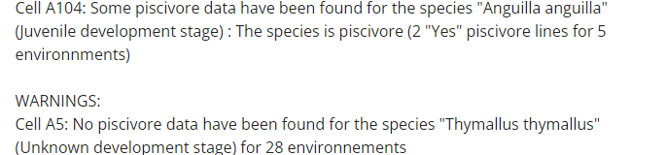

*(The interface will inform you of the data the application found. It will also warn you about the information it didn’t found.)*

## Choosing a threshold for the predation (facultative)

You can select the maximum predation probability you can tolerate in your system. To do so, click on the “Remove all results in the predationProbabilityList file equal or over a threshold” checkbox, then enter a value in the panel below. For example, a value of “1” will filter all predation probability values equal to 1. This filtering will only apply to the predationProbabilityList.xlsx file.

## Choosing the output directory

When you click «Select the Output folder», you will be able to choose the directory where your results will be stored.

**You can only navigate **within** your working directory.  
(this limitation is due to R, not the application)**

If a valid folder is selected, the final button will unlock.

## Run the predation risk calculation

The Predish.zip file should also include a regression.RData file. As long as this file is in your working directory, the application will be able to use it.

Click «GO !». The calculation should be extremely fast.

**The application will not overwrite existing output files; if such files are found, you’ll receive a warning.**

Four output files will be generated:

* predationRange.xlsx: Contains the predicted minimum and maximum prey sizes for each species (including non-piscivorous species, although this data isn’t used for them).
* predationProbabilityList.xlsx: Displays the probability that each species (first column) will be eaten by each piscivorous species (second column). This file is the only one where the predation cutoff given by the user will be applied.
* predationProbabilityMatrix.xlsx: Displays the probability that each species (rows) will be eaten by each piscivorous species (columns).
* predationProbabilityHeatMap.pdf: A heatmap of the predationProbabilityMatrix.xlsx, where red indicates a higher probability of predation.