## Full Stack Engineering-II

Project Report

Semester-VI (Batch-2022)

Skyline Voyages

**Supervised By: Submitted By:**

Rahul Singh Rajput Latika Bansal 2210991849

G-24 Lakshay 2210991839

Lovisha Goyal 2210991859

Llywellyn Sana 2210991854

Lakshay Asija 2210991843

**Department of Computer Science and Engineering**

Chitkara University Institute of Engineering & Technology,

Chitkara University, Punjab

**Index**

|  |  |  |
| --- | --- | --- |
| **S.No.** | **Title** | **Page No.** |
|  | Abstract | 3 |
| 2. | Introduction | 4 - 5 |
| 3. | Problem Definition and Requirements | 6 - 7 |
| 4. | Results | 8 |
| 5. | References | 9 |

**Abstract:**

The Tour Booking Website is a full-stack web application developed using the MERN stack (MongoDB, Express.js, React.js, and Node.js). This platform provides a seamless experience for users to explore, book, and manage tour packages. It offers key features such as user authentication, real-time availability checks, secure payment integration, and personalized recommendations.

The backend, built with Node.js and Express.js, handles user authentication, booking management, and API endpoints, while MongoDB stores user data, booking history, and tour details efficiently. The frontend, designed using React.js, provides an interactive and responsive interface for users to browse destinations, view pricing, and make reservations effortlessly.

To enhance user engagement, the system includes features like search filters, reviews and ratings, itinerary customization, and an admin dashboard for managing bookings and tours. Security measures such as JWT authentication and encrypted transactions ensure safe user interactions.

This project aims to simplify the tour booking process, offering a user-friendly and scalable solution for travel enthusiasts and agencies.

**Introduction**

* 1. **Background:**

With the rapid digital transformation across industries, the travel and tourism sector has significantly shifted toward online platforms. Traditional methods of booking tours, which required visiting travel agencies or making phone calls, have been replaced by digital solutions that offer greater convenience, flexibility, and efficiency.

The advent of web technologies, particularly full-stack development frameworks like the MERN stack (MongoDB, Express.js, React.js, and Node.js), has revolutionized the way businesses operate online. Tour booking websites have become essential for travel agencies and individual travelers, enabling seamless access to a wide range of destinations, tour packages, and personalized travel experiences.

Despite the availability of multiple online booking platforms, many suffer from issues such as lack of personalization, security concerns, limited payment options, and inefficient user experience. To address these challenges, the Tour Booking Website project is designed as a user-friendly, feature-rich, and scalable web application that enhances the tour booking process for travelers and service providers alike.

* 1. **Objectives:**

The primary objective of this project is to develop a comprehensive tour booking website that allows users to explore, book, and manage their travel plans efficiently. The specific goals include:

User Authentication and Profile Management: Implementing a secure login and registration system using JWT authentication to ensure data privacy and security.

Seamless Tour Search and Booking: Enabling users to browse various tour packages based on filters such as location, price range, duration, and user ratings.

Real-Time Availability and Booking Management: Providing an up-to-date booking system where users can check the availability of tours and receive instant booking confirmations.

Secure Payment Integration: Implementing secure payment gateways to facilitate hassle-free transactions.

Review and Rating System: Allowing users to share feedback and rate tour experiences, which enhances credibility and helps new users make informed decisions.

Personalized Recommendations: Utilizing machine learning techniques or rule-based algorithms to suggest tours based on user preferences and past interactions.

Admin Dashboard for Tour Operators: Offering an intuitive backend interface where administrators can manage tour packages, bookings, and customer queries efficiently.

* 1. **Significance:**

This project holds significant value for various stakeholders, including travelers, travel agencies, and businesses in the tourism sector.

For Travelers: It simplifies the booking process, provides an interactive and engaging user experience, and ensures secure transactions. The inclusion of reviews, ratings, and personalized recommendations makes it easier for travelers to choose the best tour options.

For Travel Agencies and Operators: The platform provides a streamlined system for managing bookings, tracking customer preferences, and handling inquiries, thus increasing operational efficiency and customer satisfaction.

For the Tourism Industry: By promoting digital adoption, this project contributes to the growth of online travel services and expands market reach for tour operators.

Moreover, the Tour Booking Website aligns with the growing trend of e-tourism, catering to the evolving needs of modern travelers who prefer digital solutions over traditional booking methods. The scalability of the MERN stack ensures that this project can be expanded with additional features such as multilingual support, AI-based chatbots, and itinerary planners, making it a versatile solution for the future of online travel booking.

**Problem Definition and Requirements**

**2.1 Problem Statement**

In the current digital landscape, travellers face challenges in finding and booking tours that precisely match their preferences. Existing tour booking platforms often offer limited search and filtering capabilities, making it difficult for users to find tours based on specific criteria such as location, group size, and distance. Additionally, the lack of secure payment methods and user-friendly interfaces hampers the overall booking experience. There is a need for a comprehensive solution that allows users to efficiently search, filter, review, and securely book tours, all within a single, intuitive platform. Tour booking Application addresses these challenges by providing a streamlined, user-centric tour booking application.

**2.2 Software and Hardware Requirements**

2.2.1. **Methods:**

The development of the Tour booking Application. application utilizes the MERN stack (MongoDB, Express.js, React.js, Node.js) for a full-stack solution. The project follows an agile development methodology, allowing for iterative progress and regular feedback. The application is built using a RESTful API architecture, enabling seamless communication between the frontend and backend. Git is used for version control, ensuring efficient collaboration among team members.

2.2.2. **Programming/Working Environment:**

• Frontend: React.js is used for building the user interface, providing a dynamic and responsive experience. HTML, CSS, and JavaScript are used alongside React.js for styling and functionality.

• Backend: Node.js, along with Express.js, serves as the backend framework. It handles routing, middleware, and API requests.

• Database: MongoDB is used as the database, providing a flexible and scalable NoSQL environment to store user data, tour details, and reviews.

• Development Tools: Visual Studio Code (IDE), Git (Version Control), Postman (API testing), and GitHub (Repository hosting).

2.2.3 **Requirements to Run the Application:**

Hardware Requirements:

• Processor: Intel Core i3 or equivalent

• RAM: 4GB or higher

• Storage: Minimum 10GB of free disk space

• Operating System: Windows 10, macOS, or Linux

Software Requirements:

• Node.js (v14.x or higher)

• MongoDB (v4.x or higher)

• NPM (v6.x or higher)

• React.js (v17.x or higher)

• Browser: Google Chrome, Firefox, or any modern browser

• Text Editor: Visual Studio Code or any modern code editor

**Results:**

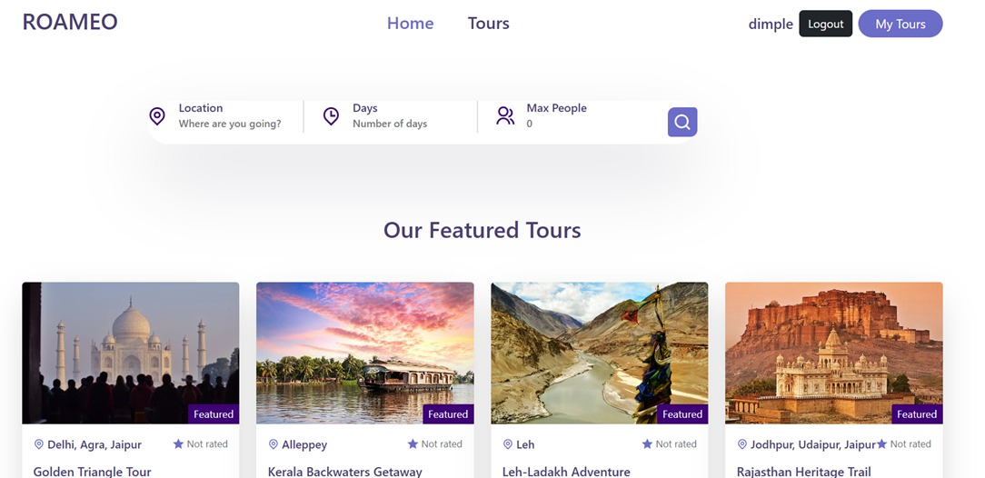

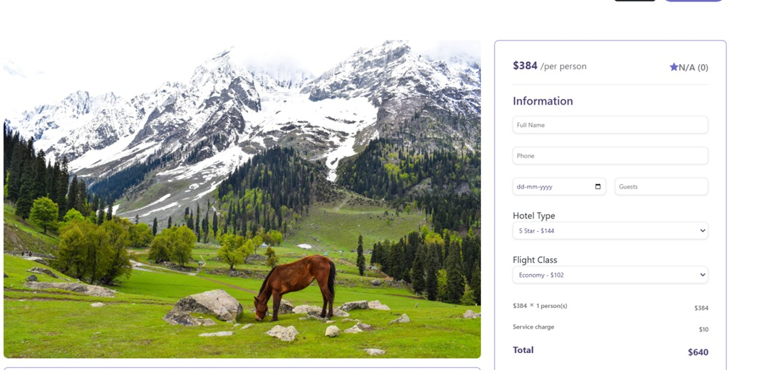

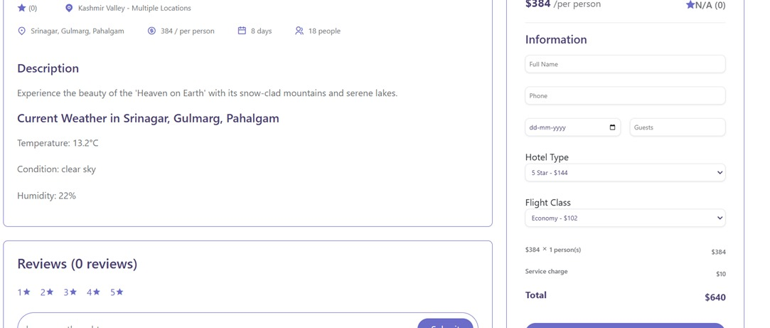

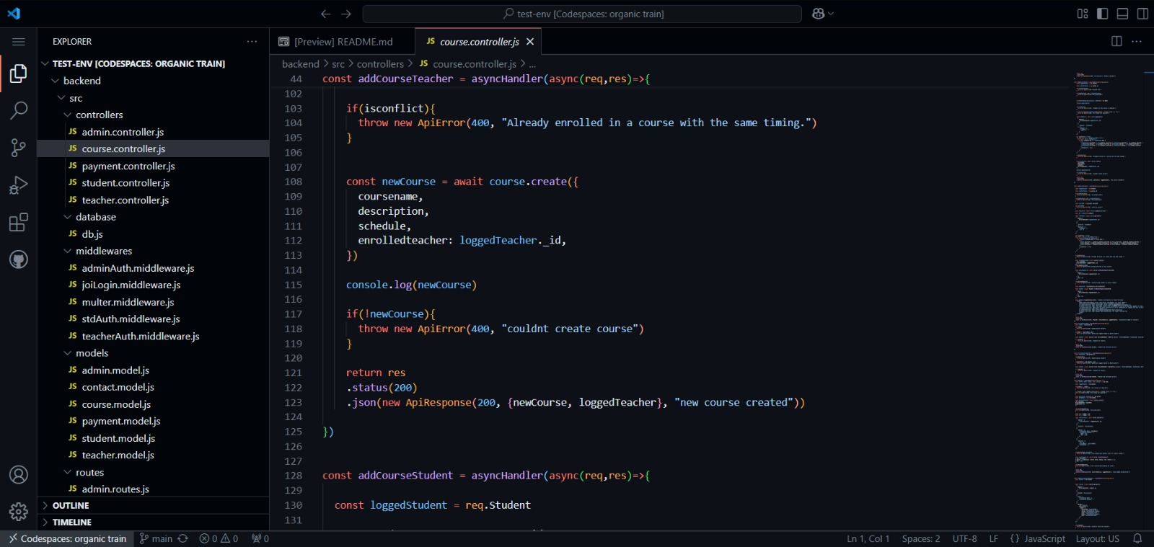

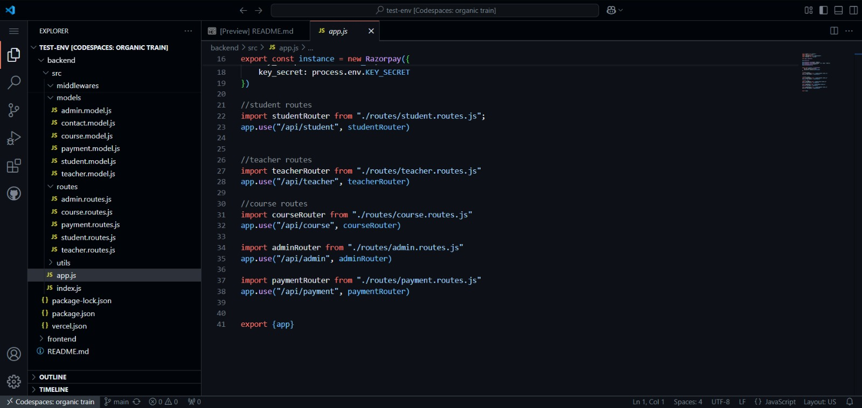

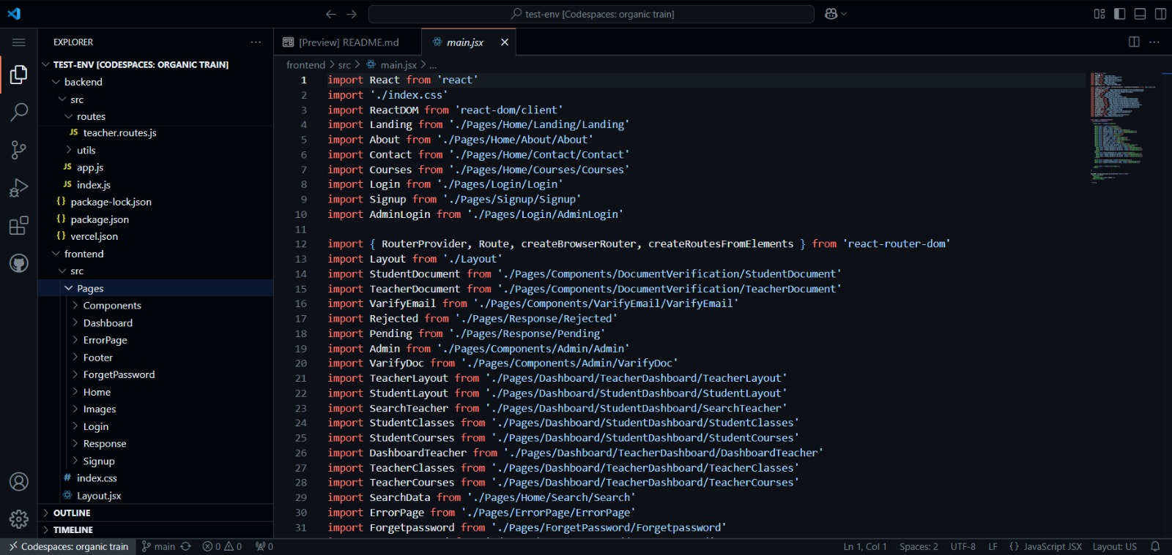

**References**

* https://developer.mozilla.org/en-US/docs/Web/JavaScript
* https://www.w3schools.com/
* Geeks for Geeks
* https://stackoverflow.com/