**TRƯỜNG ĐẠI HỌC BÁCH KHOA HÀ NỘI**

**TRƯỜNG CÔNG NGHỆ THÔNG TIN VÀ TRUYỀN THÔNG**

**------------*------------**



**CAPSTONE PROJECT REPORT**

**SUBJECT:**

**Housing price prediction**

|  |  |
| --- | --- |
| **Giáo viên hướng dẫn:** | Trần Việt Trung |
| **Sinh viên thực hiện:** | Hoàng Thanh Lâm  Phạm Thành Biên  Phạm Hải Đăng  Lê Đức Huy  Hoàng Quang Mạnh |

**TABLE OF CONTENTS**

**I.** **Problem Statement** 2

**II.** **Data Science methodology** 3

**1.** **Data Crawling** 3

**2.** **Data Preprocessing** 5

**3.** **Data Visualization** 6

**4.** **Model Training** 15

**III.** **Result** 18

**1.** **Final Result** 18

**2.** **Difficulties:** 20

**3.** **Future Improvement** 20

**IV.Conclusions** 21

**IV.** **Reference 22**

**Foreword**

In the dynamic realm of data science, where algorithms and analytics converge to uncover patterns and insights, the topic of housing price prediction stands as a testament to the transformative power of data-driven decision-making. As we navigate an era increasingly defined by technology, the ability to forecast housing prices has become a pivotal aspect of real estate, economics, and urban planning.

The Housing Price Prediction in Data Science subject represents an exciting exploration into the intersection of advanced statistical modeling, machine learning, and domain expertise. In this era of big data, where information flows in torrents, the ability to distill meaningful predictions from the data deluge has become paramount. Predicting housing prices extends beyond the confines of academic curiosity—it has tangible implications for homeowners, investors, policymakers, and the broader community.

This subject delves into a multifaceted landscape, addressing challenges that range from feature engineering and model selection to ethical considerations in algorithmic decision-making. Through hands-on exploration and theoretical understanding, students embarking on this journey will develop a keen sense of how to navigate the complexities inherent in housing market dynamics.

|  |
| --- |
| Our Team |
| Hoàng Thanh Lâm  Lê Đức Huy  Phạm Hải Đăng  Phạm Thành Biên  Hoàng Quang Mạnh |

# **Problem Statement**

• People looking to buy a new home tend to be more conservative with their budgets and market strategies.  
• This project aims to analyse various parameters like average income, average area etc. and predict the house price accordingly.  
• This application will help customers to invest in an estate without approaching an agent  
• To provide a better and fast way of performing operations.  
• To provide proper house price to the customers.  
• To eliminate need of real estate agent to gain information regarding house prices.  
• To provide best price to user without getting cheated.  
• To enable user to search home as per the budget.  
• The aim is to predict the efficient house pricing for real estate customers with respect to their budgets and priorities. By analyzing previous market trends and price ranges, and also upcoming developments future prices will be predicted.  
• House prices increase every year, so there is a need for a system to predict house prices in the future.  
• House price prediction can help the developer determine the selling price of a  
house and can help the customer to arrange the right time to purchase a house.  
• We use linear regression algorithm in machine learning for predicting the house price trends.

# **Data Science methodology**

## **Data Crawling**

Our team using webdriver from selenium to doing crawling task

First, we find “https//www.nhatot.com” is good web about housing price information and it contain enough information for us to crawl. In this website, we calculate that maximum of a web in each city by visiting last page of that and agree only information in hanoi is enough and data also good for learning purpose. So come to final, we use ha noi as default city and nhatot is default url and maximum page of hanoi have is 500



Afraid of losing data when we crawl because of device so when we have information about 5 page ( each page have 20 housing information ) we write into file and save.

After consider all appropiate field we decided to take only some data in this page

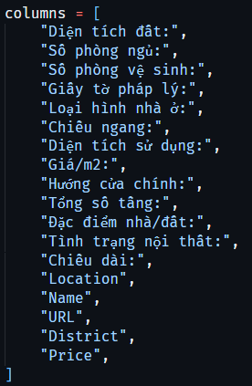

Webdriver is automatic tools to crawl, so we run loop to open each page of website, get data by function from webdriver that get contetnt by some class name or id element in that web.

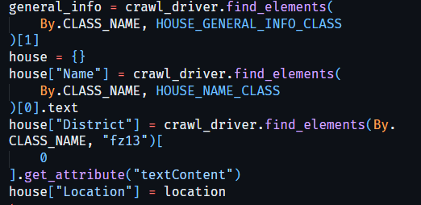

After long time we finally have data that we crawl 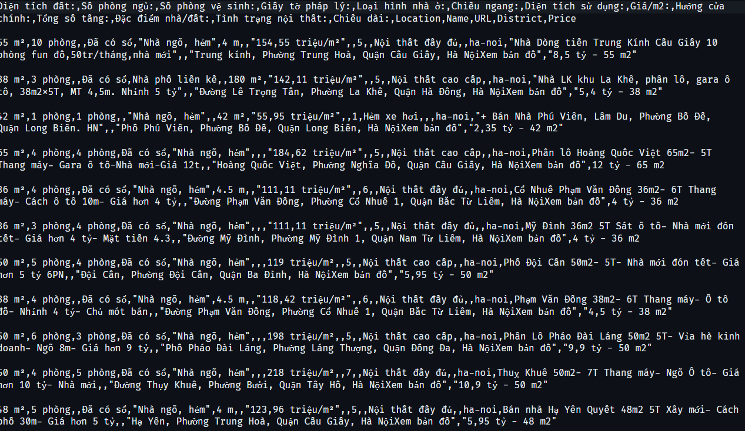

## **Data Preprocessing**

After the completion of the data crawling stage, the team proceeds to preprocess the data using the following steps [2]:

*Data normalization:

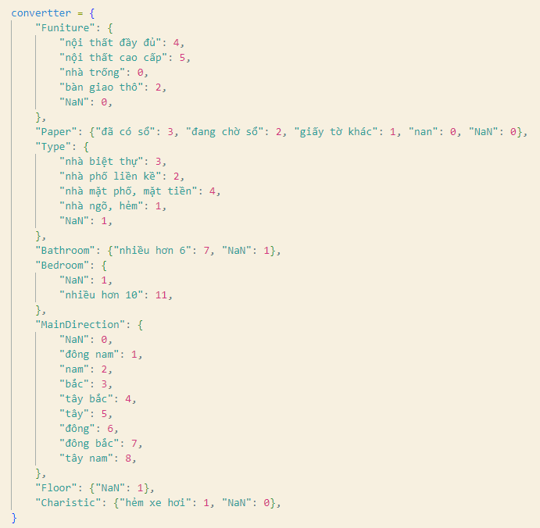

*Remove all duplicate , and null variable at “Price/m2”:

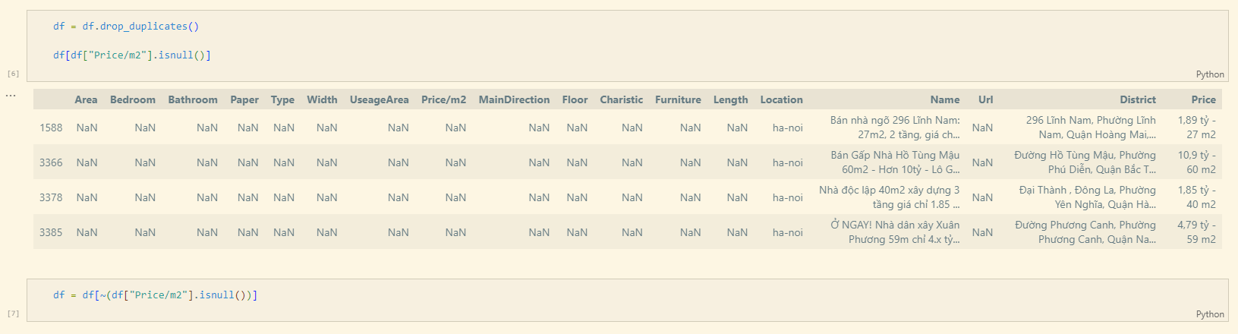

*Remove some field are not important, irrelevant:  
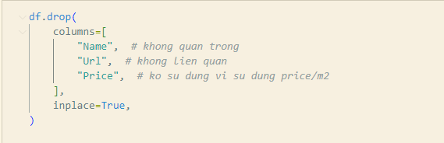

*Remove columns have too much null, lost information:

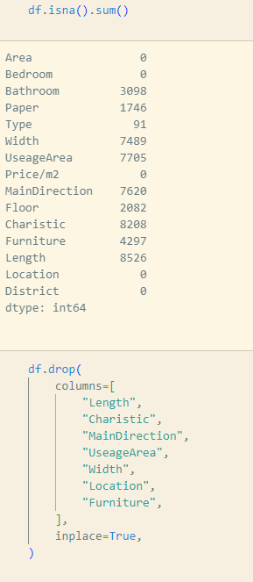

*Process data : convert to number:

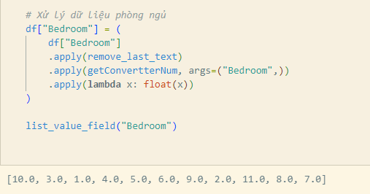

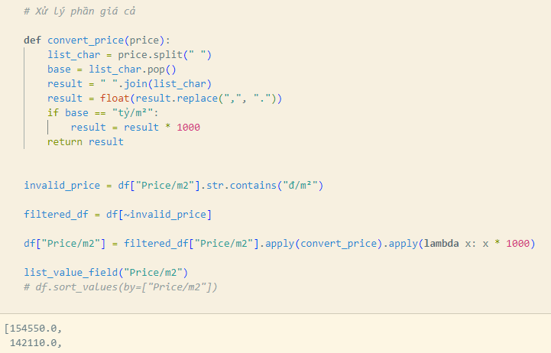

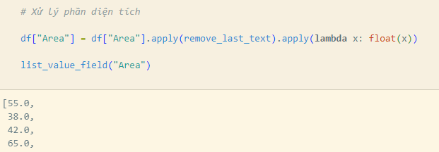

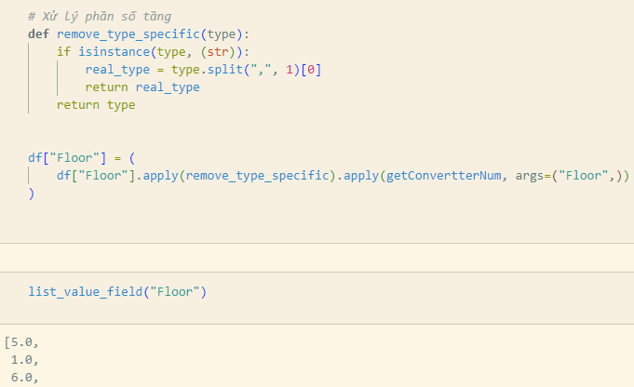

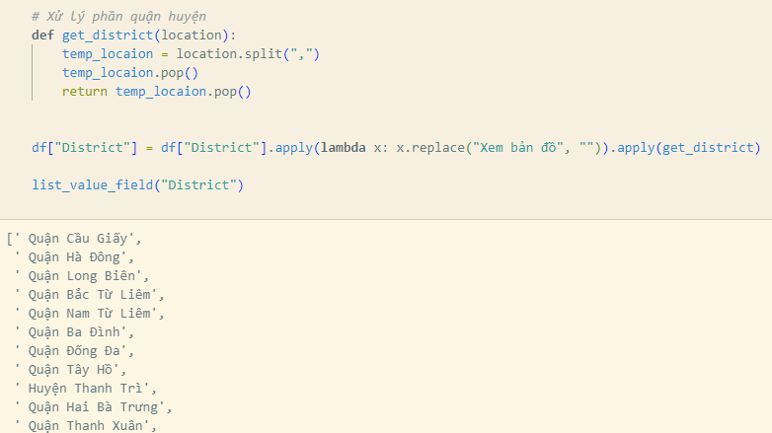

## **Data Visualization**

Our team visualizes the data after it has been cleaned and normalized in order to provide a first assessment of the obtained data set.

* 1. **The histogram shows the number and percentage of valid websites crawled by topic**

1. The bar chart illustrates the amount of crawled websites

1. The pie chart representing the percentage of the number of websites in each topic

* 1. **The WordCloud displays the most frequently used words by subject on websites**

*The text occurs in that topic more often when its icon is bigger.*

*Example:*

1. Sports

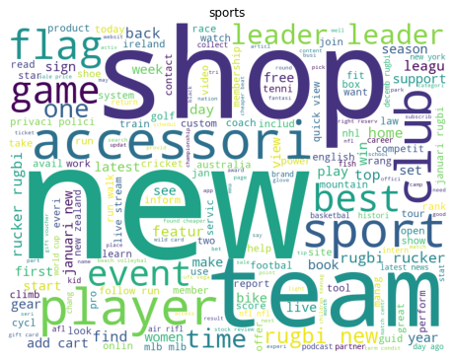

1. Science and Education



1. Pets and Animals

1. Travel and Tourism

**3.3 The bar chart that displays top 10 most frequently used words by subject on websites:**

*Example:*

1. Sport

1. Science and education

c)Pet and animals

d)Travel and tourism

**3.4 .Vectorization for feature extraction:**

Vectorization is one of the most useful approach for converting raw data input into vectors of real number that make machine learning code become more efficient.

CountVectorizer() from sklearn library is one of the helpful feature that help us keep dictionary of every word and also the frequency of each word in each document .However, there is a problem : as can be seen from the TOP 10 WORD’s bar chart ,the word “new” appears in most of categories and it is not really a special word that support us classify categories.TF-IDF helps us to resolve that issue by decreasing the important of the word “new”

**3.4.1 .TF-IDF Overview[3]:**

**a.TF**

TF stands for Term Frequency. It estimates the frequency of a word in an document. The formula of TF is:

**b.IDF**

IDF stands for Inverse Document Frequency .It estimates the importance of a word amongst the documents. The formula of IDF is :

Obviously, by taking IDF , we can downscale the frequent words while making the infrequent words have higher impact

The final formula to caculate TF-IDF score:

**3.4.2 .Apply TfIdfVectorizer:**



We use TfidVectorizer to vectorize our clean text.There are some parameters we use:

- min_df=0.01 means we ignore all the word that only appear less than 1% of all documents

-max_df=0.85 means we ignore all the word that appear more than 85% of all documents

-max_features=1500 means we only extract maximun 1500 features

-ngram_range=(1,3) means we also consider a sequence of 2 words ,3 words

After apply and extract top importance word, we can see the word “new” not appear in top 10 importance words of pets-and-animals or travel-and-tourism

**3.4.3: t-SNE Visualization**

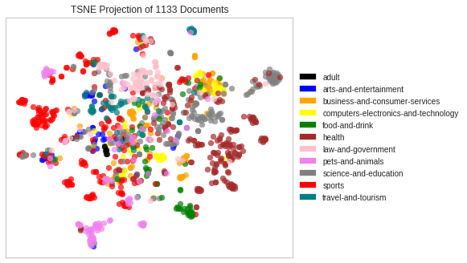

## **Model Training**

**4.1.Split dataset:**

We split the dataset into train set and test set (with ratio 8:2) and also keep the ratio between categories in training set and test set similar to the original ratio between them

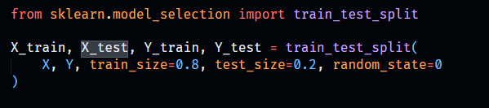

Train set include 793 records while this number in test set is 340:

**-**Train set :

-Test set:

**4.3. Apply LinearRegression**

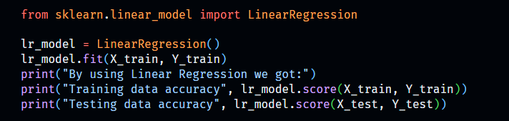

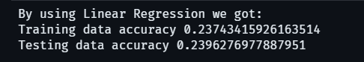

4.4 Apply RandomForestRegression

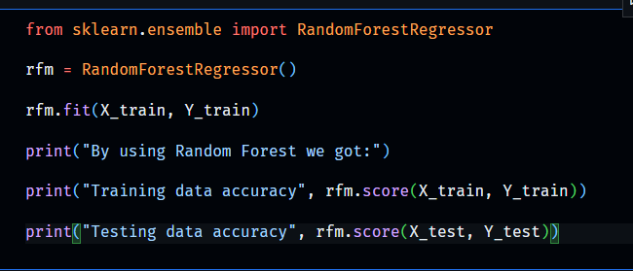

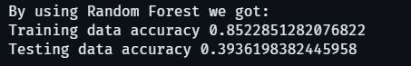

1. Conclusion

The reason why our model train’s result is quite bad because we think that our data crawling in web’s that is some marketing’s price and not real and we also collect many type of house like apartment, basement, …

# **Result**

## **Final Result**

**a)Training:**

*Accuracy: 0.93

*Classification report:

Confusion Matrix:

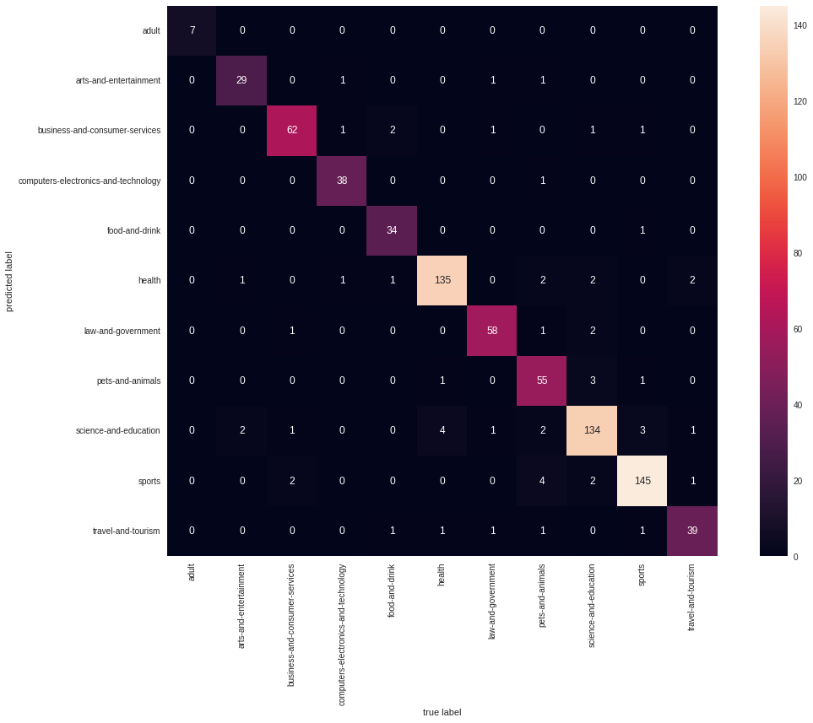

**b)Test:**

*Accuracy:0.77

*Classification Report:

*Confusion Matrix:

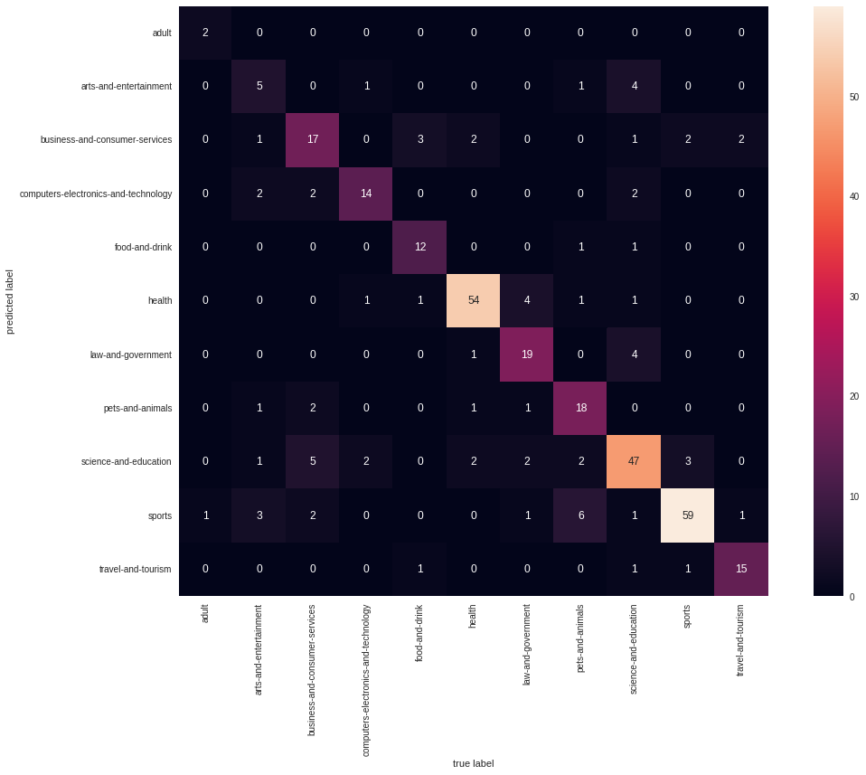

## **Difficulties:**

- The collected data is not large but it is time-consuming to collect. Difficult to continue if there is an error while crawling.

- The model accuracy is not bad but also not good. Especially , art-and-entertainment category always have a low precision in test.

## **Future Improvement**

## **-** In the future, for improvement, we are going to collect more data to increase the accuracy and detect if there are any noises in our dataset

## - In addition, we will try our best to handle the multi-class problem . Because some website we have had crawled may belong to more than 1 category and this can be the reason that make our model not work so well

-We will also try another model (SVM, Random Forest ,…) to make more improvement

## 

## **IV.Conclusions**

The report summarized the process our team did, with data science methodology. From the steps of problem statement, data collection, cleaning, model training as well as model evaluation with test set.

In this project, we tried our best to collect data, although we had to deal with a lot of faulty websites and websites that preventing us from crawling. We also learned Naïve Bayes classifier -an easy-to-implement algorithm for text classification .Despite its conditional independence assumption that rarely happening in real life, Naïve Bayes shows not bad performance in website categoring

Finally, completing this project in accordance with the data science methodology gave the team a true understanding of the process. It is not a process of downloading an existing dataset and then training to refine the model, but a practical process.

# Reference

1. <https://medium.com/website-categorization/website-categorization-api-ca6c3e0f6c4d>
2. Previous project : Email spam filtering. Nguyen Minh Tuan, Nguyen Thu Hieu
3. Understanding tf idf: <https://www.capitalone.com/tech/machine-learning/understanding-tf-idf/>
4. Slide L5-Probabilistic_learning ,PhD Nguyen Nhat Quang,Ha noi University of Science and Technology