PS 703106
Exercise 11

Group 4:
• Jonas Boutelhik
• Michael Thöni
• Thomas Urban

Hardware:
Intel i7-4710HQ was used for all calulations (Sequential and openMP)
Processor Base Frequency: 2.50 GHz (Quad-Core)

Problem:
Let A₁ , ... , A_{n} be a number of matrices of which the product A₁ × ... × A_{n} is to be computed. The size of these matrices is given by l₁ , ... , l_{n+1} , with matrix Ai having size l_{i} × l_{i+1} . Which parenthesis grouping minimizes computational costs assuming a standard matrix multiplication algorithm?
There are exponentially many ways of grouping the product terms, rendering an exhaustive search
for a larger number of matrices infeasible or impossible. Fortunately, this problem can be solved in
polynomial time using dynamic programming.

Algorithm:
The minimal cost c_{i,j} for computing the sub-product A_{i} × ... × A_{j} can be computed as

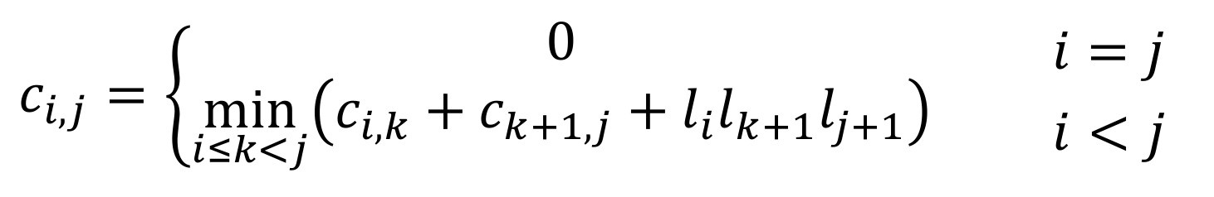

Hence, for every sub-product A_{i} × ... × A_{j} , the respective k that minimizes the computation

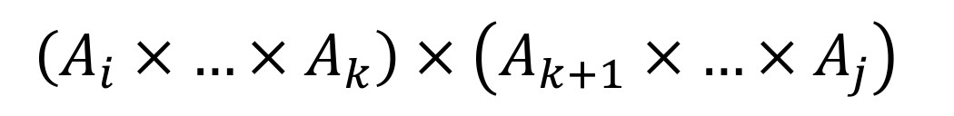

is to be found.

Assignment:
•Sketch the contents of matrix C for n = 5 and illustrate the data dependencies for
computing c_{2,2} , c_{1,3} , and c_{0,4} . Can you identify a general pattern? What does it look like?

The dependencies are shown in Fig. 1 and are illustrated as colored triangels.
- c_{2,2} has no dependencies because i = j and so c2,2 = 0 what results in distance d = 0.
- c_{1,3} has a distance of d = 2. So it depends from c_{1,1} , c_{2,2} , c_{3,3} , c_{1,2} and c_{2,3} which is illustrated by the dark blue triangle.
- c_{0,4} has a distance of d = 4. So it depends from all red nodes which are part of the yellow triangle.

→ it looks like a tree-structure with the nodes c_{2,2} , c_{1,3} and c_{0,4} as a root.

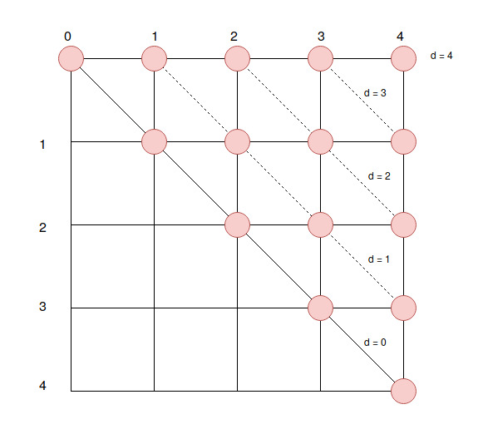
Figure 1: Calculation of minimal cost of matrix c_{i,j} for computing the sub-product A_{i} × ... × A_{j} with their depenencies and d = distance.
c_{1,3}
c_{0,4}
c_{2,2}

•Parallelize the given sequential implementation using OpenMP. Name this implementation
dynamic_programming_omp.c.

•Implement a tiled / blocked variant using OpenMP. Ensure that the block size is a compile-
time parameter and not hard-coded. Name this implementation
dynamic_programming_blocked_omp.c.

Implementation | Minimal costs [FLOPS] | Total processing time [s]
SEQ | 4048665 | 5,191
OMP | 4048665 | 3,583
BLOCK_OMP | 2340 | 0,129
Table 1: Program runtime for sequential, openMP and blocked openMP whereas min. costs = 4048665 FLOPS if the program terminates correct.

