VISION
CORE  VALUES | - Solve Pain Others Accept  - Win With the End in Mind  - Iteration Over Theory  - Move Fast, Stay Lean | 3-YEAR PICTURETM
Future Date: December 31, 2028
Revenue: $10M ARR
Proﬁt: $7M (70% margin)
Measurables:
- 7-10 FTEs (TM/SW/RS full-time at SWiM)
- 20% market penetration
- Retention => 90%
- LTV:CAC = 20:1
What does it look like?
- TM/RS/SW transitioned
- Developer team in place
- Platform IP compounds across verticals
- Partners have optionality
- One dominant lane (70%+ of revenue)
- Repeatable sales motion proven
- Non-dominant lanes monetized or killed
- Celebrating while winning – leadership retreat
- Family on the payroll
- National employee coverage

CORE  FOCUSTM | Purpose/Cause/Passion: Every independent operator deserves enterprise-grade intelligence.  Our Niche:  We solve the data and workflow problems that off-the-shelf software can’t for independent retail, self-storage, and the EOS ecosystem.
10-YEAR  TARGETTM | $100M enterprise value at exit with full liquidity for all partners.
MARKETING STRATEGY | Target Market/”The List”:  Retail: Premium distributors with 15+ retail partners  Storage: Owner-operators running 1-5 facilities  EOS: Active implementers seeking consistent lead flow  3 UniquesTM:  - AI isn’t a feature in our stack — it’s the operating layer our solutions are built on  - Real world experience  - Founder-led delivery, U.S. based team, lean by design  Proven Process: 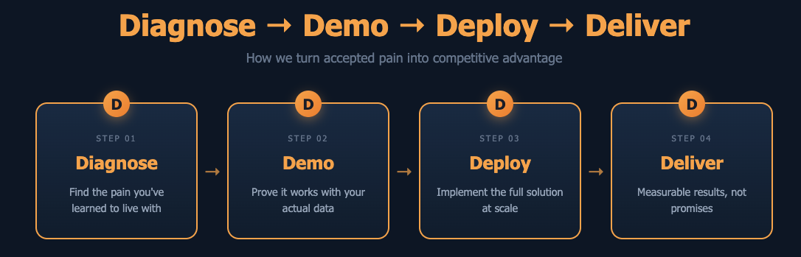  Guarantee: “We show you it works before you sign. That’s the SWiM difference.”

TRACTION
1-YEAR PLAN | ROCKS | ISSUES LIST
Future Date: December 31, 2026  Revenue: $1.14M ARR ($95K MRR)  Proﬁt: ~$855K (75% margin)  Measurables:  - 2 FTEs – 1 dev; 1 PPC  - LTV:CAC => 8:1  Goals for the Year:  1. Upsell Liverpool contract  2. Sign 2-3 additional retail vendor deals  3. 40 EOS clients  4. 100 paying Storage users by Q4  5. Channel partner for all SWiM lanes  6. Owner’s distributions  7. Establish thought leadership  8. Automate account execution for all lanes  With your cursor in the last row, press Tab to add another row. | Future Date: March 31, 2026  Revenue: $60K Booked  Proﬁt: $50K (83% margin)  Measurables:  - 10 retail leads  - 10 EOS leads  - 10 beta users onboarded  Rocks for the Quarter: Who  1. GTM for SWiM Retail RS  2. SWiM branding strategy established SW  3. SWiM EOS platform engine TM  With your cursor in the last row, press Tab to add another row. | 1. Tom bandwidth: one developer across three lanes  2. EOS proven process not yet launched  3. Agent platform is Shopify-only (POS coverage?)  4. Developer hire timing vs. cash flow  5. Tom’s JPM/SWiM balance sustainability  6. Scalable accountability chart  7. SW + RS weekly  8. Marketing budget  9. WD + TSM funnel  With your cursor in the last row, press Tab to add another row.  Prioritize  - Identify  - Discuss  - Solve

