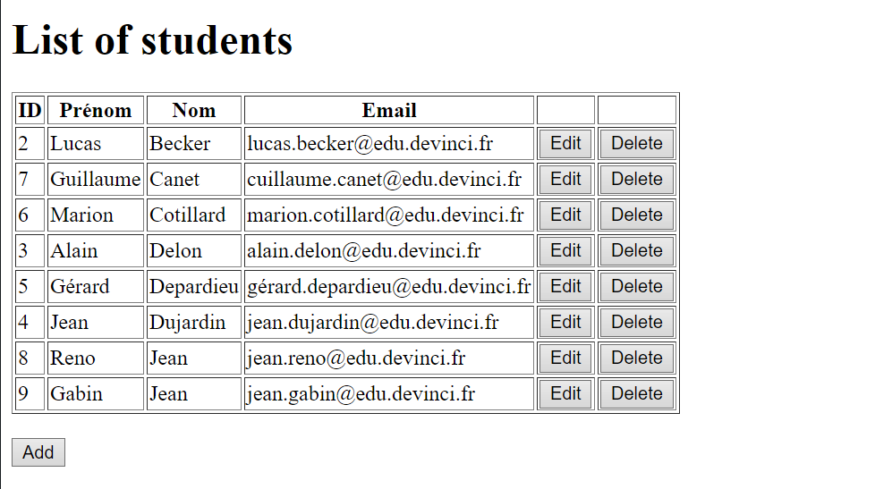

Dynamic WEB application

Web Student BOOK

Becker lucas & Ngo Thomas

IOS 1 – Promo 2022

## Description

In this project, we want to develop the « WebStudentBook » application using frameworks (JSF for JavaEE and EclipseLink for JPA).

The application allows us to:

* Display students from a MySQL student database in a browser.
* Add a new student to the database.
* Edit a displayed student.
* Delete a displayed student.

To make simple, a student is characterized by his:

* ID.
* First name
* Last name
* Email.

## The database

In the MySQL server, the database “studentdb” was created and initialized by a table:

* student: receive all the username and password for the login system

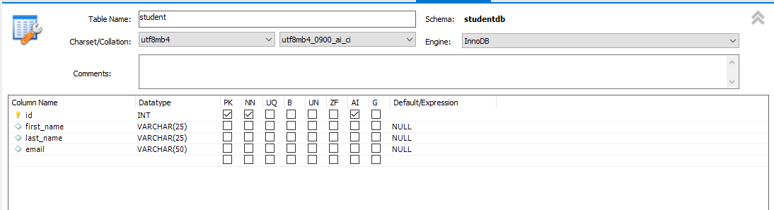

It was initialized by MySQL Workbench

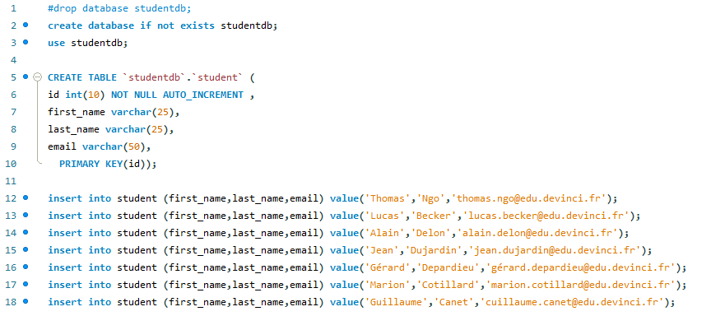

## How it WORKS?

Our program is based on MVC Design Pattern, it based on Managed Beans and JSF components.

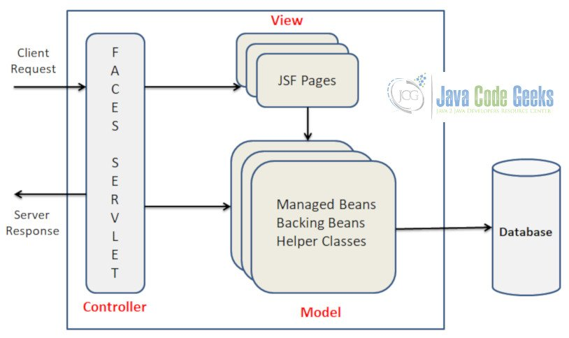

## Face servlets

We create several face servlets as shown in the picture below.



**List-student** is the main face servlet, it displays the list of students and the several modifications that we can do to it.

**Add-student** is the face servlet which allow us to enter student new information and send it to the database.

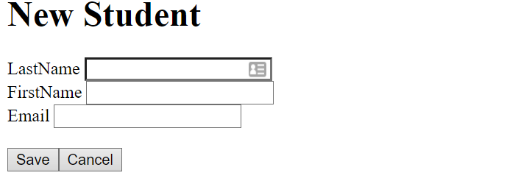

**Edit-student**, the face servlet which identify a student by his id and allow us to modify the information associate to this student

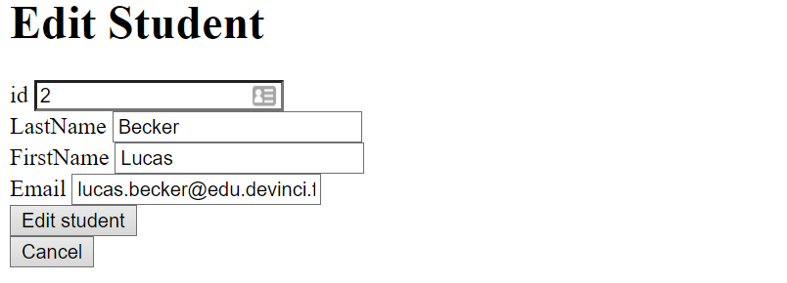

## Managed beans

We create three managed beans.

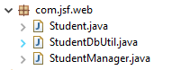

* The **student.java** have all the attribute of the student.

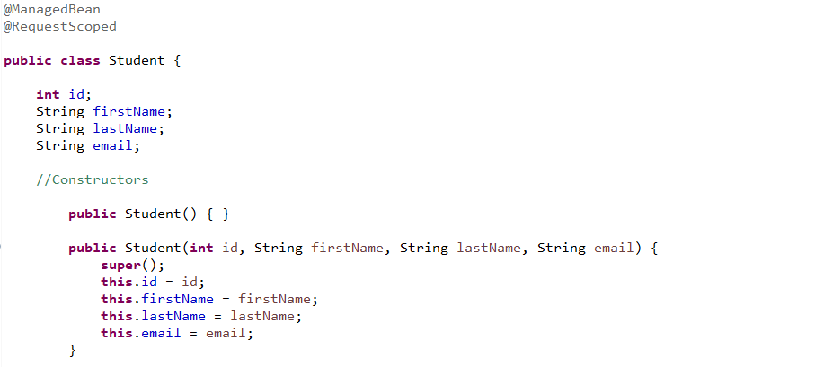

* **StudentDbUtil.java** is the model which managed the database.

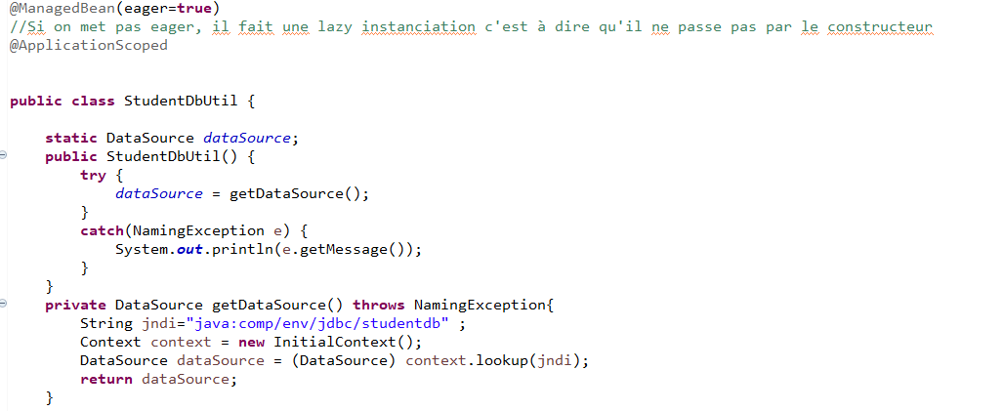

* **StudentManager.java** allows us to load, save, edit or even delete a student from the database.

