**Inhibition increase drives developmental decorrelation of neural activity**

#### **Mattia Chini1, Thomas Pfeffer2 and** **Ileana L. Hanganu-Opatz1**

*1Institute of Developmental Neurophysiology, Center for Molecular Neurobiology, University Medical Center Hamburg-Eppendorf, Hamburg, Germany*

*2Center for Brain and Cognition, Computational Neuroscience Group, Universitat Pompeu Fabra, Barcelona, Spain*

*Corresponding author: Mattia Chini

phone: +49 40 7410 56272

e-mail: mattia.chini@zmnh.uni-hamburg.de

xxx figures, xxx tables

Number of pages: xxx

Number of words in Summary: xxx

**Keywords:** E-I ratio,development, prefrontal cortex, decorrelation, spike trains, EEG, neural network modeling, optogenetics, cognitive impairment.

# 

# Abstract

It is unclear how, throughout development, the brain transitions from early stages in which neurons display highly synchronous activity patterns to a mature state in which neural activity is sparse and decorrelated. This transition has important functional consequences, as the latter state allows for more efficient storage, retrieval and processing of information. Here, we extend previous work and show that, in the developing mouse prefrontal cortex, neural activity decorrelates across timescales spanning more than three orders of magnitude. We provide extensive evidence revealing how excitation/inhibition (E-I) ratio is linked to the level of correlations between neurons in the mouse brain as well as in artificial neural networks. Across the first two postnatal weeks, in the mouse prefrontal cortex, a relative increase of inhibition drives the decorrelation of neural activity. Accordingly, in two mouse model of neurodevelopmental disorders, subtle alterations in E-I ratio are associated with specific impairments in the temporal structure of spike trains. Finally, we show that an analogous transition takes place also in the developing human brain. We conclude that changes in E-I ratio control the sparseness of neural activity, and that developmental imbalances in this process might be relevant for understanding the pathogenesis of neurodevelopmental disorders.

# Introduction

Early neural activity has several unique traits such as discontinuity1, extremely low firing rates2, a loose excitation-inhibition (E/I) balance3, and weak modulation by behavioral state4,5. Similar patterns of early activity have been described in humans6 as well as in disparate model organisms ranging from fishes7 to flies8, and rodents9 to brain organoids10. As brain networks mature, they gradually evolve into exhibiting motives with adult-like spatiotemporal properties. Oscillatory events become more rhythmic, increasing their amplitude and average frequency11, oscillation patterns become more complex10, E-I ratio decreases12 and tightens on a temporal scale3,13, and brain activity decorrelates and sparsifies14,15. The relationship between decorrelation and E-I ratio has been the subject of extensive experimental and theoretical work in the adult brain16–18. Decorrelated and sparse activity is a hallmark of adult spike trains19,20 and artificial neural networks alike21–23. This activity pattern bears important functional consequences, as it allows for efficient storing and retrieval of information, while minimizing energy consumption19,21,22. However, whether changes in E-I ratio underlie the developmental decorrelation of brain activity is not yet clear. The (pato)physiological relevance of this process is underscored by the fact that altered E-I ratio is shared across several neurodevelopmental disorders, such as autism24–28 and schizophrenia27,29 and these diseases have also been linked to altered levels of correlated activity in animal models30–32.

E-I ratio is controlled by the interplay between pyramidal neurons (PYRs) and interneurons (INs). Throughout development, both populations of neurons migrate into the cortex following an “inside-out” sequence that corresponds to their birthdate33. This process is guided by cues provided by PYRs, that populate the cortical layers at an earlier time point33. The functional integration of INs in the cortical circuitry is a slow process that undergoes the establishment of transient circuits that are dominated by somatostatin-positive (SST+) INs34,35. At later time points, parvalbumin-positive (PV+) INs are integrated into local networks34–36. In rodents, the development of inhibitory synapses is not complete until postnatal day (P)3037. It is thus conceivable that the developmental strengthening of inhibitory synapses, and the ensuing tilting of E-I ratio towards inhibition12, might underlie the decorrelation of neural activity. In favor of this hypothesis, chronic manipulation of IN activity in the murine barrel cortex resulted in impaired temporal and spatial structure of brain activity38–40. However, direct evidence linking E-I ratio and the strengthening of inhibition to the developmental decorrelation of brain activity is still lacking.

Here, using extracellular electrophysiological recordings, optogenetics, electroencephalography (EEG) and neural network modeling, we systematically explore the relationship between E-I ratio and the decorrelation of neural activity in the developing rodent and human brain. In the murine prefrontal cortex (PFC), a brain area where E-I ratio is of particular relevance in the context of neurodevelopmental disorders24, we show that inhibition increases and spike train decorrelate throughout early development 41,42. We further strengthen the link between these two processes by neural network modeling and bidirectional optogenetic manipulation of INs activity. Moreover, in two mouse models of impaired neurodevelopment, we report that decreased developmental E-I ratio results in lower spike train correlations. Finally, we illustrate the translational relevance of these findings by showing that an analogous developmental process takes place in two different EEG datasets recorded in newborn babies.

# Results

## **The electrophysiological dynamics of prefrontal activity evolve with age**

To investigate the relationship between E-I ratio and the decorrelation of neural activity that occurs throughout development, we interrogated a large dataset (n=117 mice) of extracellular recordings of local field potential (LFP) and single activity (SUA) from the prelimbic subdivision of medial PFC of unanesthetized mice of 2 to 12 postnatal (P) days of age (Figure 1A). Across this time window, the LFP evolves from an almost complete lack of activity (silent periods) to uninterrupted (continuous) activity, passing through intermediate stages in which silent periods alternate with bouts of coordinated neuronal activity (active periods) (Figure 1A). To quantify this transition, we calculated the proportion of active periods over the recording and found that it follows a smooth exponential increase over age (age slope=0.88, 95% C.I. [0.84; 0.93], p<10-50, generalized linear model) (Figure 1B). The increase in the proportion of active periods was initially driven by an increase in both the number as well as the duration of individual active periods and then, as activity became continuous, individual oscillatory bouts decreased and merged into longer ones (Supp. Figure 1A-C). Accompanying these high-level changes in activity dynamics, the maximum amplitude of active periods, the broadband LFP power, and the SUA firing rate also exponentially increased over age (age slope=0.24, 0.47 and 0.21, 95% C.I. [0.18; 0.30] [0.40; 0.53] and [0.15; 0.27], p<10-9, p<10-23, p<10-11, respectively, generalized linear model) (Figure 1C, Supp. Figure 1D-F).

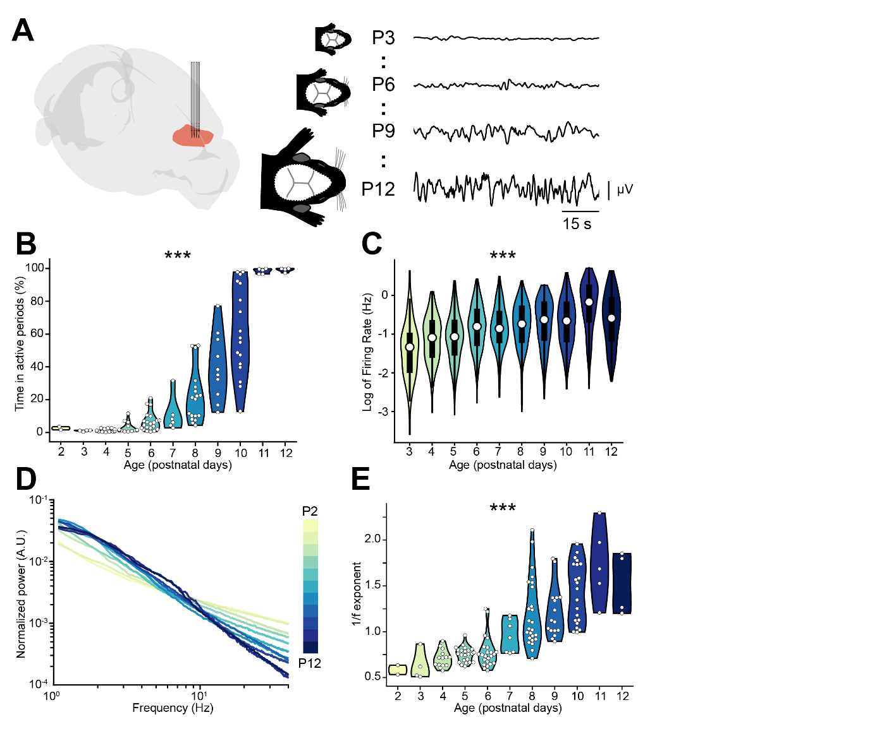

**Figure 1. Active periods and LFP properties of the mouse PFC across the first two postnatal weeks.**

(**A**) Schematic representation of extracellular recordings in the mPFC of P2-12 mice (left), and representative LFP traces from P3, P6, P9 and P12 mice (right).

(**B** and **C**) Violin plots displaying the percentage of time spent in active periods (B) and the SUA firing rate (C) of P2-12 mice (n=117 mice and 2269 single units, respectively).

(**D**) Log-log plot displaying the normalized median PSD power in the 1-40 Hz frequency range of P2-12 mice (n=117 mice). Color codes for age.

(**E**) Violin plot displaying the 1/f exponent of P2-12 mice (n=117 mice).

In (B) and (E) white dots indicate individual data points. In (C) data are presented as median, 25th, 75th percentile and interquartile range. In (B), (C) and (E) the shaded area represents the probability distribution density of the variable. In (D) data are presented as median. Asterisks in (B), (C) and (E) indicate significant effect of age. *** p < 0.001. Generalized linear models (B-C) and linear model (E). For detailed statistical results, see S1 Table.

Changes in the log-log power spectral density (PSD) slope (i.e. the 1/f exponent) have been linked to E-I ratio by several experimental24,43,44 and theoretical studies24,45,46. In particular, a relative increase in inhibition is thought of leading to a steeper PSD slope (higher 1/f exponent), whereas the opposite occurs when E-I ratio shifts towards excitation. Given that INs are thought to have a more protracted integration into cortical circuits that PYRs, we reasoned that this might be accompanied by a developmental shift of the E-I ratio towards inhibition. In line with this hypothesis, the PSD slope grew steeper over age, as readily observed when the area under the curve of the PSD was normalized (Figure 1D). To quantify this, we parameterized the PSDs using a recently published protocol47, and confirmed that the 1/f exponent increases over age (age slope=0.12, 95% C.I. [0.11; 0.14], p<10-27, linear model) (Figure 1E).

These data monitor the age-dependent dynamics of LFP and SUA in the mouse prefrontal cortex, and lead to the hypothesis that, throughout development, the E-I ratio tilts towards inhibition.

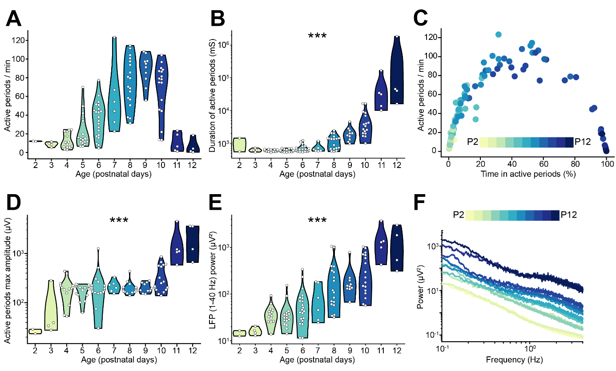

**Supp. Figure 1, related to Figure 1. LFP and SUA properties of the mouse PFC across the first two postnatal weeks.**

(**A** and **B**) Violin plots displaying the number (A) and duration (B) of active periods of P2-12 mice (n=117 mice).

(**C**) Scatter plot displaying the time spent in active periods with respect to the number of active periods per minute of P2-12 mice (n=117 mice). Color codes for age.

(**D** and **E**) Violin plot displaying the maximum amplitude of active periods (D) and the LFP power in the 1-40 Hz frequency range (E) of P2-12 mice (n=117 mice).

(**F**) Log-log line plot displaying the median LFP power in the 0.1-4 Hz frequency range of P2-12 mice (n=117 mice). Color codes for age.

In (A), (B), (D) and (E) white dots indicate individual data points and the shaded area represents the probability distribution density of the variable. In (F) data are presented as median. Asterisks in (B), (D) and (E) indicate significant effect of age. *** p < 0.001. Generalized linear models. For detailed statistical results, see S1 Table.

## **E-I ratio controls pairwise spike train correlations in a neural network model**

*To explore the relationship between the 1/f exponent, E-I ratio and the decorrelation of neural activity, we simulated a neural network of 400 interconnected leaky integrate-and-fire (LIF) neurons. Of these simulated neurons, 80% were excitatory (PYRs) and 20% were inhibitory (INs) (Figure 2A). PYRs were simulated with outgoing excitatory AMPA synapses, while INs were simulated with outgoing inhibitory GABA synapses. PYRs additionally received an external excitatory Poisson stimulus with a constant spike rate of 1.5 spikes / second. To compute the network LFP, we summed the absolute values of all synaptic currents on PYRs24,48. We manipulated E-I ratio by systematically varying the AMPA and GABA conductances on both PYRs and INs, and considered the ratio between GABA (gI) and AMPA (gE) conductance on PYRs as proxy of E-I ratio. Across all parameters combinations, INs fired more than PYRs, and both neuronal populations tended to decrease their firing rate in response to reduced E-I ratio (Supp. Figure XXX). In agreement with previous results24,46, E-I ratio strongly correlated with the 1/f exponent (stats here) (Figure 2B, Supp. Figure XXX).*

## **Prefrontal spike trains decorrelate over development**

Since neural network modeling predicts that a shift towards inhibition leads to higher 1/f exponent and decorrelation of neural activity, we tested whether the developmental increase in the 1/f exponent in the mouse PFC was accompanied by a decorrelation of neural activity. For this, we calculated the STTC between >40.000 pairs of spike trains over a large range of lags (2.5 ms to 10 s) (Figure 3A). To verify the robustness of STTC as an estimator, we compared the STTC obtained on the first and the second half of the recording. The STTC computed on the two halves of the recording strongly correlated with each other across all the investigated lags (0.70, [0.50; 0.80] median and min-max Pearson correlation; 0.70 [0.52; 0.79] median and min-max Spearman correlation) (Figure 3B, Supp. Figure 3A), thus corroborating its reliability as an estimator. Throughout the manuscript, we will consider STTC computed at 1 s, yet the summary plots and the supplementary statistical table include values calculated at all lags.

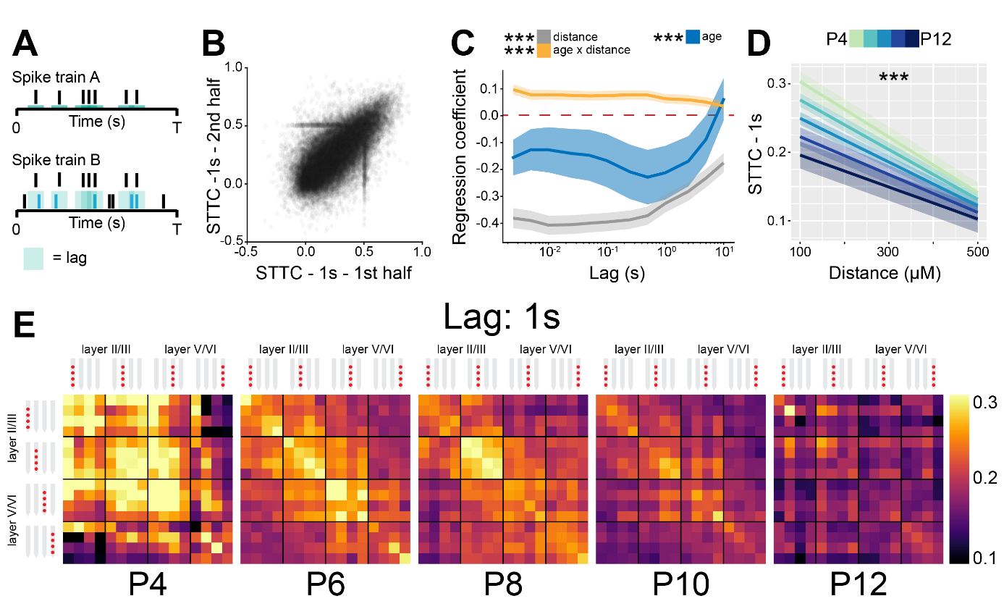

**Figure 3. The STTC decreases throughout development with a specific spatial profile in the mouse PFC.**

(**A**) Schematic representation of the STTC quantification.

(**B**) Scatter plot displaying the STTC computed in the 1st half of the recording with respect to STTC computed in the 2nd half of the recording (n=40921 spike train pairs and 82 mice).

(**C**) Multivariate linear regression coefficients with respect to STTC lag (n=40921 spike train pairs and 82 mice).

(**D**) Average STTC at 1 s lag of P4, P6, P8, P10 and P12 mice over distance (n=40921 spike train pairs and 82 mice). Color codes for age.

(**E**) Weighted adjacency matrices displaying average STTC at 1 s lag of P4, P6, P8, P10 and P12 mice as a function of the recording sites in which the spike train pair has been recorded. Color codes for STTC value.

In (C) regression coefficients are presented as mean and 95% C.I. In (D) data are presented as mean ± SEM. Asterisks in (C) indicate significant regression coefficients of the respective (interaction between) variables for STTC at 1 s lag. Asterisks in (D) indicate significant effect of age*distance interaction. *** p < 0.001. Linear mixed-effect models. For detailed statistical results, see S1 Table.

Using multivariate mixed hierarchical linear regression, we found that distance between neurons negatively correlated with STTC (i.e. nearby neurons had higher STTC values than neurons that are far apart) over all the investigated lags (main distance effect, p<10-78 at 1 s lag, linear mixed-effect model) (Figure 3C-E). This is in line with previous studies conducted in in the adult49–51 and developing brain14,52,53 of several mammalian species. Further, age negatively correlated with STTC values at lags ≤ 5 s (main age effect. p<10-4 at 1 s lag, linear mixed-effect model), an effect that was strongest in the 100-1000 ms range (Figure 3C-E). This developmental STTC decrease did not occur uniformly across all neuron pairs. Rather, nearby pairs of neurons displayed a more severe decorrelation over age than neurons that were further apart (age*distance interaction, p<10-12 at 1 s lag, linear mixed-effect model) (Figure 3C-E).

Next, we fitted a separate statistical model in which we also took in consideration the “spatial configuration” of the neuron pairs (Supp. Figure 3B, see Materials and Methods for details). Even after accounting for the distance between neuron pairs, particularly at short lags, we found that “local” (i.e. from the same recording site) and “lateral” (i.e. from the same layer) spike train pairs displayed the highest STTC values (STTC=0.73 and 0.70, 95% C.I. [0.66; 0.79] and [0.64; 0.76], respectively, linear mixed-effect model). “Translaminar” pairs (i.e. from the same “column") and pairs that did not fall in any of the previous categories (“other”) had the lowest STTC values (STTC=0.61 and 0.61, 95% C.I. [0.55; 0.67] and [0.55; 0.67], respectively, linear mixed-effect model) (Supp. Figure 3C-E). Further, “local” and “lateral” neuron pairs had a stronger developmental decrease in STTC values than “translaminar” and “other” pairs, particularly at short lags (Supp. Figure 3F, see S1 Table for details).

Taken together, these data indicate that, throughout development, as E-I ratio tilts towards inhibition, there is a concomitant decorrelation of pairwise neuronal activity computed over lags that span more than three orders of magnitude. This is in agreement with previous studies conducted in the rodent barrel cortex14,15. In addition, we report that this process follows a specific spatial and structural pattern, with the activity of nearby neurons that are in the same layer being the most affected.

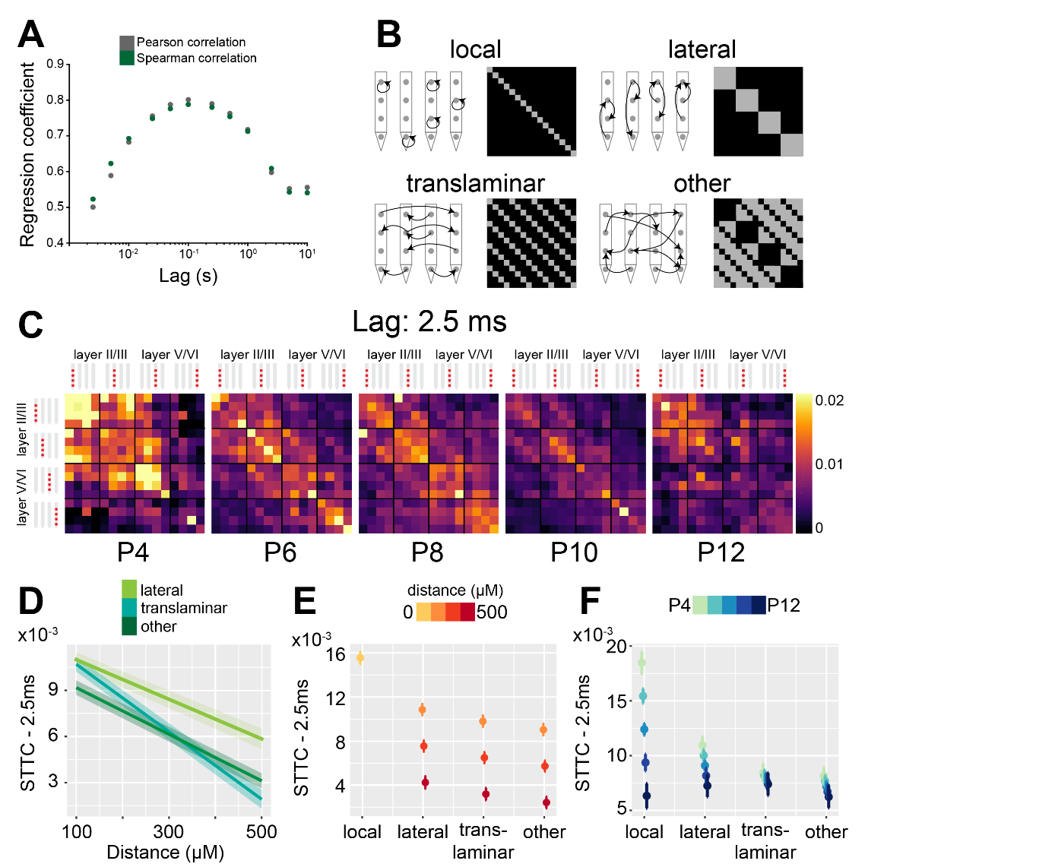

**Supp. Figure 3, related to Figure 3. The STTC developmental decrease follows specific spatial patterns in the mouse PFC.**

(**A**) Scatter plot displaying Pearson and Spearman correlation coefficient for STTC computed on the 1st and 2nd half of the recording over lags (n=40921 spike train pairs and 82 mice).

(**B**) Schematic illustration of the spatial configurations of spike train pairs.

(**C**) Weighted adjacency matrices displaying average STTC at 2.5 ms lag of P4, P6, P8, P10 and P12 mice as a function of the recording sites in which the spike train pair has been recorded. Color codes for STTC value.

(**D**) Average STTC at 2.5 ms over distance (n=40921 spike train pairs and 82 mice). Color codes for spatial configuration.

(**E** and **F**) Scatter plot displaying STTC as a function of spatial configuration (n=40921 spike train pairs and 82 mice). Color codes for distance (E) and age (F).

In (D-F), data are presented as mean ± SEM. Linear mixed-effect models. For detailed statistical results, see S1 Table.

## **Optogenetic interneuron manipulation confirm developmental increases of inhibition**

To gain more clear insights into the developmental increase of inhibition that we hypothesized as taking place in the mouse PFC, we optogenetically manipulated IN activity at different stages of early development. To this aim, we selectively transfected Dlx5/6+ and Gad2+ INs with either an excitatory (ChR2, n=19 mice) or an inhibitory opsin (ArchT, n=40 mice) using a combination of mouse lines and viral approaches. Briefly, expression of an excitatory opsin in INs was achieved by injecting Dlx5/6+ and Gad2+  mice with a virus encoding for ChR2 (AAV9-Ef1alpha-DIO-hChR2(ET/TC)-eYFP) at P0-P1. Expression of an inhibitory opsin was instead achieved by crossing Dlx5/6+ and Gad2+  mice with a mouse line (Ai40(RCL-ArchT/EGFP)-D) expressing ArchT under a cre-dependent promoter. No significant differences between experiments targeting Dlx5/6+ and Gad2+ neurons were detected and, therefore, the datasets were pooled. In line with previously developed protocols11,41,54, we applied a 3-second long “ramp-like” optogenetic stimulation of increasing intensity. This stimulation pattern gradually modulates the firing of the population of interest, while leading to minimal LFP artefacts42,55 (Figure 4A, Supp. Figure 4A).

While the LFP power was only mildly affected upon IN stimulation (Supp. Figure 4B), activation of INs shifted the E-I ratio towards inhibition as reflected by the 1/f exponent increase during stimulation when compared to baseline (main IN stimulation effect, p<10-3, linear model) (Figure 4B). In contrast to the minor effects on LFP, IN activation led to conspicuous modulation of SUA activity. Upon stimulus, a small number of neurons (putative INs) gradually increased their firing rate (Figure 4C). The proportion of stimulated INs was similar among mouse lines (main mouse line effect, p=0.14, generalized linear mixed-effect model) and across ages (main age effect=0.14, 95% C.I. [-0.04; 0.34], p=0.12, generalized linear mixed-effect model) (Supp. Figure 4C). This is in line with the histological quantification of the number of virally-transfected neurons that led to similar results for all mouse lines (main mouse line effect, p=0.45, linear mixed-effect model) and developmental stages (main age effect=-1.35, 95% C.I. [-3.22; 0.51], p=0.18, linear mixed-effect model) (Supp. Figure 4D). While putative INs increased their firing rate in response to optogenetic stimulation, a larger proportion of neurons (putative PYRs) significantly decreased their firing rate (Figure 4B). In line with our previous results that indicated increasing inhibition throughout development, the proportion of inhibited neurons augmented with age (main age effect=0.31, 95% C.I. [0.09; 0.55], p=0.005, generalized linear mixed-effect model) (Figure 4D). Regardless of age, after terminating the optogenetic stimulus, PYRs responded with a prominent “rebound” increase in firing rate, similar to what has been reported in the adult brain56,57.

To dissect the different principal “neuronal trajectories” during and after light stimulation in relationship with age, we performed principal component analysis (PCA) on trial-averaged smoothed and normalized spike trains. The two principal components that captured the dynamics of putative PYRs (1st component) and inhibitory (2nd component) neurons, were strikingly similar across age groups (Figure 4E). This indicates that, while the inhibition strength exerted by INs increases throughout development, the dynamics with which the PYR‑IN network responds to IN activation do not change across the first two postnatal weeks. These data provides support to the notion that, on a network level, GABA exerts an inhibitory effect already in the first postnatal week58,59.

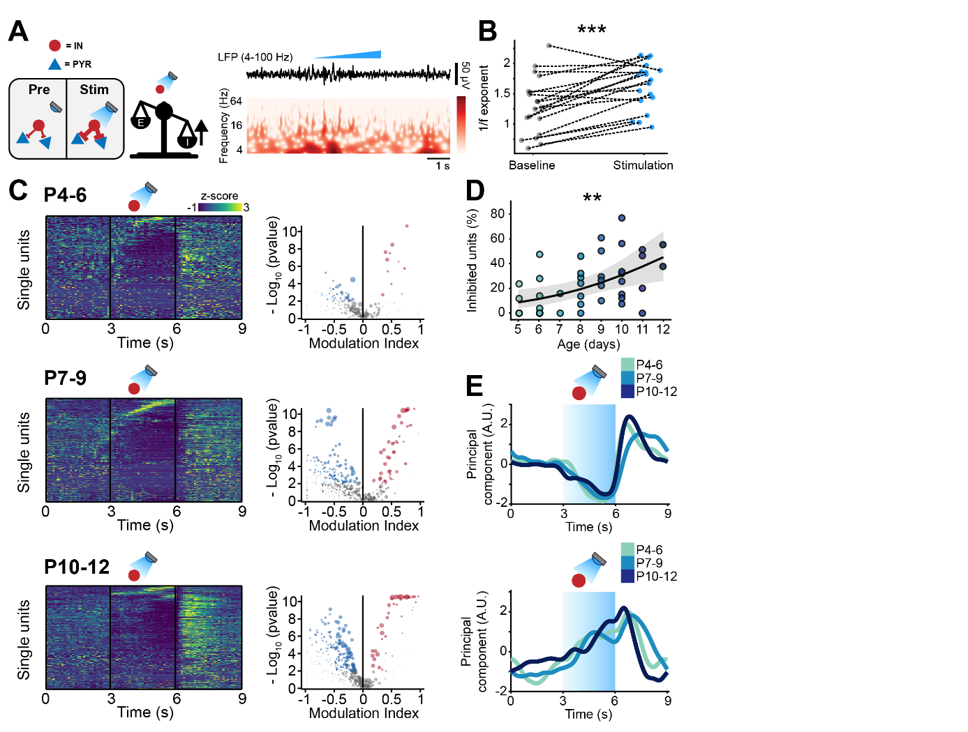

**Figure 4. Optogenetic stimulation of IN activity leads to widespread inhibition in the developing mouse PFC.**

(**A**) Schematic representation of the effects induced by optogenetic IN stimulation (left). Representative LFP trace (4-100 Hz band-pass filter) with a corresponding wavelet spectrum at an identical timescale during ramp light stimulation (473 nm, 3 s) of INs in the mPFC of a P10 mouse.

(**B**) Scatter plot displaying the 1/f exponent during baseline and IN optogenetic stimulation (n=19 mice).

(**C**) Z-scored single unit firing rates in response to optogenetic stimulation of INs (left) and volcano plot displaying the modulation index of pre vs stim single unit firing rates (right) for P4-6 (top, n=268 units and 5 mice), P7-9 (middle, n=480 units and 7 mice) and P10-12 (bottom, n=475 units and 7 mice) mice.

(**D**) Scatter plot displaying the percentage of inhibited units with respect to age (n=19 mice).

(**E**) 1st (top) and 2nd (bottom) PCA component of trial-averaged spike trains in response to optogenetic stimulation of INs. Color codes for age group.

In (D) the regression is presented as mean and 95% C.I. Asterisks in (B) and (D) indicate significant effect of IN activation and age, respectively. ** p < 0.01, *** p < 0.001. Linear model (B) and generalized linear mixed-effect model (D). For detailed statistical results, see S1 Table.

To corroborate these results, we carried out analogous experiments in mice expressing an inhibitory opsin in INs (Figure 5A, Supp. Figure 4E). Optogenetic inhibition of INs led to conspicuous effects on LFP power, with an increase that was mostly limited to lower frequencies in P2-P6 mice and covered a broader frequency spectrum at older ages (Supp. Figure 4F). Further, inhibiting INs paradoxically tilted E-I ratio towards inhibition and induced an increase in the PSD slope when compared to baseline (main IN inhibition effect, p=0.017, linear model) (Figure 5B). Analogous paradoxical effects induced by IN inhibition have already been reported in the literature, and are attributed by rebound IN excitation13. In support of this hypothesis, the PSD slope computed on the 2nd half of the stimulation showed a tendency towards increasing that bordered statistical significance when compared to the PSD slope computed on the 1st half of the stimulation (main condition effect, p=0.053, linear mixed-effect model) (Supp. Figure 4G).

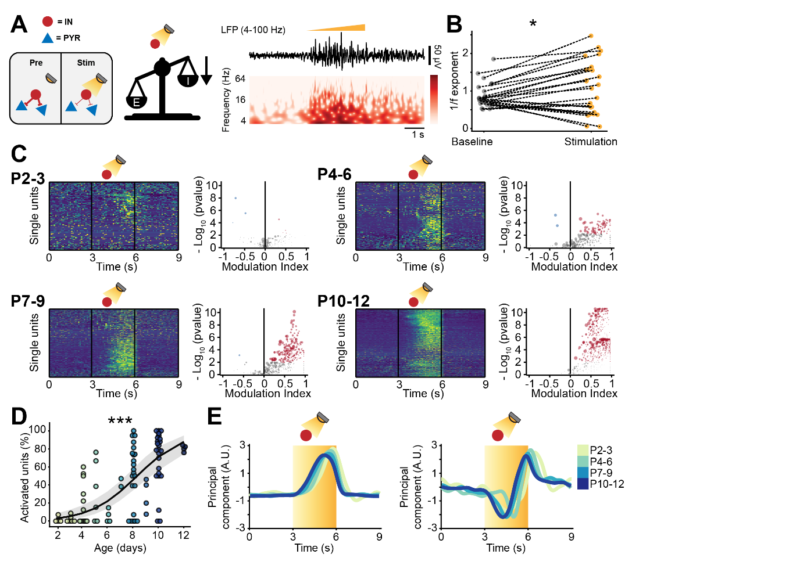

**Figure 5. Optogenetic inhibition of IN activity leads to widespread excitation in the developing mouse PFC.**

(**A**) Schematic representation of the effects induced by optogenetic IN inhibition (left). Representative LFP trace (4-100 Hz band-pass filter) with a corresponding wavelet spectrum at an identical timescale during ramp light stimulation (525 nm, 3 s) of INs in the mPFC of a P10 mouse.

(**B**) Scatter plot displaying the 1/f exponent during baseline and IN optogenetic inhibition.

(**C**) Z-scored single unit firing rates in response to optogenetic stimulation of INs (left) and volcano plot displaying the modulation index of pre vs stim single unit firing rates (right) for P2-3 (top left, n=164 units and 5 mice), P4-6 (top right, n=286 units and 11 mice), P7-9 (bottom left, n=470 units and 13 mice) and P10-12 (bottom right, n=691 units and 11 mice) mice.

(**D**) Scatter plot displaying the percentage of activated units with respect to age (n=40 mice).

(**E**) 1st (top) and 2nd (bottom) PCA component of trial-averaged spike trains in response to optogenetic inhibition of INs. Color codes for age.

In (D) the regression is presented as mean and 95% C.I. Asterisks in (B) and (D) indicate significant effect of IN inhibition and age, respectively. * p < 0.05, *** p < 0.001. Linear model (B) and generalized linear mixed-effect model (D). For detailed statistical results, see S1 Table.

Conforming with this interpretation, light-induced IN silencing resulted in a widespread progressive increase of firing, with very few inhibited neurons (12/1611 neurons*trials) (Figure 5C). Independent of age group, the increased firing abruptly returned to baseline levels upon terminating the optogenetic stimulus (Figure 5C). The proportion of neurons responding with an increase in during IN inhibition augmented with age (main age effect=0.54, 95% C.I. [0.37; 0.74], p<10-8, generalized linear model) (Figure 5D). To qualitatively compare “neuronal trajectories”, we performed trial-averaged PCA. The 1st component that captured the activity of putative PYRs responded to the light stimulus with a monotonic rise of firing rate, that quickly dropped as soon as the stimulus stopped (Figure 5E). On the contrary, and in line with previous experimental13,60,61 and theoretical work62,63 in the adult brain, putative INs (the trajectory captured by the 2nd component), had a biphasic response. They were initially inhibited but, halfway through the optogenetic stimulation, displayed a steep increase in firing rate, that persisted until end of the stimulus (Figure 5E). This “paradoxical” increase in interneuronal firing rate emerged more rapidly as mice developed (Figure 5E), and might be the cause of the shift of the 1/f exponent towards higher values. Thus, while the network excitation derived from IN inhibition increases throughout development, the dynamics with which the PYR‑IN network responds to IN inhibition do not change across the first two postnatal weeks. These data provides support to the notion that, on a network level, GABA exerts an inhibitory effect already in the first postnatal week58,59.

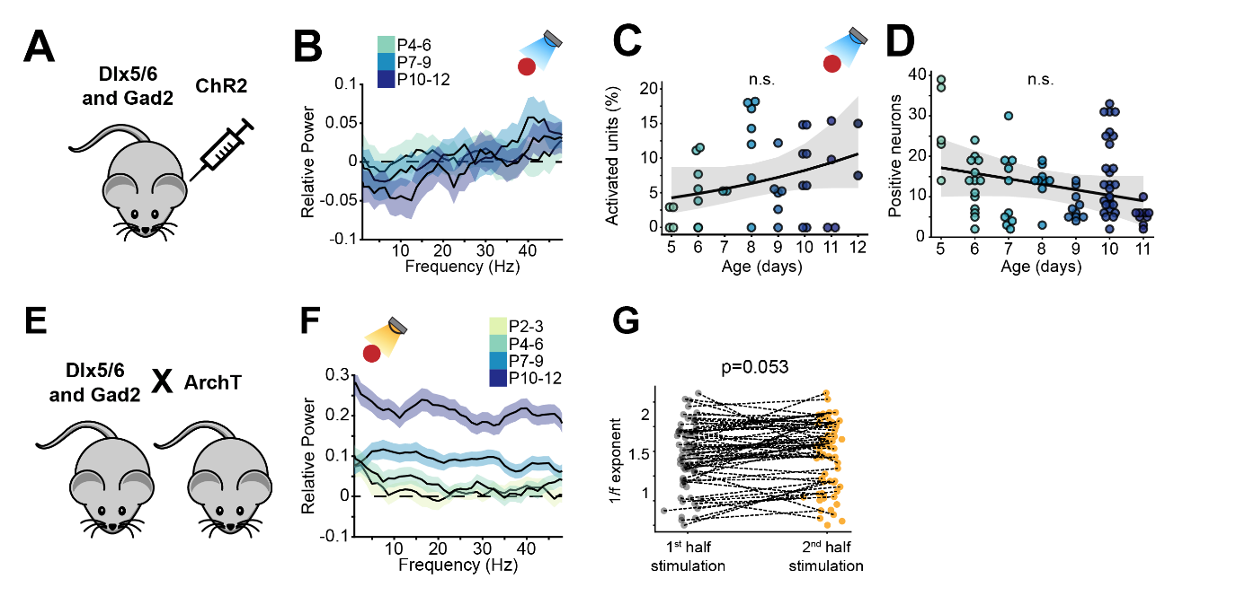

**Supp. Figure 4, related to Figures 4 and 5. Optogenetic manipulation of IN activity affects LFP activity in the mouse developing PFC.**

(**A**) Schematic representation of the experimental approach employed to target INs with an excitatory opsin.

(**B**) Relative LFP power in response to ramp light stimulation of INs (n=19 mice). Color codes for age group.

(**C**) Proportion of activated units in response to ramp light stimulation of INs as a function of age (n=19 mice).

(**D**) Number of virally transfected neurons as a function of age (n=87 images and 16 mice).

(**E**) Schematic representation of the experimental approach employed to target INs with an inhibitory opsin.

(**F**) Relative LFP power in response to ramp light inhibition of INs (n=40 mice).

(**G**) Scatter plot displaying the 1/f exponent during the 1st and 2nd half of the IN optogenetic inhibition. Color codes for age.

In (B) and (F) data are presented as mean ± SEM. In (C) and (D) the regression is presented as mean and 95% C.I. Generalized linear mixed-effect model (C) and linear mixed-effect model (D). For detailed statistical results, see S1 Table.

We have previously shown that the optogenetic paradigm that we utilized does not lead to significant tissue heating54, but to further rule out possible nonspecific effects, we applied the same stimulation paradigm to cre- mice (n=10 mice, 380 neurons*trials, Supp. Figure 5A). Pooling together all mice, there were a total of 6 activated units and 0 inhibited ones. These results are in line with the 0.01 statistical threshold that was used for this analysis (proportion of modulated units 0.016, C.I. [0.007; 0.034], Supp. Figure 5B) and show that the optical stimulation paradigm that we applied leads to minimal, if any, unspecific modulation of neuronal firing.

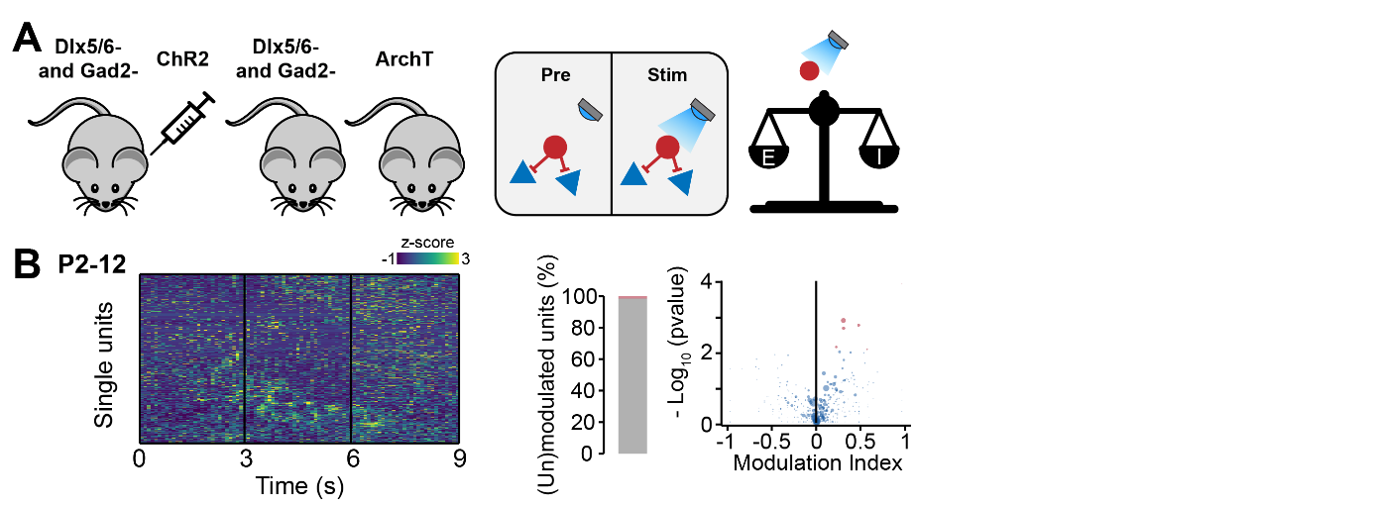

**Supp. Figure 5, related to Figures 4 and 5. Optogenetic manipulation of IN activity in cre- mice does not affect the developing mouse PFC.**

(**A**) Schematic representation of the experimental approach employed to generate control (cre‑) mice (left) and schematic representation of the lack of effects induced by optogenetic IN stimulation in cre- mice (right).

(**B**) Z-scored single unit firing rates response to optogenetic stimulation in cre- mice (left) and volcano plot displaying the modulation index of pre vs stim single unit firing rates (right) for P2-12 mice (n=380 units and 24 mice),

Taken together, these data show that optogenetic manipulation of INs robustly affects the neonatal prefrontal network in an age-dependent manner. Stimulating IN induces widespread inhibition of putative PYRs, whereas the contrary is true of IN inhibition. Both effects get stronger with age. However, the ability of INs to control the cortical inhibition does not qualitatively change during the first two postnatal weeks, resembling adult patterns.

## **Optogenetic manipulation of IN activity impacts pairwise spike train correlations**

To investigate the relationship between age-dependent dynamics of inhibition and decorrelation of spike trains, we compared STTC before IN optogenetic manipulation (STTCpre) to STTC during optogenetic manipulation (STTCstim). Considering that STTCpre and STTCstim could only be computed in 3 seconds epochs (times the number of trials), we first verified whether STTCpre was a good predictor of “baseline” STTC. Pooling across mice and different IN manipulation, STTCpre robustly correlated with baseline STTC across every investigated lag, from 2.5 ms to 1 s (0.66, [0.48; 0.72] median and min-max Pearson correlation; 0.68 [0.40; 0.71] median and min-max Spearman correlation) (Supp. Figure 6A-B). Further, STTCstim exhibited lower correlation values with baseline STTC across all lags, a first hint that optogenetic IN manipulation affected STTC (Supp. Figure 6A-B).

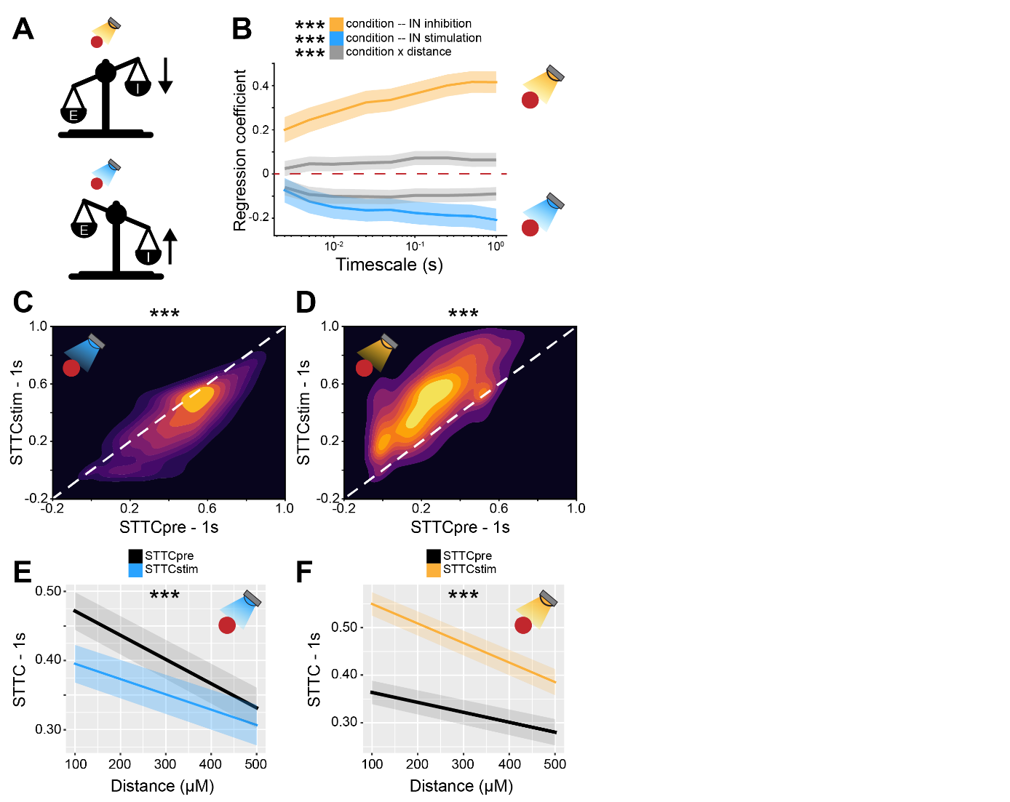

**Figure 6. Bidirectional optogenetic manipulation of IN activity affects STTC in the developing mouse PFC.**

(**A**) Schematic representation of the effects induced by optogenetic IN inhibition (top) and stimulation (bottom).

(**B**) Multivariate linear regression coefficients as a function of STTC lag (n=19951 spike train pairs and 59 mice).

(**C** and **D**) 2D kernel density plots displaying STTCpre and STTCstim during IN activation (C) and inhibition (D) (n=10173 spike train pairs and 19 mice, n=9778 spike train pairs and 40 mice, respectively).

(**E** and **F**) Average STTCpre and STTCstim during IN activation (E) and inhibition (F) over distance (n=10173 spike train pairs and 19 mice, n=9778 spike train pairs and 40 mice, respectively).

In (B) regression coefficients are presented as mean and 95% C.I.. In (E and F) data are presented as mean ± SEM. Asterisks in (B) indicate significant regression coefficients of the respective interactions between variables for STTC at 1 s lag Asterisks in (C and D) indicate significant effect of IN activation and inhibition, respectively. Asterisks in (E and F) indicate significant effect of IN activation*distance and IN inhibition*distance interaction, respectively. *** p < 0.001. Linear mixed-effect models. For detailed statistical results, see S1 Table.

As predicted by modeling and our previous experimental results, optogenetic modulation of IN activity affected the STTC values across every investigated timescale (Figure 6A-B). IN stimulation resulted in decreased STTC values (main IN stimulation effect, p<10-69, 1 s lag, linear mixed-effect model) (Figure 6C), whereas IN inhibition increased STTC (main IN inhibition effect, p<10-273, 1 s lag, linear mixed-effect model) (Figure 6D).

In line with our previous results indicating that the effect of the developmental increased inhibition is particularly strong on nearby neurons (Figure 3D), IN modulation had a larger impact on STTC values of nearby neurons when compared to pairs that are further apart (IN stimulation*distance interaction, p<10-4; IN inhibition*distance interaction p<10-8, 1 s lag, linear mixed-effect model) (Figure 6E).

Conversely, when fitting a separate statistical model that included the “spatial configuration” of the neuron pair, we found that it only weakly affected STTC (IN stimulation/inhibition*spatial configuration interaction, p=0.21 and p<0.002, 1 s lag, respectively, linear mixed-effect model) (Supp. Figure 6C-F). Further, when fitting another statistical model that included age as a covariate, we found that age interacted with IN inhibition/stimulation, leading to larger effects of IN manipulation (IN stimulation*age interaction, p<10-3; IN inhibition*age interaction p<10-24, 1 s lag, respectively, linear mixed-effect model) (Supp. Figure 6G).

In summary, these data strengthen our previous modeling and correlative experimental results and indicate that IN manipulation causally impacts pairwise correlations between spike trains. The effect of IN manipulation increases as mice develop, in agreement with the notion that inhibition strengthens throughout development.

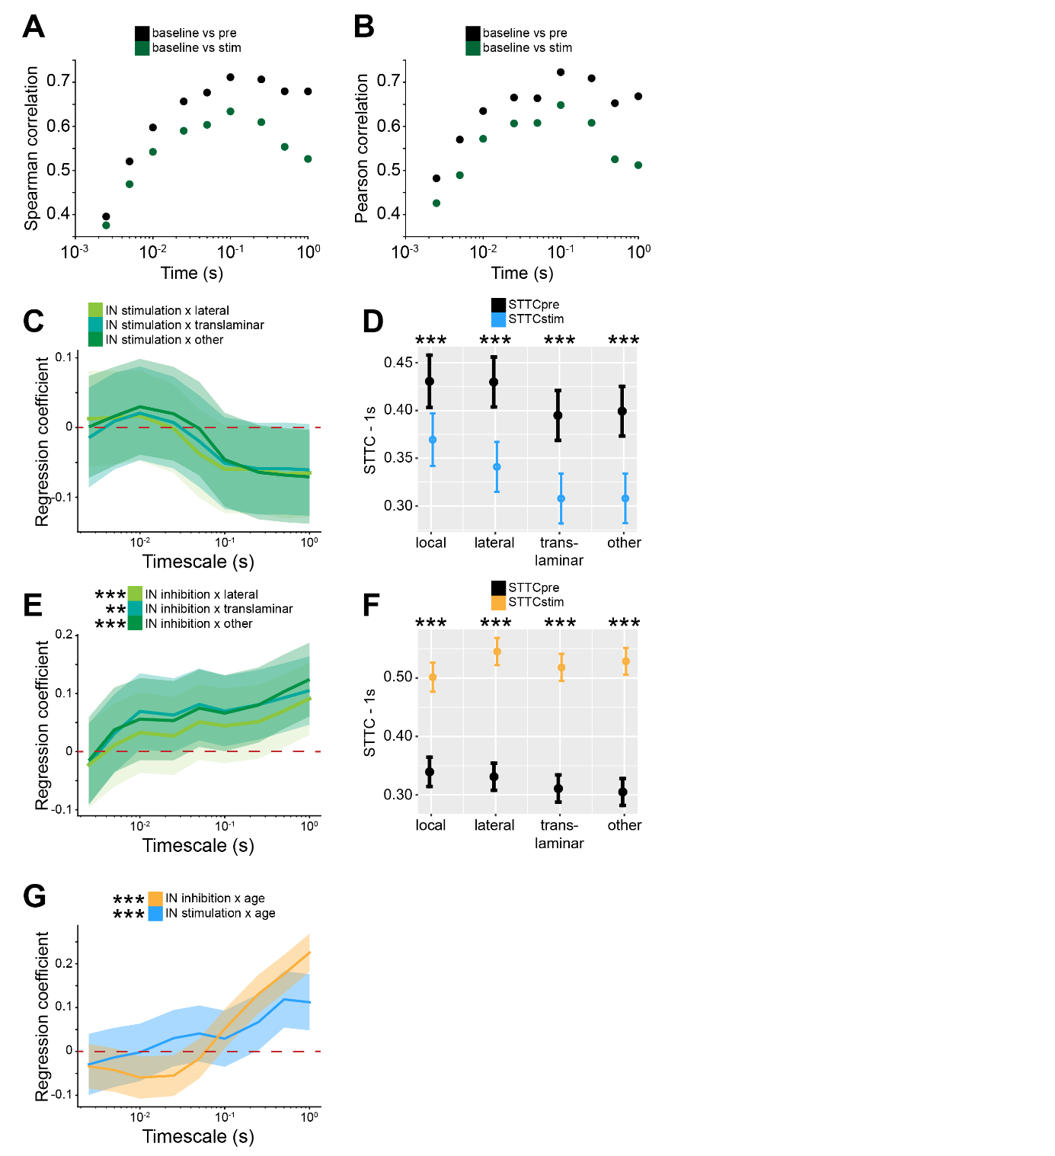

**Supp. Figure 6, related to Figure 6. Bidirectional optogenetic manipulation of IN activity effects on STTC depends on spatial configurations and age.**

(**A** and **B**) Scatter plot displaying Pearson (A) and Spearman (B) correlation coefficients for STTCpre and STTCstim with STTC computed on baseline data over lags (n=19951 spike train pairs and 59 mice).

(**C**) Multivariate linear regression coefficients for IN stimulation interaction with spatial configuration as a function of STTC lag (n=10173 spike train pairs and 19 mice).

(**D**) STTCpre and STTCstim with respect to spatial configuration (n=10173 spike train pairs and 19 mice).

(**E** and **F**) Same as (C and D) for IN inhibition (n=9778 spike train pairs and 40 mice).

(**G**) Multivariate linear regression coefficients for IN stimulation (blue) and IN inhibition (yellow) interaction with age as a function of STTC lag (n=10173 spike train pairs and 19 mice and n=9778 spike train pairs and 40 mice, respectively).

Asterisks in (D and F) indicate significant effect of IN stimulation (D) and inhibition (F). Asterisks in (E and G) indicate significant regression coefficients of the respective interactions between variables for STTC at 1 s lag. ** p < 0.001; *** p < 0.001. In (C, E and G) regression coefficients are presented as mean and 95% C.I.. In (D and F) data are presented as mean ± SEM. Linear mixed-effect models. For detailed statistical results, see S1 Table.

## **Mouse models with altered developmental E-I ratio have impaired correlated activity**

Developmental imbalances in E-I ratio have been linked to the pathophysiology of neurodevelopmental disorders25,42. A corollary of the results that we have discussed so far is that impaired E-I ratio would predict altered correlation levels of neuronal activity. To test this hypothesis, we interrogated two open-source datasets that we recently published64,65. They consist of recordings from the prelimbic subdivision of the PFC from two different developmental mouse models of disease with reduced E-I ratio41,42.

The first dataset included extracellular recordings of SUA from the PFC of P4-10 control and dual-hit genetic-environmental (GE) mice. GE mice mimic the etiology and cognitive impairment of developmental neuropsychiatric disorders, showing already at neonatal age reduced excitatory activity in the superficial layers of the PFC41,66 (Figure 7A). We therefore hypothesized that GE mice should have lower STTC then controls. Considering the layer-specificity of the deficit, we reasoned that this effect should be particularly strong in spike trains that involve neurons in the superficial layers. Overall, GE mice had lower levels of STTC when compared to controls (main condition effect, p=0.032, 1 s lag, linear mixed-effect model) (Supp. Figure 7A). In line with our hypothesis, this deficit depended on whether the neuron pair was situated in the superficial layers of the PFC (condition*layer interaction, p<10-7, 1 s lag, linear mixed-effect model). While there was no significant difference between STTC of controls and GE spike trains pairs situated in the deep layers (p=0.15, 1 s lag, linear mixed-effect model), spike train pairs of GE mice in which one of the two neurons was located in the superficial layers had reduced STTC values (p=0.016, 1 s lag). This difference was even more robust if both neurons were situated in the superficial layers (p=10-3, 1 s lag) (Figure 7B-E). Lastly, the effect did not depended on the age of the mouse (condition*age interaction, p=0.16, 1s lag, linear mixed effect model) (Supp. Figure 7A-B).

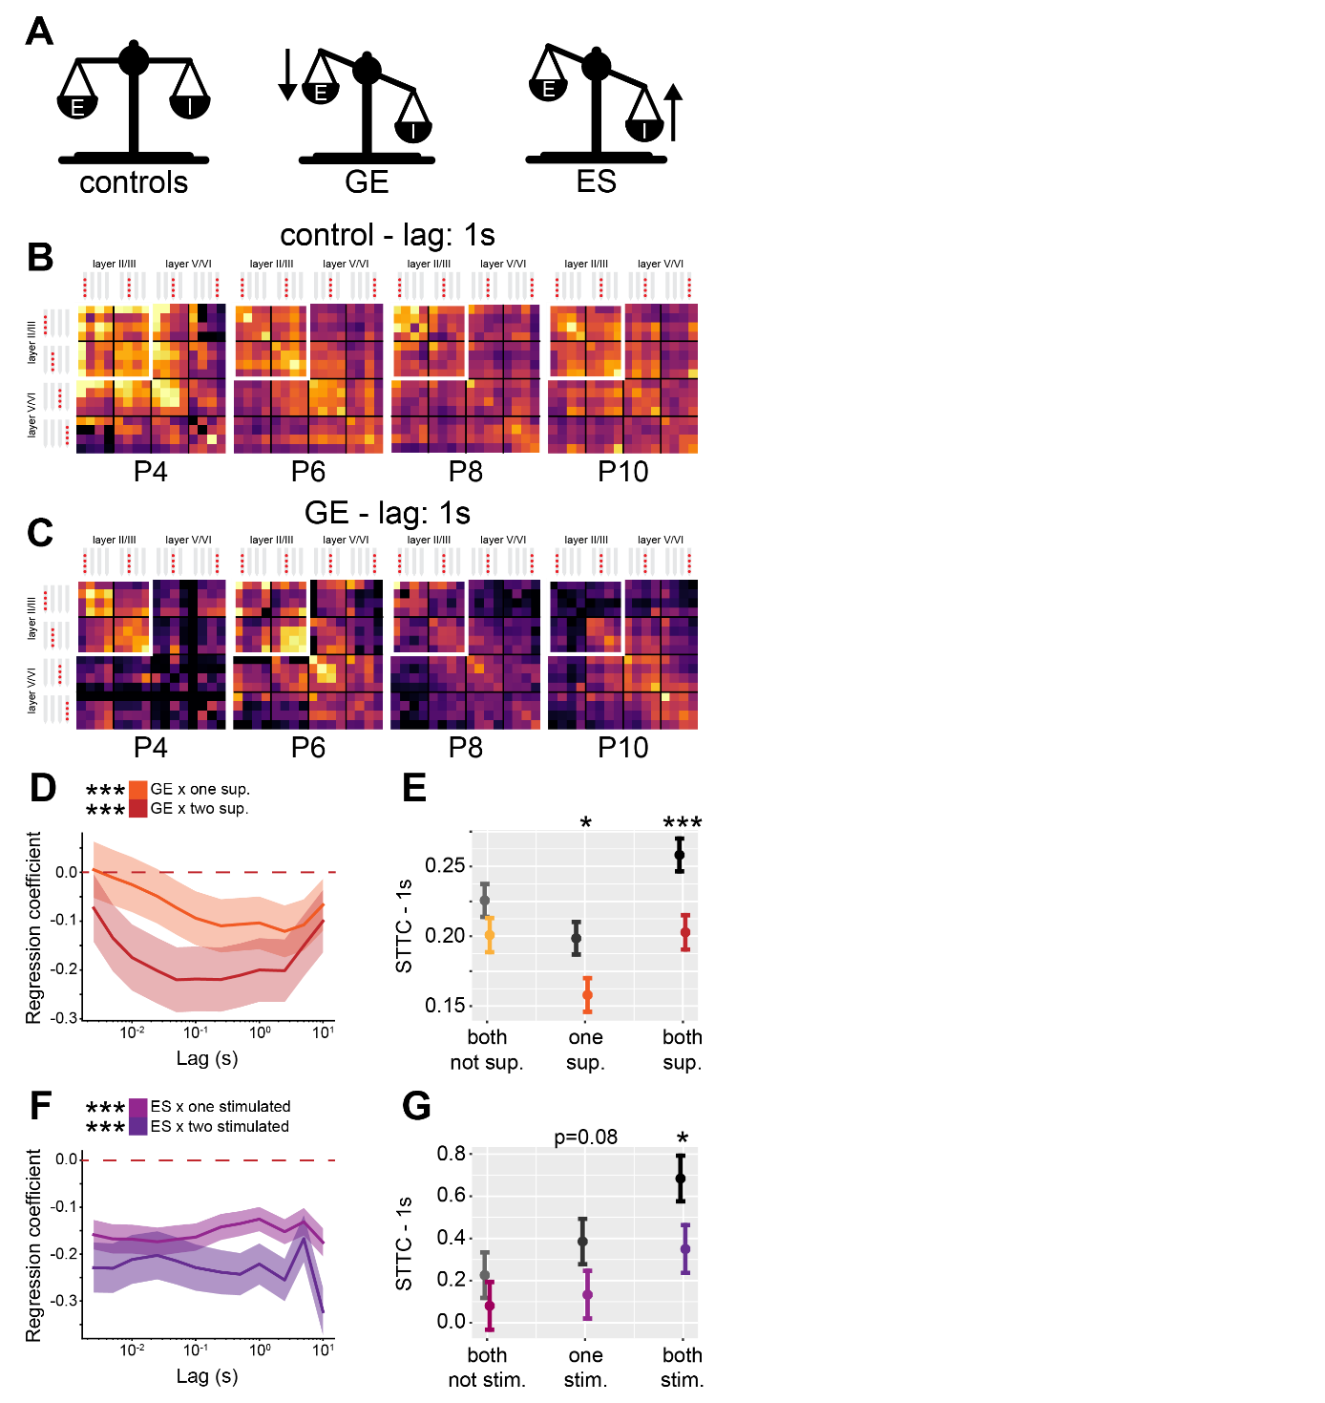

**Figure 7. GE and ES mice have reduced STTC values with specific spatial profiles.**

(**A**) Schematic representation of the E-I ratio imbalance affecting GE and ES mice.

(**B**) Weighted adjacency matrices displaying average STTC at 1 s lag of P4, P6, P8, P10 and control mice as a function of the recording sites in which the spike train pair has been recorded (n=18839 spike train pairs and 33 mice). White inset indicates STTC values between spike trains that are located in the superficial layers of the PFC. Color codes for STTC value.

(**C**) Same as (B) for GE mice (n=11051 spike train pairs and 30 mice).

(**D**) Multivariate linear regression coefficients as a function of STTC lag (n=29890 spike train pairs and 63 mice).

(**E**) STTC of control and GE mice (n=18839 and 11051 spike train pairs; 33 and 30 mice, respectively) with respect to the number of neurons in the superficial layers in the PFC.

(**F** and **G**) Same as (D) and (E) for control and ES mice (n=17150 and 11449 spike train pairs; 10 and 11 mice, respectively) with respect to the number of chronically stimulated neurons.

In (D) and (F) regression coefficients are presented as mean and 95% C.I. In (E) and (G) data are presented as mean ± SEM. Asterisks in (D) and (F) indicate significant regression coefficients of the respective interactions between variables for STTC at 1 s lag. Asterisks in (E) and (G) indicate significant difference to control mice. Asterisks in (E and G) indicate significant effect of the respective variable for STTC at 1 s lag. * p < 0.05, *** p < 0.001. Linear mixed-effect models. For detailed statistical results, see S1 Table.

The second dataset included extracellular recordings of SUA from the PFC of P11-12 control and early stimulated (ES) mice. ES mice are generated by chronic optogenetic stimulation of a subpopulation of layer II/III PYRs42. We have previously shown that this results in long-lasting E-I imbalance and in an increased feedback inhibition onto neuronal connections that involve the chronically stimulated population of PYRs42 (Figure 7A). We therefore hypothesized that spike trains pairs that involve chronically stimulated PYRs in ES mice should have lower STTC then controls. Overall, ES mice did not show lower levels of STTC (main condition effect, p=0.13, 1 s lag, linear mixed-effect model) (Supp. Figure 7C). However, there was a strong interaction between condition and the number of neurons in the spike train pair that had been chronically stimulated (condition*number of tagged neurons interaction, p<10-45, 1s lag, linear mixed-effect model). Pairs of spike trains that consisted of two neurons that were not chronically stimulated did not have reduced STTC levels (p=0.36, 1 s lag, linear mixed effect model). However, when one neuron in the pair had been chronically stimulated, this tended to result in decreased STTC (p=0.078, 1 s lag, linear mixed effect model), an effect that became more robust when both neurons had been chronically stimulated (p=0.026, 1 s lag, linear mixed effect model) (Figure 7F-G).

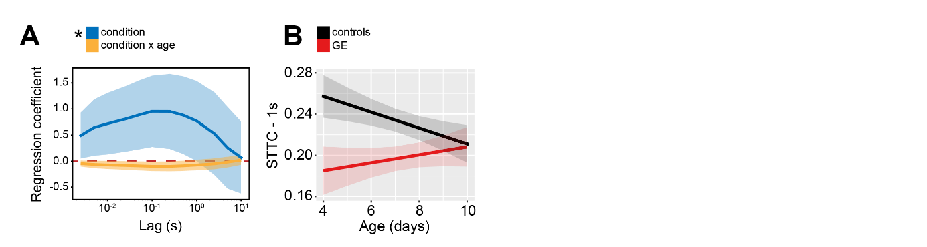

**Supp. Figure 7, related to Figure 7. Age and spatial profile of STTC values in GE and ES mice.**

(**A**) Multivariate linear regression coefficients as a function of STTC lag (n=29890 spike train pairs and 63 mice).

(**B**) STTC of control and GE mice (n=18839 and 11051 spike train pairs; 33 and 30 mice, respectively) over age.

Asterisks in (A) indicate significant regression coefficients of the respective variable for STTC at 1 s lag. * p < 0.05. In (A) regression coefficients are presented as mean and 95% C.I.. In (B) and data are presented as mean ± SEM. Linear mixed-effect models. For detailed statistical results, see S1 Table.

Taken together, these data support the hypothesis that decreased developmental E-I ratio results in reduced spike train pairwise correlations. Further, we show that this effect is remarkably specific. In GE mice, a mouse model characterized by reduced excitatory drive in prefrontal PYRs of the superficial layers, the reduced correlation levels are largely limited to spike train pairs involving PYRs of the superficial layers. Similarly, in ES mice, a mouse model characterized by increased feedback inhibition onto chronically stimulated PYRs, the decreased correlation levels are largely limited to spike train pairs involving chronically stimulated PYRs.

## **1/f exponent increases with age in newborn babies**

We next sought out to test whether a similar developmental process occurs also in newborn babies. To this aim, we interrogated two EEG datasets recorded in newborn babies of an age between 35 and 46 post-conception weeks (PCW), a time point that is roughly equivalent to the one that we studied in mice1. While it is not straightforward to compare intracranial recordings from a deep structure like the mouse PFC to EEG data, to maximize consistency between the approach used for mouse and human data, we limited our analysis to channels from the frontal derivations of the EEG (Figure 8A).

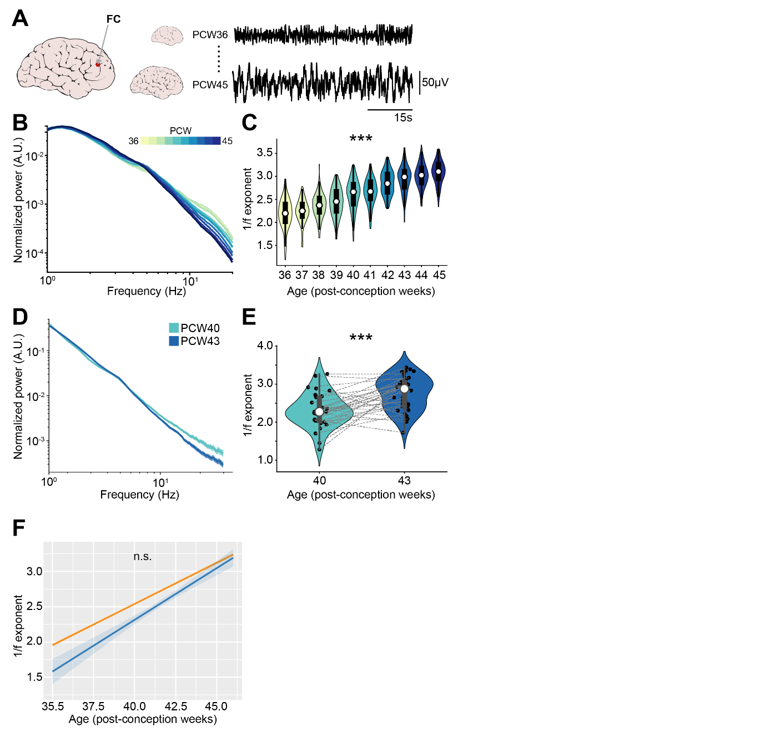

**Figure 8. 1/f exponent of EEG recordings increases with age in newborn babies.**

(**A**) Schematic representation of EEG recording from frontal derivations of PCW36-45 newborn babies (left), and representative EEG traces from PCW36 and PCW45 newborn babies (right).

(**B**) Log-log plot displaying the normalized mean PSD power in the 1-20 Hz frequency range of PCW36-45 newborn babies (n=1110 babies). Color codes for age.

(**C**) Violin plots displaying the 1/f exponent of PCW36-45 newborn babies (n=1110 babies).

(**D** and **E**) same as (B) and (C) for PCW40 and PCW43 newborn babies (n=72 EEG recordings and 40 babies).

(**F**) 1/f exponent over age for the two EEG datasets (n=1110 babies and n=72 EEG recordings and 40 babies, respectively).

In (E) black dots indicate individual data points. In (C) and (E) data are presented as median, 25th, 75th percentile and interquartile range. In (C) and (E) the shaded area represents the probability distribution density of the variable. In (B), (D) and (F) data are presented as mean ± SEM. Asterisks in (C) and (E) indicate significant effect of age. *** p < 0.001. Linear model (C) and linear mixed-effect models (E-F). For detailed statistical results, see S1 Table.

The first dataset67,68 consisted of 1100 EEG recordings of sleeping babies with an age comprised between 36 and 45 post-conception weeks. Similarly to the PSDs of recordings from the neonatal mice PFC, the 1/f exponent grew steeper over age (Supp. Figure 8A), a phenomenon that was even more apparent after normalization of the PSD (Figure 8B). We quantified the 1/f exponent similarly to the mouse LFP data, and confirmed that it increases over age (age coefficient=0.26, 95% C.I. [0.24; 0.27], p<10-183, linear model) (Figure 8C). A second dataset69 consisted of EEG recordings from 42 sleeping participants, recorded at 40 and 43 post-conception weeks. Analogously to the first dataset, the PSD slope grew steeper over age (Figure 8D, Supp. Figure 8B) and the 1/f exponent increased over age (age coefficient=0.30, 95% C.I. [0.17; 0.42], p<10-4, linear mixed-effect model) (Figure 8E). Importantly, the increase in 1/f slope over age was very similar across the two different datasets (mean age coefficients=0.26 and 0.30), and no statistical difference was found between them (main dataset effect, p=0.15; age*dataset interaction, p=0.21, linear mixed effect model).

Thus, there is robust and converging evidence that the 1/f exponent decreases with age also in newborn humans.

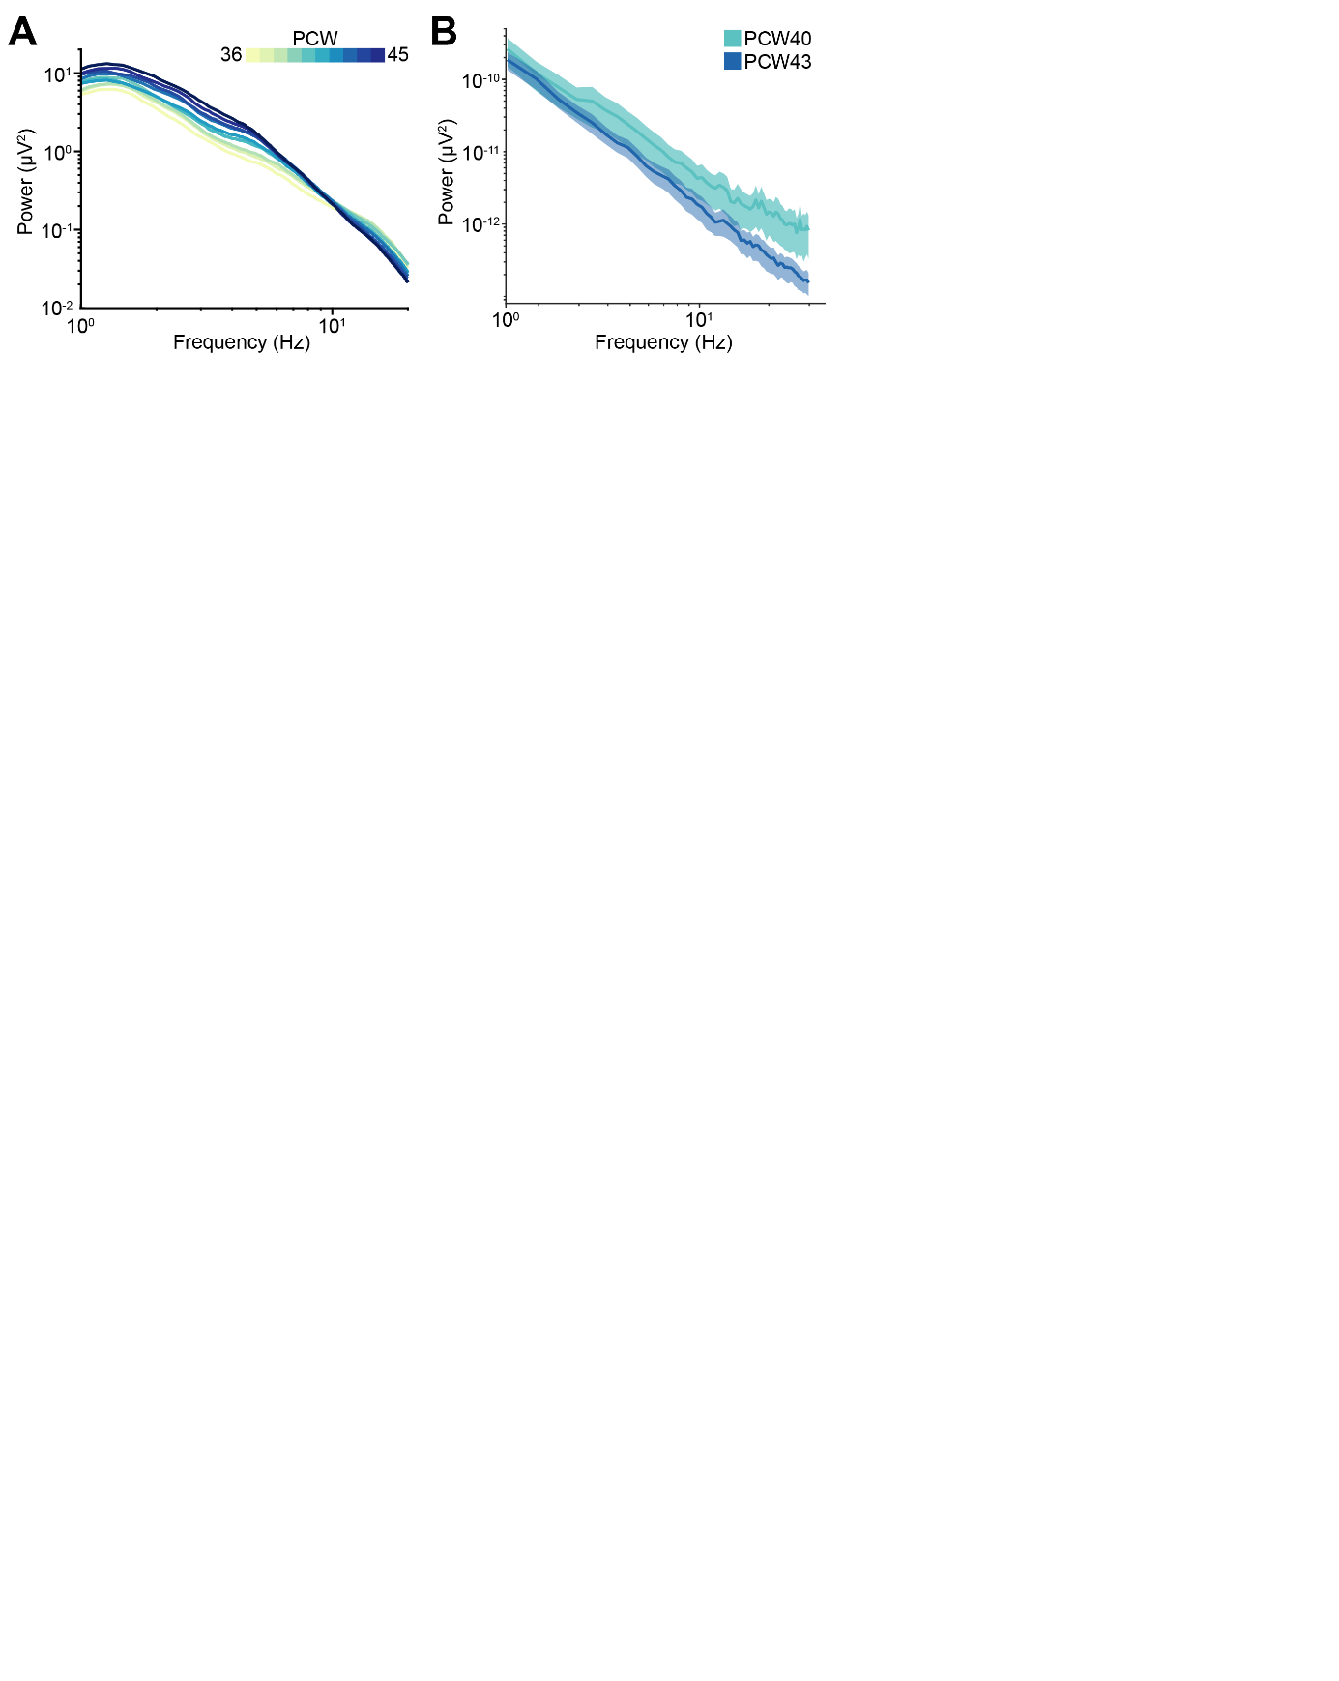

**Supp. Figure 8, related to Figure 8. EEG PSDs of newborn babies.**

(**A**) Log-log plot displaying the mean PSD power in the 1-20 Hz frequency range of PCW36-45 newborn babies (n=1110 babies). Color codes for age.

(**B**) Same as (A) for PCW40 and PCW43 newborn babies (n=72 EEG recordings and 40 babies). Color codes for age.

In (A-B) data are presented as mean ± SEM.

# Discussion

# Acknowledgments

We thank P. Putthoff, A. Marquardt and A. Dahlmann for excellent technical assistance. This work was funded by grants from the European Research Council (ERC-2015-CoG 681577 to I.L.H.-O.) and the German Research Foundation (Ha 4466/10-1 , Ha4466/11-1, Ha4466/12-1, SPP 1665, and SFB 936 B5 to I.L.H.-O.).

## **Author Contributions**

M.C. and I.L.H.-O. designed the experiments. M.C. carried out the experiments and analyzed the data. M.C. and T.P. carried out neural network modeling. All authors interpreted the data, wrote, discussed and commented on the manuscript.

## **Declaration of interests**

The authors declare no competing interests.

# 

# Methods

## **Data and code availability**

LFP and SUA data that were newly generated for this study are available at the following open-access repository: https://gin.g-node.org/mchini/development_EI_decorrelation.

Code supporting the findings of this study is available at the following open-access repository: https://github.com/mchini/Chini_et_al_EI_decorrelation.

## **Experimental models and subject details**

All experiments were performed in compliance with the German laws and following the European Community guidelines regarding the research animals use. All experiments were approved by the local ethical committee (G132/12, G17/015, N18/015). Experiments were carried out on C57BL/6J, Dlx5/6-Cre (Tg(dlx5a-cre)1Mekk/J, Jackson Laboratory), Gad2-IRES-Cre (Gad2tm2(cre)Zjh, Jackson Laboratory) and ArchT (Ai40(RCL-ArchT/EGFP)-D, Jackson Laboratory) mice of both sexes. Mice were housed in individual cages on a 12 h light/12 h dark cycle, and were given access to water and food ad libitum. The day of birth was considered P0. To inhibit IN activity, mice from the Dlx5/6-Cre and Gad2-IRES-Cre driver lines were crossed with mice from the ArchT reporter line. To stimulate IN activity, P0-P1 mice from the Dlx5/6-Cre and Gad2-IRES-Cre driver lines were injected in the PFC with a virus encoding for ChR2 (AAV9-Ef1alpha-DIO-hChR2(ET/TC)-eYFP) as previously described (ref to Xiaxia’s preprint). Details on the data acquisition and experimental setup of open-access datasets that were used in this project are available in the respective publications41,42,67–70.

## ***In vivo* electrophysiology and optogenetics**

*Surgery.* In vivo electrophysiological extracellular recordings were performed in the PL of non-anesthetized P2-P12 mice. Before starting with the surgical procedure, a local anesthetic was applied on the mice neck muscles (0.5% bupivacain / 1% lidocaine). The procedure was carried out under isoflurane anesthesia (induction: 5%; maintenance: 1-3%, lower for older pups, higher for younger pups). Neck muscles were cut to reduce muscle artifacts. A craniotomy over the PFC (0.5 mm anterior to bregma, 0.1-0.5 mm lateral to the midline) was performed by first carefully thinning the skull and then removing it with the use of a motorized drill. Mice were then head-fixed into a stereotactic frame where they rested on a heated (37°) surface throughout the entire recording. (Opto)Electrodes (four-shank, A4x4 recording sites, 100 µm between recording sites, 125 µm shank distance; NeuroNexus, MI, USA) were then slowly inserted into the target area at a depth varying between 1.4 and 2 mm depending on the age of the mouse. A silver wire implanted into the cerebellum was used as ground and external reference. Before signal acquisition, mice were allowed a recovery period of 30-45 minutes, to maximize the quality and stability of the recording as well as single units yield.

*Signal acquisition*. Extracellular signals were acquired and digitized at a 32 kHz sampling rate after band-pass filtering (0.1-9000 Hz) using an extracellular amplifier (Digital Lynx SX; Neuralynx, Bozeman, MO, USA, Cheetah , Neuralynx, Bozeman, MO, USA).

*Optogenetic stimulation.* Optical stimuli were delivered by an Arduino Uno-controlled (Arduino, Italy) diode laser (Omicron, Austria). The delivered light stimuli varied in wavelength (472 nm or 525 nm) according to the experimental paradigm (IN stimulation and inhibition, respectively). Laser power was titrated before signal acquisition and adjusted to the minimum level that induced the desired neuronal response. Typical light power at the fiber tip was measured in the range of 15-40 mW/mm2. Optogenetic stimulations consisted of ramp-like stimuli of 3s length as previously described41,42,54,55. Ramp stimulations were repeated 30-120 times. Ramp stimulations were carried out on the two outmost lateral shanks of the 4-shank electrodes, corresponding to superficial and deep layers of the PFC.

*Post mortem histological assessment of electrode position.* Epifluorescence images of coronal brain sections were acquired after surgery to reconstruct the position of the recording electrode. Only mice in which the electrodes were placed in the correct position were kept for further analysis.

## **Neural network modeling**

The architecture of the network is depicted schematically in Figure 2X and was loosely based on the implementation of Trakoshis et al. (2020)24.

The network was composed of a total of 400 conductance-based leaky integrate-and-fire units, 80% of which were excitatory (E) (N=320) and 20% were inhibitory (I) (N=80). The units in the network were randomly connected with each other, with a connection probability of 0.2 for each type of synaptic connection. Excitatory (E→E, E→I) and inhibitory (I→I and I→E) synapses were mediated by AMPA and GABA, respectively. An overview of all baseline parameter values used in the simulations can be found in Table 1. All simulations were performed using Brain2 for Python3.771.

The dynamics of each excitatory and inhibitory cell were governed by the following stochastic differential equation:

(Eq. 1)

with

(Eq. 2)

and

(Eq. 3)

where is the membrane potential, is the leak membrane potential and and denote the AMPA and GABA current reversal potentials. The synaptic conductance parameters and the corresponding decay time constants are denoted by , and , , respectively. is a noise term that is generated by an Ornstein-Uhlenbeck process with zero mean. Due to the near-instantaneous rise times of AMPA- and GABA-mediated currents (both typically < 0.5 ms), we opted to neglect these in the current simulations. Moreover, synaptic transmission was assumed to be instantaneous (i.e., with zero delay). The excitatory units of the network received an additional external input in the form of AMPA-mediated Poisson spike trains from an external pool of 100 units with a constant spike rate of 1.5 spikes / second.

In order to assess the effect of altered E-I ratio (), we parametrically modulated all excitatory (through multiplication with 21 linearly spaced values from 0.75 to 3) and all inhibitory (21 linearly spaced values from 0.25 to 1.5) synaptic conductances. The network was simulated for a duration of 30 s for each of the 21x21 parameter combinations.

The local field potential (LFP) of the network was computed, for each parameter combination, by taking the sum of the absolute values of the AMPA and GABA currents on all excitatory cells24. Neuronal correlation was estimated by means of the spike time tiling coefficient (see below), assessed at a lag of 1s.

**Table 1.** Parameters of the leaky integrate-and-fire network.

|  |  |  |  |
| --- | --- | --- | --- |
| Neuron model | | | |
| *Parameter* | *Description* | *Excitatory cells* | *Inhibitory cells* |
|  | Leak membrane potential | -70 mV | -70 mV |
|  | Spike threshold potential | -52 mV | -52 mV |
|  | Reset potential | -59 mV | -59 mV |
|  | Refractory period | 2 ms | 1 ms |
|  | Membrane capacitance | 500 pF | 500 pF |
|  | Membrane leak conductance | 25 nS | 20 nS |
|  | Membrane time constant | 20 ms | 10 ms |
| Synapse model | | | |
| *Parameter* | *Description* | *Excitatory cells* | *Inhibitory cells* |
|  | Reversal potential (AMPA) | 0 mV | 0 mV |
|  | Reversal potential (GABA) | -80 mV | -80 mV |
|  | Conductance (AMPA) | 0.178 * 5 nS | 0.254 * 5 nS |
|  | Conductance (GABA) | 2.01 * nS | 2.7 * 5 nS |
|  | Conductance external input (AMPA) | 0.234 * 5 nS | - |
|  | Time constant of AMPA decay | 2 ms | 1 ms |
|  | Time constant of GABA decay | 8 ms | 8 ms |

## **Electrophysiological analysis**

Data from in vivo electrophysiological recordings was analyzed with custom-written algorithms in the MATLAB and Python environment that are available on the following github repository: https://github.com/mchini/Chini_et_al_EI_decorrelation.

*Detection of active periods.* In early development, brain activity is characterized by an alternation of periods of isoelectric traces (silent periods) and oscillatory bursts (active periods). To detect and quantify the properties of active periods, we applied a custom written algorithm. The extracellular signal was band-pass filtered (4-20Hz) and downsampled to 100 Hz, before being averaged across recording electrodes. The average signal (raw and z-scored) was then passed through a boxcar square filter (500ms) on which a hysteresis threshold was applied. Active periods were first detected as oscillatory peaks exceeding an absolute or relative threshold (100µV or 4 standard deviations, respectively), and then extended to all neighboring time points that exceed a lower threshold (50µV or 2 standard deviations, respectively). The combination of absolute and relative thresholding makes this approach suitable to a wide range of signals, from the highly discontinuous brain activity of P2 mice, to the nearly continuous brain activity of P11-12 mice (Figure 1A-B). Oscillatory periods whose inter-oscillation-interval was shorter than 1s were merged. Oscillatory periods whose duration was smaller than 300ms were discarded.

*Power spectral density (PSD).* PSDs for mouse and human data (see below for exception) were computed with the *mtspecgramc* function of the Chronux Toolbox (10s long-windows, 5s overlap). Median averaging was the preferred measure of central tendency72. To quantify the PSD modulation by IN optogenetic stimulation/inhibition, we computed the MI (see below) of the PSD computed on the last 1.5s of the optogenetic stimulation with the PSD computed on the 1.5s preceding stimulus delivery.

*EEG preprocessing.* EEG signal was extracted only from frontal electrodes (Fp1, F7, F3, Fp2, F8, F4, Fpz, when available) and re-referenced to a common average reference before further analysis. From the EEG dataset of 1100 sleeping babies67, epochs whose average envelope amplitude exceeded two standard deviations from the mean were considered as possible artefacts and were removed from further analysis. No preprocessing was applied to the EEG dataset of sleeping babies recorded at 40 and 43 post-conception weeks, as PSDs were already included in the freely available data69.

*1-f decay exponent.* The 1-f decay exponent was extracted on the 5-20 Hz and 5-45 Hz (human and mouse data, respectively) frequency range of PSDs using the FOOOF package47with the “fixed” aperiodic mode. To quantify the 1/f decay exponent modulation by IN optogenetic stimulation/inhibition, we compared the exponent obtained by PSDs computed on the second half of the optogenetic stimulation with the baseline exponent.

*Spike sorting.* Spike sorting was performed using Klusta73. Automatically-obtained clusters were then manually curated using phy (<https://github.com/cortex-lab/phy>).

*Spike-Time Tiling Coefficient (STTC)*. The STTC, a metric that tracks correlations between spike trains and is robust to changes in firing rate, was computed as previously described53,74 (Figure 3A). Briefly, STTC is computed as:

XXXXXXXXXXX

Where PA is defined as the proportion of spikes in spike train A that falls within ±Δt of a spike from spike train B. TA is defined as the proportion of time that occurs within (is “tiled” by) ±Δt from the spikes of spike train A. The same applies for PB and TB. The “lag” parameter ±Δt controls the “timescale” at which the STTC is computed, a parameter that we systematically varied across more than three orders of magnitude (from 2.5ms to 10s). Baseline STTC analysis was limited to spike trains pairs that were recorded for at least an hour and for which both spike trains had at least 50 spikes (40921 of 56613 spike train pairs). To quantify the STTC modulation by IN optogenetic stimulation/inhibition, we compared the STTC derived by spike matrices obtained during the 3s optogenetic stimulation with the STTC derived by spike matrices obtained during the 3s preceding optogenetic stimulation.

*Spatial arrangements of spike train pairs*. To refine our statistical modeling of the sparsification of neural data, we encoded the spatial arrangement of spike train pairs as “local”, “lateral”, “translaminar” or “other” (Figure 3A). Spike trains pairs that consisted of neurons recorded on the same recording site were defined as “local”. Spike trains pairs that consisted of neurons recorded on the same shank (putatively belonging to the same layer) were defined as “lateral”. Spike trains pairs that consisted of neurons recorded on different shanks but at the same depth (putatively belonging to the same “column”) were defined as “translaminar”. Spike train pairs that did not satisfy any of the previous conditions were defined as “other”.

*Modulation Index (MI).* The MI is a normalization strategy that has the desirable property of bounding the obtained normalized value between -1 and 1. MI was computed as: (value_cond - value_pre) / (value_cond + value_pre).

*Optogenetic modulation of electrophysiological parameters.* Modulation of firing rate by optogenetic manipulation was quantified using the MI and signed-rank testing that compared the firing rate during the last 1.5s of optical stimulation with the firing rate during the 1.5s preceding stimulus delivery.

*PCA of spike matrices during optogenetic stimulations.* The first two PCA components of the spike during optogenetic stimulations were computed on trial-averaged spike trains that were convolved with a gaussian window (500ms length, 50ms standard deviation) and z-scored across the time dimension.

## **Statistical modeling**

Statistical modeling was carried out in the R environment. All the scripts and the processed data on which the analysis is based are available from the following github repository: https://github.com/mchini/Chini_et_al_EI_decorrelation.

Nested data were analyzed with (generalized) linear mixed-effects models (*lmer* and *glmer* functions of the *lme4* R package75). Depending on the specific experimental design, we used “mouse” or “subject” as random effects. For statistical analysis of STTC, to maximize interpretability of the results (i.e. avoid multiple triple interactions), separate (identical) models were fit for the different lags. Regression on data that, upon visual inspection seemed to be better fit by an exponential curve, were fitted with generalized linear (mixed-effect) models (family=Gamma, α=1, link=inverse). Proportions (e.g. the proportion of activated/inhibited units) were also fitted with generalized linear (mixed-effect) models (family=Binomial, link=logit). Statistical significance for linear mixed-effects models were computed with the *lmerTest* R package76 , using the Satterthwaite’s degrees of freedom method. When possible, model selection was performed according to experimental design. When this was not possible, models were compared using the *compare_performance* function of the *performance* R package77, and model choice was based on an holistic comparison of AIC, BIC, RMSE and R2. Model output was plotted with the *plot_model* (type=’pred’) function of the *sjPlot* R package78. 95% confidence intervals were computed using the *confint* R function. Post hoc analysis with Tukey multiple comparison correction was carried out using the *emmeans* and *emtrends* functions of the *emmeans* R package79.

# References

1. Chini, M. & Hanganu-Opatz, I. L. Prefrontal Cortex Development in Health and Disease: Lessons from Rodents and Humans. *Trends Neurosci.* (2020) doi:10.1016/j.tins.2020.10.017.

2. Shen, J. & Colonnese, M. T. Development of Activity in the Mouse Visual Cortex. *J. Neurosci.* **36**, 12259–12275 (2016).

3. Dorrn, A. L., Yuan, K., Barker, A. J., Schreiner, C. E. & Froemke, R. C. Developmental sensory experience balances cortical excitation and inhibition. *Nature* **465**, 932–936 (2010).

4. Cirelli, C. & Tononi, G. Cortical development, electroencephalogram rhythms, and the sleep/wake cycle. *Biol. Psychiatry* **77**, 1071–1078 (2015).

5. Chini, M. *et al.* Neural Correlates of Anesthesia in Newborn Mice and Humans. *Front Neural Circuits* **13**, 38 (2019).

6. Vanhatalo, S. & Kaila, K. Development of neonatal EEG activity: From phenomenology to physiology. *Semin. Fetal. Neonatal Med.* **11**, 471–478 (2006).

7. Avitan, L. *et al.* Spontaneous Activity in the Zebrafish Tectum Reorganizes over Development and Is Influenced by Visual Experience. *Curr. Biol. CB* **27**, 2407-2419.e4 (2017).

8. Akin, O., Bajar, B. T., Keles, M. F., Frye, M. A. & Zipursky, S. L. Cell-type-Specific Patterned Stimulus-Independent Neuronal Activity in the Drosophila Visual System during Synapse Formation. *Neuron* **101**, 894-904.e5 (2019).

9. Khazipov, R. *et al.* Early motor activity drives spindle bursts in the developing somatosensory cortex. *Nature* **432**, 758–761 (2004).

10. Trujillo, C. A. *et al.* Complex Oscillatory Waves Emerging from Cortical Organoids Model Early Human Brain Network Development. *Cell Stem Cell* **25**, 558–569 (2019).

11. Bitzenhofer, S. H., Pöpplau, J. A. & Hanganu-Opatz, I. Gamma activity accelerates during prefrontal development. *eLife* **9**, e56795 (2020).

12. Zhang, Z., Jiao, Y.-Y. & Sun, Q.-Q. Developmental maturation of excitation and inhibition balance in principal neurons across four layers of somatosensory cortex. *Neuroscience* **174**, 10–25 (2011).

13. Moore, A. K., Weible, A. P., Balmer, T. S., Trussell, L. O. & Wehr, M. Rapid Rebalancing of Excitation and Inhibition by Cortical Circuitry. *Neuron* **97**, 1341-1355.e6 (2018).

14. Golshani, P. *et al.* Internally Mediated Developmental Desynchronization of Neocortical Network Activity. *J. Neurosci.* **29**, 10890–10899 (2009).

15. Rochefort, N. L. *et al.* Sparsification of neuronal activity in the visual cortex at eye-opening. *Proc. Natl. Acad. Sci. U. S. A.* **106**, 15049–15054 (2009).

16. Zhou, S. & Yu, Y. Synaptic E-I Balance Underlies Efficient Neural Coding. *Front. Neurosci.* **12**, 46 (2018).

17. Yu, Y., Migliore, M., Hines, M. L. & Shepherd, G. M. Sparse coding and lateral inhibition arising from balanced and unbalanced dendrodendritic excitation and inhibition. *J. Neurosci. Off. J. Soc. Neurosci.* **34**, 13701–13713 (2014).

18. Shew, W. L., Yang, H., Yu, S., Roy, R. & Plenz, D. Information capacity and transmission are maximized in balanced cortical networks with neuronal avalanches. *J. Neurosci. Off. J. Soc. Neurosci.* **31**, 55–63 (2011).

19. Olshausen, B. A. & Field, D. J. Sparse coding of sensory inputs. *Curr. Opin. Neurobiol.* **14**, 481–487 (2004).

20. Vinje, W. E. & Gallant, J. L. Sparse coding and decorrelation in primary visual cortex during natural vision. *Science* **287**, 1273–1276 (2000).

21. Cun, Y. L., Denker, J. S. & Solla, S. A. Optimal Brain Damage. in *Advances in Neural Information Processing Systems* 598–605 (Morgan Kaufmann, 1990).

22. Frankle, J. & Carbin, M. The Lottery Ticket Hypothesis: Finding Sparse, Trainable Neural Networks. *ArXiv180303635 Cs* (2019).

23. Cogswell, M., Ahmed, F., Girshick, R., Zitnick, L. & Batra, D. Reducing Overfitting in Deep Networks by Decorrelating Representations. *ArXiv151106068 Cs Stat* (2016).

24. Trakoshis, S. *et al.* Intrinsic excitation-inhibition imbalance affects medial prefrontal cortex differently in autistic men versus women. *eLife* **9**, (2020).

25. Antoine, M. W., Langberg, T., Schnepel, P. & Feldman, D. E. Increased Excitation-Inhibition Ratio Stabilizes Synapse and Circuit Excitability in Four Autism Mouse Models. *Neuron* **101**, 648-661.e4 (2019).

26. Sohal, V. S. & Rubenstein, J. L. R. Excitation-inhibition balance as a framework for investigating mechanisms in neuropsychiatric disorders. *Mol. Psychiatry* **24**, 1248–1257 (2019).

27. Gao, R. & Penzes, P. Common mechanisms of excitatory and inhibitory imbalance in schizophrenia and autism spectrum disorders. *Curr. Mol. Med.* **15**, 146–167 (2015).

28. Medendorp, W. E. *et al.* Selective Postnatal Excitation of Neocortical Pyramidal Neurons Results in Distinctive Behavioral and Circuit Deficits in Adulthood. *bioRxiv* 2020.01.18.911347 (2020) doi:10.1101/2020.01.18.911347.

29. Ferguson, B. R. & Gao, W.-J. PV Interneurons: Critical Regulators of E/I Balance for Prefrontal Cortex-Dependent Behavior and Psychiatric Disorders. *Front. Neural Circuits* **12**, 37 (2018).

30. Luongo, F. J., Horn, M. E. & Sohal, V. S. Putative Microcircuit-Level Substrates for Attention Are Disrupted in Mouse Models of Autism. *Biol. Psychiatry* **79**, 667–675 (2016).

31. Hamm, J. P., Peterka, D. S., Gogos, J. A. & Yuste, R. Altered Cortical Ensembles in Mouse Models of Schizophrenia. *Neuron* **94**, 153-167.e8 (2017).

32. Zick, J. L. *et al.* Blocking NMDAR Disrupts Spike Timing and Decouples Monkey Prefrontal Circuits: Implications for Activity-Dependent Disconnection in Schizophrenia. *Neuron* **98**, 1243-1255.e5 (2018).

33. Lim, L., Mi, D., Llorca, A. & Marín, O. Development and Functional Diversification of Cortical Interneurons. *Neuron* **100**, 294–313 (2018).

34. Tuncdemir, S. N. *et al.* Early Somatostatin Interneuron Connectivity Mediates the Maturation of Deep Layer Cortical Circuits. *Neuron* **89**, 521–535 (2016).

35. Marques-Smith, A. *et al.* A Transient Translaminar GABAergic Interneuron Circuit Connects Thalamocortical Recipient Layers in Neonatal Somatosensory Cortex. *Neuron* **89**, 536–549 (2016).

36. Guan, W. Q. *et al.* Eye opening differentially modulates inhibitory synaptic transmission in the developing visual cortex. *Elife* **6**, e32337 (2017).

37. Gour, A. *et al.* Postnatal connectomic development of inhibition in mouse barrel cortex. *Science* **371**, (2021).

38. Che, A. *et al.* Layer I Interneurons Sharpen Sensory Maps during Neonatal Development. *Neuron* **99**, 98–116 (2018).

39. Duan, Z. R. S. *et al.* GABAergic Restriction of Network Dynamics Regulates Interneuron Survival in the Developing Cortex. *Neuron* **105**, 75–92 (2020).

40. Modol, L. *et al.* Assemblies of Perisomatic GABAergic Neurons in the Developing Barrel Cortex. *Neuron* **105**, 93–105 (2020).

41. Chini, M. *et al.* Resolving and Rescuing Developmental Miswiring in a Mouse Model of Cognitive Impairment. *Neuron* **105**, 60–74 (2020).

42. Bitzenhofer, S. H., Pöpplau, J. A., Chini, M., Marquardt, A. & Hanganu-Opatz, I. L. A transient developmental increase in prefrontal activity alters network maturation and causes cognitive dysfunction in adult mice. *Neuron* (2021) doi:10.1016/j.neuron.2021.02.011.

43. Lendner, J. D. *et al.* An electrophysiological marker of arousal level in humans. *eLife* **9**, (2020).

44. Colombo, M. A. *et al.* The spectral exponent of the resting EEG indexes the presence of consciousness during unresponsiveness induced by propofol, xenon, and ketamine. *NeuroImage* **189**, 631–644 (2019).

45. Lombardi, F., Herrmann, H. J. & de Arcangelis, L. Balance of excitation and inhibition determines 1/f power spectrum in neuronal networks. *Chaos Woodbury N* **27**, 047402 (2017).

46. Gao, R., Peterson, E. J. & Voytek, B. Inferring synaptic excitation/inhibition balance from field potentials. *NeuroImage* **158**, 70–78 (2017).

47. Donoghue, T. *et al.* Parameterizing neural power spectra into periodic and aperiodic components. *Nat. Neurosci.* **23**, 1655–1665 (2020).

48. Mazzoni, A., Panzeri, S., Logothetis, N. K. & Brunel, N. Encoding of naturalistic stimuli by local field potential spectra in networks of excitatory and inhibitory neurons. *PLoS Comput. Biol.* **4**, e1000239 (2008).

49. Smith, M. A. & Kohn, A. Spatial and temporal scales of neuronal correlation in primary visual cortex. *J. Neurosci. Off. J. Soc. Neurosci.* **28**, 12591–12603 (2008).

50. Goltstein, P. M., Montijn, J. S. & Pennartz, C. M. A. Effects of isoflurane anesthesia on ensemble patterns of Ca2+ activity in mouse v1: reduced direction selectivity independent of increased correlations in cellular activity. *PloS One* **10**, e0118277 (2015).

51. Greenberg, D. S., Houweling, A. R. & Kerr, J. N. D. Population imaging of ongoing neuronal activity in the visual cortex of awake rats. *Nat. Neurosci.* **11**, 749–751 (2008).

52. Blankenship, A. G. *et al.* The Role of Neuronal Connexins 36 and 45 in Shaping Spontaneous Firing Patterns in the Developing Retina. *J. Neurosci.* **31**, 9998–10008 (2011).

53. Cutts, C. S. & Eglen, S. J. Detecting pairwise correlations in spike trains: an objective comparison of methods and application to the study of retinal waves. *J. Neurosci. Off. J. Soc. Neurosci.* **34**, 14288–14303 (2014).

54. Bitzenhofer, S. H. *et al.* Layer-specific optogenetic activation of pyramidal neurons causes beta-gamma entrainment of neonatal networks. *Nat. Commun.* **8**, (2017).

55. Bitzenhofer, S. H., Ahlbeck, J. & Hanganu-Opatz, I. L. Methodological Approach for Optogenetic Manipulation of Neonatal Neuronal Networks. *Front. Cell. Neurosci.* **11**, 239 (2017).

56. Roux, L., Stark, E., Sjulson, L. & Buzsáki, G. In vivo optogenetic identification and manipulation of GABAergic interneuron subtypes. *Curr. Opin. Neurobiol.* **0**, 88–95 (2014).

57. Sessolo, M. *et al.* Parvalbumin-Positive Inhibitory Interneurons Oppose Propagation But Favor Generation of Focal Epileptiform Activity. *J. Neurosci. Off. J. Soc. Neurosci.* **35**, 9544–9557 (2015).

58. Kirmse, K. *et al.* GABA depolarizes immature neurons and inhibits network activity in the neonatal neocortex in vivo. *Nat. Commun.* **6**, 7750 (2015).

59. Murata, Y. & Colonnese, M. T. GABAergic interneurons excite neonatal hippocampus in vivo. *Sci. Adv.* **6**, (2020).

60. Tsodyks, M. V., Skaggs, W. E., Sejnowski, T. J. & McNaughton, B. L. Paradoxical effects of external modulation of inhibitory interneurons. *J. Neurosci. Off. J. Soc. Neurosci.* **17**, 4382–4388 (1997).

61. Sadeh, S. & Clopath, C. Patterned perturbation of inhibition can reveal the dynamical structure of neural processing. *eLife* **9**, (2020).

62. Kato, H. K., Asinof, S. K. & Isaacson, J. S. Network-Level Control of Frequency Tuning in Auditory Cortex. *Neuron* **95**, 412-423.e4 (2017).

63. Sanzeni, A. *et al.* Inhibition stabilization is a widespread property of cortical networks. *eLife* **9**, (2020).

64. mchini. mchini/Resolving_and_rescuing_developmental_miswiring_in_a_mouse_model_of_cognitive_impairment. https://gin.g-node.org/mchini/Resolving_and_rescuing_developmental_miswiring_in_a_mouse_model_of_cognitive_impairment.

65. Jastyn. Jastyn/Early_activity_is_critical_for_prefrontal_development. https://gin.g-node.org/Jastyn/Early_activity_is_critical_for_prefrontal_development.

66. Xu, X. X., Chini, M., Bitzenhofer, S. H. & Hanganu-Opatz, I. L. Transient Knock-Down of Prefrontal DISC1 in Immune-Challenged Mice Causes Abnormal Long-Range Coupling and Cognitive Dysfunction throughout Development. *J. Neurosci.* **39**, 1222–1235 (2019).

67. Schetinin, V. & Schult, J. The combined technique for detection of artifacts in clinical electroencephalograms of sleeping newborns. *IEEE Trans. Inf. Technol. Biomed. Publ. IEEE Eng. Med. Biol. Soc.* **8**, 28–35 (2004).

68. Holthausen, K., Breidbach, O., Scheidt, B. & Frenzel, J. Clinical relevance of age-dependent EEG signatures in the detection of neonates at high risk for apnea. *Neurosci. Lett.* **268**, 123–126 (1999).

69. Wielek, T. *et al.* On the development of sleep states in the first weeks of life. *PloS One* **14**, e0224521 (2019).

70. Stevenson, N. J., Tapani, K., Lauronen, L. & Vanhatalo, S. A dataset of neonatal EEG recordings with seizure annotations. *Sci. Data* **6**, 190039 (2019).

71. Stimberg, M., Brette, R. & Goodman, D. F. Brian 2, an intuitive and efficient neural simulator. *eLife* **8**, (2019).

72. Izhikevich, L., Gao, R., Peterson, E. & Voytek, B. Measuring the average power of neural oscillations. *bioRxiv* 441626 (2018) doi:10.1101/441626.

73. Rossant, C. *et al.* Spike sorting for large, dense electrode arrays. *Nat. Neurosci.* **19**, 634–641 (2016).

74. Yang, W. *et al.* Anesthetics fragment hippocampal network activity, alter spine dynamics, and affect memory consolidation. *PLoS Biol.* **19**, (2021).

75. Bates, D., Mächler, M., Bolker, B. & Walker, S. Fitting Linear Mixed-Effects Models using lme4. *ArXiv14065823 Stat* (2014).

76. Kuznetsova, A., Brockhoff, P. B. & Christensen, R. H. B. lmerTest Package: Tests in Linear Mixed Effects Models. *J. Stat. Softw.* **82**, 1–26 (2017).

77. Lüdecke, D., Ben-Shachar, M. S., Patil, I., Waggoner, P. & Makowski, D. performance: An R Package for Assessment, Comparison and Testing of Statistical Models. *J. Open Source Softw.* **6**, 3139 (2021).

78. Lüdecke, D. *et al.* *sjPlot: Data Visualization for Statistics in Social Science*. (2021).

79. Lenth, R. V. *et al.* *emmeans: Estimated Marginal Means, aka Least-Squares Means*. (2020).