

Introduction to Machine Learning:
Project

Summary

Summary - 1 -
Can we predict the price of a car? - 2 -
Introduction Aim and objective - 2 -
Related works - 2 -
Methods - 3 -
Model creation using KNN - 3 -
Dataset Preparation - 3 -
Model Implementation - 6 -
Model Validation - 7 -
Analysis and recommendation - 9 -
Conclusion - 9 -
Model creation using Polynomial regression - 9 -
Dataset Preparation - 9 -
Model Implementation - 10 -
Model Validation - 12 -
Analysis and recommendation - 12 -
Conclusion - 13 -
Project Conclusion - 13 -

Can we predict the price of a car?
We're both car enthusiasts, and we both know that cars are often expensive, especially the sportier or more luxurious models. But what about cars designed for the common man? Is it possible to predict the price of a car based on its features? To do this, we had to pre-process a data set and run a regression model using two different methods, so we could compare their results.

Introduction Aim and objective
We had this idea and after some research, we found the perfect data set on Kaggle. People buy and sell cars in their everyday lives. Cars are expensive, they're often one of the most expensive things a person buys in their life, after their house. Since we're not talking about a small amount of money, it's useful to know the price of a specific car to avoid losing money when buying or selling. In fact, it would be useful to try and create a machine learning model to predict the price of a car.

We used the following dataset https://www.kaggle.com/datasets/syedanwarafridi/vehicle-sales-data/data

To address the problem, we omitted the market price as this value change in time and we wanted to see if we could predict the car value based only on the car related variables.

Related works
https://www.kaggle.com/code/totoro29/vehicle-sales-eda/notebook

https://www.kaggle.com/code/khaledsayedaaaaa/eda-car-price

https://www.kaggle.com/code/syedanwarafridi/eda-visualizaton-random-forest-on-vehicle-data

https://www.kaggle.com/code/mrudhuhas/car-price-prediction

https://www.kaggle.com/code/beridzeg45/vehicle-selling-price-prediction-with-xgboost

https://www.kaggle.com/code/arslanr369/vehicle-sales-analysis

https://www.kaggle.com/code/zeyadsayedadbullah/vehicle-sales-analysis-unveiling-trends-and

https://www.kaggle.com/code/jacksondivakarr/car-sales-notebook

https://www.kaggle.com/code/yusupibrahim/selling-predict-with-voting-regression-mape-13

https://www.kaggle.com/code/totoro29/vehicle-sales-eda

Those references include some EDA of the dataset but also some different predictions. The different EDA shows the correlation of the selling price to all other features but also the repartition of other features inside the dataset, pointing the unique cases and the one we should consider when creating our own model. For the prediction part of those analysis, multiple methods are used like regression but also XGBoost or Random Forest algorithm. It’s also important to notice that most of those predictions include the MMR which we don’t want to use. In order to compare our results, we should be careful about the inclusion of that feature in the different analysis.

Methods
The dataset contains 16 features:

- Year: the car's year of manufacture
- Make: vehicle manufacturer's brand
- Model: specific model of the car
- Trim: additional designation for the vehicle
- Body: body type for the vehicle (SUV, sedan …)
- Transmission: transmission type
- Vin: vehicle unique identification number
- State: state where the vehicle is registered
- Condition: condition of the vehicle on a scale from 0 to 100
- Odometer: vehicle’s mileage
- Color: vehicle’s color
- Interior: color of the interior
- Seller: place that sell the vehicle
- Mmr: estimated value of the vehicle on the market
- Sellingprice: price at which the vehicle was sold

This dataset contains 559,000 different records and most of the columns are not filled. In this case, we want to predict the selling price of the car we already own. For this reason, we'll use a KNN model but also a regression model, as we're trying to predict a numerical value. As the dataset is too large to be computed entirely on our computers, we decided to take only a sample of this dataset and use 100,000 records, which already represents a significant amount of information.

To carry out the analysis, we obviously used the pandas package, seaborn and matplotlib for data visualization. We imported the statsmodel API to get the OLS summary for polynomial regression. We also decided to use the KNN algorithm and polynomial regression, which meant we had to import the sklearn package.

As we are using a supervised algorithm, we had to evaluate the model with the belongings metrics that are R-squared, Mean Square Error, Root Mean Square Error and Mean Absolute Error. This concerns the supervised algorithm part, as we also use a specific function to show us the best parameter KNN has found in the interval we defined. We also plot various graphs and the correlation matrix to evaluate our model and see what would be the best fit. To evaluate our model and compare it to others, we'll use the R-squared metric, which represents the accuracy of the model, i.e. how close to the value the model can predict.

Model creation using KNN

Dataset Preparation

Before starting the analysis, we knew there were too many variables to work with. That's why we decided to drop the features that, in our opinion, had no impact on the selling price (this was largely correct, but it was a big mistake. We'll see why later).Indeed, we dropped the following features:

- Trim: too specific and too many different strings values that we must work with.
- Vin: identification number does not influence the vehicle’s price.
- State: it’s a string feature (harder to work with) and we don’t think it influence the decision process that much.
- Seller: we dropped it for the same reason as the state.
- Mmr: the value is too close to the final price, and we want to try to predict the final price only based on the vehicle’s information.

NB : We obtain an accuracy of 97% well predicted results when including the mmr. Although we already knew that we would drop it, it shows that the model is overfitting when using this feature.

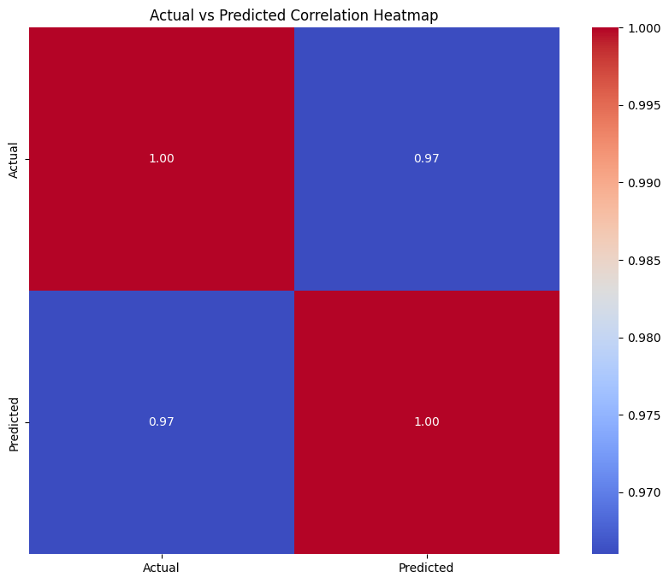

First, we didn’t used the whole dataset as it would be too large to compute on our computers. We used 100,000 records of this dataset which we thought was a significant amount to work with

The dataset we used wasn’t totally complete. Most of the columns were containing a small percentage of missing values. But because this percentage never exceeded 15%, we were allowed to fill them with either the mean value of the feature or the most recurrent one.

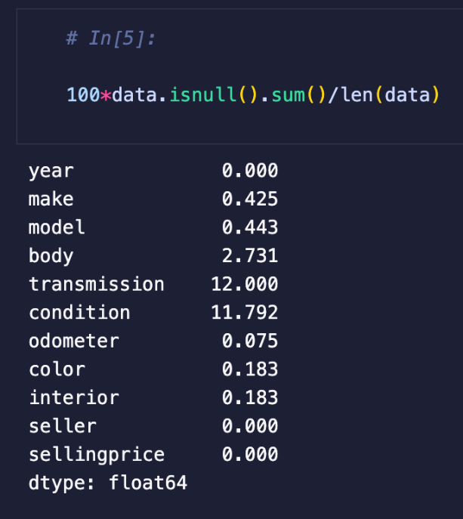

After doing so, we needed to convert string features to integers. We decided that we’ll use the factorize() method instead of the get_dummies() because there were way too many different strings to work with (it would have made a huge table to compute).

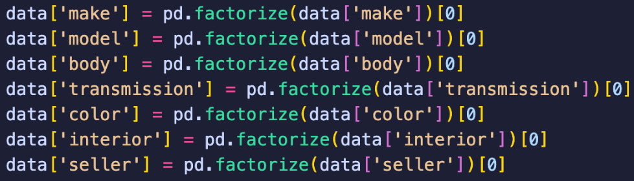

That was the end of our first pre-processing. But after finishing the model, the accuracy was too low and we went back to the preprocessing stage to continue tweaking the dataset so the model would gain in accuracy. Indeed, we made the following changes.

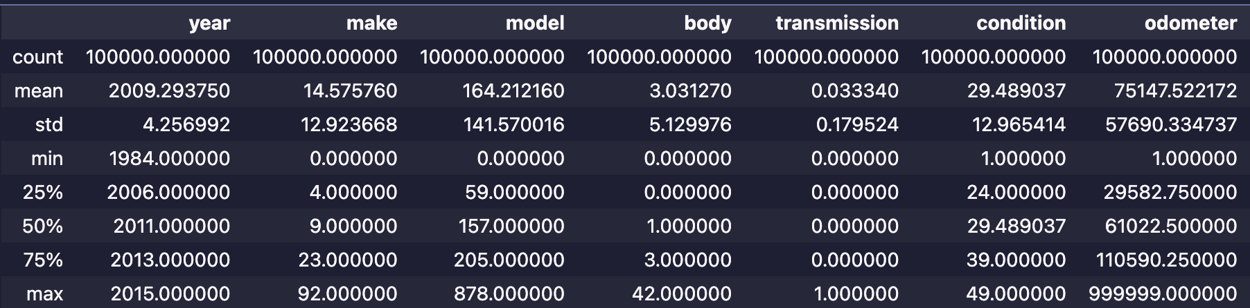

For example, the odometer have a maximum value of 999,999 kilometers, but 75% of its value are under 110,590.25 kilometers. Because of that, we decided to drop all rows that had a, odometer above 500,000 kilometers as it would have a bias on the result (while still trying to keep the maximum of data).

We also found that some variables like the odometer or some string converted features like seller had huge differences between the minimum and maximum value. To help reducing these differences we logged those features:

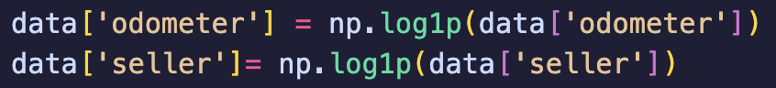

NB: We said earlier that we dropped the seller variable. Because of that we were stuck at a 73% accuracy. As we didn't know what to try to increase accuracy, we decided to go back on our decision and try to include this feature. To better understand their relationship, we used a correlation matrix, and it was here that we saw that the seller feature had a correlation of 0.3 with the selling price, which is quite significant compared to other features. This is where we made a mistake of excluding a feature only based on personal judgement. We also did the correlation matrices for the others features we dropped on judgement but none of the other one were significant to the result.

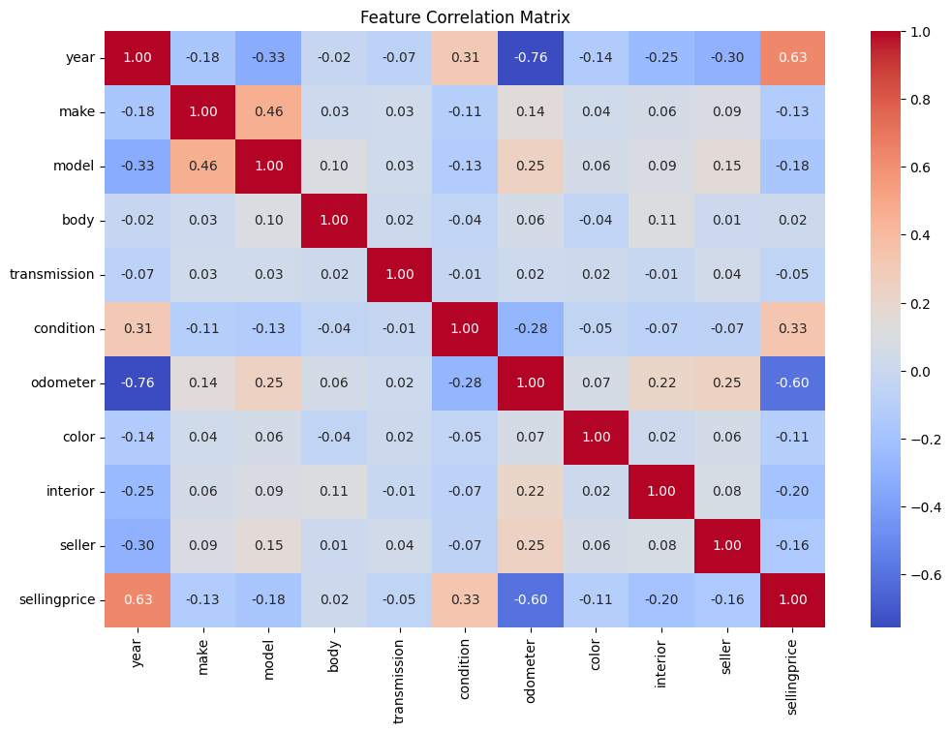

We also noticed that features that seemed important to us, such as make, body, model, transmission or color, didn’t matter that much on the final price. That's when we learned that, when it comes to machine learning, it's often better not to trust your first instinct and to analyze the data before deciding.

Then, the final step was to normalize the data to further reduce the difference between the minimum and maximum value of each feature, in order to reduce the bias due to the different scales of each variable.

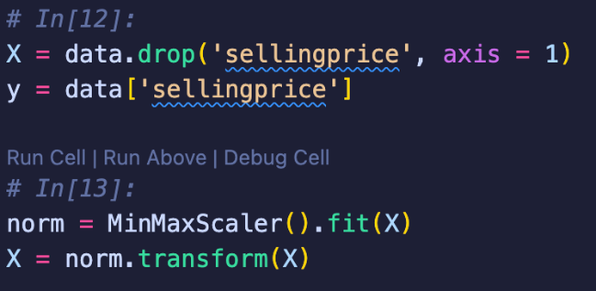

Here we only normalized the features and not the label as we want to keep the original price to train the data.

Model Implementation

To train the model we used the train_test_split() function, to allow the model to train on 80% of the data :

After doing so, we made a first prediction using the default KNN parameters:

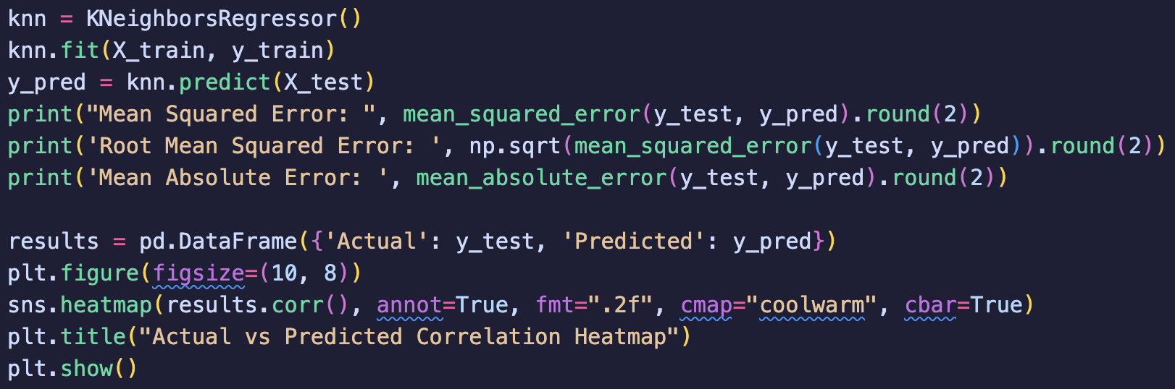

We obtain these results:

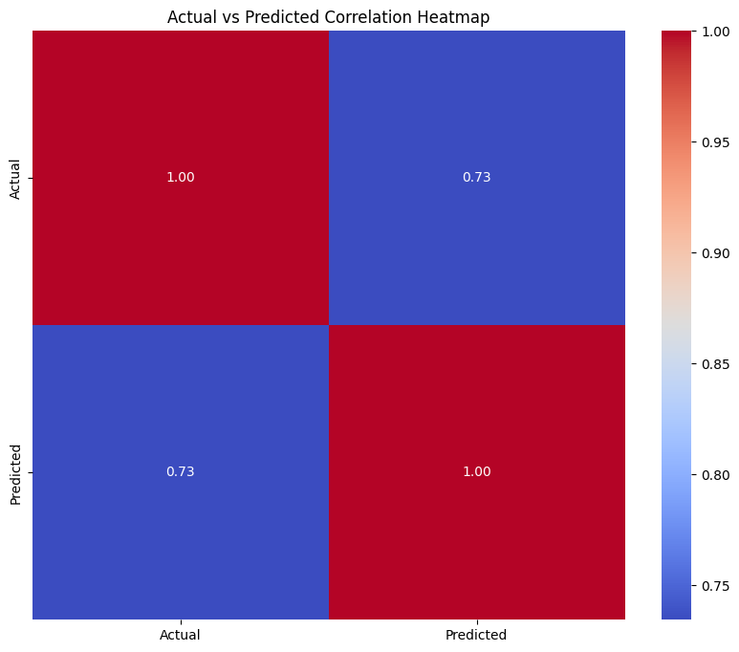

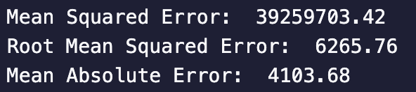

This indicates us that without any tweaking of the model that we already have an accuracy of 73%. Also, the MSE indicate that model prediction can be far from their real price which is to be expected as the price of the car can cost up to $156,000.

Root Mean Squared Error represent the average prediction error in the unit of the label variable which is dollar in this case. And we see that without tweaking, the average error is only $6,265 which isn’t that much considering the price variation and average selling price of a car.

Finally, the MAE show that the true difference between predicted result and reality is only $4103 which is 34.5% less.

Model Validation

Having adjusted our data to obtain the best possible dataset, we now need to do hyperparameters tuning to find the best possible configuration for the KNN algorithm. We first tried to use the GridSearch algorithm, as it is more precise and accurate. But after a few trials, we realized that it would take at least three days to produce a single model. This was obviously not viable, so we decided to use RandomSearch instead.
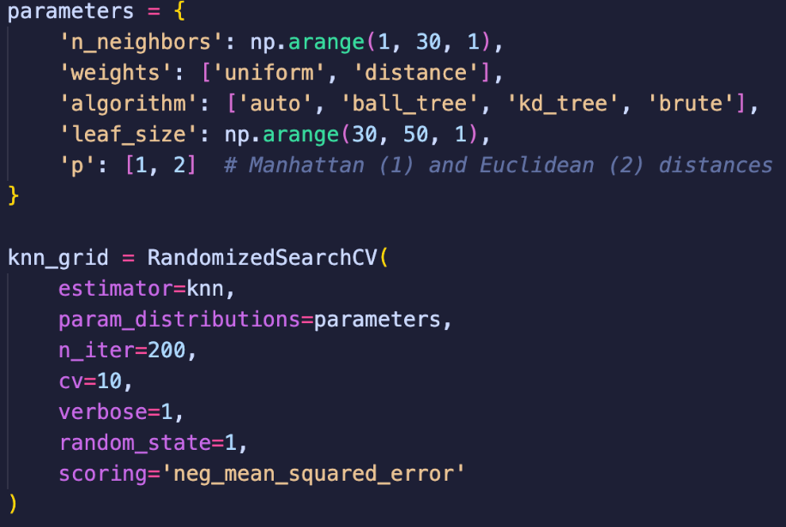

- N_neighbors: means that we check the results taking 1 to 30 neighbors into consideration
- Weight: how a neighbors impact the prediction
- Algorithm: the way KNN compute the neighbors and ‘auto’ select the best
- Leaf_size: determine the size of the leaf in the kd_tree algorithm (which is often the best algorithm to compute with)
- P: the way we compute distance between 2 points

Also, for the Random Search:

- N_iter: we decided to do a maximum of 200 iterations
- Cv: each iteration as 10 cross-validation fold
- Scoring: we decided to use the negative MSE as it was the most appropriate here

After a long computation we obtained:

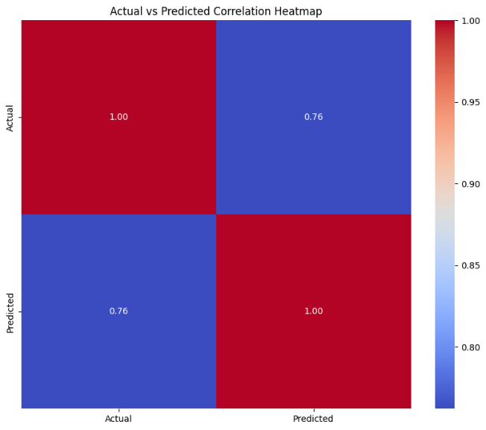
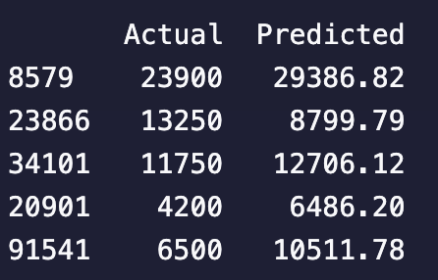

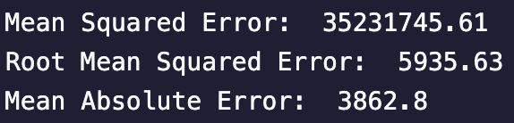

Here we see that we've achieved an accuracy of 76% of correctly predicted results, which is starting to look pretty good considering what we're trying to predict. We also see the difference between the predicted price and the correct price which, depending on your point of view, can be huge or tiny. Finally, we see that KNN tuning has optimized MSE, RMSE and MAE, which all slightly went down.

Analysis and recommendation

Even if we manage to achieve significant results. These can still be far from reality. Indeed, the difference between certain prices can be enormous from a normal person's point of view. For example, buying a car for $13,000 is far too much when the real price is $8,000. But the difference isn't that great when you're buying a $150,000 car. The results are excellent from a data analyst's point of view, and it's important to keep that in mind.

Conclusion

In conclusion, I don't think our model is suited to a real-life scenario. The market factor we've avoided using here would be the most important factor to consider. In fact, it might even be the only one if we had to choose. And by plotting the correlation of mmr, we can observe that its relationship with final price is really important (0.83):
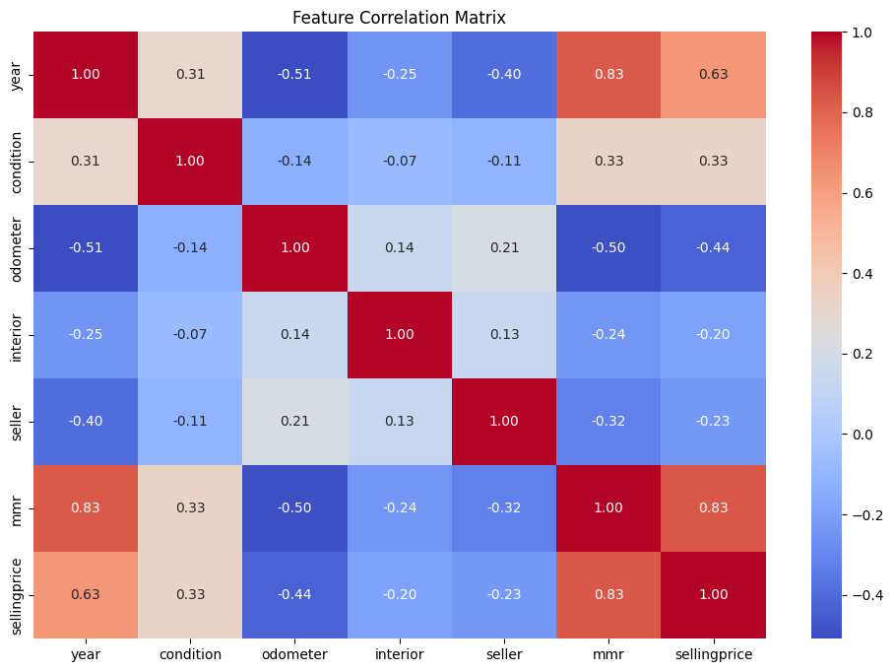

Doing this analysis was interesting because it involved pre-processing the dataset in many different ways and dealing with computational issues due to the size of the dataset, so we learned a lot from this project. According to the resources we found, we were the only ones to use the KNN algorithm (other used regression, Random Forest, XGBoost or did some EDA) to create this model. But if we compare our accuracy results and the way we carry out the analysis, we can see that we execute it in almost the same way. We start by identifying the most important variable and drop the others, fill in the gaps, code them and then apply our specific algorithm.

Model creation using Polynomial regression

Dataset Preparation

For the polynomial model, we mainly used the same data as for the KNN (almost the same data preprocessing). The only difference is that we decided to include more features, as polynomial regression can handle them (KNN is too influenced by weakly correlated features, which reduces the final accuracy). That's why we've included features we'd previously dropped, such as make, body, transmission, model and color.

These features are mostly strings, which means we need to convert them to integers. We used the factorize() method, which avoids creating too many columns, as there can be up to hundreds of different values for each variable.
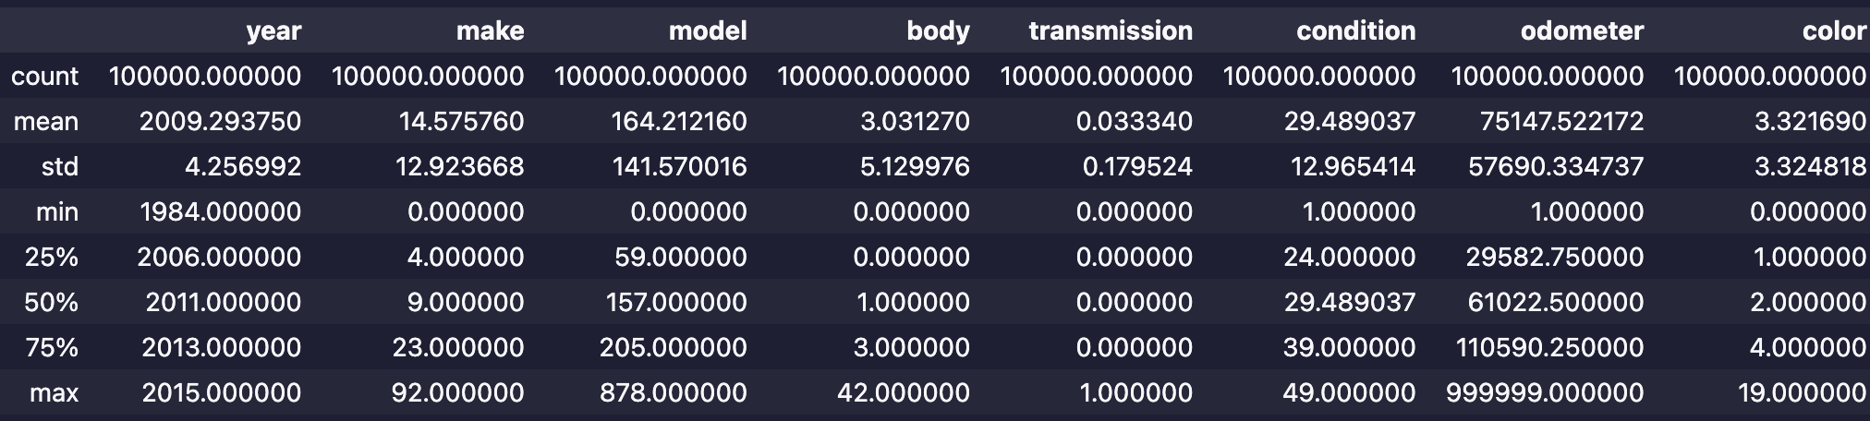

As we now have large differences between the minimum and maximum values of these converted features, we decided to apply a logarithm to them in order to reduce the bias of these features. We decided to apply a logarithm to reduce the bias of these features.

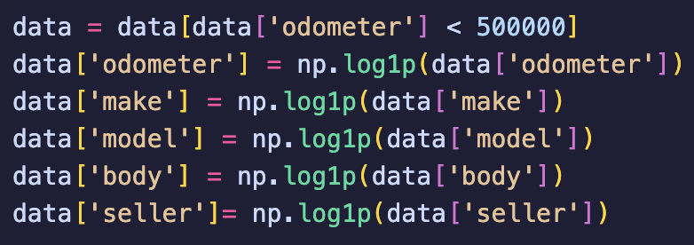

Other than that, the pre-processing stage is the same.

Model Implementation

To implement the polynomial, we must first try to fit the linear regression without tuning it. We obtain a score of 44%, which is far too low and confirms that we should use polynomial regression instead of linear regression.

NB: When using MMR, price correlation is strongly related to this function and some people have used linear regression to create the model in these specific cases.

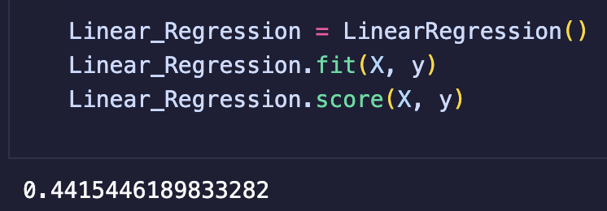

For good measure, we printed out the OLS summary of the linear model and obtained various pieces of information such as the correlation coefficient of each feature with the selling price. We see that all variables except x2 are highly significant for the result (low p values), but also that x1, x2 and x6 are highly positively correlated, x7, x8, x9 and have significant negative impact.

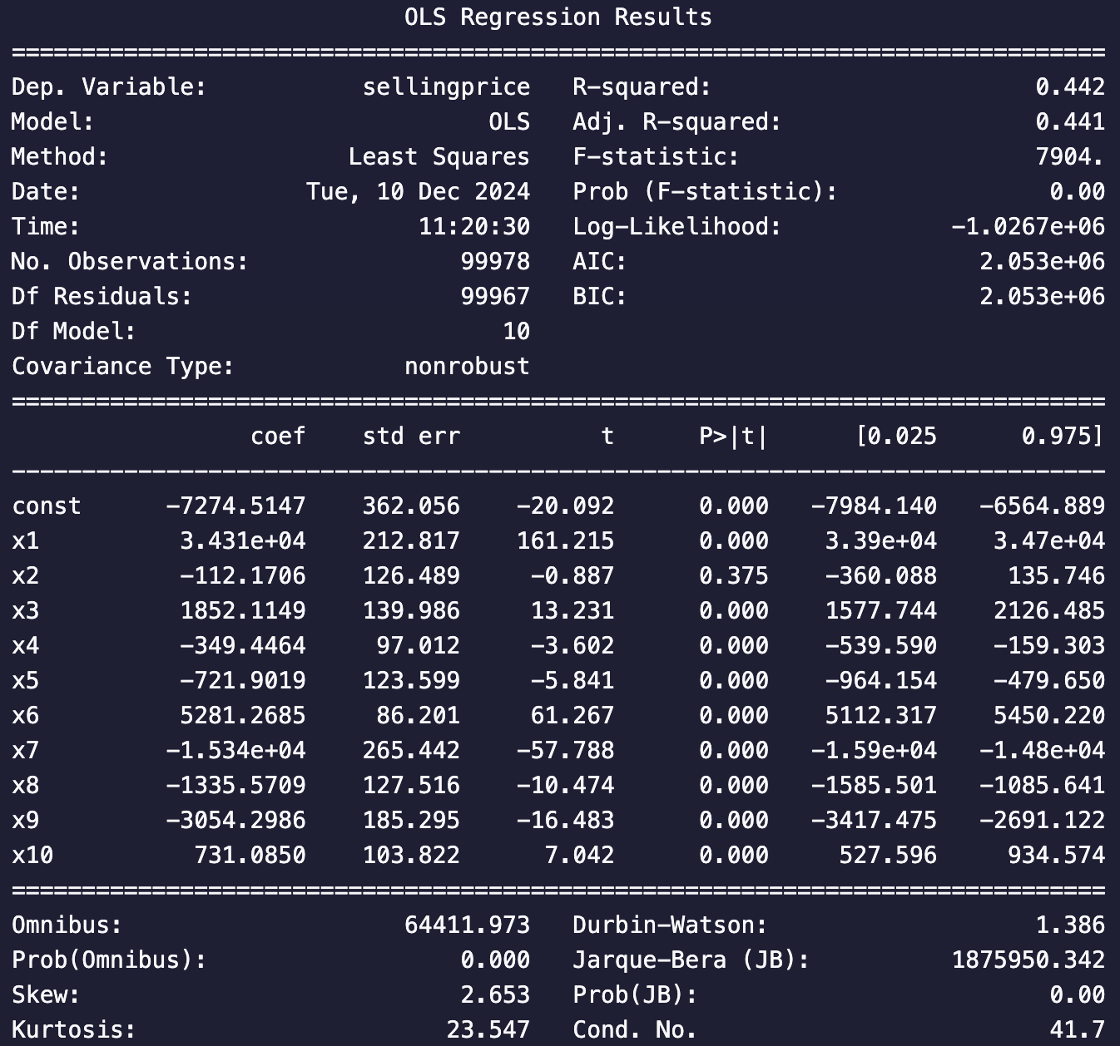

After that first analysis we start to split the model into training and testing groups using the train_test_split() function. To obtain good measurements, we again print the accuracy score of the linear regression model without tuning for the training group and the test group and obtain the following results:

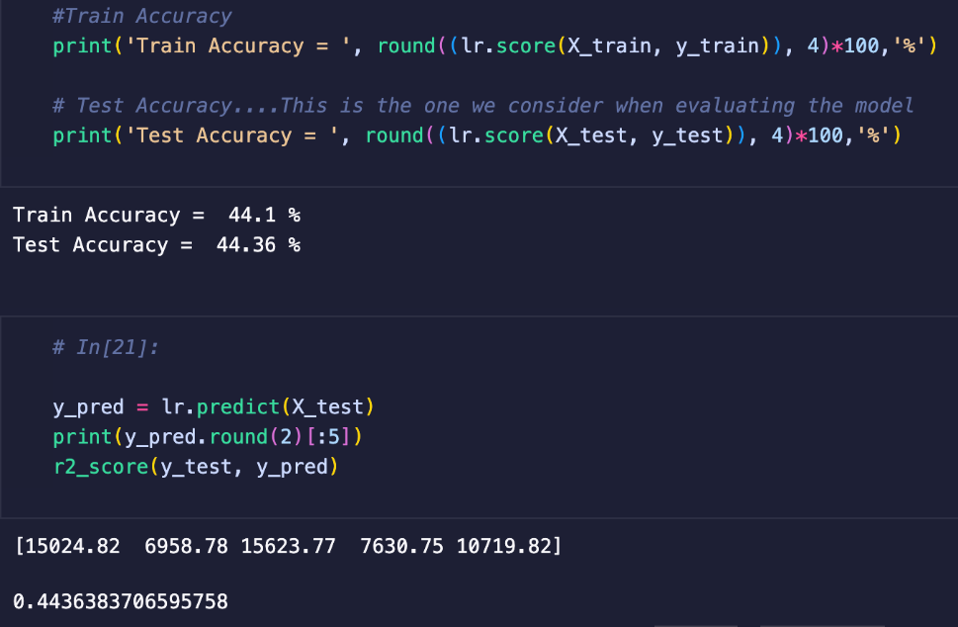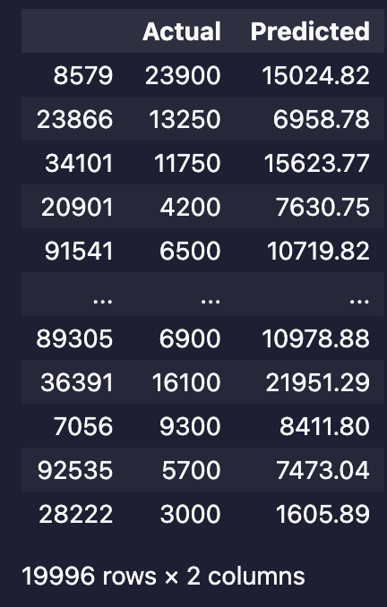

The results of the simple linear regression is way too low (44.36%) indicating that we should use a polynomial regression. To better visualize the model and the correlation, we decided to make a scatter plot of the features and the selling price, but also the residual diagram, which gave us :
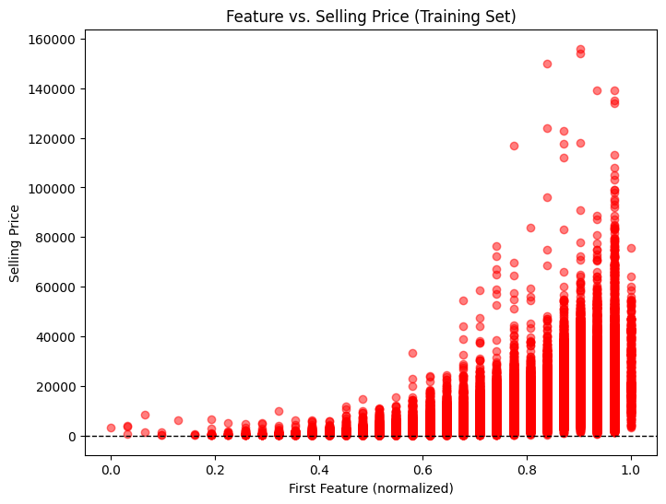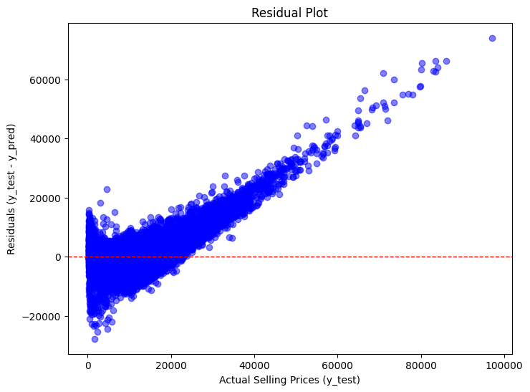

These plots also show that a linear regression cannot effectively represent the model. In fact, the data should fall under a polynomial function, as the curves of the data appear more curved and the residual curves have a tunnel shape. The residual plot is non consistent (homoscedasticity) showing that it isn’t following a linear regression.

Model Validation

To prove this hypothesis, we have to train a polynomial model and tune the hyperparameter (which in this case is the degree of the polynomial function).

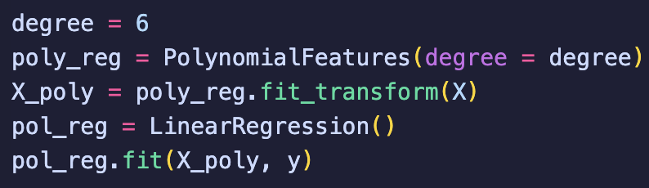

To tune the model, we tried different degree of polynomiality. We went from 53% accuracy at degree 2 to 74.8% of accuracy for the degree 6. We tried to test a value of 7 but the algorithm ran for 15 hours straight before crashing and we couldn’t figure out how to obtain the result. We also tried to test it for less values (10 000 instead of 100 000) but it still didn’t ran for a degree 7. However, we obtain a 90% accuracy for the degree 6 at 10 000 values which show that the polynomial model is fitting well to the data.

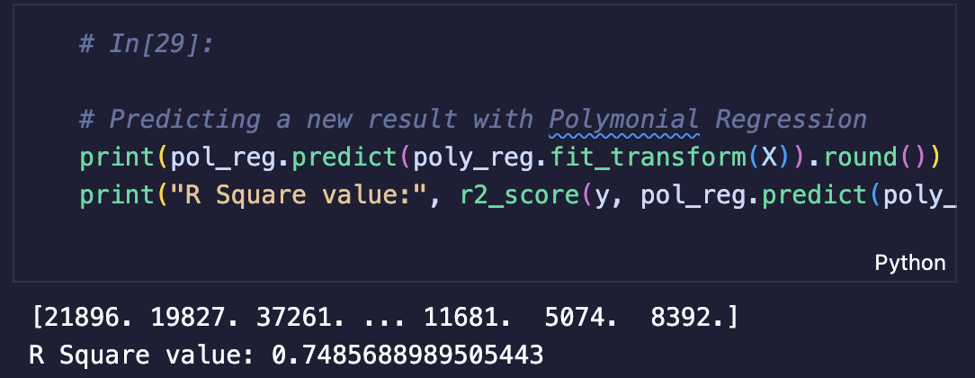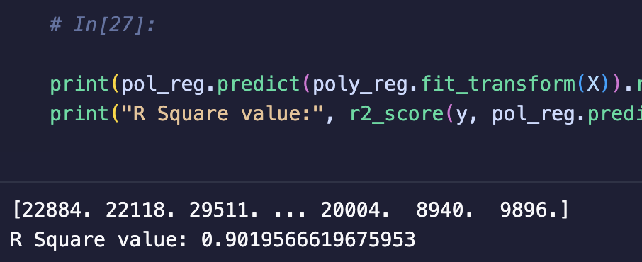

Analysis and recommendation

With an accuracy rate of almost 75%, we're satisfied. However, with more time and more computing capacity, we feel that a model built on a 7-degree polynomial function might be even better suited. To compare the two models, we printed out the regression metrics:

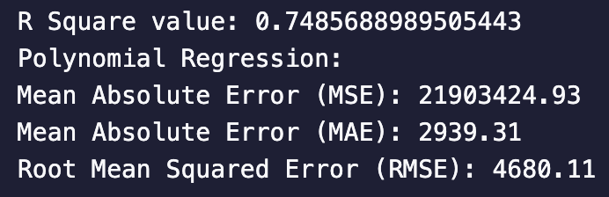

This shows that the average prediction error (RMSE) is on average $4,680.11 compared to the actual value. But in fact, when compared with the label value, the predicted value is within $2,939.31 (MAE) of the actual value, which is much closer.

Conclusion

Even if the accuracy is slightly lower than that of the KNN model, these measurements are still better and show that even if the exact value is predicted a little less often. On average, the values are closer to the actual price than the KNN model. As this data set seems to follow a polynomial function, this method seems more efficient than the KNN model. This is all the more true as, with fewer data (10,000), the polynomial function shows an accuracy of 90% without market price information, which means that it is truly efficient and suitable.

Project Conclusion
Although we didn't check any related work before proceeding with the analysis, we followed the same direction as the others, both in the pre-processing and analysis stages. The main difference with our project is that we wanted to predict the price of a car using only information about the car, not the current state of the market. We know that this feature mainly dictates the actual selling price of a car, but as it is not stable over time and changes, we wanted to focus on the car. We obtained significant results (75/76%), but these results should not be considered as the only factor when selling a car, for the reason mentioned above and because even if the precision is starting to be mathematically great, it is still too far from reality to be used.

To improve on this, we could have used other prediction algorithms that we haven't seen in class, as in the other related work we've seen, or calculated a larger model. However, the fact that others obtained results like ours, even though they were using the MMR function, confirms that we took the right approach when working on the dataset.

This project allowed us to apply our new knowledge of machine learning and work on a real-life use case. Even though we only used some of the basic knowledge and methods of machine learning, it showed us that it can be applied to a wide range of situations and be useful in everyday life.

