

**MINISTRY OF EDUCATION AND TRAI­NING**

**HCMC UNIVERSITY OF TECHNOLOGY AND EDUCATION**

**FACULTY OF INTERNATIONAL EDUCATION**

🙠🙟🕮🙝🙢



Project on Software Engineering

**DEVELOPING AN ANDROID APPLICATION**

**FOR SELLING WATCHES**

**Lecturer: Lê Văn Vinh**

**Group Members:**

Nguyễn Việt Anh 20110352

Lê Y Thiện 20110403

*Ho Chi Minh City, September, 2023*

**Chapter 2: CURRENT STATUS SURVEY AND REQUIREMENT MODELING**

**2.1. CURRENT STATUS SURVEY**

2.1.1 Chrono24

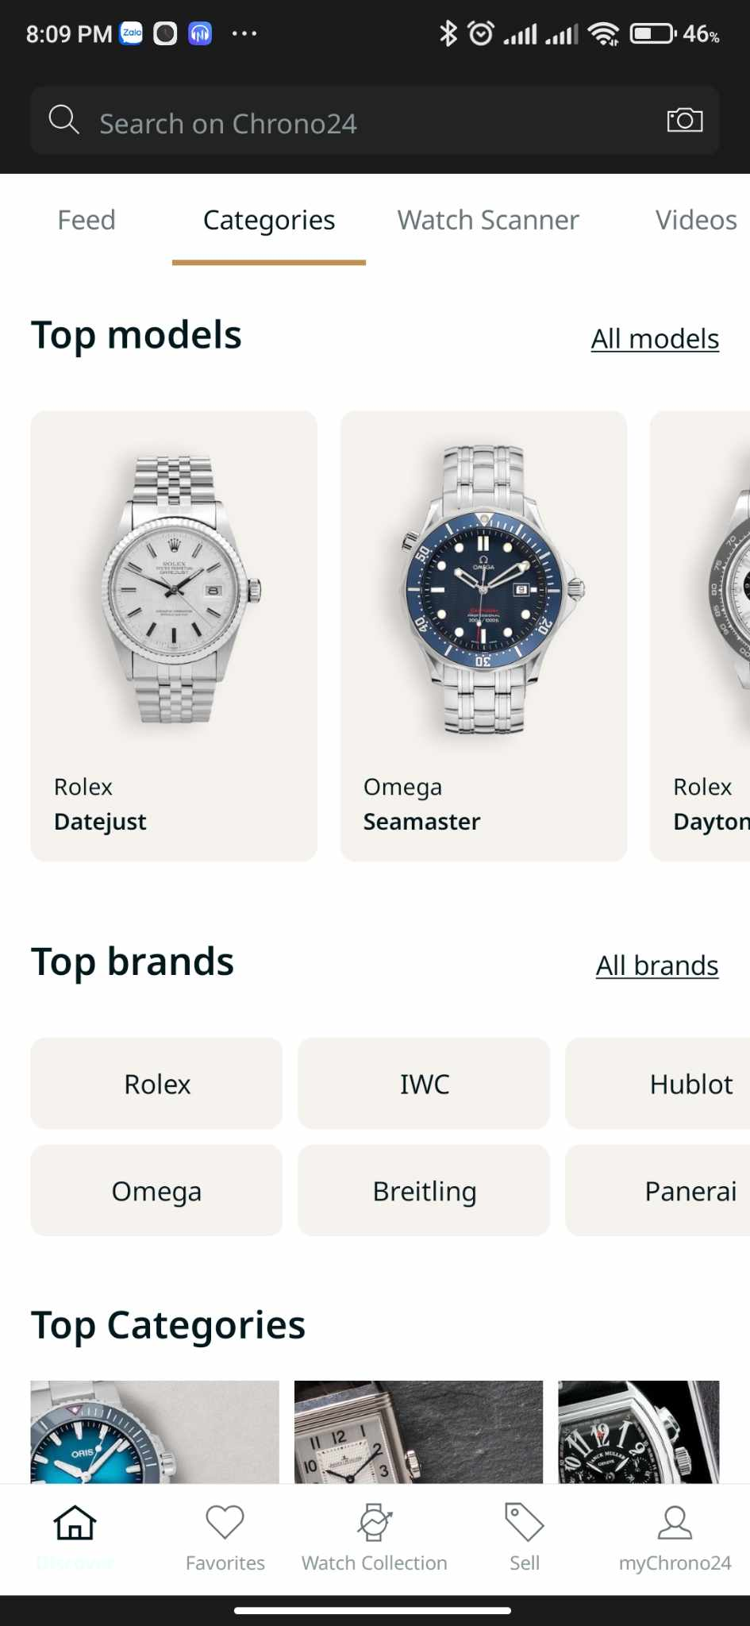

- Main function:

+ View, search, filter products

+ Manage the product in the cart

+ Add the product to the wishlist

+ Checkout

- Overview:

+ Products are classified in detail (gender, style, price, color, …)

+ You can look up order information

+ The UI/UX is friendly.

2.1.2 G-shock



- Some main functions of the app:

+ See the product of G-Shock.

+ Connect G-Shock watches

+ Sign up/login account

- Overview:

+ The UI/UX is friendly.

2.1.3 Banggood

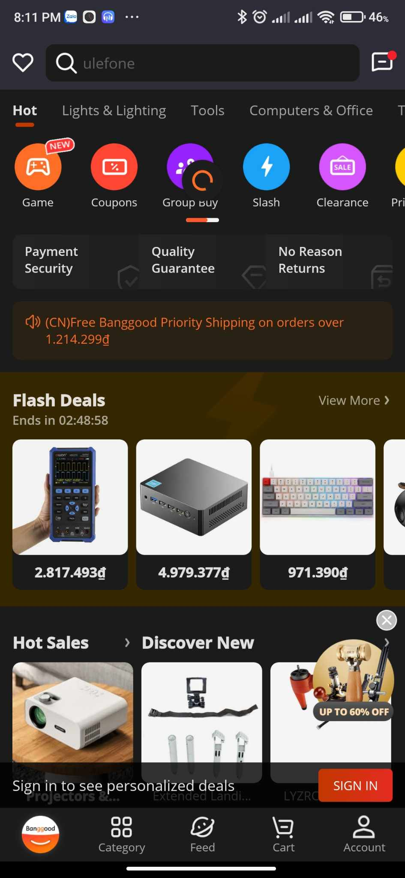

- Main function:

+ Login, Register

+ View, search, and filter products.

+ Add product to cart

+ Manage the product in the cart

+ Pagination for the products

+ Checkout

+ Chat with the vendor

- Overview:

+ Users can easily use the advanced search function

+ Products are filtered in detail (brand, gender, price, size, …)

+ Can view product images in zoom mode

2.1.4 Daraz

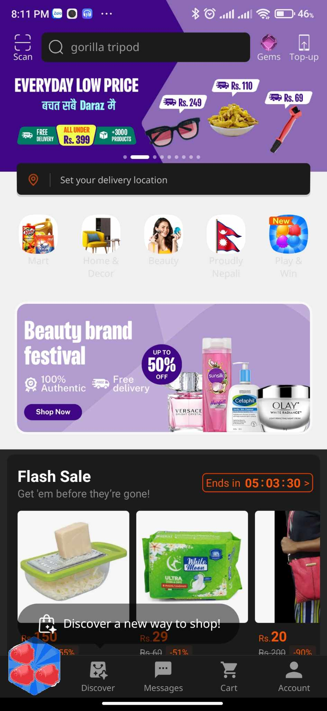

- Main functions:  
+ View, quick view, search, and filter products.

+ Manage the product in the cart.

+ Pagination for the products.

+ Checkout.

+ Contact with the vendor

- Overview:

+ Users can easily use the advanced search function

+ Products are filtered in detail (brand, gender, price, size, …)

+ Can view product images in zoom mode

**2.2 MODELING REQUIREMENTS**

## **2.1. Usecase diagram**

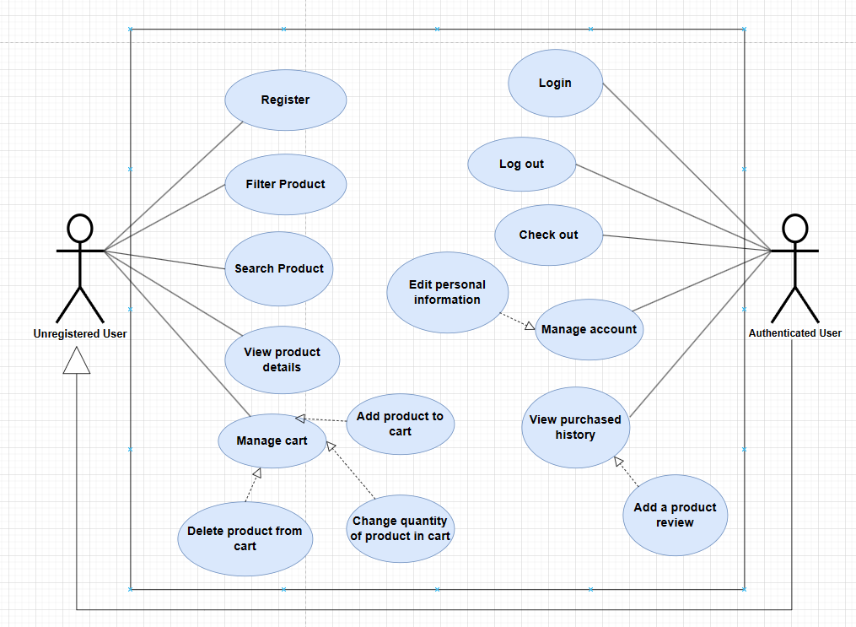

Figure Use Case User

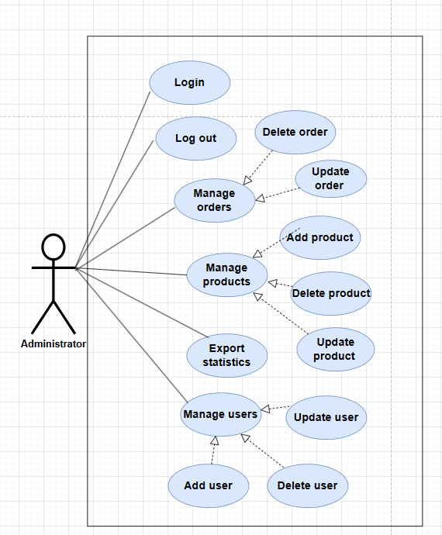

Figure Use Case Admin

|  |  |
| --- | --- |
| **Actor** | **Description** |
|  | Anonymous user, a person who come to app to view and do not need to log in |
|  | Register Customer – a person who joins the system and has registered an account with the system (Login) |
|  | Admin – a person who has full authority over the system (Logged in) |

* 1. **Class diagram**

Figure Conceptual diagram

* 1. **Use Case Specification**

### *Describe use case login*

Table: Describe Use Case Login

|  |  |
| --- | --- |
| **Use Case Login** | |
| **Short Description** | Allow Actor to log into the system. |
| **Actor** | Register customer |
| **Pre-Condition** |  |
| **Basic Flow** | 1. User selects login function from home page  2. The system returns the login form page.  3. User enters information and clicks confirm.  4. System checks username and password.  5. The system redirects to the homepage. |
| **Alternative Flow** | 3a. If the user forgets the password, click forgot password, the page will redirect to Use case Forgot Password. |
| **Exception flow** | 3.1 If the information input empty, system will request to re-input data, system return step 3.  4.1 If the user enters the wrong password information, the system will notify the wrong information and return to step 2.  4.2 If the account does not exist, the system will notify you if you want to create a new account.  4.2.1 If you choose Yes, you will go to the account registration form.  4.2.2 If No is selected, return to step 2. |

### *2.3.2 Describe use case register*

Table: Describe Use case Register

|  |  |
| --- | --- |
| **Use Case Register** | |
| **Short Description** | Allow Actor to register account. |
| **Actor** | New customer |
| **Pre-Condition** |  |
| **Post-Condition:** | Sign Up Success |
| **Basic Flow** | 1. Actor accesses Register function from Login page  2. The system returns the account registration form  3. User enters required information and clicks submit.  4. System will send OTP code to actor email and redirect to verify page.  5. Actor enters the confirmation code in the email verification form and clicks submit, the system will log in with the successfully registered email.  6. The system redirects to the homepage with the registered username. |
| **Alternative Flow** |  |
| **Exception flow** | 3a. If the information entered is incorrect (missing important fields such as email, password,...) the system will ask to re-enter the information and back to step 3  3b. If the email, username information already exists, the system will ask to re-enter it from step 3.  5.a. If the user enters the wrong authentication code, the system displays the wrong authentication code, please re-enter it and return to step 5. |

### *2.3.3 Describe use case update information*

Table: Describe Use Case Update Information

|  |  |
| --- | --- |
| **Use Case Update User Information** | |
| **Short Description** | Allow actor to update information. |
| **Actor** | Admin |
| **Pre-Condition** | Log in to the app |
| **Post-Condition:** | Actor successfully update user information |
| **Main Flow** | 1. Actor click “user management page” at navigation tab, website move to user management page. User management page will show all user and their data from database. There are add button on top of the list, edits and deletes buttons on each user line.  2. Actor click update button on the line of the user need to update. Website open new tab which displays all the information of the product selected. Below the form there is a “edit” button.  3. Actor adjust information.  4. Actor click edit button to update information to database. Then the website will move to user page. (E1) |
| **Alternative Flow** |  |
| **Exception flow** | E1: If actor does not enter all the text field. A message “Please fill out this field” will appear on the missing field. |

### *2.3.4 Describe use case payment*

Table: Describe Use Case Payment

|  |  |
| --- | --- |
| **Use Case Payment** | |
| **Short Description** | Allow Actor to Payment. |
| **Actor** | Register Customer |
| **Pre-Condition** |  |
| **Post-Condition:** | Actor Payment successfully |
| **Basic Flow** | 1. Actor selects to cart. 2. System will redirect to checkout page. 3. Actor input information. 4. Successful authentication system will redirect to home page. |
| **Alternative Flow** | 3.1. Actor click on the online payment method, the system will redirect to the online payment page.  3.1.1 Actor confirms payment information and clicks submit.  3.1.2 Payment information verification system.  3.2. Actor click on the cash payment method, the system will redirect to the cash payment page. |
| **Exception flow** | 3.1.2a If the payment account cannot be verified, the system will report an error and return to step 3.  3.1.2b If the payment account is not enough for payment, the system notices that there is not enough money in the account and returns to step 3.  4b. If input information is empty, the system request actor re-input data. |

### *2.3.5 Describe use case search*

Table 12 Describe Use Case Search

|  |  |
| --- | --- |
| **Use Case Search** | |
| **Short Description** | Allow Actor Search Product |
| **Actor** | Anonymous, register, admin |
| **Pre-Condition** | Have product need search |
| **Post-Condition:** | Actor Search successfully |
| **Basic Flow** | 1. Actor selects search bar 2. The actor enters the product name in the filter bar and click submit 3. System returns search result. |
| **Alternative Flow** |  |
| **Exception flow** | 3a. If the product exists, the system will display the product list.  3b. If the product does not exist, the system returns no products. |

### *2.3.6 Describe use case detail product*

Table 13 Describe Use Case Detail Product

|  |  |
| --- | --- |
| **Use Case Detail Product** | |
| **Short Description** | Allow actor View Detail Product. |
| **Actor** | Anonymous Customer/ Register Customer, admin |
| **Pre-Condition** |  |
| **Post-Condition:** | System direct to product detail page. |
| **Basic Flow** | 1. 1. Actor clicks on a product. 2. 2. System direct to selected product detail page |
| **Alternative Flow** |  |
| **Exception flow** |  |

### *2.3.6 Describe Use Case Update Product Information*

Table 14 Describe Use Case Update Product Information

|  |  |
| --- | --- |
| **Use Case Update Product Information** | |
| **Short Description** | Allows actor to edit the information of a selected product |
| **Actor** | Admin |
| **Pre-Condition** | Log in to the admin web. |
| **Post-Condition:** | Product information is updated successfully |
| **Basic Flow** | 1. Actor click “product management page” at navigation tab, website move to product management page. The product management page will show all products and their ids, names, images on lines from database. There are add button on top of the list, edits and deletes buttons on each product line. 2. Actor click update button on the line of the product need to update. The website opens new tab which display all the information of the product selected. Below the form there is a “edit” button. 3. Actor adjust information. ***(E1)*** 4. Actor click edit button to update information to database. Then the website will redirect to product management page. ***(E2)*** |
| **Alternative Flow** |  |
| **Exception flow** | E1: If actor leaves the Update page without clicking “Edit”, all changes will not be saved.  E2: If actor does not enter all the text field. A message “Please fill out this field” will appear on the missing field. |

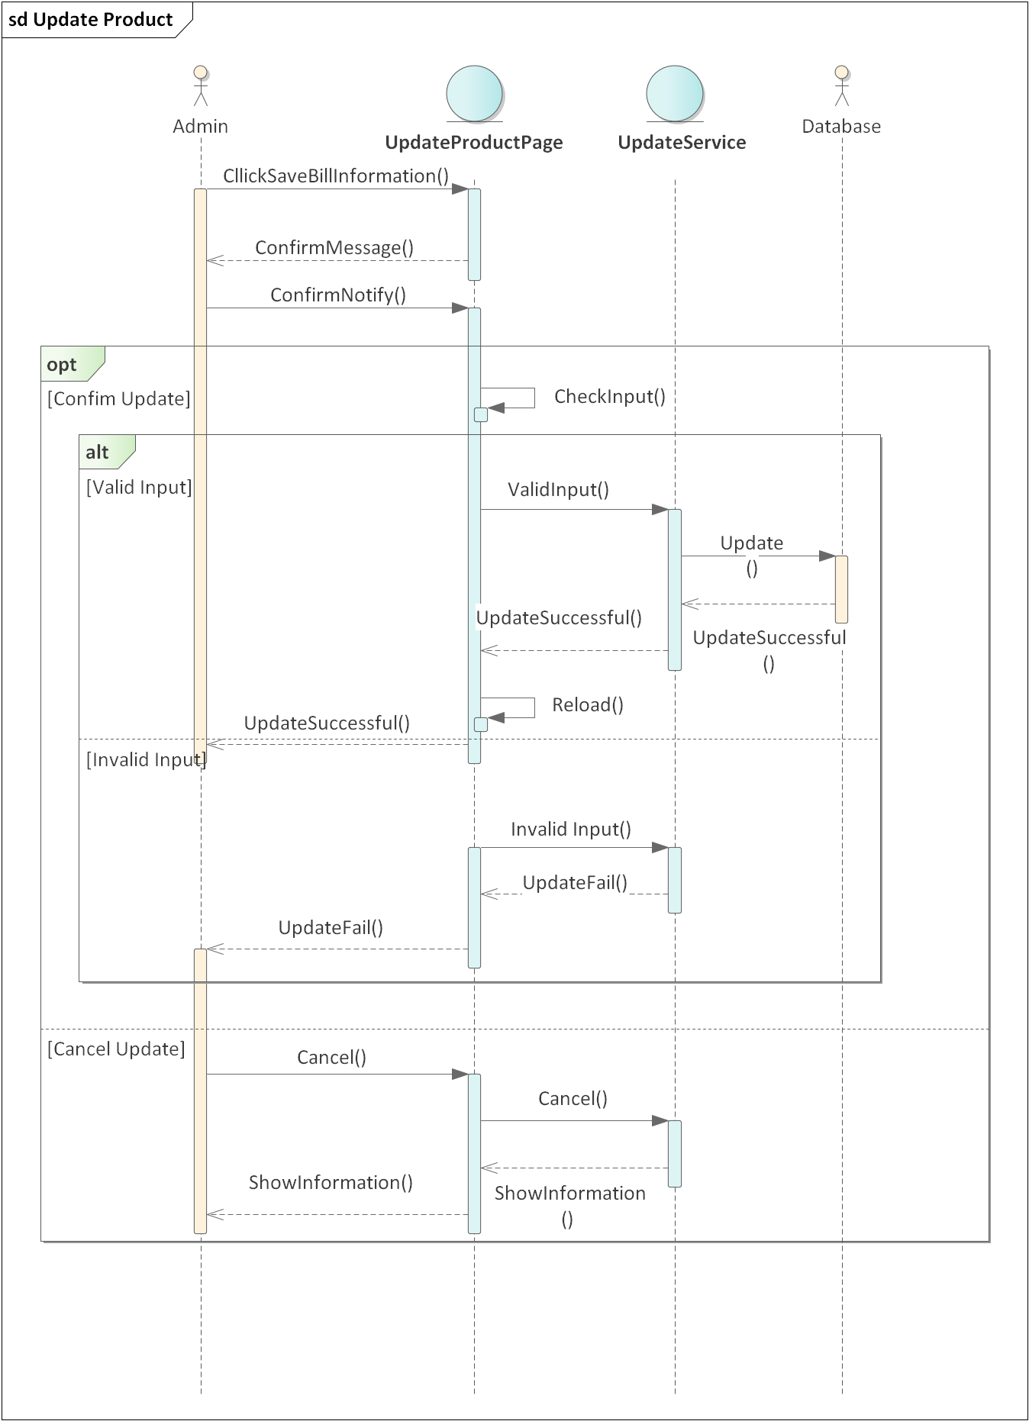

### *Describe use case delete product*

Table 15 Describe Use Case Delete Product

|  |  |
| --- | --- |
| **Use Case Delete Product** | |
| **Short Description** | Allow actor to deleted product |
| **Actor** | Admin |
| **Pre-Condition** | Log in to the admin web. |
| **Post-Condition:** | The selected product is removed from the database |
| **Basic Flow** | 1. Actor click “product management page” at navigation tab, website move to product management page. The product management page will show all products and their ids, names, images on lines from database. There are add button on top of the list, edits and deletes buttons on each product line. 2. Actor click “delete” button on the line of the product need to delete. 3. A message box “Are you sure you want to delete product *id selected*?” will appear with “OK” and “Cancel” button. 4. Click “OK” to confirm the deletion of the product. **(E1)** |
| **Alternative Flow** |  |
| **Exception flow** | E1: If the product is already in any of the orders, the deletion process fails and the message "There is a product in other invoice: id1, id2, …" is displayed. Then return step 1. |

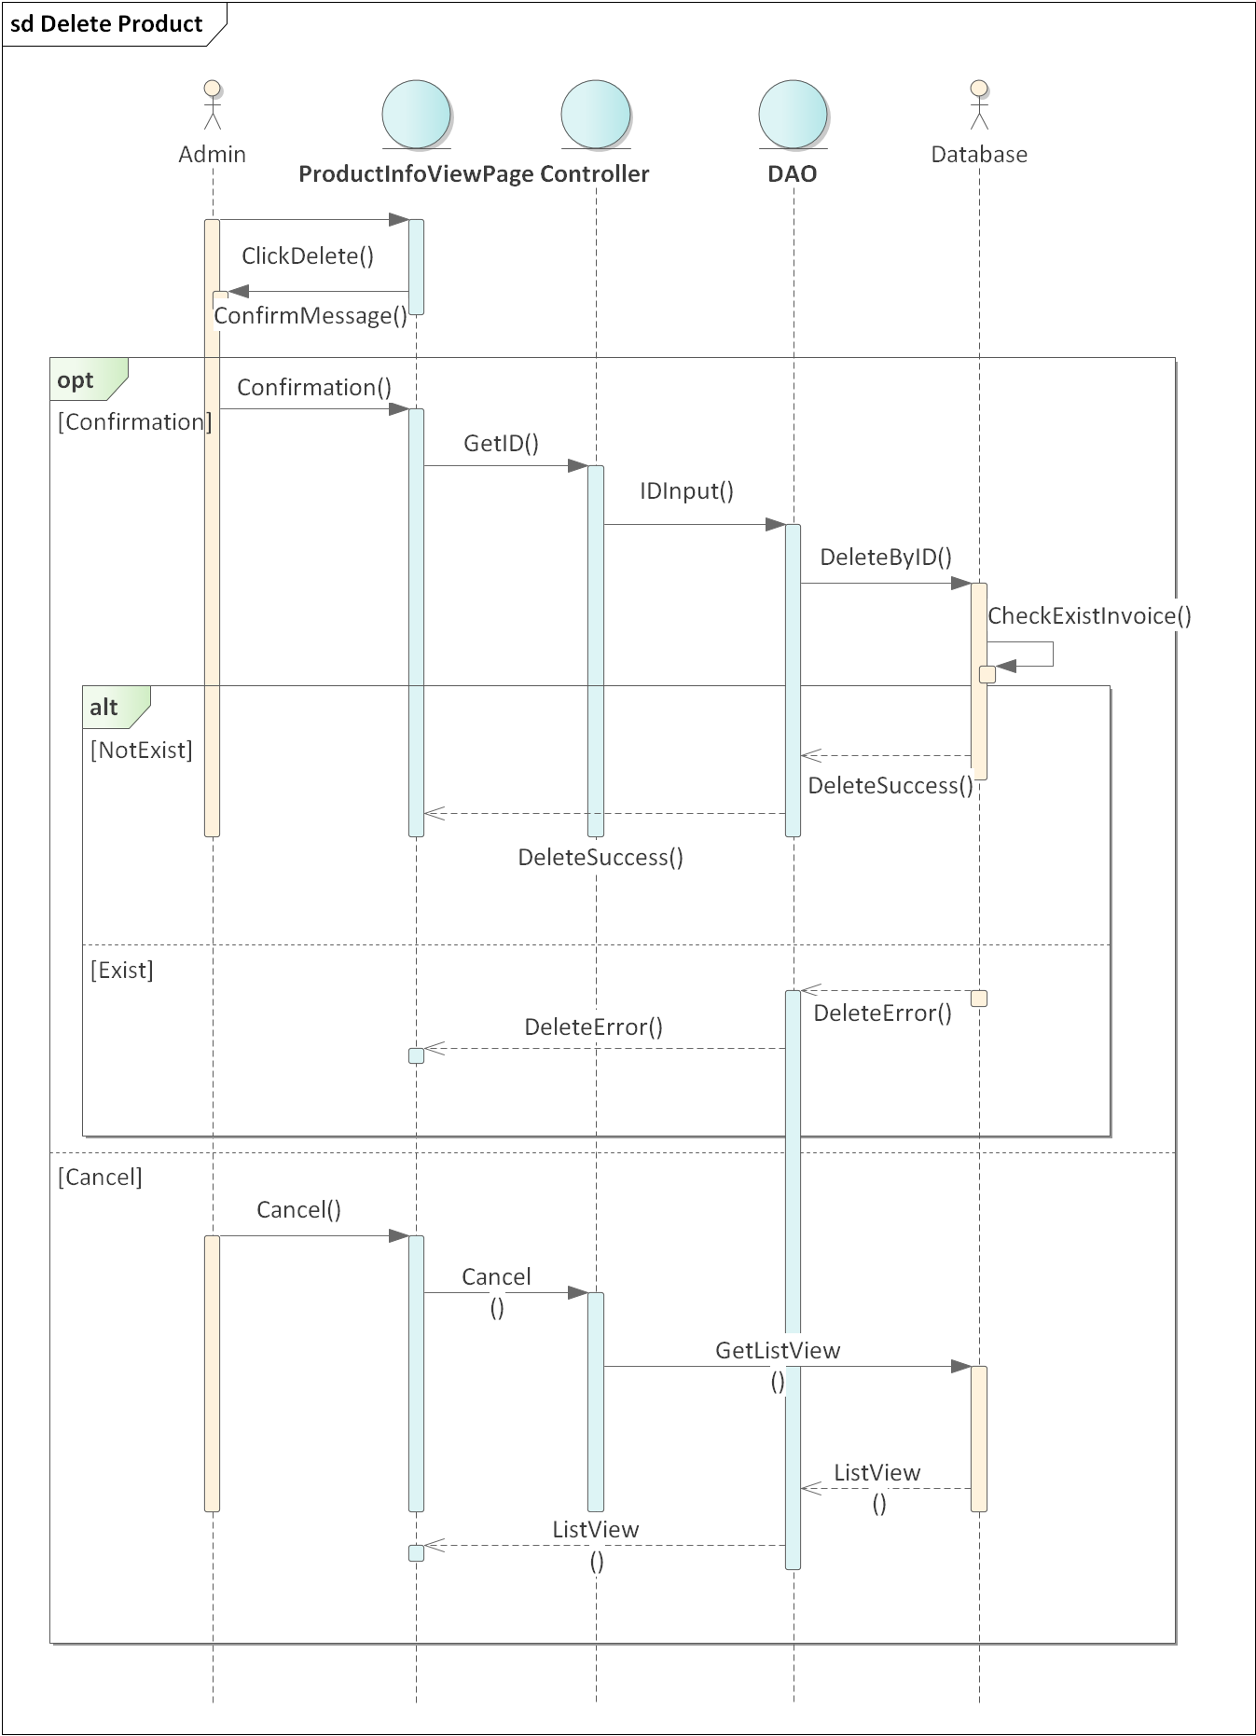

### *2.3.7 Describe use case update invoice information*

Table 16 Describe Use Case Update Invoice Information

|  |  |
| --- | --- |
| **Use Case Update Invoice Information** | |
| **Short Description** | Allows actor to edit the information of a selected invoice. |
| **Actor** | Admin |
| **Pre-Condition** | Log in to the app |
| **Post-Condition:** | Invoice information is updated to the database |
| **Basic Flow** | 1. Actor click “Invoice management” at navigation tab, website move to Invoice management page, which will show all Invoices information on lines from database. There are add buttons on top of the list, edits and deletes buttons on each Invoice line. 2. Admin click update button on the line of the Invoice need to update. The website open new tab which display all the information of the Invoice selected. Below the form there is a “edit” button. 3. Actor adjust information. ***(E1)*** 4. Actor click edit button to update information to database. Then the website will redirect to product management page. ***(E2)*** |
| **Alternative Flow** |  |
| **Exception flow** | E1: If actor leaves the Update page without clicking “Edit”, all changes will not be saved.  E2: If actor does not enter all the text field. A message “Please fill out this field” will appear on the missing field. |

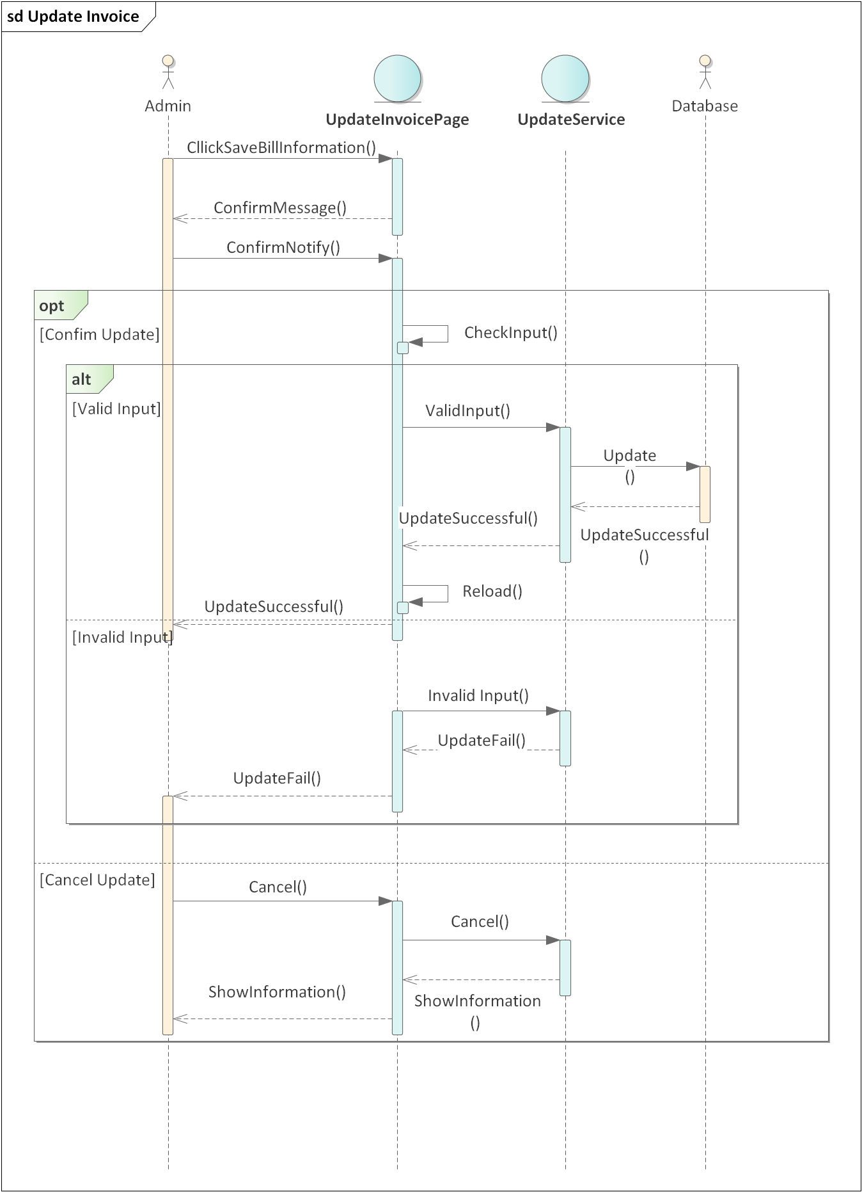

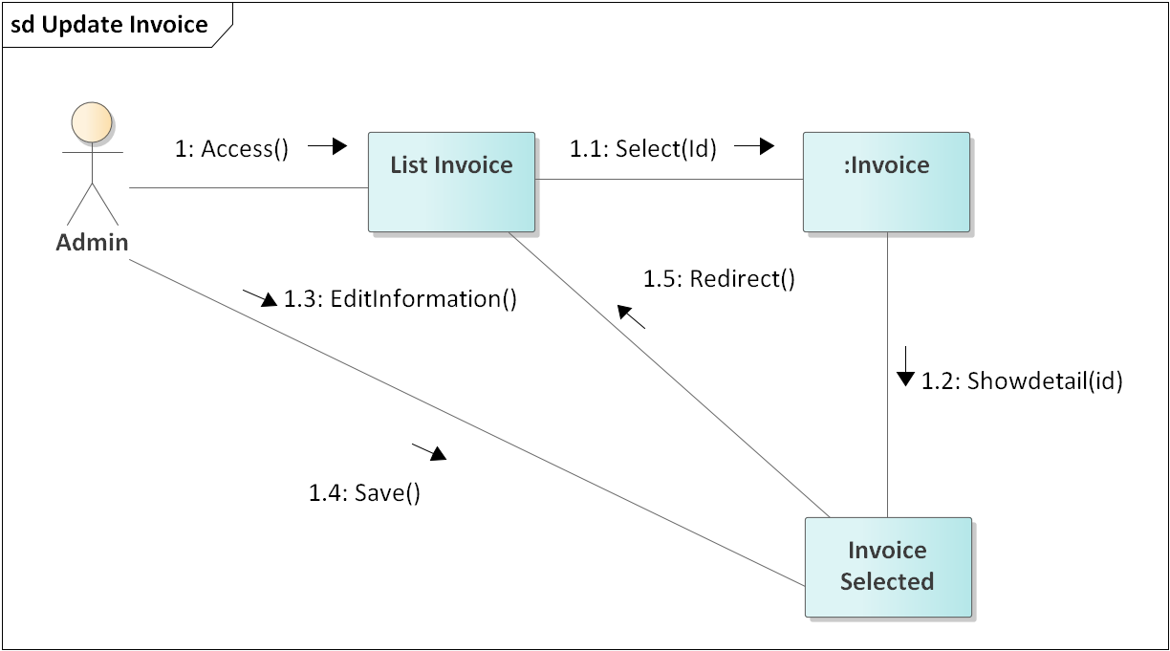

### *2.3.8 Describe use case revenue statistics*

Table 17 Describe Use Case Revenue statistics

|  |  |
| --- | --- |
| **Use Case Revenue statistics** | |
| **Short Description** | Allow actor view revenue statistics. |
| **Actor** | Admin |
| **Pre-Condition** | Log in to the admin web. |
| **Post-Condition:** | Show revenue by date on page |
| **Basic Flow** | 1. Actor click “Revenue” at navigation tab, website move to Revenue page. There are a tool box to select date. 2. Actor select a date to see that day revenue. 3. Website will show the list of Invoices of and total revenue of selected day. ***(E1)*** |
| **Alternative Flow** | 3.a Actor choose another day to see it revenue. |
| **Exception flow** | E1: If the selected day does not exist in database then return nothing, Use case return step 2. |

### *2.3.9 Describe use case delete invoice*

Table 18 Describe Use Case Delete Invoice

|  |  |
| --- | --- |
| **Describe Use Case Delete Invoice** | |
| **Short Description** | Allow actor to remove selected invoice. |
| **Actor** | Admin |
| **Pre-Condition** | Log in to the admin web. |
| **Post-Condition:** | The selected bill is removed from the database |
| **Basic Flow** | 1. 1 Actor click “Invoice management” at navigation tab, website move to Invoice management page, which will show all Invoices information on lines from database. There are add button on top of the list, edits and deletes buttons on each Invoice line. 2. Actor click “delete” button on the line of the Invoice need to delete. 3. A message box “Are you sure you want to delete Invoice id selected?” will appear with “OK” and “Cancel” button. 4. Click “OK” to confirm the deletion of the Invoice. |
| **Alternative Flow** |  |
| **Exception flow** |  |

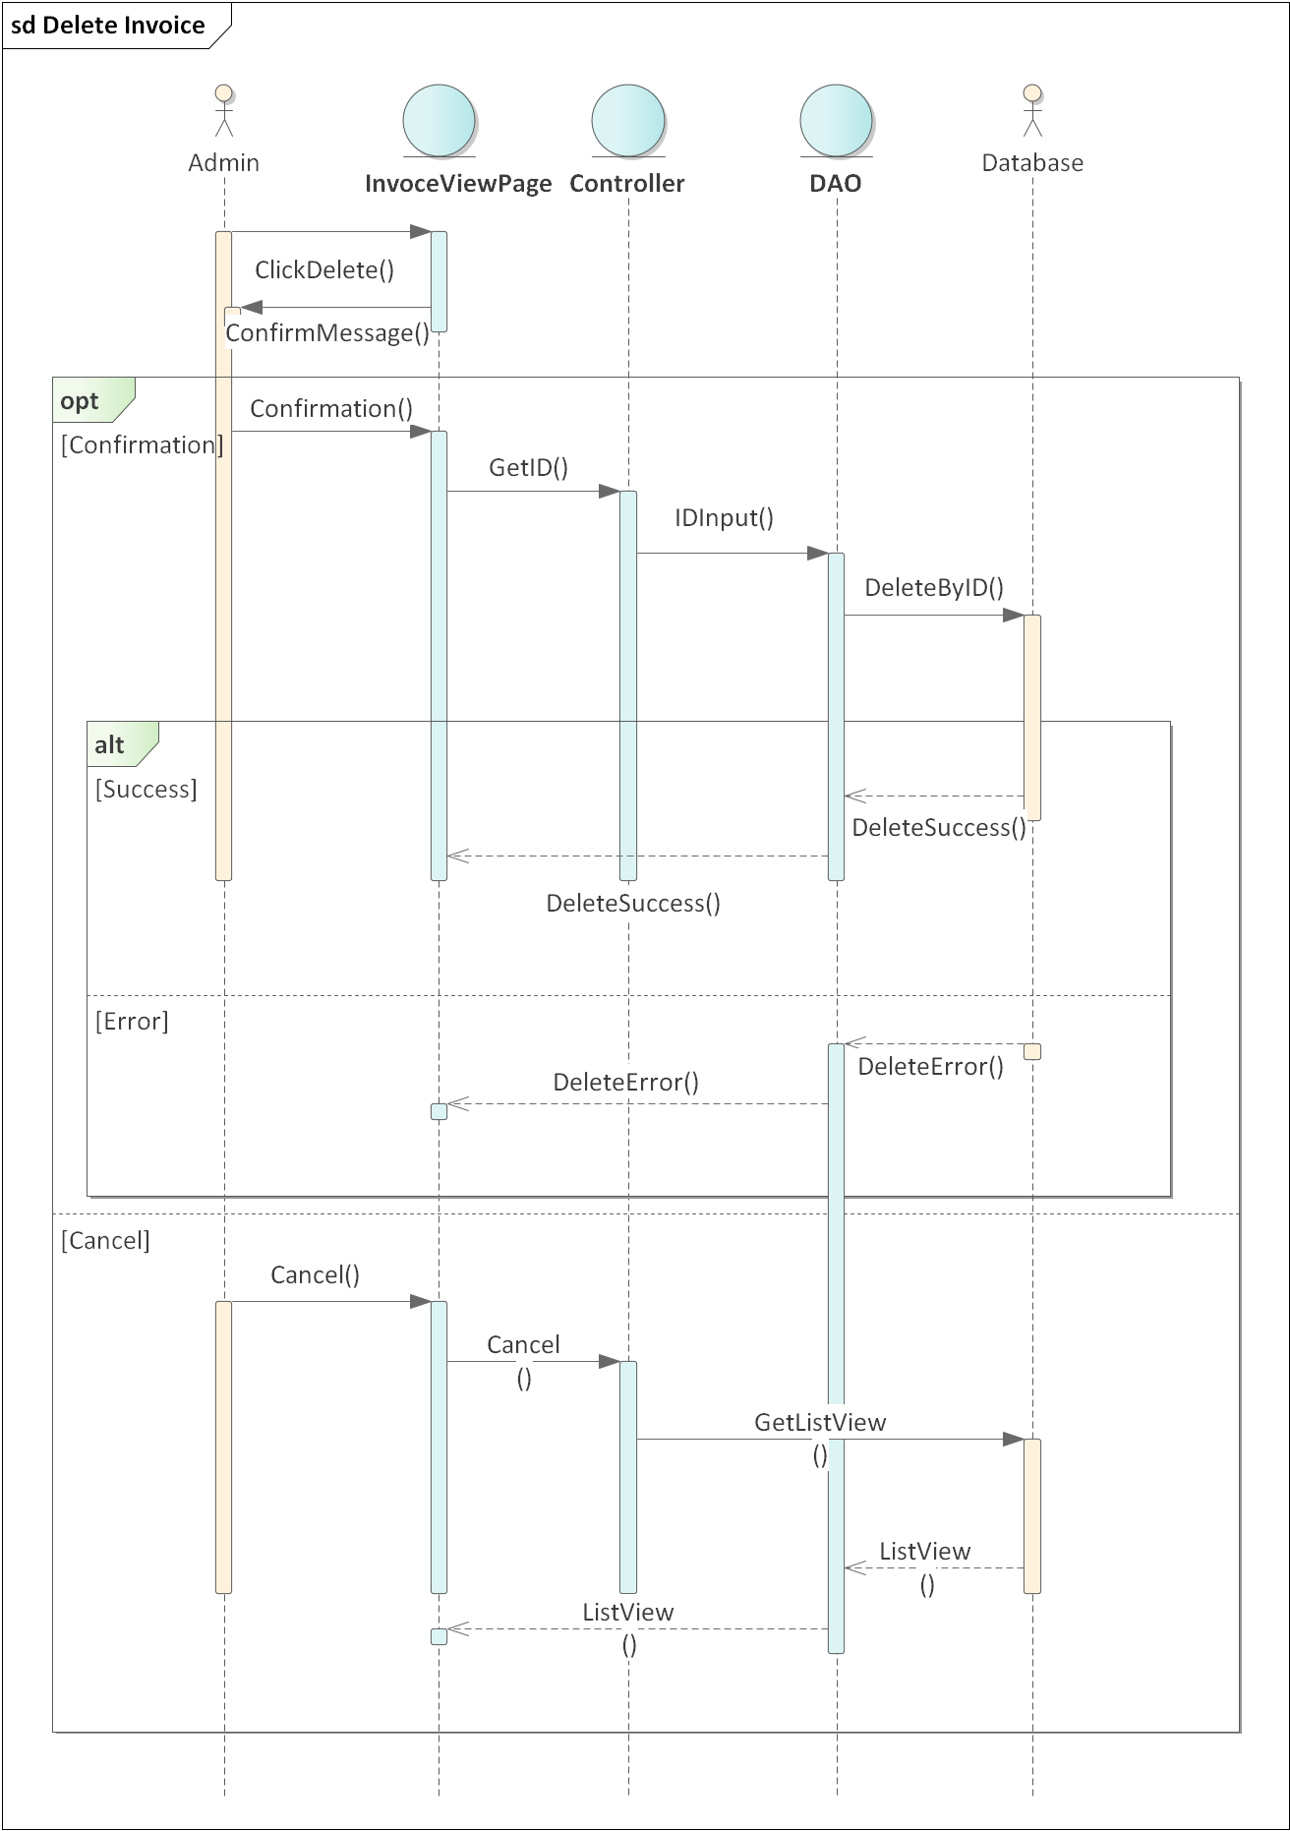

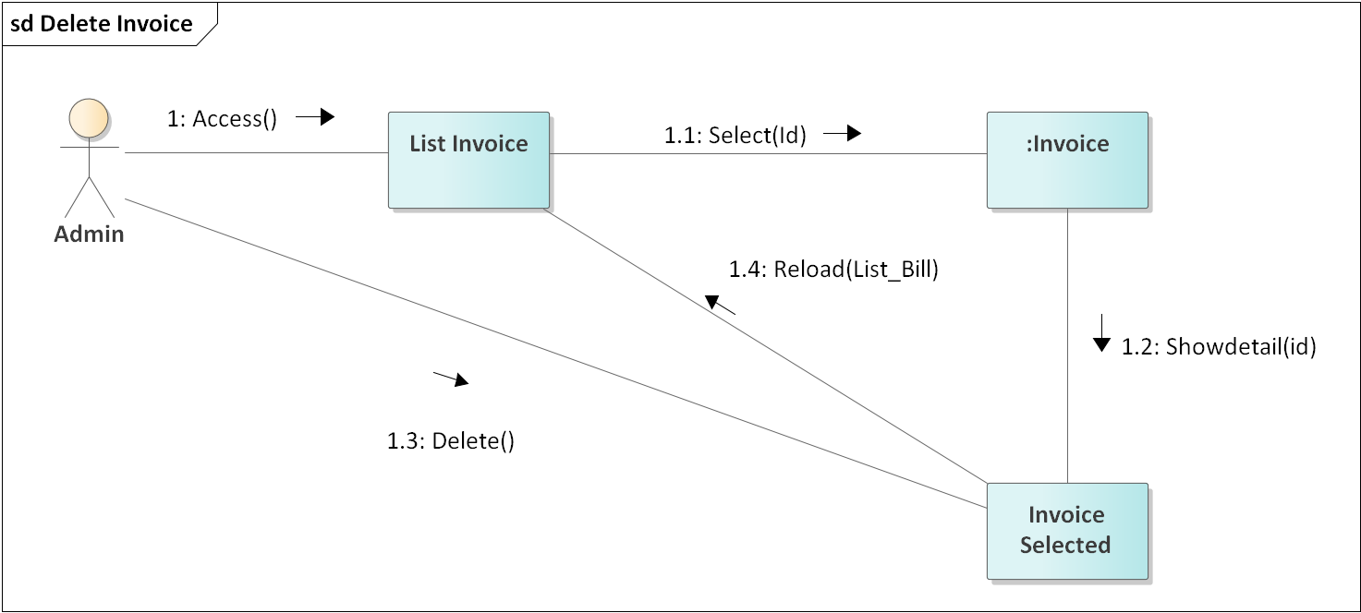

### *2.3.10 Describe use case delete user*

Table 19 Describe Use Case Delete User

|  |  |
| --- | --- |
| **Use Case Delete User** | |
| **Short Description** | Allow actor to delete user. |
| **Actor** | Admin |
| **Pre-Condition** | Log in to the admin web. |
| **Post-Condition:** | The selected user is deleted from the database |
| **Basic Flow** | 1. Actors click “User management” at navigation tab, website move to user management page. User management page will show all users and their information on lines from database. There are add buttons on top of the list, edits and deletes buttons on each user line. 2. Admin click “delete” button on the line of the actor need to delete. 3. A message box “Are you sure you want to delete user id selected?” will appear with “OK” and “Cancel” button. 4. Click “OK” to confirm the deletion of the user. **(E1)** |
| **Alternative Flow** |  |
| **Exception flow** |  |

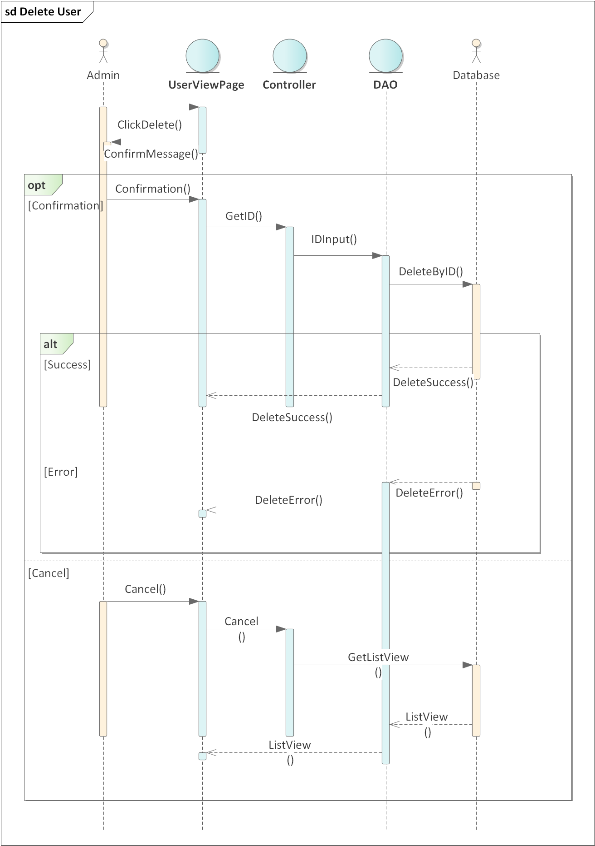

### *2.3.11 Describe use case product review*

Table 20 Describe Use Case Product Review

|  |  |
| --- | --- |
| **Use Case Product Reviews** | |
| **Short Description** | Allows actor to rate purchased products |
| **Actor** | Register customer |
| **Pre-Condition** | The product has been successfully purchased and paid. |
| **Post-Condition:** | The system records the rating information from the review account. |
| **Basic Flow** | 1. 1. Actor click buy history page from navigation bar. System move to buy history page. This page will show this list of products which actor has bought. 2. 2. Actor selects the product he wants to rate and clicks the "Review" button. 3. 3. The system appear a form for actor to input review. 4. 4. Actor enter the review content **(E1)** 5. 5. Once completed, the user selects the "Confirm" button to update the review content. 6. The review is saved and showed at product detail page. |
| **Alternative Flow** |  |
| **Exception flow** | E1: If actor exist the form before click “save” all review will not be saved. |

### *2.3.12 Describe use case add products to cart*

Table 21 Describe Use Case Add Product To Cart

|  |  |
| --- | --- |
| **Use Case Add Products To Cart** | |
| **Short Description** | Allows actor to add new products to the store |
| **Actor** | Admin |
| **Pre-Condition** | Log in to the app. |
| **Post-Condition:** | Products with entered information are saved in the database |
| **Basic Flow** | 1. Actor logs into the system with admin account 2. Actor chooses to add products, the system shows the form to add products. 3. Enter information. (E1) 4. The system will check the information. 5. After adding successfully, the system will notify the admin and proceed to add the product. (E2) |
| **Alternative Flow** |  |
| **Exception flow** | E1: Notify the admin about the required fields that have not been filled in.  E2: Notify the admin about the error when proceed to add product occur error. |

### *2.3.13 Describe use case view cart*

Table 22 Describe Use Case View Cart

|  |  |
| --- | --- |
| **Use Case View Cart** | |
| **Short Description** | Allows the actor to view products added to cart |
| **Actor** | Anonymous, Register customer, Admin |
| **Pre-Condition** |  |
| **Post-Condition:** | Actor can see the list of products in the cart |
| **Basic Flow** | 1. Actor selects to cart. 2. System return to cart page 3. Actor can see list product in cart 4. Actor can adjust the quantity of each product in cart. |
| **Alternative Flow** | 4.a: Actor can change the quantity of each product by click “+” or “-“.  4.b: Actor can remove a product from cart by click “remove”  4.c: If the quantity is “0” then product will be remove from cart. |
| **Exception flow** |  |

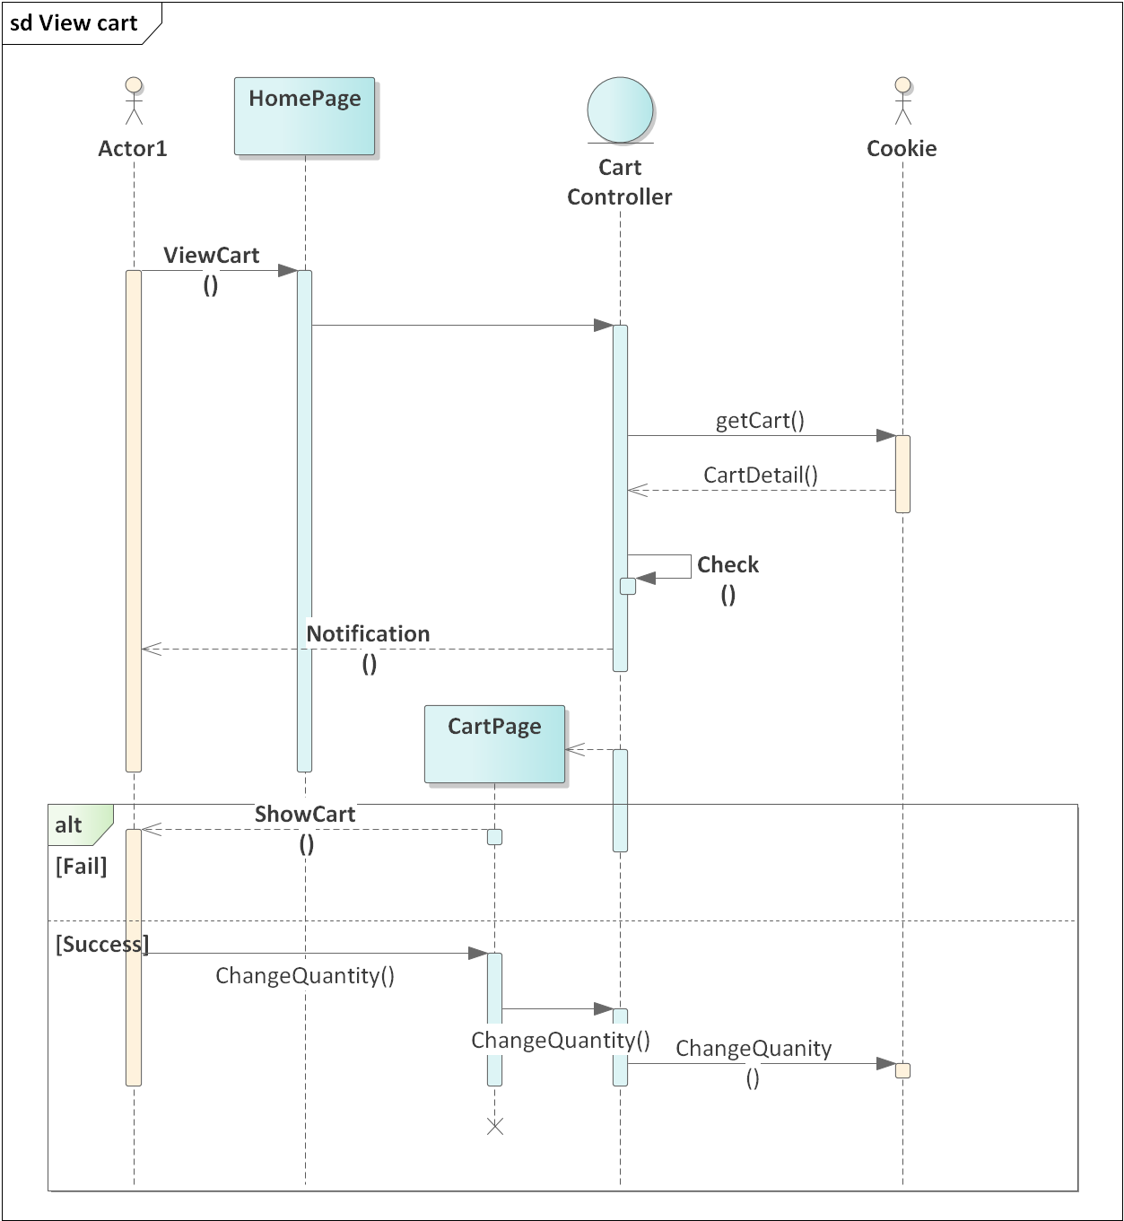

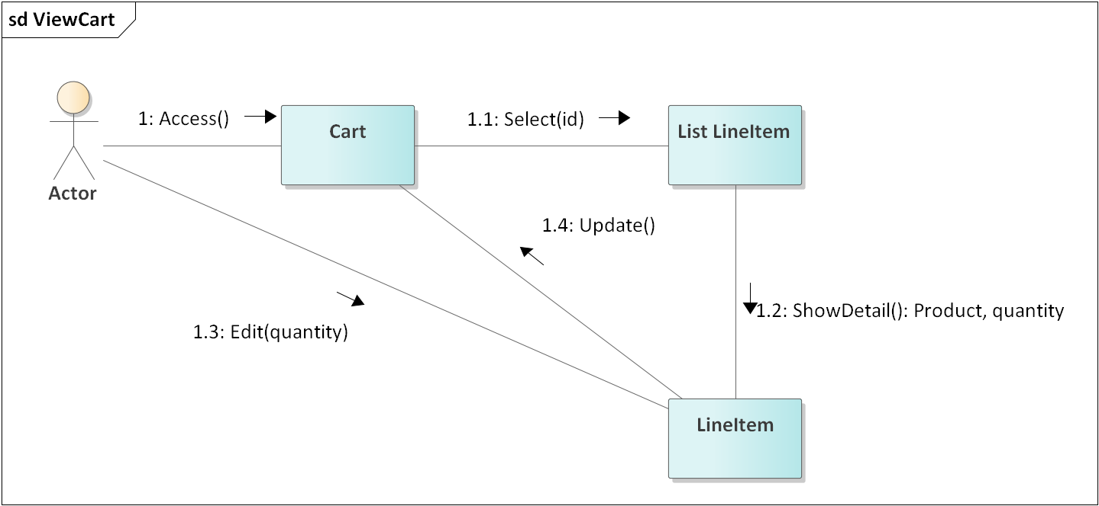

### *2.3.14 Describe use case add product to store*

Table 23 Describe Use Case Add product to store

|  |  |
| --- | --- |
| **Use Case Add Products To The Store** | |
| **Short Description** | Allows actor to add new products to the store |
| **Actor** | Admin |
| **Pre-Condition** | Log in to the app. |
| **Post-Condition:** | Products with entered information are saved in the database |
| **Basic Flow** | 1.Actor logs into the system with admin account  2.Actor chooses to add products, the system shows the form to add products.  3.Enter information. (E1)  4.The system will check the information.  5.After adding successfully, the system will notify the admin and proceed to add the product. (E2) |
| **Alternative Flow** |  |
| **Exception flow** | E1: Notify the admin about the required fields that have not been filled in.  E2: Notify the admin about the error when proceed to add product occur error. |

