HANOI UNIVERSITY
FACULTY OF INFORMATION TECHNOLOGY
-------oOo------




ATI - FINAL PROJECT REPORT

INDUSTRIAL PUMP PREDICTIVE MAINTENANCE

Teacher: Mr.Nguyen Xuan Thang
Group: 05
Student name:
- Pham Dinh Huy - 2201140037
- Nguyen Thanh Thuy - 2201140092
- Nguyen Thu Trang - 2201140095

December 19, 2025

Table of Contents
- Introduction 1
- Data Analysis and Preprocessing 1
- Methodology 2
- Results and Discussion 3
- Conclusion 5

Executive Summary
This project addresses the critical challenge of predicting failures in industrial water pumps to enable proactive maintenance strategies. The primary obstacle identified was the extreme class imbalance within the sensor dataset, where failure events constituted a negligible fraction of the total operational history. To overcome this, the research team developed a Deep Learning solution utilizing a Bidirectional Gated Recurrent Unit (GRU) architecture. The methodology integrated advanced data engineering and optimization techniques, including Pre-fail Labeling, Strategic Sampling, Aggressive Class Weighting, and Threshold Moving. Experimental results demonstrate that by optimizing the decision threshold to 0.1, the model achieved a Recall of 75.03% for failure events. This performance confirms the system's capability to detect the majority of impending failures approximately 12 hours in advance, thereby satisfying the operational requirement of minimizing unplanned downtime while maintaining a manageable false alarm rate.

1. Introduction
In the era of Industry 4.0, the transition from reactive to predictive maintenance (PdM) is essential for optimizing the lifecycle of high-value industrial assets. Unplanned failures of industrial pumps can lead to catastrophic operational stoppages and significant financial losses. Traditional maintenance approaches, such as running equipment to failure or performing rigid schedule-based servicing, often result in either excessive repair costs or unnecessary maintenance activities. Predictive maintenance aims to resolve this dilemma by leveraging historical time-series data from sensors to forecast the future health state of equipment.
The core objective of this study was to construct a robust time-series classification model capable of distinguishing between three operational states: Normal, Broken, and Recovering. A significant technical challenge inherent in this domain is the "Accuracy Paradox" caused by class imbalance. A naive model could achieve near-perfect accuracy by simply predicting the "Normal" state for every instance, yet it would fail to identify any actual defects. Therefore, this project prioritized the maximization of Recall (Sensitivity) for the "Broken" class to ensure that potential failures are flagged for inspection, accepting a calculated trade-off with Precision.

2. Data Analysis and Preprocessing
The research utilized a dataset comprising high-frequency readings from 52 sensors monitoring various physical parameters such as vibration, temperature, and pressure. A preliminary data quality assessment revealed the presence of missing values and redundant features. Specifically, sensor_15, which contained no valid data, was removed. To preserve the temporal continuity essential for recurrent neural networks, missing values were imputed using a Forward Fill method followed by a Backward Fill.
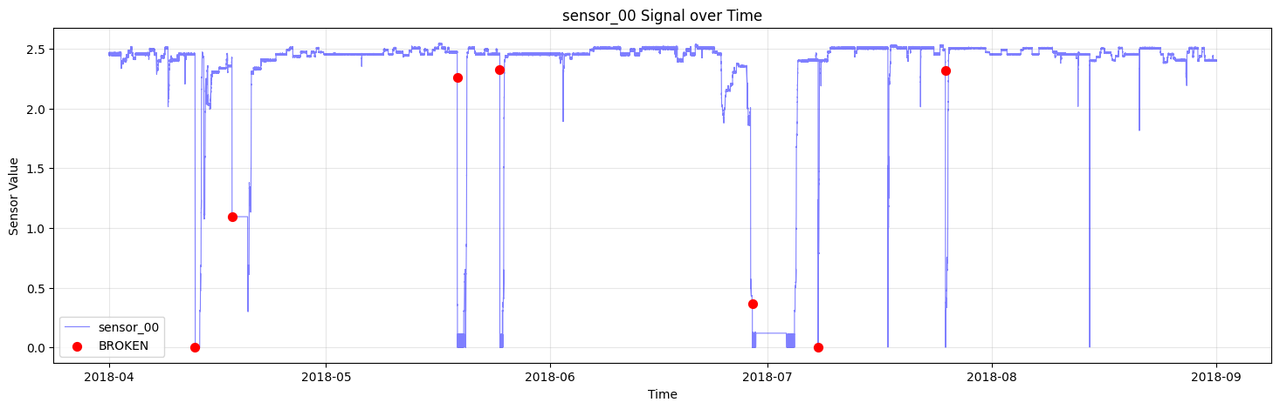
FIGURE 1: VISUALIZATION OF SENSOR_00 SIGNAL OVER TIME
As illustrated in Figure 1, the sensor signals exhibit distinct volatility and precursor patterns before failure events, validating the hypothesis that historical data contains predictive information. However, the raw dataset labeled only the exact moment of failure as "Broken," which provides no predictive utility. To rectify this, a Label Engineering technique known as Pre-fail Labeling was implemented. The 12-hour window preceding each failure event was relabeled from "Normal" to "Broken" (Class 1). This modification enabled the model to learn the degradation characteristics leading to a crash rather than solely the crash event itself. Additionally, a Strategic Sampling technique was employed to mitigate memory constraints and class imbalance. While all sequences corresponding to "Broken" and "Recovering" states were retained, the "Normal" sequences were downsampled by retaining only one sample every ten timesteps.

3. Methodology
The predictive model was built upon the Bidirectional Gated Recurrent Unit (GRU) architecture. GRUs were selected for their computational efficiency and ability to mitigate the vanishing gradient problem in long sequences. The Bidirectional wrapper enhanced the model's feature extraction capability by processing the input sequence-a 60-minute sliding window-in both forward and reverse temporal directions.
The network architecture consists of an input layer that accepts a tensor of shape (60, 51), followed by a Bidirectional GRU layer with 64 units, which returns full sequences. This is succeeded by Batch Normalization and Dropout layers (rate 0.3) to stabilize learning and prevent overfitting. A second unidirectional GRU layer with 32 units extracts high-level temporal features, which are then passed to a Dense layer. The final output is generated by a Softmax layer with three units corresponding to the three target classes.
To further address the imbalance, an Aggressive Class Weighting strategy was applied within the loss function. The penalty for misclassifying a "Broken" instance was set to be 100 times higher than that for a "Normal" instance, forcing the optimization algorithm to prioritize the minority class.
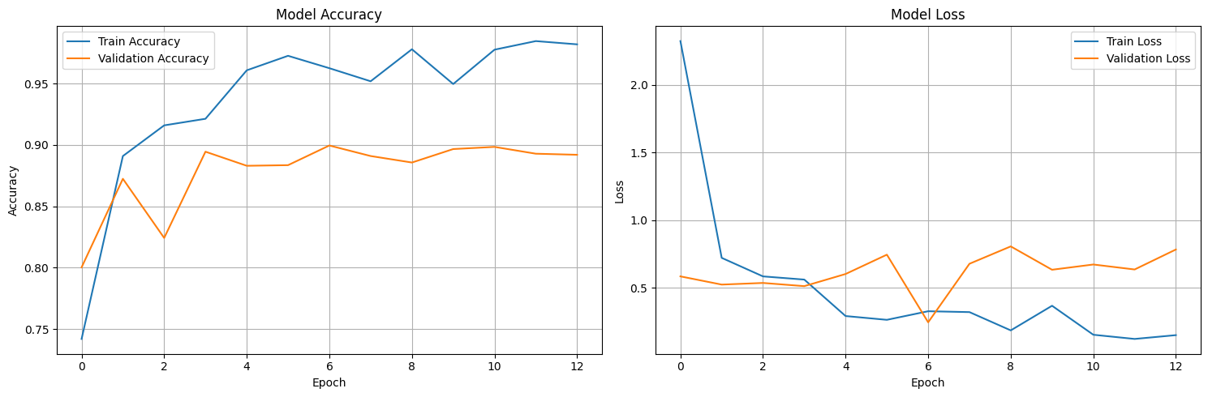
FIGURE 2: TRAINING HISTORY (ACCURACY AND LOSS)
The model training process was governed by Early Stopping and Learning Rate Reduction callbacks. As shown in Figure 2, the training was halted at epoch 13 when the validation loss stabilized, ensuring the model did not overfit to the training noise.

4. Results and Discussion
The evaluation of the model required a departure from standard metrics due to the specific business requirements of maintenance. Initial testing with a standard decision threshold of 0.5 yielded high accuracy but insufficient sensitivity to faults. Consequently, a Threshold Moving analysis was conducted using the Precision-Recall Curve to identify an optimal operating point.
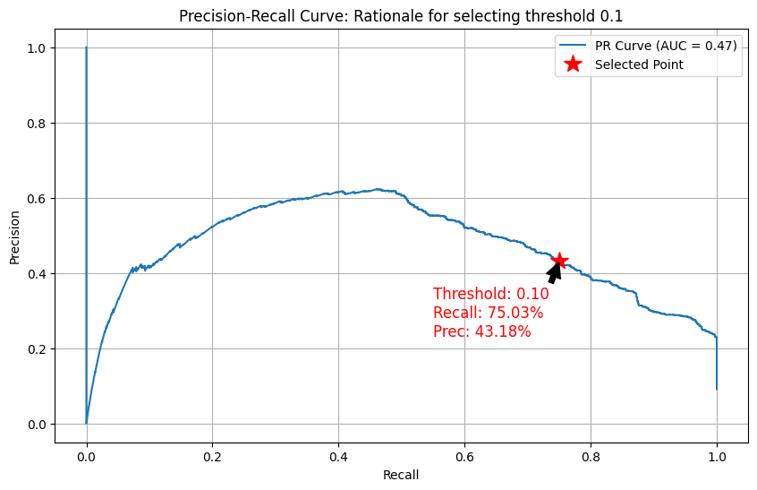
FIGURE 3: PRECISION-RECALL CURVE WITH SELECTED THRESHOLD
The analysis indicated that lowering the decision threshold for the "Broken" class to 0.1 would significantly enhance Recall. At this optimized threshold, the system demonstrated the performance metrics detailed in Table 1 below.
Table 1: Classification Report (Threshold = 0.1)
Class | Precision | Recall | F1-Score | Support
NORMAL | 0.97 | 0.90 | 0.93 | 7123
BROKEN | 0.43 | 0.75 | 0.55 | 721
RECOVERING | 0.61 | 0.87 | 0.72 | 75
Accuracy |  |  | 0.88 | 7919
Data Source: Evaluation results from the test set.
As presented in Table 1, the model achieved a Recall of 75% for the "Broken" class, meaning it successfully identified three out of every four potential failures. The Precision of 43% implies that while false alarms do occur, nearly half of the alerts correspond to genuine threats.
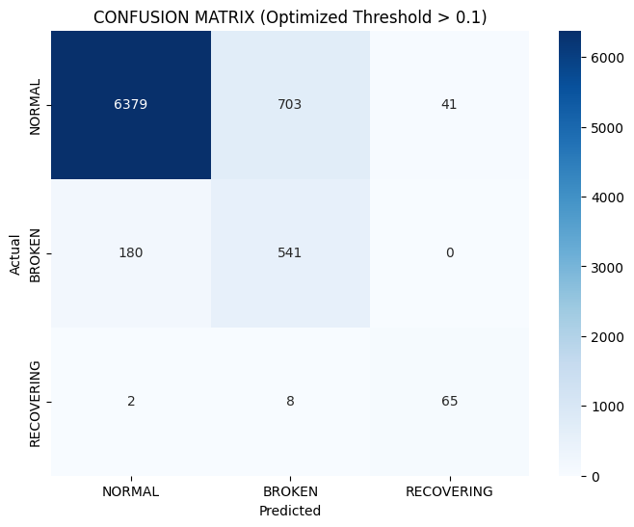
FIGURE 4: CONFUSION MATRIX
The Confusion Matrix in Figure 4 visually confirms this result, showing a high concentration of correct predictions for the "Broken" class relative to the missed detections. The trade-off between Precision and Recall is justified in this industrial context. The cost associated with a False Negative—a missed detection leading to machine failure and production downtime—is exponentially higher than the cost of a False Positive, which typically incurs only a brief inspection. Therefore, the strategic decision to prioritize Recall through threshold optimization is validated.

5. Conclusion
This project successfully demonstrated the efficacy of Deep Learning in the domain of predictive maintenance. By combining a Bidirectional GRU architecture with rigorous data engineering techniques such as Pre-fail Labeling and Strategic Sampling, the system overcame severe class imbalance to achieve a 75% fault detection rate. The implementation of Threshold Moving proved to be a critical post-processing step, transforming the model from a theoretical classifier into a practical tool for industrial monitoring. Future work will focus on integrating unsupervised anomaly detection methods to improve precision and reduce the rate of false alarms.

