


Technical Safety Concept Lane Assistance
Document Version: 2.0

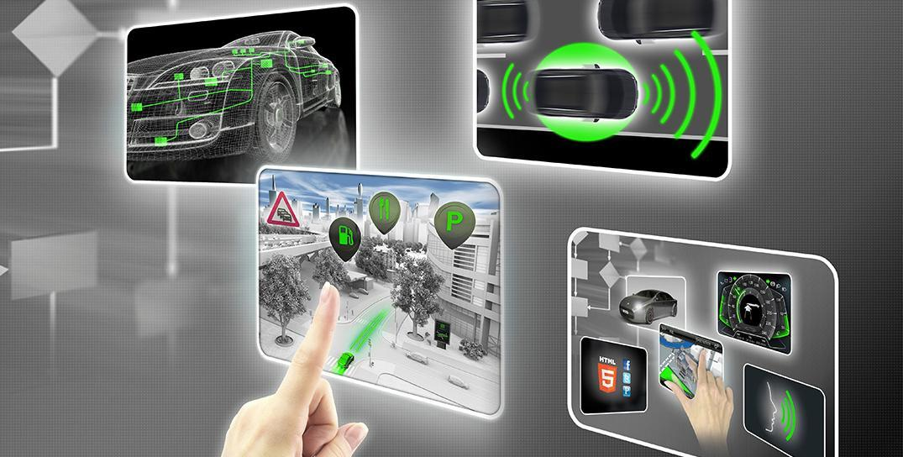

Document history

Date | Version | Editor | Description
08/08/2017 | 1.0 | Thomas Ho | Initial Release
08/11/2017 | 2.0 | Thomas Ho | Revised based on review feedback

Table of Contents

Document history
Table of Contents
Purpose of the Technical Safety Concept
Inputs to the Technical Safety Concept
Functional Safety Requirements
Refined System Architecture from Functional Safety Concept
Functional overview of architecture elements
Technical Safety Concept
Technical Safety Requirements
Refinement of the System Architecture
Allocation of Technical Safety Requirements to Architecture Elements
Warning and Degradation Concept

Purpose of the Technical Safety Concept
The purpose of this document is to specify technical safety requirement based on functional safety requirements, and allocate technical safety requirements to the system architecture.

Inputs to the Technical Safety Concept

Functional Safety Requirements

ID | Functional Safety Requirement | ASIL | Fault Tolerant Time Interval | Safe State
Functional  Safety  Requirement  01-01 | The electronic power steering subsystem shall ensure that the oscillating torque amplitude is less than Max_Torque_Amplitude | C | 50 ms | OFF
Functional  Safety  Requirement  01-02 | The electronic power steering subsystem shall ensure that the oscillating torque frequency is less than Max_Torque_Frequency | C | 50 ms | OFF
Functional  Safety  Requirement  02-01 | The electronic power steering ECU shall ensure that the lane keeping assistance torque is applied for only Max_Duration | B | 500 ms | OFF

Refined System Architecture from Functional Safety Concept
The refined system architecture is shown on following figure.

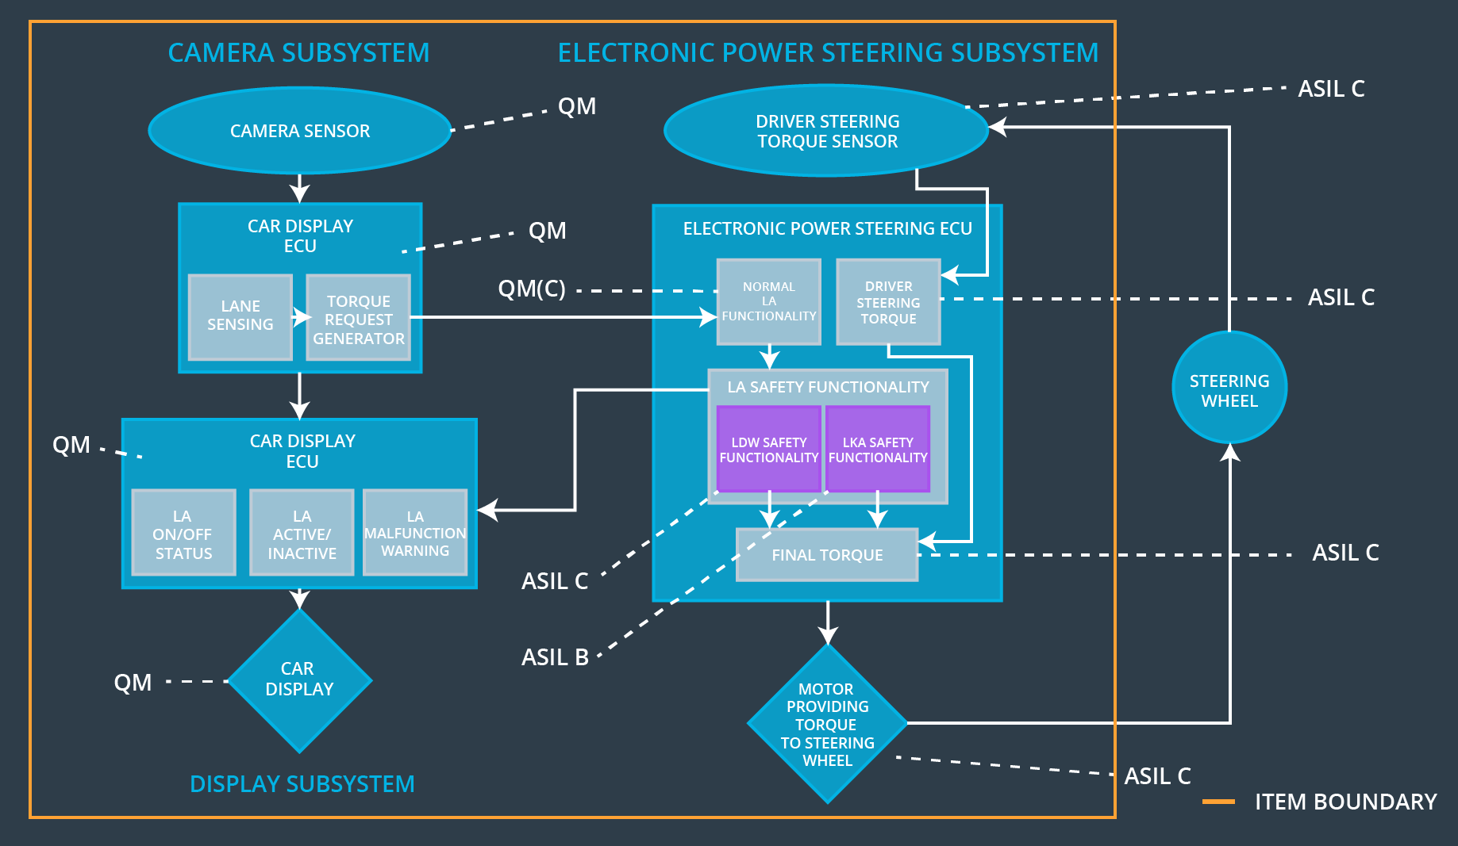

Functional overview of architecture elements

Element | Description
Camera Sensor | Capture and stream images to Camera Sensor ECU for processing
Camera Sensor ECU - Lane Sensing | Detect the lane and check if the vehicle is moving away from the ego lane
Camera Sensor ECU - Torque request generator | Responsible for sending a torque request to the electronic power steering subsystem
Car Display | Graphic interface used to display the warning messages and setting changes etc.
Car Display ECU - Lane Assistance On/Off Status | Controlling a light that tells the driver if the lane keeping system on or off.
Car Display ECU - Lane Assistant Active/Inactive | Controlling a light telling the driver that if the lane departure warning is activated.
Car Display ECU - Lane Assistance malfunction warning | Displaying warning message if LA system is malfunctioning
Driver Steering Torque Sensor | Responsible for measuring the torque applied by the driver.
Electronic Power Steering (EPS) ECU - Driver Steering Torque | Sends the information to the EPS ECU Final Torque about the torque applied by the driver sensed by the Driver Steering Torque sensor.
EPS ECU - Normal Lane Assistance Functionality | Sends Vibrational_Torque_Request to the Lane Departure Warning Safety Software element.
EPS ECU - Lane Departure Warning Safety Functionality | Alert driver when vehicle start deviating from its lane by applying oscillating torque to steering wheel. The oscillating torque amplitude is limited to be less than Max_Torque_Amplitude, the frequency is less than Max_Torque_Frequency
EPS ECU - Lane Keeping Assistant Safety Functionality | Applying an amount of torque no longer than Max_Duration to help the car to stay in the lane.
EPS ECU - Final Torque | Add torque requests together to output a final torque to the motor that move the steering wheel.
Motor | Actuator used to apply requested torque to steering wheel.

Technical Safety Concept

Technical Safety Requirements
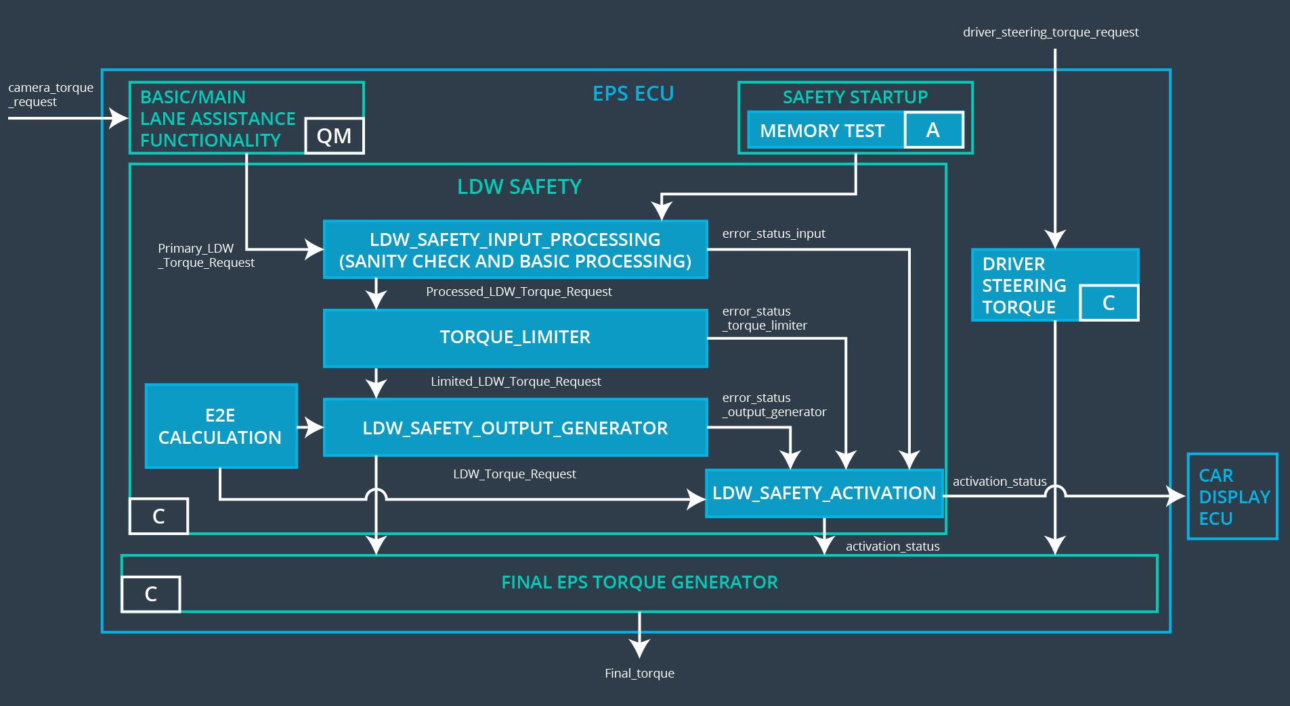

Lane Departure Warning (LDW) Requirements:

Functional Safety Requirement 01-01 with its associated system elements (derived in the functional safety concept)

ID | Functional Safety Requirement | Electronic Power Steering ECU | Camera ECU | Car Display ECU
Functional  Safety  Requirement  01-01 | The lane keeping item shall ensure that the lane departure oscillating torque amplitude is below Max_Torque_Amplitude | X

Technical Safety Requirements related to Functional Safety Requirement 01-01 are:

ID | Technical Safety Requirement | ASIL | Fault Tolerant Time Interval | Architecture Allocation | Safe State
Technical  Safety  Requirement  01 | The LDW safety component shall ensure that the amplitude of the 'LDW_Torque_Request' sent to the 'Final electronic power steering Torque' component is below 'Max_Torque_Amplitude. | C | 50 ms | LDW Safety block | Off
Technical  Safety  Requirement  02 | As soon as the LDW function deactivates the LDW feature, the 'LDW Safety' software block shall send a signal to the car display ECU to turn on a warning light. | C | 50 ms | LDW Safety block | Off
Technical  Safety  Requirement  03 | As soon as a failure is detected by the LDW function, it shall deactivate the LDW feature and the 'LDW_Torque_Request' shall be set to zero. | C | 50 ms | LDW Safety block | Off
Technical  Safety  Requirement  04 | The validity and integrity of the data transmission for 'LDW_Torque_Request' signal shall be ensured. | C | 50 ms | Data Transmission Integrity Checking | Off
Technical  Safety  Requirement  05 | Memory test shall be conducted at start up of the EPS ECU to check for any faults in memory. | A | Ignition Cycle | Memory Test | Off

Functional Safety Requirement 01-2 with its associated system elements (derived in the functional safety concept)

ID | Functional Safety Requirement | Electronic Power Steering ECU | Camera ECU | Car Display ECU
Functional  Safety  Requirement  01-02 | The lane keeping item shall ensure that the lane departure oscillating torque frequency is below Max_Torque_Frequency | X

Technical Safety Requirements related to Functional Safety Requirement 01-02 are:

ID | Technical Safety Requirement | ASIL | Fault Tolerant Time Interval | Architecture Allocation | Safe State
Technical  Safety  Requirement  01 | The LDW safety component shall ensure that the amplitude of the 'LDW_Torque_Request' sent to the 'Final electronic power steering Torque' component is below 'Max_Torque_Frequency. | C | 50 ms | LDW Safety block | Off
Technical  Safety  Requirement  02 | As soon as the LDW function deactivates the LDW feature, the 'LDW Safety' software block shall send a signal to the car display ECU to turn on a warning light | C | 50 ms | LDW Safety block | Off
Technical  Safety  Requirement  03 | As soon as a failure is detected by the LDW function, it shall deactivate the LDW feature and the 'LDW_Torque_Request' shall be set to zero. | C | 50 ms | LDW Safety block | Off
Technical  Safety  Requirement  04 | The validity and integrity of the data transmission for 'LDW_Torque_Request' signal shall be ensured. |  | 50 ms | Data Transmission Integrity Checking | Off
Technical  Safety  Requirement  05 | Memory test shall be conducted at startup of the EPS ECU to check for any faults in memory. | A | Ignition Cycle | Memory Test | Off

Lane Departure Warning (LDW) Verification and Validation Acceptance Criteria:

ID | Validation Acceptance Criteria | Verification Acceptance Criteria
Technical  Safety  Requirement  01-01-01 | Validate that the Max_Torque_Amplitude is chosen from LDW validation acceptance criteria | Verify that the amplitude of the ‘LDW_Torque_Request’ sent is always below ‘Max_Toque_Amplitude’
Technical Safety Requirement 01-01-02 | Validate that error_status_xxx message is sent to LDW_SAFETY_ACTIVATION when errors occur | Verify the LDW function is deactivated when error status received, and display ECU turns on warning light
Technical Safety Requirement 01-01-03 | Validate a zero LDW_Torque_Request is sent to LDW_SAFETY_ACTIVATION as soon as a failure is detected by LDW | Verify the LDW_SAFETY_ACTIVATION receives a zero LDW_Torque_Request when a failure is detected
Technical Safety Requirement 01-01-04 | Validate appropriate algorithms are chosen for checking validity and integrity of the data transmission | Verify the validity and integrity of data transmission for ‘LDW_Torque_Request’ signal is implemented
Technical Safety Requirement 01-01-05 | Validate the algorithm used to test memory can detect any fault in memory | Verify memory test is conducted at start up of the EPS ECU
Technical Safety Requirement 01-02-01 | Validate that the Max_Torque_Frequency is chosen from LDW validation acceptance criteria | Verify that the frequency of the ‘LDW_Torque_Request’ sent is always below ‘Max_Toque_Frequency’

Lane Keeping Assistance (LKA) Requirements:

Functional Safety Requirement 02-1 with its associated system elements (derived in the functional safety concept)

ID | Functional Safety Requirement | Electronic Power Steering ECU | Camera ECU | Car Display ECU
Functional  Safety  Requirement  02-01 | The lane keeping item shall ensure that the lane keeping assistance torque is applied for only Max_Duration | X

Technical Safety Requirements related to Functional Safety Requirement 02-01 are:

ID | Technical Safety Requirement | ASIL | Fault Tolerant Time Interval | Allocation to Architecture | Safe State
Technical  Safety  Requirement  01 | The LKA safety component shall ensure that the duration of the lane keeping assistance torque applied is less than Max_Duration | C | 500 ms | LKA Safety block | Off
Technical  Safety  Requirement  02 | As soon as the LKA function deactivates the LKA feature, the ‘LKA Safety’ software block shall send a signal to the car display ECU to turn on a warning light | C | 500 ms | LKA Safety block | Off
Technical  Safety  Requirement  03 | As soon as a failure is detected by the LKA function, it shall deactivate the LKA feature and the 'LKA_Torque_Request' shall be set to zero. | C | 500 ms | LKA Safety block | Off
Technical  Safety  Requirement  04 | The validity and integrity of the data transmission for 'LKA_Torque_Request' signal shall be ensured. | C | 500 ms | Data Transmission Integrity Check | Off
Technical  Safety  Requirement  05 | Memory test shall be conducted at start up of the EPS ECU to check for any faults in memory | A | Ignition cycle | Memory Test | Off

Lane Keeping Assistance (LKA) Verification and Validation Acceptance Criteria:

ID | Validation Acceptance Criteria | Verification Acceptance Criteria
Technical  Safety  Requirement  02-01-01 | Validate that the Max_Duration is chosen from LKA validation acceptance criteria | Verify that the LKA is turned off if the assistant torque is applied for longer than MAX_Duration
Technical Safety Requirement 02-01-02 | Validate that error_status_xxx message is sent to LKA_SAFETY_ACTIVATION when errors occur | Verify the LKA function is deactivated when error status received, and display ECU turns on warning light
Technical Safety Requirement 02-01-03 | Validate a zero LKA_Torque_Request is sent to LKA_SAFETY_ACTIVATION as soon as a failure is detected by LKA | Verify the LKA_SAFETY_ACTIVATION receives a zero LKA_Torque_Request when a failure is detected
Technical Safety Requirement 02-01-04 | Validate appropriate algorithms are chosen for checking validity and integrity of the data transmission | Verify the validity and integrity of data transmission for ‘LKA_Torque_Request’ signal is implemented
Technical Safety Requirement 02-01-05 | Validate the algorithm used to test memory can detect any fault in memory | Verify memory test is conducted at start up of the EPS ECU

Refinement of the System Architecture
The refined system architecture is shown as following figure:

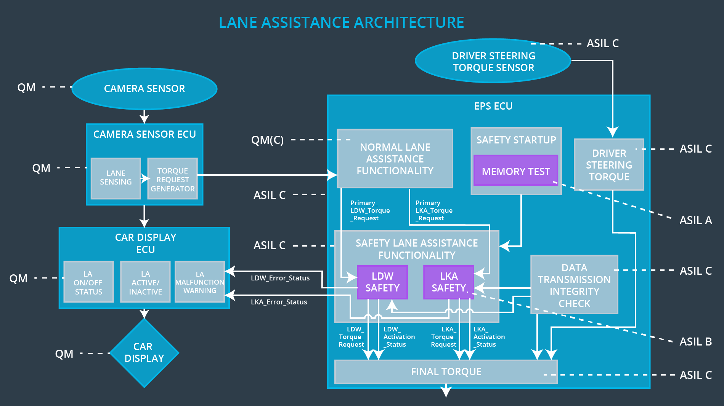

Allocation of Technical Safety Requirements to Architecture Elements
All Technical Safety Requirements have been allocated to the Electronic Power Steering ECU.

Warning and Degradation Concept

ID | Degradation Mode | Trigger for Degradation Mode | Safe State invoked? | Driver Warning
WDC-01 | OFF | Oscillating torque frequency is higher than Max_Torque_Frequency or torque is higher than Max_Torque_Amplitude | Yes | Car Display
WDC-02 | OFF | Lane keeping assistance torque is applied for more than Max_Duration | Yes | Car Display

