

Functional Safety Concept Lane Assistance

**Document Version: 1.0**



# Document history

|  |  |  |  |
| --- | --- | --- | --- |
| Date | Version | Editor | Description |
| 08/08/2017 | 1.0 | Thomas Ho | Initial version |
|  |  |  |  |
|  |  |  |  |
|  |  |  |  |
|  |  |  |  |

# Table of Contents

Document history

Table of Contents

Purpose of the Functional Safety Concept

Inputs to the Functional Safety Analysis

Safety goals from the Hazard Analysis and Risk Assessment

Preliminary Architecture

Description of architecture elements

Functional Safety Concept

Functional Safety Analysis

Functional Safety Requirements

Refinement of the System Architecture

Allocation of Functional Safety Requirements to Architecture Elements

Warning and Degradation Concept

# Purpose of the Functional Safety Concept

The purpose of functional safety concept is to identify which subsystems and elements can be used to meet safety goals, and allocates functional safety requirements to the relevant parts in the system architecture. Allocation could involve expanding the system architecture with new element blocks.

# Inputs to the Functional Safety Concept

## Safety goals from the Hazard Analysis and Risk Assessment

|  |  |
| --- | --- |
| **ID** | **Safety Goal** |
| Safety_Goal_01 | 1. The oscillating steering torque from the lane departure warning function shall be limited. |
| Safety_Goal_02 | The lane keeping assistance function shall be time limited, and the additional steering torque shall end after a given time interval so that the driver cannot misuse the system for autonomous driving. |
| Safety_Goal_03 | The LDW function shall deactivate when the camera sensor is unable to detect road markings, and shall warn the driver of its deactivation. |
| Safety_Goal_04 | The LKA system should check if the Electronic Power Steering ECU is functioning and give warning to driver if it stops working. |

## Preliminary Architecture

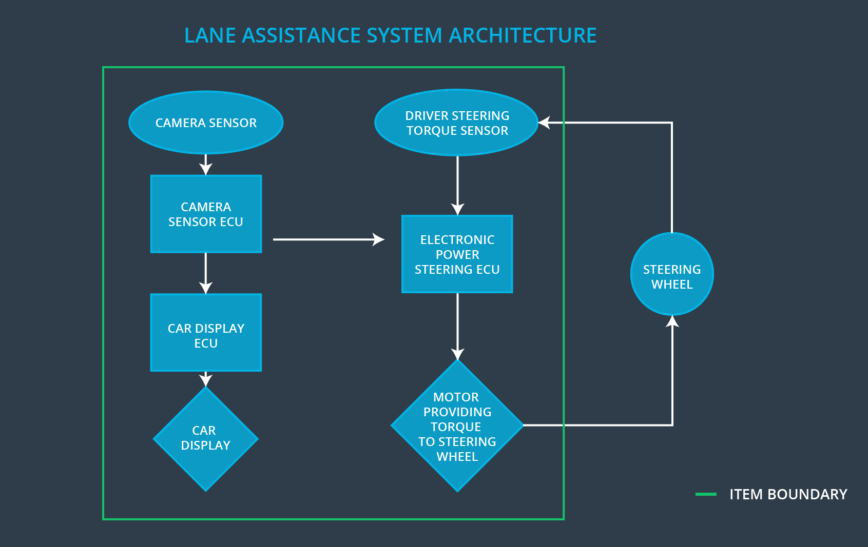

### Description of architecture elements

|  |  |
| --- | --- |
| **Element** | **Description** |
| Camera Sensor | Capture and stream images to Camera Sensor ECU for processing |
| Camera Sensor ECU | Processes image stream from camera sensor to detect lane lines on the road and determine if the vehicle is moving out of the lane unintentionally |
| Car Display | Graphic interface used to display the warning messages and setting changes. |
| Car Display ECU | Processes input from camera subsystem and display the messages on the Car Display |
| Driver Steering Torque Sensor | Responsible for measuring the torque applied by the driver. |
| Electronic Power Steering ECU | Vibrates the steering wheel when vehicle is drifting away from the current lane unintentionally. Add appropriate amount of torque based on feedback from torque sensor to keep vehicle in current lane. |
| Motor | Actuator used to apply requested torque to steering wheel. |

# Functional Safety Concept

The functional safety concept consists of:

* Functional safety analysis
* Functional safety requirements
* Functional safety architecture
* Warning and degradation concept

## Functional Safety Analysis

|  |  |  |  |
| --- | --- | --- | --- |
| **Malfunction ID** | **Main Function of the Item Related to Safety Goal Violations** | **Guidewords (NO, WRONG, EARLY, LATE, MORE, LESS)** | **Resulting Malfunction** |
| Malfunction_01 | Lane Departure Warning (LDW) function shall apply an oscillating steering torque to provide the driver a haptic feedback | MORE | The lane departure  warning function  applies an oscillating  torque with very high  torque amplitude  (above limit) |
| Malfunction_02 | Lane Departure Warning (LDW) function shall apply an oscillating steering torque to provide the driver a haptic feedback | MORE | The lane departure  warning function applies  an oscillating torque  with very high torque  frequency(above limit) |
| Malfunction_03 | Lane Keeping Assistance (LKA) function shall apply the steering torque when active in order to stay in ego lane | NO | The lane keeping  assistance function is  not limited in time  duration which leads to misuse as an  autonomous driving  function |
| Malfunction_04 | The LDW function shall deactivate when the camera sensor is unable to detect road markings, and shall warn the driver of its deactivation. | WRONG | The lane keeping warning function is unexpectedly activated and vibrated the steering wheel. |
| Malfunction_05 | The LKA system should check if the Electronic Power Steering ECU is functioning and give warning to driver if it stops working. | WRONG | The lane keep assistance fails to function, but the display shows that it is activated. |

## Functional Safety Requirements

Lane Departure Warning (LDW) Requirements:

|  |  |  |  |  |
| --- | --- | --- | --- | --- |
| **ID** | **Functional Safety Requirement** | **ASIL** | **Fault Tolerant Time Interval** | **Safe State** |
| Functional  Safety  Requirement  01-01 | The electronic power steering subsystem shall ensure that the oscillating torque amplitude is less than Max_Torque_Amplitude | C | 50 MS | OFF |
| Functional  Safety  Requirement  01-02 | The electronic power steering subsystem shall ensure that the oscillating torque frequency is less than Max_Torque_Frequency | C | 50 MS | OFF |

Lane Departure Warning (LDW) Verification and Validation Acceptance Criteria:

|  |  |  |
| --- | --- | --- |
| **ID** | **Validation Acceptance**  **Criteria and Method** | **Verification Acceptance**  **Criteria and Method** |
| Functional  Safety  Requirement  01-01 | Test how drivers react to different torque amplitudes to prove that we chose an appropriate value | Verify that when the torque amplitude crosses the limit, the lane assistance output is set to zero within the 50 ms fault tolerant time interval |
| Functional  Safety  Requirement  01-02 | Test how drivers react to different torque frequencies to prove that we chose an appropriate value | Verify that when the torque frequency crosses the limit, the lane assistance output is set to zero within the 50 ms fault tolerant time interval |

Lane Keeping Assistance (LKA) Requirements:

|  |  |  |  |  |
| --- | --- | --- | --- | --- |
| **ID** | **Functional Safety Requirement** | **ASIL** | **Fault Tolerant Time Interval** | **Safe State** |
| Functional  Safety  Requirement  02-01 | The electronic power steering ECU shall ensure that the lane keeping assistance torque is applied for only Max_Duration | B | 500 | OFF |

Lane Keeping Assistance (LKA) Verification and Validation Acceptance Criteria:

|  |  |  |
| --- | --- | --- |
| **ID** | **Validation Acceptance**  **Criteria and Method** | **Verification Acceptance**  **Criteria and Method** |
| Functional  Safety  Requirement  02-01 | Validate that the Max_Duration chosen really did dissuade drivers from taking their hands off the wheel | Verify that the system really does turn off if the lane keeping assistance every exceeded MAX_DURATION |

## Refinement of the System Architecture

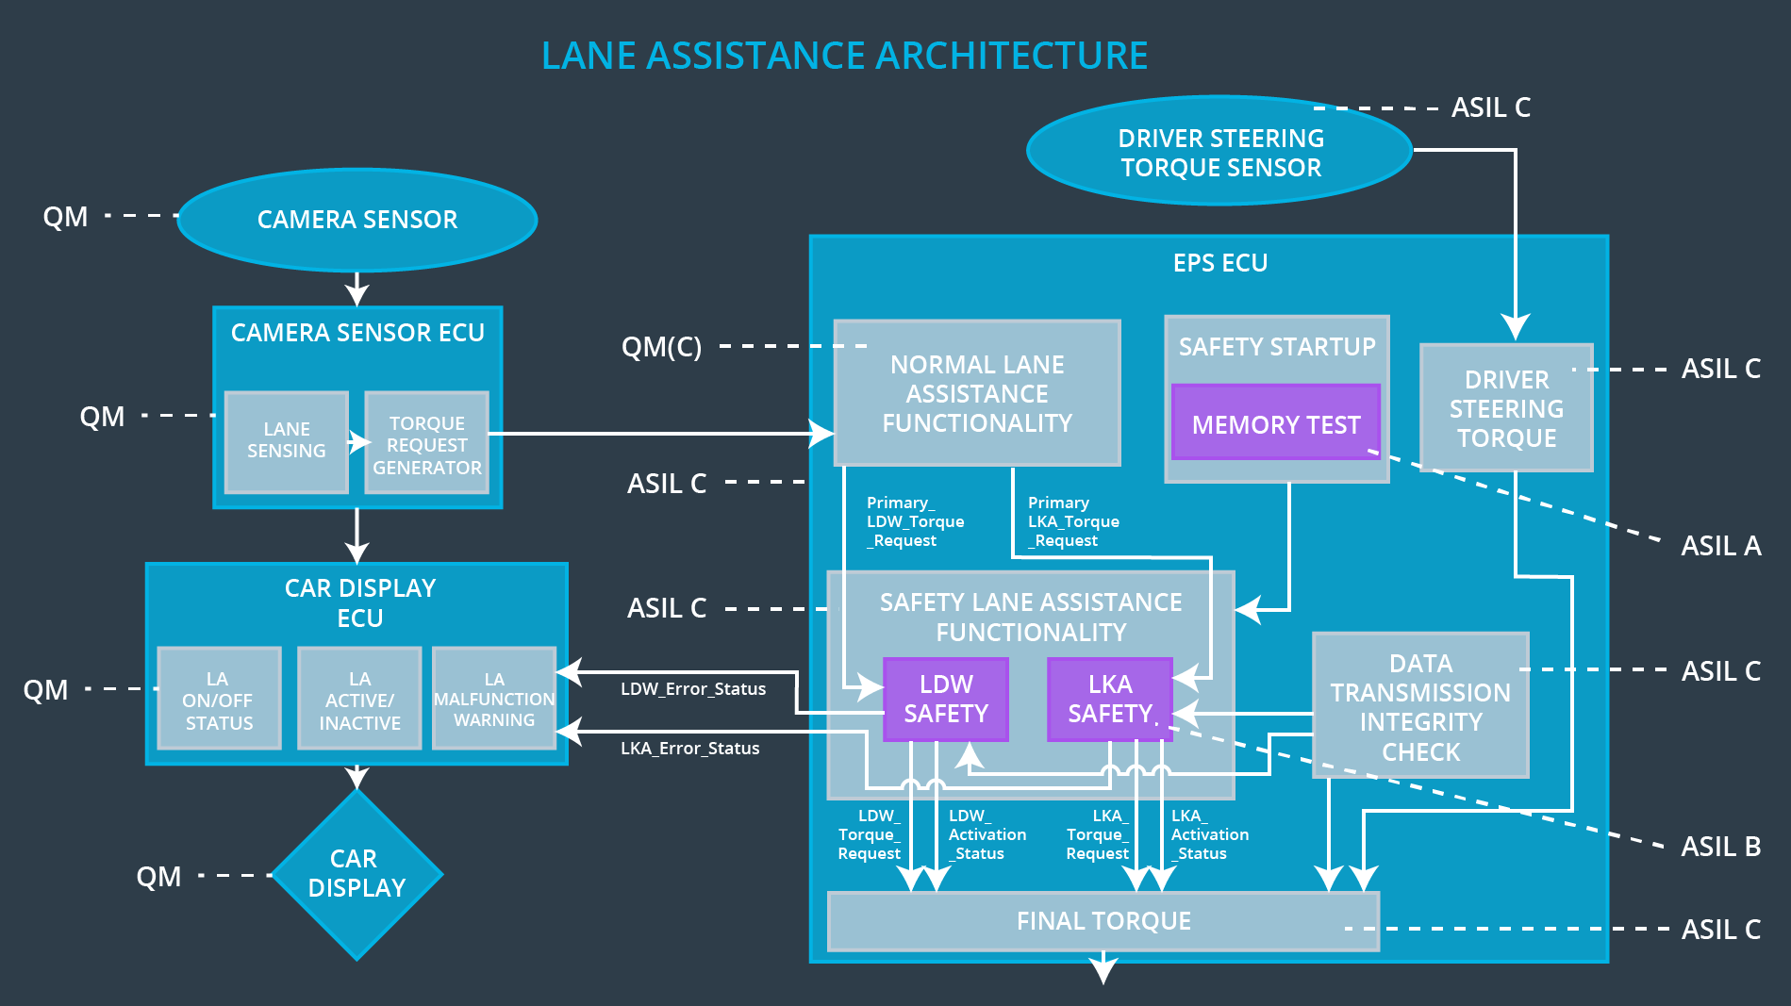

The camera sensor ECU has two software blocks:

1. **Lane Sensing** – detect the lane and check if the vehicle is moving away from the ego lane.
2. **Torque Request Generator** – send a torque request to the electronic power steering subsystem

The car display subsystem has three software blocks:

1. **LA ON/OFF Status** – control a light that tells the driver if the lane keeping system on or off.
2. **LA Active/Inactive** – control a light telling the driver that if the lane departure warning is activated.
3. **LA Malfunction Warning** – display warning message if LA system is malfunctioning.

The electronic power steering subsystem has three software blocks:

1. **Normal Lane Assistance Functionality** – receive the vibrational torque request form camera subsystem.
2. **Driver Steering Torque** – sense how much the driver is turning the steering wheel.
3. **Final Torque** – add torque requests together to output a final torque to the motor that move the steering wheel.

## Allocation of Functional Safety Requirements to Architecture Elements

|  |  |  |  |  |
| --- | --- | --- | --- | --- |
| **ID** | **Functional Safety Requirement** | **Electronic Power Steering ECU** | **Camera ECU** | **Car Display ECU** |
| Functional  Safety  Requirement  01-01 | The electronic power steering ECU shall ensure that the oscillating torque amplitude is below Max_Torque_Amplitude | **x** |  |  |
| Functional  Safety  Requirement  01-02 | The electronic power steering ECU shall ensure that the oscillating torque amplitude is below Max_Torque_Frequency | **x** |  |  |
| Functional  Safety  Requirement  02-01 | The electronic power steering ECU shall ensure that the lane keeping assistance torque is applied for only Max_Duration | **x** |  |  |

## Warning and Degradation Concept

|  |  |  |  |  |
| --- | --- | --- | --- | --- |
| **ID** | **Degradation Mode** | **Trigger for Degradation Mode** | **Safe State invoked?** | **Driver Warning** |
| WDC-01 | OFF | Oscillating torque frequency is higher than Max_Torque_Frequency or torque is higher than Max_Torque_Amplitude | Yes | Car Display |
| WDC-02 | OFF | Lane keeping assistance torque is applied for more than Max_Duration | Yes | Car Display |