

Safety Plan Lane Assistance

**Document Version: 2.0**



# Document history

|  |  |  |  |
| --- | --- | --- | --- |
| Date | Version | Editor | Description |
| 08/08/2017 | 1.0 | Thomas Ho | Initial version |
| 08/11/2017 | 2.0 | Thomas Ho | Revised based on review feedback |
|  |  |  |  |
|  |  |  |  |
|  |  |  |  |

# Table of Contents

Document history

Table of Contents

Introduction

Purpose of the Safety Plan

Scope of the Project

Deliverables of the Project

Item Definition

Goals and Measures

Goals

Measures

Safety Culture

Safety Lifecycle Tailoring

Roles

Development Interface Agreement

Confirmation Measures

# Introduction

## Purpose of the Safety Plan

The purpose of this document is to specify how functional safety will be achieved for the lane assistance system throughout the entire development project and in production. The safety plan lists the various techniques and measures that will be implemented as part of the development project to ensure that the targeted ASIL is achieved.

## Scope of the Project

For the lane assistance project, the following safety lifecycle phases are in scope:

Concept phase

Product Development at the System Level

Product Development at the Software Level

The following phases are out of scope:

Product Development at the Hardware Level

Production and Operation

## Deliverables of the Project

The deliverables of the project are:

Safety Plan

Hazard Analysis and Risk Assessment

Functional Safety Concept

Technical Safety Concept

Software Safety Requirements and Architecture

# Item Definition

The Lane Assistance System is vehicle safety feature designed to alert the driver when the vehicle moving from its lane unintentionally, and assist the driver to navigate the car to stay on the current lane.

The lane assistance system has two main functions:

1. **Lane Departure Warning** alerts the driver when the vehicle starts to deviate from its lane and apply an oscillating steering torque to provide the driver a haptic feedback.
2. **Lane Keeping Assistance** helps the car to stay near the center of lane by applying an amount of torque in a limit time.

The item boundary includes three subsystems in the lane assistance system architecture shown in the following figure:

* Camera subsystem
* Electronic Power Steering subsystem (EPS)
* Car Display subsystem

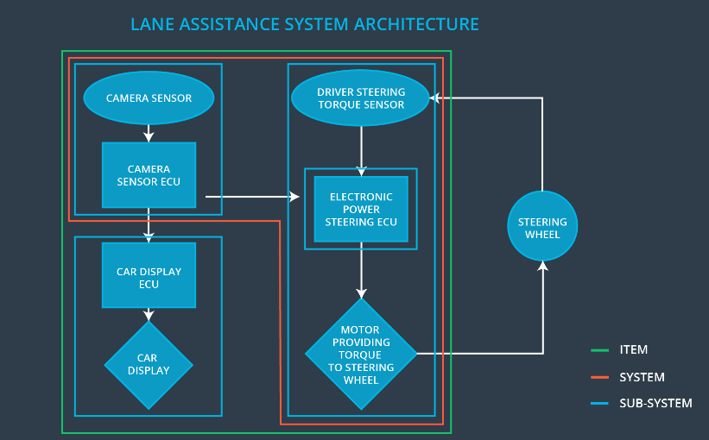

The camera monitors the road and recognizes the lane structure. Once it detects the vehicle is drifting out of the current lane, it sends a signal to car display ECU to turn on a warning light, at the same time, it also send a signal to electronic power steering subsystem to asking it to vibrate the steering wheel.

If the driver wants the change the lane, the driver uses a turn signal, then the lane assistance system deactivates so that the vehicle can leave the lane. The driver can also turn off the system completely with a button on the dashboard.

The driver is still expected to have both hands on the steering wheel at all times. The electronic power steering subsystem has a sensor to detect how much the driver is already turning. The lane keeping assistance function will merely add the extra torque required to get the car back towards center. The extra torque is applied directly to the steering wheel via a motor.

As shown in the architecture diagram, the Lane Assistance item does not include following subsystems found in ADAS:

1. Adaptive cruise control (ACC)
2. Automatic parking
3. Blind spot monitor
4. Collision avoidance system
5. Pedestrian protection system
6. Tire Pressure Monitoring
7. Turning assistant

# Goals and Measures

## Goals

The goals of this functional safety project are:

1. Identify the hazardous situation from electronic malfunctions that could cause injury to human or damage human health.
2. Assess the risk level of hazards
3. Lower the high risk level of hazardous situation to an acceptable risk level via system engineering.

## Measures

|  |  |  |
| --- | --- | --- |
| Measures and Activities | Responsibility | Timeline |
| Follow safety processes | All Team Members | Constantly |
| Create and sustain a safety culture | All Team Members | Constantly |
| Coordinate and document the planned safety activities | Safety Manager | Constantly |
| Allocate resources with adequate functional safety competency | Project Manager | Within 2 weeks of start of project |
| Tailor the safety lifecycle | Safety Manager | Within 4 weeks of start of project |
| Plan the safety activities of the safety lifecycle | Safety Manager | Within 4 weeks of start of project |
| Perform regular functional safety audits | Safety Auditor | Once every 2 months |
| Perform functional safety pre-assessment prior to audit by external functional safety assessor | Safety Manager | 3 months prior to main assessment |
| Perform functional safety assessment | Safety Assessor | Conclusion of functional safety activities |

# Safety Culture

Safety is critical to the success of a vehicle product and the organization:

* **High priority**: safety has the highest priority among competing constraints like cost and productivity.
* **Accountability**: processes ensure accountability such that design decisions are traceable back to the people and teams who make the decisions
* **Rewards**: the organization motivates and supports the achievement of functional safety.
* **Penalties**: the organization penalizes shortcuts that jeopardize safety or quality.
* **Independence**: teams who design and develop a product should be independent from the teams who audit the work.
* **Well defined processes**: company design and management processes should be clearly defined.
* **Resources**: projects have necessary resources including people with appropriate skills.
* **Diversity**: intellectual diversity is sought after, valued and integrated into process.
* **Communication**: communication channels encourage disclosure of problems.

# Safety Lifecycle Tailoring

For the lane assistance project, the following safety lifecycle phases are in scope:

* Concept phase
* Product Development at the System Level
* Product Development at the Software Level

The following phases are out of scope:

* Product Development at the Hardware Level
* Production and Operation

# Roles

|  |  |
| --- | --- |
| Role | Org |
| Functional Safety Manager- Item Level | OEM |
| Functional Safety Engineer- Item Level | OEM |
| Project Manager - Item Level | OEM |
| Functional Safety Manager- Component Level | Tier-1 |
| Functional Safety Engineer- Component Level | Tier-1 |
| Functional Safety Auditor | OEM or external |
| Functional Safety Assessor | OEM or external |

# Development Interface Agreement

The development interface agreement (DIA) defines the roles and responsibilities between companies involved in the product development. All involved parties need to agree on the contents of the DIA before begins.

The DIA also specifies what evidence and work products each party will provide to prove that work was done according to the agreement. The ultimate goal is to ensure that all parties are developing safe vehicles in compliance with ISO 26262.

The OEM shall be responsible for supplying a functioning lane assistance system. The tier-1 organization has following responsibilities:

1. Provide functional safety requirements.
2. Work with OEM partner to develop safety plan to software and hardware level.
3. Validate and verify the final product meets the functional safety requirements.

The responsibilities and personals of the companies involved in the project include:

* An **OEM program manager** who will communicate with OEM partners on product schedule, resource allocation and component selections. Functional safety plan shall be provided to OEM partner at the beginning and ensure the confirmation of requirements by working with third party auditor and safety assessor.
* **OEM** **Safety manager** who will develop safety plan and work with OEM safety manager during the whole safety lifecycle.

Tier one OEM is responsible for supplying a functioning lane assistance system. The personal interfaces with the company include:

* A **project manager** who will manage the resource to develop the lane assistance system based on the requirement provided by the vendor. The manager also communicates with vendor program manager on product requirement and development schedule.
* **Safety manager** who will work with vendor’s safety manager to ensure the product confirms the safety requirement.

# Confirmation Measures

The confirmation measures serve two purposes:

* The lane assistance system safety project conforms to ISO26262, and
* The project does make the vehicle safer.

The **confirmation review** ensures that the product compiles with ISO26262. As the product is developed, a third party safety auditor will review the work to ensure its compliance with standard. The **functional safety audit** will ensure the actual implementation of the project conforms to safety plan. The **functional safety assessment** will ensure that plans, designs and product development actually achieve functional safety.

A safety plan could have other sections that we are not including here. For example, a safety plan would probably contain a complete project schedule.

There might also be a "Supporting Process Management" section that would cover "Part 8: Supporting Processes" of the ISO 26262 functional safety standard. This would include descriptions of how the company handles requirements management, change management, configuration management, documentation management, and software tool usage and confidence.

Similarly, a confirmation measures section would go into more detail about how each confirmation will be carried out.