#Chloe Ho

#Assignment 7

#write a program to trace input strings. show the content of the stack after each match

def trace(words):

stack = []

index = 0

stack.append('$')

stack.append('E')

while len(stack) > 0:

top = stack.pop()

if top == words[index]:

print("Match '{}': Stack:{}".format(words[index], stack))

if words[index] == '$':

print("Word is accepted")

break

index += 1

if top == 'E':

if words[index] == 'a':

stack.append('Q')

stack.append('T')

continue

elif words[index] == '(':

stack.append('Q')

stack.append('T')

continue

else:

print("Word is not accepted")

break

elif top == 'Q':

if words[index] == '+':

stack.append('Q')

stack.append('T')

stack.append('+')

continue

elif words[index] == '-':

stack.append('Q')

stack.append('T')

stack.append('-')

continue

elif words[index] == ')' or words[index] == '$':

continue

else:

print("Word is not accepted")

break

elif top == 'T':

if words[index] == 'a':

stack.append('R')

stack.append('F')

continue

elif words[index] == '(':

stack.append('R')

stack.append('F')

continue

else:

print("Word is not accepted")

break

elif top == 'R':

if words[index] == '+' or words[index] == '-' or words[index] == ')' or words[index] == '$':

continue

elif words[index] == '\*':

stack.append('R')

stack.append('F')

stack.append('\*')

continue

elif words[index] == '/':

stack.append('R')

stack.append('F')

stack.append('/')

continue

else:

print("Word is not accepted")

break

elif top == 'F':

if words[index] == 'a':

stack.append('a')

continue

elif words[index] == '(':

stack.append(')')

stack.append('E')

stack.append('(')

continue

else:

print("Word is not accepted")

break

print("\n(a+a)\*a$")

trace('(a+a)\*a$')

print("\na\*(a/a)$")

trace('a\*(a/a)$')

print("\n(a+a)$")

trace('a(a+a)$')

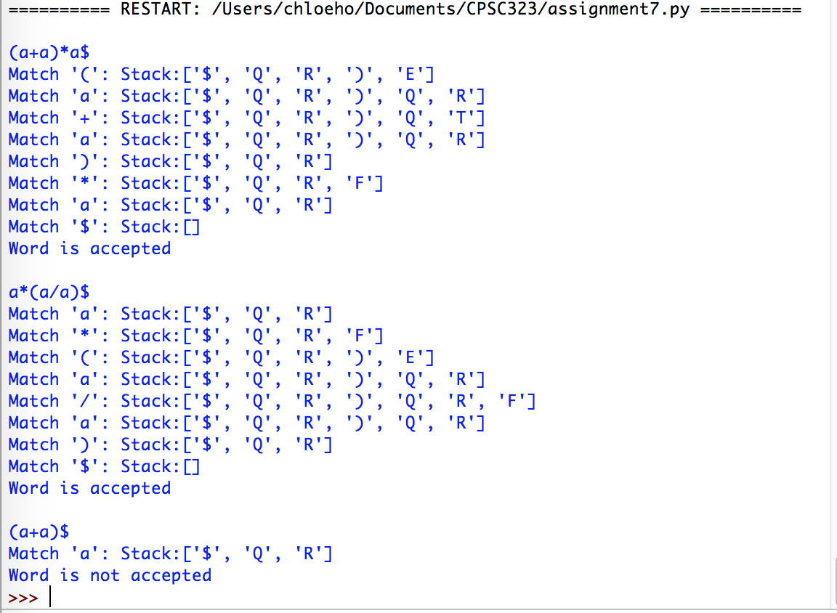

#Assignment 7 - part 2

def trace(words):

index = 0

stack = []

stack.append('$')

stack.append('S')

while len(stack) > 0:

top = stack.pop()

if top == words[index]:

print("Matched '{}'!, Stack:{}".format(words[index], stack))

if words[index] == '$':

print("Word is accepted")

break

index += 1

if top == 'S':

if words[index:index+2] == 'a=':

stack.append('E')

print("Matched '{}': Stack:{}".format(words[index:index+2], stack))

index += 2

continue

else:

print("Word is not accepted")

break

if top == 'E':

if words[index] == '(' or words[index] == 'a' or words[index] == 'b':

stack.append('Q')

stack.append('T')

continue

else:

print("Word is not accepted")

break

elif top == 'Q':

if words[index] == '+':

stack.append('Q')

stack.append('T')

stack.append('+')

continue

elif words[index] == '-':

stack.append('Q')

stack.append('T')

stack.append('-')

continue

elif words[index] == ')' or words[index] == '$':

continue

else:

print("Word is not accepted")

break

elif top == 'T':

if words[index] == '(' or words[index] == 'a' or words[index] == 'b':

stack.append('R')

stack.append('F')

continue

else:

print("Word is not accepted")

break

elif top == 'R':

if words[index] == '+' or words[index] == '-' or words[index] == ')' or words[index] == '$':

continue

elif words[index] == '\*':

stack.append('R')

stack.append('F')

stack.append('\*')

continue

elif words[index] == '/':

stack.append('R')

stack.append('F')

stack.append('/')

continue

else:

print("Word is not accepted")

break

elif top == 'F':

if words[index] == 'a':

stack.append('a')

continue

elif words[index] == 'b':

stack.append('b')

elif words[index] == '(':

stack.append(')')

stack.append('E')

stack.append('(')

continue

else:

print("Word is not accepted")

break

print("\na=(a+a)\*b$")

trace('a=(a+a)\*b$')

print("\na=a\*(b-a)$")

trace('a=a\*(b-a)$')

print("\na=(a+a)b$")

trace('a=(a+a)b$')

