Model: Build predictive model for CTR
Part 1: Introduction
Problem Statement
Target Variable:
The dataset is highly imbalanced, with 83% non-booking cases and 14% booking cases. This represents a significant class imbalance for a binary classification task.
Features:
- One datetime feature: hour
- All other features are categorical
- Binary target: click
Planned Solution
1. Data Processing
Datetime Feature:
- Apply cyclical encoding to capture the cyclical nature of time (hour) and convert it to a numeric format.
Categorical Features:
- Low-cardinality features: keep unchanged.
- High-cardinality features: apply target encoding to convert to numeric features.
2. Correlation Analysis
- Use Pearson correlation for numeric features.
- Use Cramér's V for categorical features.
3. Model Selection
- Baseline Model: Logistic Regression with Weight of Evidence (WOE) encoding.
- Challenger Model: CatBoost, preferred due to the dominance of categorical features + adjust class weights or the loss function to penalize misclassification of the minority (booking) class more heavily.
4. Evaluation Metrics
Due to the imbalanced dataset, use the following metrics:
- AUC (Area Under the Curve)
- Precision
- Recall
- F1-score
- Precision-Recall Curve
5. Model Explainability
- Use SHAP or LIME for model interpretation and feature importance analysis.
Part 2: Implementation
Data Optimization:
The dataset is quite large, containing 44 million rows with a memory usage of 26.5 GB. To optimize memory usage, I converted all categorical features (except for device_ip and device_id) from the object type to the category type.
- Memory before optimization: 26.54 GB
- Memory after optimization: 6.82 GB
- Memory reduction: 74.3%
- Memory saved: 19.73 GB
Data Processing:
Feature Engineering:
- Convert hour to the right format
- Create 2 more features: dayofweek of ‘hour’ and is_weekend of ‘hour’. They mean date of week (mon, tues, wed, etc) and (weekend or not weekend) from ‘hour’
- Perform cyclical encoding on ‘hour’ to get 8 more features: hour_day_sin, hour_day_cos, hour_month_sin, hour_month_cos, hour_hour_sin, hour_hour_cos, hour_minute_sin, hour_minute_cos
- Target encoding for device_ip and device_id
EDA (more details 2_eda.ipynb):
- No missing rate
- Due to insufficient description of features and their categories, understanding the data quality and exploring data insights is very limited; as a result, all analysis of EDA is conducted in a largely superficial manner, relying on generic statistical summaries rather than meaningful, context-specific interpretations.
- hour feature has range from 2022 to 2031—including future dates? (I don’t know why??) and only one value for month and minute (questioning again??)
- Based on Cramér's V correlation, we found the following categorical features with high correlation: ["C21", "C14"], ["C21", "C17"], ["C21", "C18"], ["C14", "C15"], ["C14", "C16"], ["C14", "C17"], ["C14", "C18"], ["C14", "C19"], ["C14", "C21"] ["site_id", "site_category"], ["app_id", "app_domain"], ["app_id", "app_category"]. For pairs with high correlation, I will keep the one with more information/insights (more categories) => remove ["app_domain", "app_category", "C21", "C17", "C16", "C15", "C18"]
- in "hour" feature, there is only one value for month and minute => not predictive => remove "hour_month_sin" "hour_month_cos", "hour_minute_sin", "hour_minute_cos"
- No pair with very high correlation for numeric features
- Overall, these features demonstrate good predictive power, as the booking rates vary distinctly across different categories.
Train/Val/Test Splitting:
- Split data into train (65%), validation (10%), and test (25%) sets
- Apply target encoding to `device_id` and `device_ip` columns
Model Training:
Baseline:
- Base 1: Train Logistic Regression + WOE encoding for all categorical (IV > 1% and IV <= 100%)
- Final Base: Base 1 + recursive feature elimination to reduce more features
Challenger Model:
- Challenger 1: CatBoost + Feature Selection by feature importance
- Final Challenger: Challenger 1 + Bayesian Optimization for params tunning (optuna)
Model Comparison:
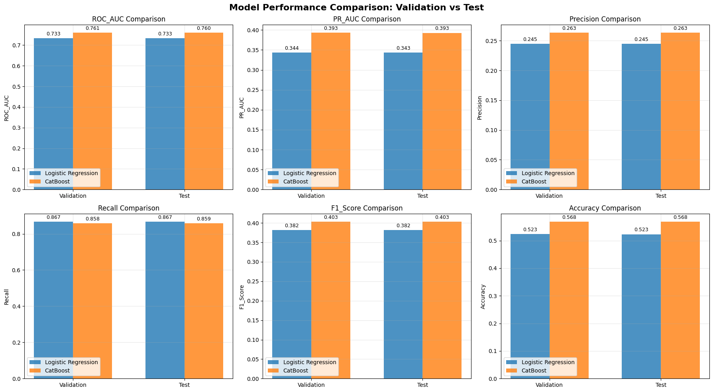
Logistic Regression:
-----------------------------------
ROC_AUC : Val=0.7330, Test=0.7327, Diff=+0.0003 (+0.0%) - ✅ Good generalization
PR_AUC : Val=0.3437, Test=0.3434, Diff=+0.0003 (+0.1%) - ✅ Good generalization
Precision : Val=0.2448, Test=0.2447, Diff=+0.0001 (+0.1%) - ✅ Good generalization
Recall : Val=0.8671, Test=0.8671, Diff=+0.0001 (+0.0%) - ✅ Good generalization
F1_Score : Val=0.3818, Test=0.3817, Diff=+0.0002 (+0.0%) - ✅ Good generalization
Accuracy : Val=0.5232, Test=0.5229, Diff=+0.0003 (+0.1%) - ✅ Good generalization

CatBoost:
-----------------------------------
ROC_AUC : Val=0.7605, Test=0.7602, Diff=+0.0004 (+0.0%) - ✅ Good generalization
PR_AUC : Val=0.3933, Test=0.3928, Diff=+0.0005 (+0.1%) - ✅ Good generalization
Precision : Val=0.2635, Test=0.2634, Diff=+0.0001 (+0.0%) - ✅ Good generalization
Recall : Val=0.8585, Test=0.8585, Diff=-0.0000 (-0.0%) - ✅ Good generalization
F1_Score : Val=0.4032, Test=0.4031, Diff=+0.0001 (+0.0%) - ✅ Good generalization
Accuracy : Val=0.5685, Test=0.5683, Diff=+0.0002 (+0.0%) - ✅ Good generalization

======================================================================
MODEL COMPARISON SUMMARY
======================================================================
Metric Best on Validation Best on Test
------------------------------------------------------------
ROC_AUC CatBoost CatBoost
PR_AUC CatBoost CatBoost
Precision CatBoost CatBoost
Recall Logistic Regression Logistic Regression
F1_Score CatBoost CatBoost
Accuracy CatBoost CatBoost
- Catboost is better
Feature Importance
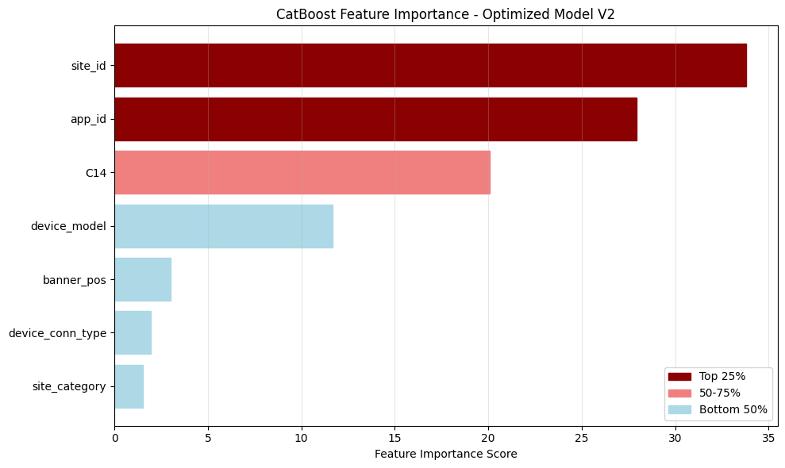
- site_id, app_id are most predictive features
Model interpretation:
- SHAP (see the notebook 7_model_explaination.ipynb)
Model deployment:
- See the notebook 8_model_deployment.ipynb
Part 3: Business impact (more details see notebook 9_business_impact.ipynb)
Assumptions:
- The cost per ad/session is $2.
- Each successful booking after viewing the ad generates a profit of $12
In the test data: we have 10107242 ads and 1716267 of them has booking.
Without model:
Revenue in test
Our revenue = -10107242 * 2 + 1716267 * 12 = 380720$
With model:
Threshold finding
We need to find the optimal threshold where we can predict if person see this ad will make a booking? To do that we use the train data. For a given threshold, we can estimate the optimize threshold revenue.
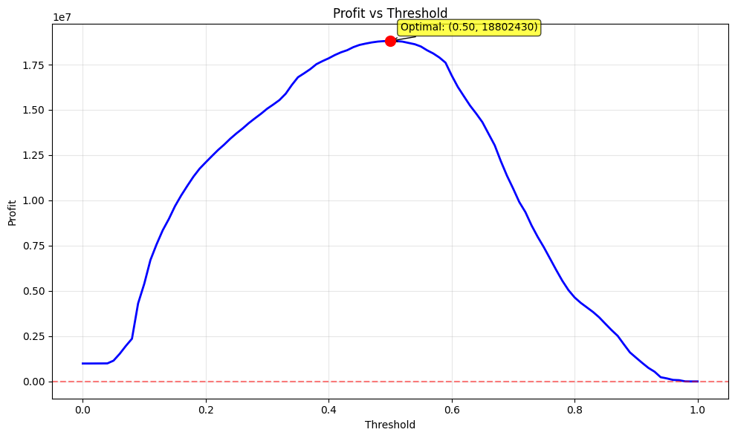
From the training data, we can estimate the optimal threshold is 0.5. Now we will apply 0.5 to test data
Revenue in test
With 0.5 in test data, we have
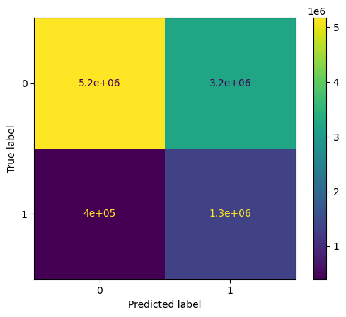
Revenue = -(3218351 + 1320787)* 2 + 1320787 * 12 = 6,771,168$ (is 17 times greater than the revenue without the model ($380,720)).
Note: This calculation is based on several assumptions and does not account for other expenses or opportunity costs.
Part 4: Future Work
- Try other tree-based algorithms such as: XGB, CatBoost, HistGradientBoosting, Extra Trees, TabPFN (Tabular Prior-data Fitted Network), XTab (Cross-table Pretraining for Tabular Transformers), Tabular Transformers (FT-Transformer, SAINT, TabTransformer), NGBoost (Natural Gradient Boosting), TabNet
- Combine a lot of algorithms to make predictions (Model stacking and blending)
- Resampling methods for imbalanced data (RUS, ROS, SMOTE, Tomek links etc...)
- Spend more time on EDA to find insights.
- Feature engineering: creation of new features by extracting/or apply domain knowledge, feature selection/importance, feature combination, feature encoding (mean/target encoding, one-hot-encoding, WOE encoding, frequency encoding, ranking encoding, etc.)
- Dimensionality reduction with PCA, t-SNE, etc.
- Combine multiple techniques:

For example, we have an imbalanced dataset (80000 - 80% vs 20000 - 20%), one of the suggested solutions are:
- Divide data of majority class (class 0) into 4 sets
- Use all data of class 1 and each subset of class 0 to train multiple models (4 models) => ensemble these models to get the final one.
