Question 1

Pseudocode and Code
- Draw n = 300 real numbers uniformly at random on [0, 1]: x = [x_1, x_2, ..., x_n]'
- Draw n real numbers uniformly at random on [-1/10, 1/10]: nu = [nu_1, ..., nu_n]'
- Let d_i = sin(20*x_i) + 3*x_i + nu_i for i = 1,...,n. Let d = [d_1, ..., d_n].
Plot 1 (the points (x_i, d_i)):
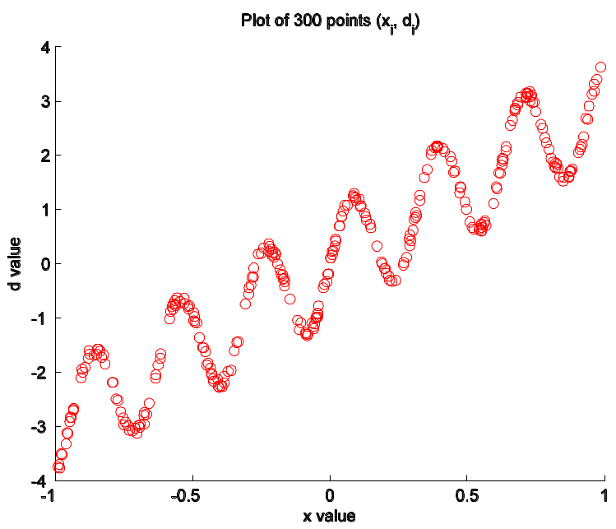
Number of input neuron M = 1
Number of hidden neuron N = 24
Number of output neuron L = 1
Let W1 be the weight matrix (including biases) from input layer to hidden layer
Let W2 be the weight matrix (including biases) from hidden layer to output layer
- Backpropagation training with online learning:
eta = 0.01
Initialize weight matrices randomly
Given threshold for stopping criteria: threshold = 0.1
Given number of maximum epochs: max_iteration = 50
Activation function for hidden layers: phi(v) = tanh(v)
Activation function for output layer: q(v) = v
Mean-squared error (MSE) function:
For i = 1 to max_iteration
  - For i = 1 to n
    - Calculate induced local fields v = W1 * x(i), where x(i) is the ith training sample.
    - Update weight matrices: W1 = W1 - eta *
W2 = W2 - eta *
  - Decrease eta whenever MSE increases: eta = eta * 0.9
Plot 2 (# epoch vs MSE)
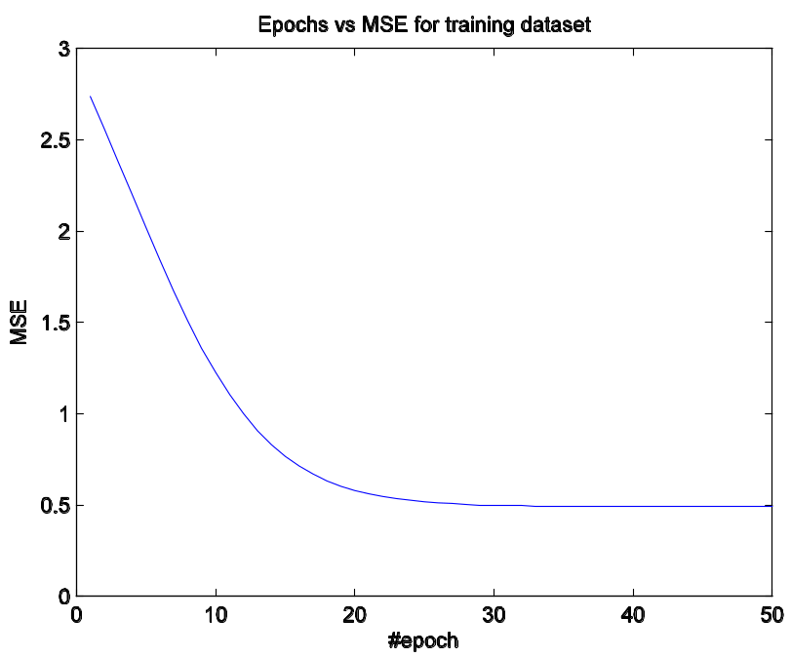
- Let W₁*, W₂* be the final weight matrices (including biases) from the backpropagation algorithm.
Plot 3 (plot the resulting curve f on top of plot 1):
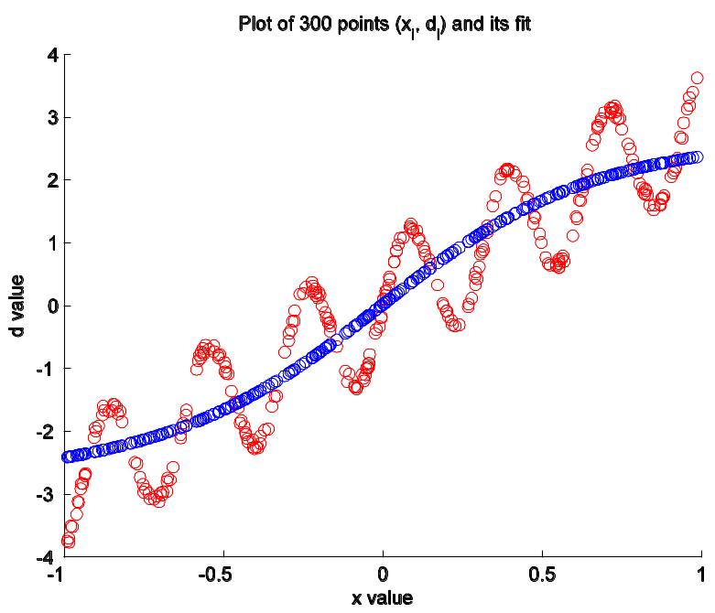
- Code:
%%
clc
close all
clear all

% number of data sample
n = 300;

% data input vector
x = zeros(n, 1);

for i = 1:n
x(i) = 2 * rand(1) -1;
end

nu = zeros(n, 1);

for i = 1:n
nu(i) = 2/10 * rand(1) - 1/10
end

d = zeros(n, 1);

for i = 1:n
d(i) = sin(20 * x(i)) + 3 * x(i) + nu(i);
end

figure(1)
hold on
plot(x, d, 'or')
%hold off

title('Plot of 300 points (x_i, d_i)')
xlabel('x value')
ylabel('d value')
%Set PaperPositionMode to auto so that the exported figure looks like it does on the screen.
set(gcf, 'PaperPositionMode', 'auto');
print('-depsc2', strcat('Plot 300 points', '-', date, '.eps'));

%%
% number of input, hidden, and output neurons
M = 1; N = 24; L = 1;

max_epochs = 50; % # of maximum epoch
threshold = 0.1; % mean-squared error threshold
eta = 0.01; % learning rate

% Initialize weight and bias
%W1 = rand(N, M+1);
%W2 = rand(L, N+1);
W1 = 2.*rand(N, M+1) -1;
W2 = 2.*rand(L, N+1) -1;

%W1(:,1) = 0;
%W2(:,1) = 0;

% Mean-squared error vector for respective epoch
mse = zeros(max_epochs, 1);

y = zeros(n, 1);

% previous mse, rescale eta to a smaller if mse is increasing
previous_mse = 1;

% Begin training
for iter = 1:max_epochs
for i = 1:n
[W1, W2] = backPropagation(eta, x(i), d(i), W1, W2);
end

%plot overall network error at end of each iteration
error = zeros(n, L);

for i = 1:n
[v1, y1, v2, y2] = feedForwardNet(x(i), W1, W2);
error(i,:) = d(i) - y2;
y(i) = y2;
end

mse(iter) = (sum(error.^2))/n;
if (mse(iter) >= previous_mse)
eta = eta * 0.5
end

previous_mse = mse(iter)

figure(2);
plot(mse);
if mse(iter) < threshold
break;
end

end

figure(1)
hold on
plot(x, y, 'ob')
hold off

title('Plot of 300 points (x_i, d_i) and its fit')
xlabel('x value')
ylabel('d value')
%Set PaperPositionMode to auto so that the exported figure looks like it does on the screen.
set(gcf, 'PaperPositionMode', 'auto');
print('-depsc2', strcat('Plot 300 points and its fit', '-', date, '.eps'));

% Plot of #epoch and MSE for training case
figure(2)
plot(mse)
title('Epochs vs MSE for training dataset')
xlabel('#epoch')
ylabel('MSE')
%Set PaperPositionMode to auto so that the exported figure looks like it does on the screen.
set(gcf, 'PaperPositionMode', 'auto');
print('-depsc2', strcat('Epochs vs mse', '-', date, '.eps'));

