Assumption:

* Computer can run shell script, javac, java
* The project folder contains all students’ submitted folder with the name of type “Name_*”
* The project folder also contains a private test named “*Test.java”
* The project folder also contains “junit-platform-console-standalone-1.5.2.jar” (you can find it in JunitTest/Junit/junit-platform-console-standalone-1.5.2 downloaded from github )

Example of expected project folder:

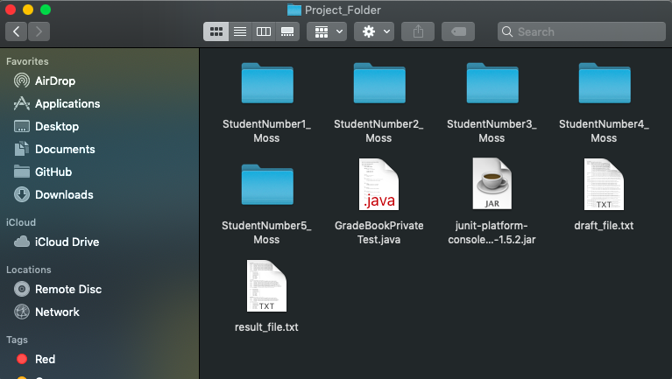

NOTE: if the junit-platform-console-standalone has different version, there should be some configuration in the runner.sh

**MACOS**

Step 1:

**After download the JunitTest from GitHub, go to Junit/ScripTesting to find the runner.sh and Runner.java**

Put “runner.sh” and “Runner.java” into the directory that contains Project folder.

For example:

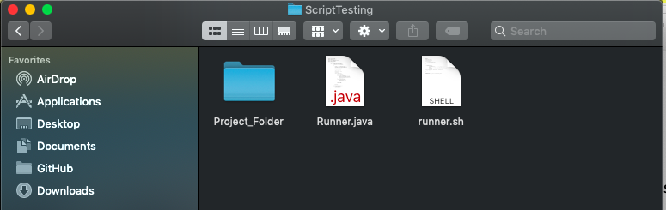

Step 2:

Open cmd, change directory to the one that contains project folder, then run:

chmod +x runner.sh

./runner.sh [name of Project folder]

For example:

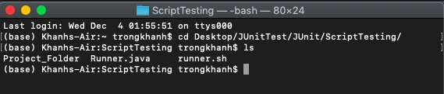

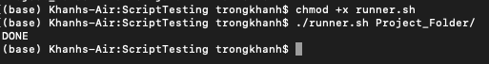

Step 3:

Open the Project folder, we will have the two new text files: draft_file.txt that contains all the result of Junit tests, result_file.txt that contains the condensed version draft_file.txt

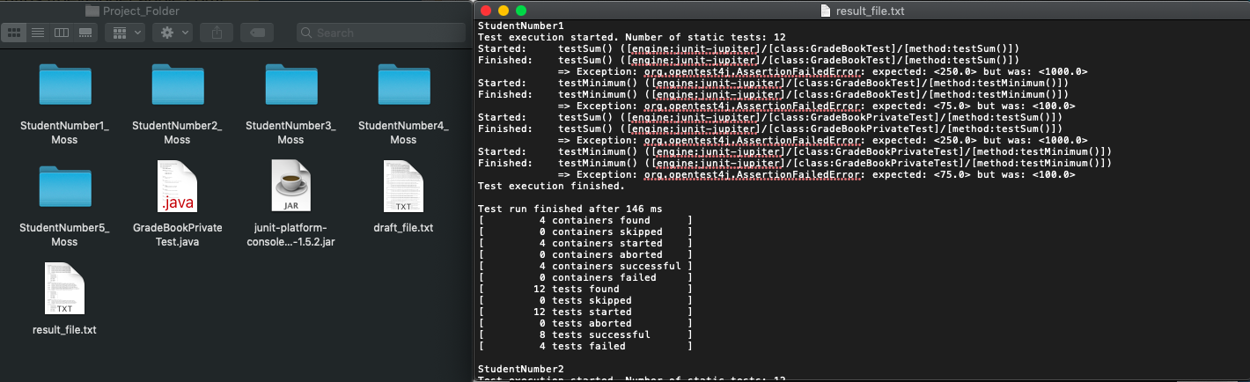

**Windows**

It will be the same as the steps we did in the MacOS section.

In Step 1, instead of putting “runner.sh”, we put “runner.cmd” with “runner.java” in the directory that contain the project folder

In Step 2, we run command:

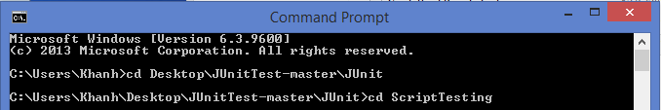

Go to the ScriptTesting, this directory contains runner.cmd, runner.java, and Project_Folder (containing students’ submitted folders)

We run command:



**Result detail:**

-Name of student

-Total tests run

-Tests that fail with assertions

-A table that summarize: number of tests run, number of failed tests, number of successful tests.