Table of contents:

* How to run
* Common errors
* How to name the test files
* What if I run the test files with incorrect names.

**1. How to run**

* **Put removePackage.java, runner.cmd, Runner.java at the same level with the project folder.**

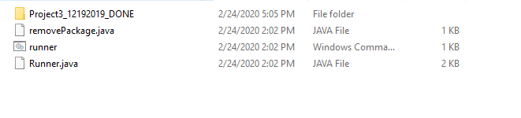

* **Put private tests, junit jar file inside the Project folder**

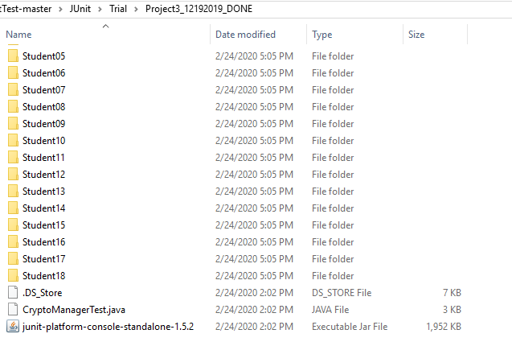

* **Use command line, change directory to the one containing project folder, removePackage.java, Runner.java, runner.cmd**

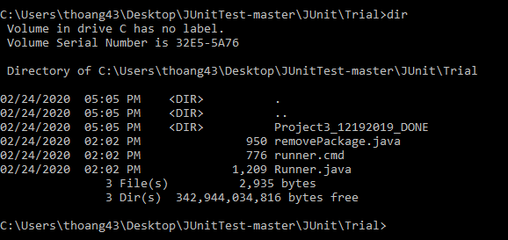

* **Run the runner with the name of project folder as argument**



**The result will be shown in the Project folder.**

**2. Common errors**

**Error case:**

**It will show this way if there is compiling error. The compiling error can come from the loss of necessary .java file to run test or the errors in java files. For example, the test needs Property.java and Plot.java. However, the Plot.java was not submitted. It will show 0 test in that case. In another case, compiling error can come from the different ways of naming methods. For example, in the Test.java, it calls object1.getValue(). However, in student’s Object class, it was named valueGetter() instead of getValue().**

**3. How to name test files**

**Assumption:**



**Please make sure the private tests end with *test.java. For example, privateTicketTest.java, PlotTest.java, ManagementCompanyTest.java.**

**4. What if I used the test files with incorrect names**

**If you mistakenly name it privateTicketTestDriver.java and run the program. Please consider change the name to privateTicketTest.java and the class name to privateTicketTest, and remove all the privateTicketTestDriver.java in each student’s folder. Then, you can run again.**