**MAC OS:**

**Step 1:**

Go to my JUnit repository:

<https://github.com/thoang43/JUnitTest>

and download/clone JUnitTest repository

**Step 2:**

In Junit folder, we have:

* Test5: containing GradeBook.java, GradeBookTest.java written with Junit 5 annotations and library, and out folder to contain binary file when compile
* Test4: containing GradeBook.java, GradeBookTest.java written with Junit 4 annotations and library, and out folder to contain binary file when compile
* SimpleTest: containing SimpleTest.java, which I used to test how Junit 5 worked, and out folder to contain binary file when compile (We do not need this one)
* Screenshot: containing all the screenshots I put in writeup.docx
* junit-platform-console-standalone-1.5.2.jar: this will be the only jar file we use to compile test and run test. It can be download at: https://mvnrepository.com/artifact/org.junit.platform/junit-platform-console-standalone/1.5.2

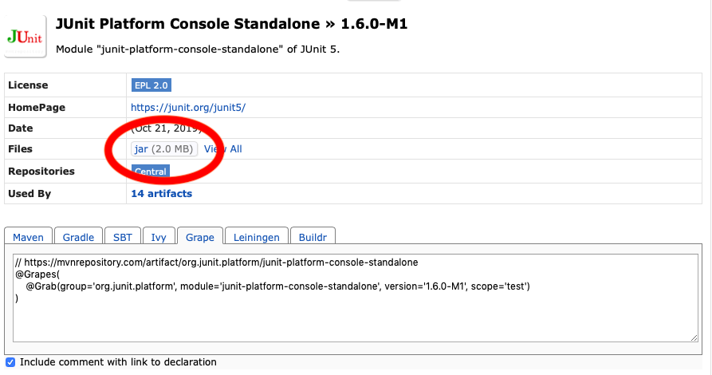

* Writeup.docx and how_to_run.docx

**Step 3:**

Move Junit folder to desired directory. In this example, I move it to my Desktop.

**Step 4: Running Junit 5**

In Terminal, change directory to /Desktops/Junit/Test5 (the GradeBook.java and GradeBookTest.java location):

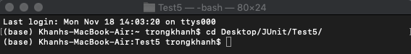

Then, we compile the GradeBook.java and GradeBookTest.java with the downloaded jar file (junit-platform-console-standalone-1.5.2.jar in Junit folder) using command:

javac -d out GradeBook.java

javac -d out -cp out:../junit-platform-console-standalone-1.5.2.jar GradeBookTest.java

#Note: I put “-d out” to put the binary file into the out folder

“-cp out:../junit-platform-console-standalone-1.5.2.jar”: the class path includes the GradeBook.class in out and junit-platform-console-standalone-1.5.2.jar in the previous directory level (../)

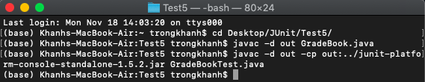

Then we run the compiled files:

java -jar ../junit-platform-console-standalone-1.5.2.jar –class-path out –scan-classpath

#Note: “—class-path” and “—scan-classpath” have two dashes - - going together. This two options are for the console to find Test in out directory.

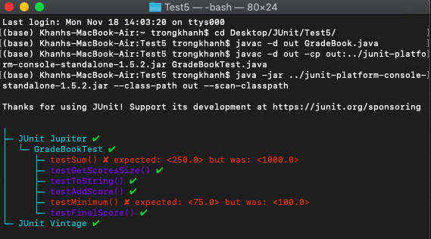

**Running Junit 4 (The same as running Junit 5)**

In Terminal, change directory to /Desktops/Junit/Test4 (the GradeBook.java and GradeBookTest.java location):

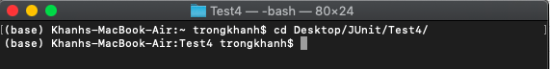

Then, we compile the GradeBook.java and GradeBookTest.java with the downloaded jar file ([junit-platform-console-standalone-1.5.2.jar](https://github.com/thoang43/JUnitTest/blob/master/JUnit/junit-platform-console-standalone-1.5.2.jar) in Junit folder) using command:

javac -d out GradeBook.java

javac -d out -cp out:../junit-platform-console-standalone-1.5.2.jar GradeBookTest.java

#Note: I put “-d out” to put the binary file into the out folder

“-cp out:../junit-platform-console-standalone-1.5.2.jar”: the class path includes the GradeBook.class in out and junit-platform-console-standalone-1.5.2.jar in the previous directory level (../)

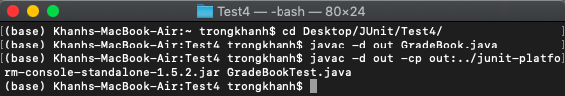

Then we run the compiled files:

java -jar ../junit-platform-console-standalone-1.5.2.jar –class-path out –scan-classpath

#Note: “—class-path” and “—scan-classpath” have two dashes - - going together. This two options are for the console to find Test in out directory.

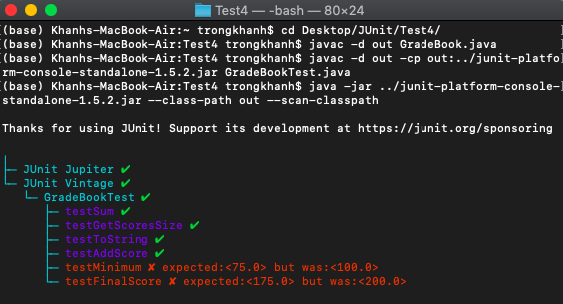

**Window:**

**Step 1,2, and 3 will be the same as in MacOS**

**Step 4: Running Junit 5**

In Command Prompt, change directory to /Desktops/Junit/Test5 (the GradeBook.java and GradeBookTest.java location):

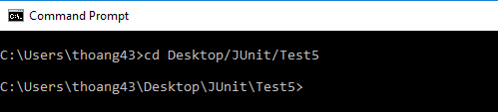

Then, we compile the GradeBook.java and GradeBookTest.java with the downloaded jar file ([junit-platform-console-standalone-1.5.2.jar](https://github.com/thoang43/JUnitTest/blob/master/JUnit/junit-platform-console-standalone-1.5.2.jar) in Junit folder) using command:

javac -d out GradeBook.java

javac -d out -cp out;..\junit-platform-console-standalone-1.5.2.jar GradeBookTest.java

#Note: I put “-d out” to put the binary file into the out folder

“-cp out;..\junit-platform-console-standalone-1.5.2.jar”: the class path includes the GradeBook.class in out and junit-platform-console-standalone-1.5.2.jar in the previous directory level (..\)

The difference between MacOS and Window command is instead of separating by “:”, and “/” like in MacOS, in Window we use “;”, and “\”

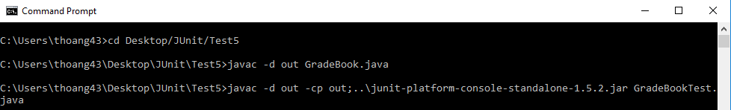

Then we run the compiled files:

java -jar ..\junit-platform-console-standalone-1.5.2.jar –class-path out –scan-classpath

#Note: “—class-path” and “—scan-classpath” have two dashes - - going together. This two options are for the console to find Test in out directory.

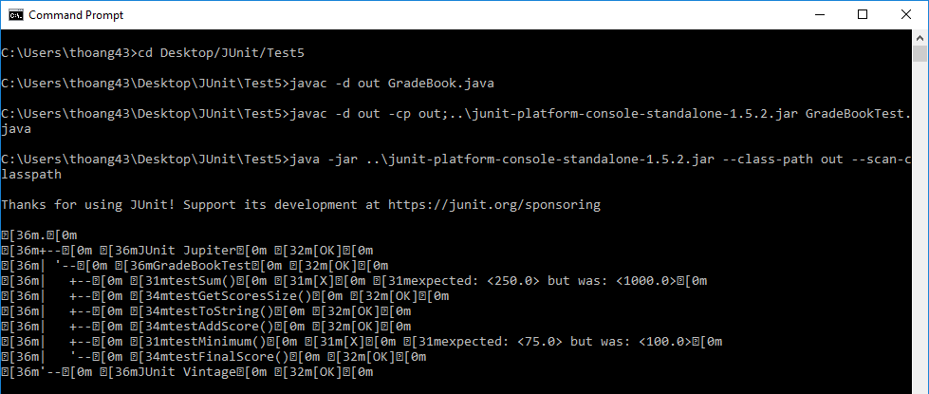

**Running Junit 4**

In Command Prompt, change directory to /Desktops/Junit/Test5 (the GradeBook.java and GradeBookTest.java location):

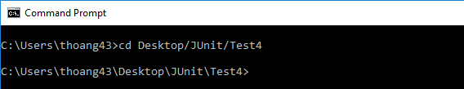

Then, we compile the GradeBook.java and GradeBookTest.java with the downloaded jar file ([junit-platform-console-standalone-1.5.2.jar](https://github.com/thoang43/JUnitTest/blob/master/JUnit/junit-platform-console-standalone-1.5.2.jar) in Junit folder) using command:

javac -d out GradeBook.java

javac -d out -cp out;..\junit-platform-console-standalone-1.5.2.jar GradeBookTest.java

#Note: I put “-d out” to put the binary file into the out folder

“-cp out;..\junit-platform-console-standalone-1.5.2.jar”: the class path includes the GradeBook.class in out and junit-platform-console-standalone-1.5.2.jar in the previous directory level (..\)

The difference between MacOS and Window command is instead of separating by “:”, and “/” like in MacOS, in Window we use “;”, and “\”

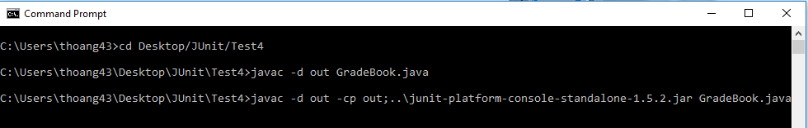

Then we run the compiled files:

java -jar ..\junit-platform-console-standalone-1.5.2.jar –class-path out –scan-classpath

#Note: “—class-path” and “—scan-classpath” have two dashes - - going together. This two options are for the console to find Test in out directory.

